**Accident Detection and SMS Alert System Using Mobile Phone**

**Prof.AmolHalde 1, Miss AakanshaMahirale 2, Mr. BhaveshChavhan 3, Mr. ShubhamKatyare 4 Mr. Manish Patil 5, Mr. SaurabhParskar 6**

1Professor, Department of Electrical Engineering, Padm. Dr. V.B.Kolte College of Engineering, Malkapur, Maharashtra, India

2,3,4,5,6UG Student, Department of Electrical Engineering, Padm. Dr. V.B.Kolte College of Engineering, Malkapur, Maharashtra, India

**ABSTRACT**

The main aim of this paper is to develop a GSM and GPS Based vehicle accident location alert system.In recent studies it is found that there is rapid increase of road accidents day by day and not getting proper rescue system and alert of accident location,due to this many people lost their lives. This system is designed with minimum number of circuit components.We are going to implement here a system using a vibration sensor to detect heavily collision, accelerometer sensor to check orientation of vehicle, GPS module to collect longitude and latitude of accident location and GSM module to send SMS of location of accident to family members or rescue team. By using this type of system in all types of vehicles can help to save lives of many people in road accident condition.

**Keywords:** Microcontroller ATmega328, Accelerometer Sensor, Vibration Sensor, GSM Module, GPS Module, 16x2 LCD.

1. **INTRODUCTION**

Vehicle has great importance in our daily lives today. Vehicle road accidents are one of the most important issues around the world. According to the World Health Organization, over 1 million people die every year due to transportation and tourism related road accidents. Speed is one of the most important and basic risk factors while driving vehicle. It not only affects the severity of a crash but also increases the risk of being involved in road accident. Despite the many efforts made by various NGO and governmental organizations all around the world through various awareness programs against careless driving, accidents are still taking place every now and then. However, many lives could have been saved if the emergency services could have gotten the immediate accident location data in time. This will aid in the detection and alert of the accident, potentially saving the lives of the injured. This system can be used to deal with accidents in areas where no one is available to report them. The usage of vehicles has increased over the past era, which has increased the risk of human life. Although various vehicle manufacturers have taken several steps to improve safety of the vehicle, the problem remains for the above reasons. Due to the delay in medical help, death rates are high, causing economic and social burdens for people involved. Like aircraft data recorders on a plane, "black box" technology now plays a major role in motor vehicle accident investigation. The black box is defined as an electronic device, which is used to record and store information in particular. We used the same concept herein this system as a black box in the car or any two, three wheelers for help rescue operation. Here the black box is used to record and store vehicle acceleration, orientation, interruption values in real time and store the vehicle's driving history. We can analyze and monitor the driving conditions of the vehicle and the accident. We used analog to digital converter (ADC) to collect analog values collected by the sensors and convert them into a digital value to feed into the microcontroller. The main objective of the project is made no accident level in real time all over the world and if accidents occur to recover it fast very short time, increases the probability of survival of the injured, and reduces the injury severity and automatically deployed the actions required, thereby reducing the time to assist the injured person.

1. **HARDWARE DISCRIPTION**

The hardware components used in this project are mentioned below.

**2.1 Vibration Sensor**

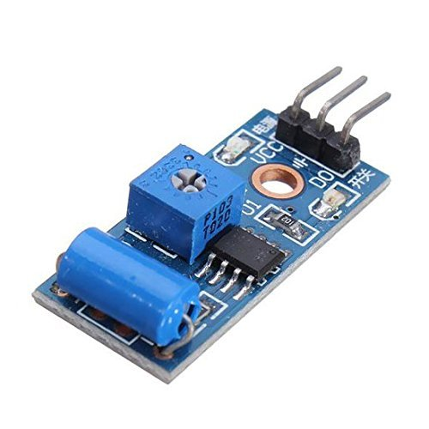

**Fig.1: Vibration Sensor**

A vibration sensor module is a device that measures the amount of vibration in a given system, machine, or piece of equipment. Those measurements can be used to detect imbalances or other issues in system and predict future breakdowns. Vibration sensor module is high sensitivity non- directional vibration sensor. The default state of the switch is close. Its digital output supply voltage is 3.3v- 5 Volt. It is onboard indicator LED to show the results. When the module is stable the circuit will be briefly disconnected and output low SW-420 based sensor, normally it is closed type vibration sensor.

**2.2 Accelerometer Sensor**

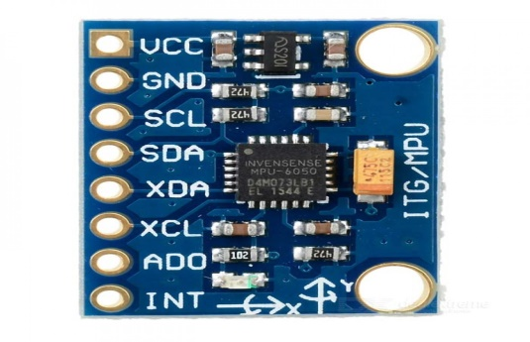

**Fig 2: Accelerometer Sensor**

The accelerometer module is to find the angle of tilt of a vehicle during any accident or in some improper road ways. This accelerometer value as an angle of tilt is fed to AVR microcontroller unit each time. Here the threshold range is 130 degree in a clockwise direction and 190 degrees in an anticlockwise direction, if car tilts less than 130 degrees and tilts greater than 190 degrees then the car would be in danger. The accelerometer sensor helps us to identify the orientation of vehicle in accident conditions.

**2.3 GPS Module**

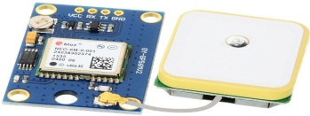

**Fig 3: GPS Module**

The system Global Positioning System is a navigational system that uses network of 24-32 satellites to determine the exact position of any object on earth. The satellites are positioned in orbit about an altitude of 12,000 miles from the earth surface. There are currently between 27 and 32 global positions system (GPS) satellites in orbit around the earth. Of these, three act as backups. Each satellite transmits a regular GPS signal that is carried by radio waves in the microwave part of the electromagnetic spectrum. Each GPS satellite continuously broadcasts a navigation message at 50 bits per second on the microwave carrier frequency of approximately 1600 MHz.FM radio, for comparison, is broadcast at between 87.5 and 108.0 MHz and Wi-Fi networks operate at around 5000 MHz and 2400 MHz More precisely, all satellites broadcast at 1575.42 MHz. The GPS module will help us to get vehicle accident location.

**2.4 GSM Module**

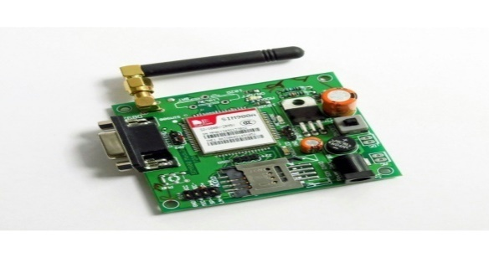

**Fig 4: GSM Module**

GSM stands for Global System for Mobile Communication. GSM module accepts AT commands from microcontroller and work as per instructions given from controller. We can send SMS and make calls using this GSM Module. GSM module is used in ensuring the safety of the vehicle. It is programmed in such a way that whenever the accident has detected the location of the vehicle is sent to registered telephone number through GSM & all the sent details can be used to locate the vehicle using Google map.

**2.5 16x2 LCD Display**

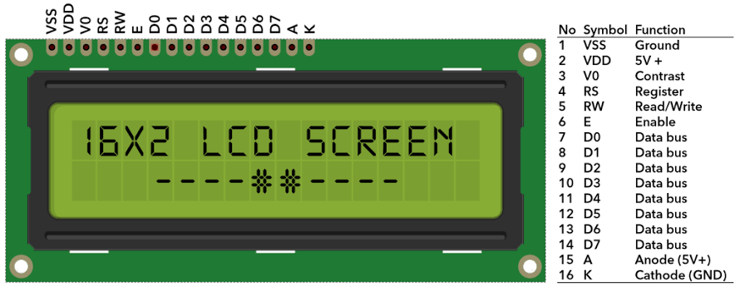

**Fig 5: 16x2 LCD Display**

LCD (Liquid Crystal Display) screen is an electronic display module and find a wide range of applications. A 16x2 LCD display is very basic module and is very commonly used in various devices and circuits. These modules are preferred over seven segments and other multi segment LEDs. The reasons being: LCDs are economical; easily programmable; have no limitation of displaying special & even custom characters (unlike in seven segments), animations and so on. A 16x2 LCD means it can display 16 characters per line and there are 2 such lines. In this LCD each character is displayed in 5x7 pixel matrix. This LCD has two registers, namely, Command and Data. The command register stores the command instructions given to the LCD. A command is an instruction given to LCD to do a predefined task like initializing it, clearing its screen, setting the cursor position, controlling display etc. The data register stores the data to be displayed on the LCD. The data is the ASCII value of the character to be displayed on the LCD. In this project we are using LCD for displaying GPS coordinates longitude and latitude.

**2.6 MicrocontrollerATmega328**

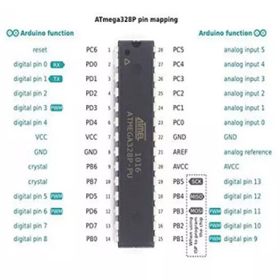

**Fig 6: Microcontroller ATmega328**

**Key parameters for ATmega328:**

Flash (KBytes):32kBytes, Pin count :28, Max. Operating Frequency ( MHz): 20MHz, CPU: 8-bit AVR, Touch channels: 16, Hardware touch Acquisition: No, Max I/o pins: 22, Ext Interrupts:24, SPI: 221, TWI(12c):1, UART:1, ADC Channels:8

ADC Resolution (bits): 10, ADC speed (kbps): 15, Analog comparator:1, DAC Resolution:0, Temperature sensor: yes, Operating voltage: 1.8 to 5.5

1. **SOFTWARE DISCRIPTION (ARDUINO IDE)**

Arduino IDE is an open source software that is mainly used for writing and compiling the code into the Arduino Module. It is an officialArduino software, making code compilation too easy that even a common person with no prior technical knowledge can get their feet wet with the learning process. It is easily available for operating systems like MAC, Windows, Linux and runs on the Java Platform that comes with inbuilt functions and commands that play a vital role for debugging, editing and compiling the code in the environment. A range of Arduino modules available including Arduino Uno, Arduino Mega, Arduino Leonardo, Arduino Micro and many more, each of them contains a microcontroller on the board that is actually programmed and accepts the information in the form of code. The main code, also known as a sketch, created on the IDE platform will ultimately generate a Hex File which is then transferred and uploaded in the controller on the board. The IDE environment mainly contains two basic parts: Editor and Compiler where former is used for writing the required code and later is used for compiling and uploading the code into the given Arduino Module. This environment supports both C and C++ languages.

1. **BLOCK DIAGRAM**

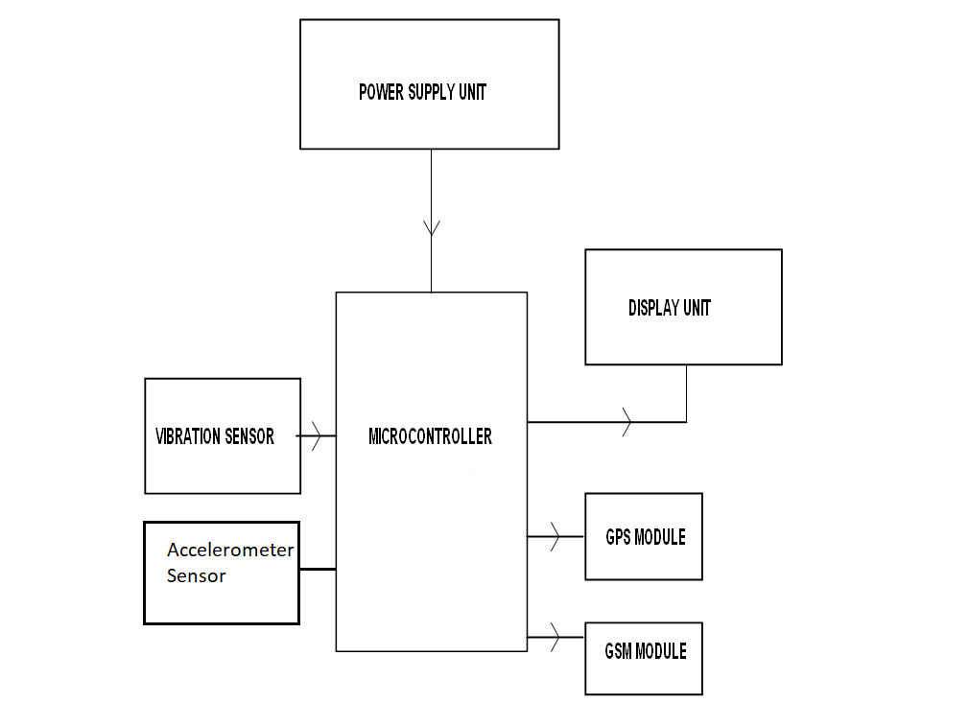

**Fig 7: Block Diagram**

**Working:**

This is accident detection system using MEMS accelerometer and GPS tracking system for accidental monitoring. The system consists of cooperative components of an accelerometer, microcontroller unit GPS device and GSM module. If any accident occurs, this wireless device will send mobile phone a short massage indicating the position of vehicle by tracing the location of the vehicle through GPS system to emergency medical service. The main objective of this work is to reduce the human death rate in road accident. The system is to give quick assistance to the people who got the accident. The fall detection and reporting system for the vehicle can gain the attention because the system consists of ADXL335 accelerometer sensor, RF module. An ADXL335 is used to detect the orientation of vehicle. It is the main sensor used to detect the accident. Once the accident is detected, controller gives this information to GSM module. By using GSM module we can send the location of accident message to family and ambulance operator.

1. **RESULTS AND DISCUSSION**

The result shows the accident detection system for vehicle in which the system configuration is included. Mobile screen shows the massage which contains location of vehicles during accident.

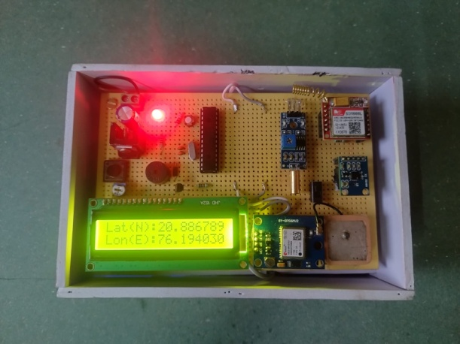

Fig 8: Accident Detection System

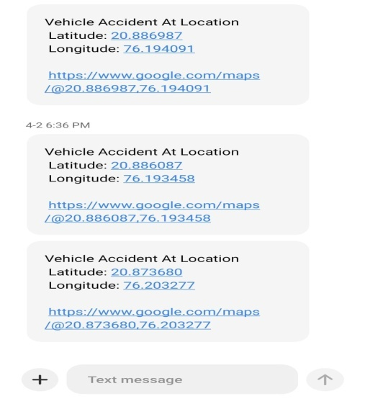

Fig 9: SMS of Accident Location

1. **CONCLUSION**

The proposed system makes good use of GPS and ADXL335 sensor, vibration sensor. It gives the safety to travelers during travelling. The human deaths are reduced by this safe and secure system. It helps to find the current location of the vehicle. It is the traveler’s safety mechanism. As per traveler’s safety concern, the proposed system also gives massage to family members and also hospital telephone number so that in short time treatment is given to crash victim.

1. **REFERENCES**
2. Dimple, Nanda B S; International Journal of Advance Research, Ideas and Innovations in Technology
3. DetectionandReportingSystemUsingGPSandGSMModule.forMr.DineshKumarHSDK,ShreyaGupta,SumeetKumar,SonaliSrivastava.JETERMay2015
4. M.J.Al-Hindawi,IbraheemTalib,“ExperimentallyEvalutionofGPS/GSMBasedSystemDesign”,JournalofElectronicSystemsVolume2Number2June2012.
5. BlackBoxSystemIEEEInternationalsystemsconference.AbdallahKassem,RabihJabr,GhadySalamouni
6. AliMazidi&JaniceGillispieMazidi,The8051Microcontroller,andembeddedsystems,6thedition,PearsonEducation.
7. P.AjayKumarReddy,P.DileepKumar,K.BhaskarReddy,E.Venkataramana,M.ChandraSekharReddy,“Blackboxforvehicles”,InternationalJournalofEngineeringInventionsISSN:2278-7461,www.ijeijournal.com,Vol1,Issue7,PP:06-12,October2012.
8. Doshi, A., Shah, B., &Kamdar, J. Accident Detection And Alert System. International Journal of All Research Educa- tion and Scientific Methods (IJARESM), 9(11), 114-119.
9. Kattukkaran, N., George, A., &Haridas, T. M. (2017, Jan- uary). Intelligent accident detection and alert system for emergency medical assistance. In 2017 international confer- ence on computer communication and informatics (ICCCI) (pp. 1-6). IEEE.
10. BlackBoxSystemIEEEInternationalsystemsconference.AbdallahKassem,RabihJabr,GhadySalamouni
11. Kodali, R. K., &Sahu, S. (2017, December). MQTT based vehicle accident detection and alert system. In 2017 3rd International Conference on Applied and Theoretical Com- puting and Communication Technology (iCATccT) (pp. 186-189). IEEE.
12. Borikar, D. A., &Chandak, M. B. (2020). Accident De- tection and Emergency Alerting System for Road Safety. Biosc. Biotech. Res. Comm, 13(14), 256-259.
13. http:/www.arduino.cc/en/Main/ArduinoBoardUno
14. Gomathy, C. K., Rohan, K., Reddy, B. M. K., &Geetha, V. Accident Detection and Alert System. Journal of Engineer- ing, Computing & Architecture, 12(3), 32-43.
15. Shahzadi, H. M., Rafique, H. M., &Riaz, M. S. (2018). Auto of Innovative Research in Computer and Communication
16. Engineering, Website: www. ijircce. com, 6(9), 7615-7626.
17. Raffik, R., Jones, M. M., Murugajothi, T., &Kannadasan,
18. B. (2021). Intelligent Accident Detection and Smart Alert System for Vehicles. International Journal of Mechanical Engineering, 6(3), 2391-2396.
19. , A. G., Gottursamy, C., Kumar, S. R., Vignesh, M., Kavin, T. P. (2020). Accident Detection and Alerting Sys- tem Using GPS & GSM. International Journal of Advanced Science and Technology, 29(3), 3598-3601.
20. Sumathy, B., Sundari, L., Priyadharshini, S. J., &Jayavarsh- ini, G. (2021). Vehicle accident emergency alert system. In IOP Conference Series: Materials Science and Engineering (Vol. 1012, No. 1, p. 012042). IOP Publishing.
21. Balfaqih, M., Alharbi, S. A., Alzain, M., Alqurashi, F., &Almilad, S. (2021). An accident detection and classifica- tion system using internet of things and machine learning towards smart city. Sustainability, 14(1), 210.