# Formulation And Evaluation Antibacterial Polyherbal Ointment Containing Aloevera ;Review

Devraj Sahu, Divyani Soni, Shamili Singh, Sakshi Gupta, Dr. Ritesh Jain

B. Pharmacy Student, LCIT school of Pharmacy, Bilaspur, Chhattisgarh Assistant Professor, LCIT School of Pharmacy, Bilaspur, Chhattisgarh Principal, LCIT School of Pharmacy, Bilaspur, Chhattisgarh

Abstract

Parkinson’s disease (PD) is a neurodegenerative disorder primarily characterized by motor symptoms such as tremors, rigidity, bradykinesia, and postural instability, resulting from the progressive loss of dopaminergic neurons in the brain. Conventional treatment options, including levodopa and dopamine agonists, offer symptomatic relief but are often associated with long-term side effects. This has led to increasing interest in the use of herbal drugs as alternative or adjunctive therapies in the management of Parkinson’s disease. Numerous plantbased compounds have been investigated for their potential neuroprotective, antiinflammatory, and antioxidant effects, all of which play a role in modulating the pathophysiology of PD. Herbs such as Withania somnifera (Ashwagandha), Ginkgo biloba, Panax ginseng, Mucuna pruriens, and Curcuma longa (turmeric) have shown promising results in preclinical and clinical studies, exhibiting effects on dopamine levels, motor functions, and neuroinflammation. These herbal agents are believed to provide symptomatic relief, slow disease progression, and improve the quality of life for patients. Despite these potential benefits, the clinical evidence remains inconclusive, and further rigorous studies are needed to establish the safety, efficacy, and optimal dosages of herbal drugs in Parkinson’s disease. This review explores the current evidence surrounding herbal drugs for Parkinson’s disease, highlighting their mechanisms of action, therapeutic

potential, and the challenges of integrating herbal medicine into conventional PD treatment regimens.

1.



INTRODUCTION

Medicinal plants are naturally gifted with invaluable bioactive compounds which form the backbone of traditional medicines [1]. The basic herbs have the answer with no side effects and effective remedies and the golden fact is use of herbal treatment is independent of any age group. When two or more herbs are used in the formulation they are known as Polyherbal formulations [2]. Antibacterial activity is the ability of the substance to inhibit or kill bacterial cells. Microorganisms such as bacteria can cause many types of skin-related diseases such as skill rashes, acne, eczema, psoriasis, dermatitis and etc. Staphylococcus aureu and Escherichia coli are the mai pathogen that causes these skin infections. Topical ointment containing extract of medicinal plant is one alternative to treat the skin infection caused by bacteria and prevent the use of oral antibiotic which then can develop bacterial-resistant.[3,4,5] Honey consists of various constituents such as water, carbohydrates, proteins, vitamins, amino acid, energy and minerals. Besides the major ones, there must also be several minor constituents in honey, which may be playing a key role in determining the antibacterial behavior of honey.[6,7] Murraya koenigii (Linn.)spreng, a member of the family Rutaceae, is a deciduous to semievergreen aromatic tree found throughout India. Curry leaf tree is commonly used as spice due to the aromatic nature of leaves. Carbazole alkaloids, the major constituents of the plant are known to possess Cytotoxic, Antioxidative, Antimutagenic and Anti- inflammatory, Antibacterial activities. Tagetes erecta L.(Asteraceae) is a medicinal and ornamental plant as nematocide, cosmetic and medicinal properties. It is used in olden days for the treatment of wounds, burns, and skin rashes. [8,9]

Becterial Infection

Bacterial infections are diseases that can affect your skin, lungs, brain, blood and other parts of your body. You get them from single-celled organisms multiplying or releasing toxins in your body.

Common bacterial diseases include UTIs, food poisoning, STIs and some skin, sinus and ear infections. They’re often treated with antibiotics. Harmful bacteria from the environment, an infected person or animal, a bug bite or something contaminated (like food, water or surfaces) can cause infections. Bacteria that’s not normally harmful but That gets into a place in your body where it shouldn’t be can Also cause infections.(6***)***

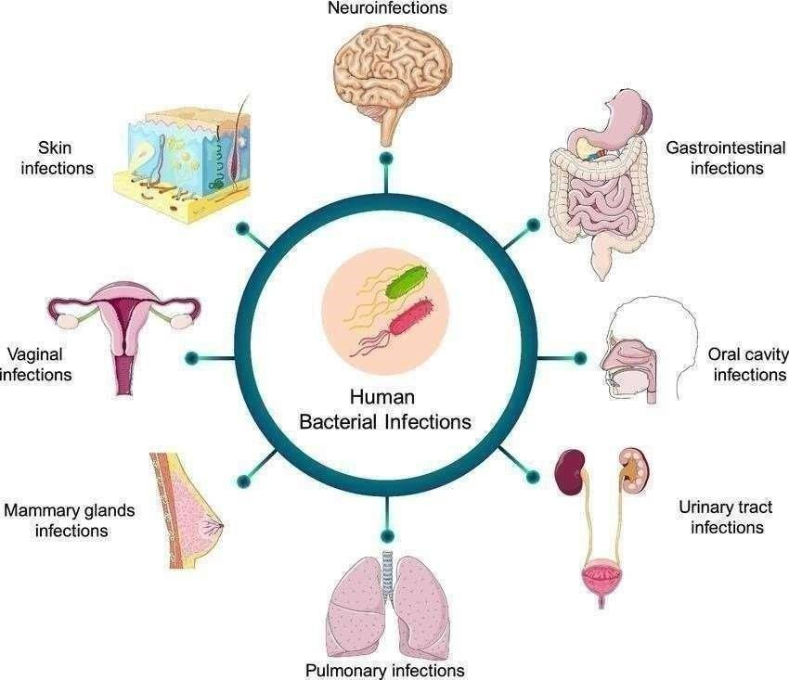

# Fig 1 :- Bacterial Infection



TYPES OF BACTERIAL INFECTION

Bacteria can cause many types of infections, depending on How you’re exposed and what part of your body it infects. Some common types of bacterial infections include:

* **Food poisoning (gastroenteritis).** – Stomach flu, viral Gastroenteritis, is a viral infection in your digestive system. It Causes gastrointestinal symptoms like vomiting and diarrhea. It’s usually brief, but can be very contagious.(3)
* **Some skin, ear or sinus infections.** – Ear infections (acute Otitis media) occur when a virus or bacteria infects the space Behind your child’s eardrum. Symptoms include ear that May cause your infant or toddler to be especially fussy or Irritable. Often, ear infections clear on their own. Sometimes, Children need antibiotics, pain-relieving medications or ear Tubes. Sinusitis is an inflammation of the tissues in Your sinuses (spaces in your forehead, cheeks and nose Usually filled with air). It causes facial pain, a stuffy or runny Nose, and sometimes a fever and other symptoms. It’s usually caused by the common cold, but other viruses, bacteria, Fungi and allergies can also cause sinusitis.
* **Some sexually transmitted infections (STIs).** – A sexually Transmitted infection (sexually transmitted disease) is a Serious condition that can develop after you have sex. Common STI symptoms include itching and burning around Your genital area. The good news is that most STI treatments Can cure the infection, but not all types. You can get an STI Again, even after treatment to cure it Bacterial pneumonia.
* **Most urinary tract infections (UTIs).** – A urinary tract Infection is a very common type of infection in your urinary System. It can Involve any part of your urinary system. Bacteria — especially E. coli — are the most common cause Of UTIs. Symptoms include needing to pee often, pain while peeing and pain in your side or lower back. Antibiotics can Treat most UTIs

**Antibacterial and antifungal herbal treatment**

*1.*



Garlic (Allium sativum)

Garlic is renowned for its potent antimicrobial and antifungal effects, particularly against a range of bacteria and fungi like Candida.



*2. Tea Tree Oil (Melaleuca alternifolia)*

Tea tree oil is one of the most powerful antifungal and antimicrobial oils, often used in topical treatments for skin infections and fungal conditions.

3 Echinacea (Echinacea purpurea)

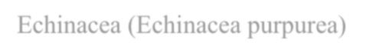

Echinacea boosts the immune system and has both antimicrobial and antifungal properties, often used to treat infections and support immune health.

Oregano oil contains compounds like carvacrol and thymol that have strong antifungal and antimicrobial effects, particularly against yeast infections and bacterial pathogen.



4 Oregano (Origanum vulgare)



5 Turmeric (Curcuma longa)

Curcumin, the active compound in turmeric, has both antimicrobial and antifungal effects, especially useful in treating skin conditions and infections.

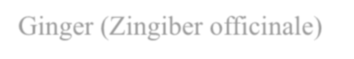

6 Ginger (Zingiber officinale)

Ginger has both antifungal and antimicrobial properties, helpful in reducing infections and boosting overall immune response.



Uses of Antibacterial and antifungal dosage form

# Antibacterial Dosage Forms:

**Oral Forms:**

Tablets/Capsules: For systemic infections (e.g., amoxicillin for bacterial infections). Suspensions: Often used for pediatric or geriatric patients who have difficulty swallowing

tablets (e.g., liquid antibiotics like amoxicillin syrup).

# Topical Forms:

Creams/Ointments: Used for skin infections (e.g., mupirocin for skin infections).

Lotions/Gels: Used for localized infections or rashes (e.g., clindamycin gel for acne). Powders: Used to treat fungal or bacterial infections on the skin (e.g., clotrimazole

powder for Fungal infections ❖ Injectable Forms:

IV/IM Injections: For serious or systemic infections (e.g., vancomycin for hospital- acquired infections)

# Inhalation Forms:

Nebulizers/Inhalers: Used for respiratory infections (e.g., colistin inhalation for respiratory Pseudomonas infections).

# Eye Drops/Ointments:

Used for ocular infections (e.g., ciprofloxacin eye drops for bacterial conjunctivitis).

# Antifungal Dosage Forms: Oral Forms:

Tablets/Capsules: Used for systemic fungal infections (e.g., fluconazole for candidiasis or fungal infections).

Suspensions: For children or those who have difficulty swallowing pills (e.g., nystatin suspension for oral thrush).

# Topical Forms:

Creams/Ointments: Used for superficial fungal infections like athlete’s foot or ringworm (e.g., clotrimazole cream).

Powders/Sprays: Often used for fungal infections in the skin folds (e.g., miconazole powder).

Shampoos: For scalp fungal infections (e.g., ketoconazole shampoo for dandruff caused by fungi. (14)

# Injectable Forms:

IV Infusion: Used for severe, systemic fungal infections (e.g., amphotericin B for serious fungal infections).

# Vaginal Forms:

Suppositories: Used for vaginal yeast infections (e.g., miconazole vaginal suppositories).

Creams/Gels: For treating fungal infections of the vaginal area.



4. DRUG PROFILE



NEEM

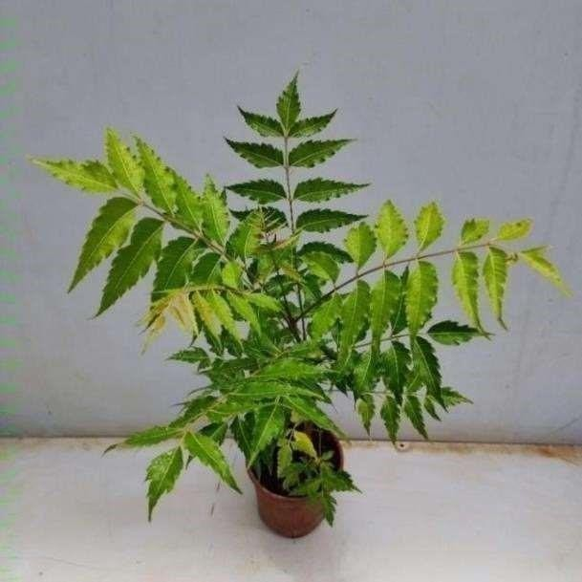

IDENTITY

Botanical name: Azadirachta indica Kingdom: Plantae

Order: Sapindales

Family: Meliaceae

Genus: Azadirachta

Species: A indica

Synonym: Margosa

Uses – Neem is widely used in herbal medicine for its antimicrobial, anti-inflammatory, and antioxidant properties. It helps treat skin conditions like acne, eczema, and psoriasis, and is also effective in promoting oral health by reducing plaque and gum inflammation. Neem leaves and oil are used in various body care products for their ability to detoxify, soothe irritation, and improve overall skin health. Additionally, neem is used in traditional remedies for digestive issues and boosting immunity.

TURMERIC

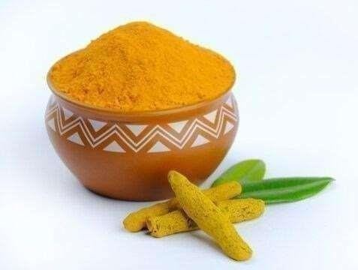

IDENTITY

Botanical name: Curcuma longa

Kingdom: Plantae

Order : Zingiberals

Family: Zingiberaceae

Genus: Curcuma longa

Synonym: Curcuma domestica

Uses – Haldi (turmeric) is a well-known herbal remedy with numerous health benefits. It contains curcumin, a powerful anti- inflammatory and antioxidant compound. In traditional medicine, it is used to treat skin conditions, wounds, and digestive issues. As a body care ingredient, haldi is often included face masks and scrubs for its skin-brightening and antibacterial properties. It also helps in reducing pain, improving joint health, and boosting immunity when consumed regularly.

ALOE VERA

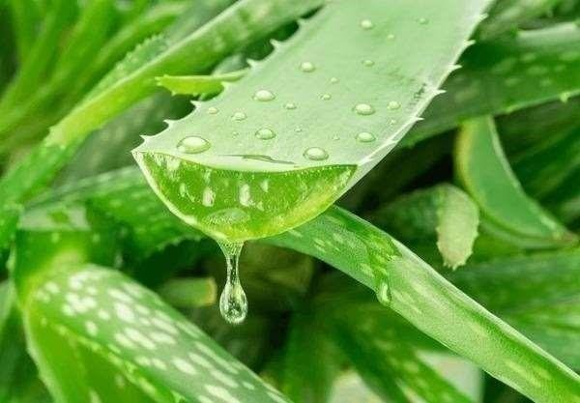

IDENTITY

Botanical name Aloe vera (L.)

Synonyms Aloe barbadensis Mill

Kingdom : Burm.f. Plantae

Order : Asparagales

Family Asphodelaceae

Genus aloe

Species Aloe vera

Uses – Aloe vera is a versatile herbal remedy known for its healing properties. It is commonly used in body care for its soothing and moisturizing effects on the skin, especially for burns, cuts, and dryness. In herbal medicine, aloe vera aids digestiation promotes detoxification, and supports immune health. Its anti-inflammatory and antioxidant properties also help reduce inflammation and skin irritation, while its gel is often applied topically to reduce acne and promote skin heal.



5. MATERIALS AND METHODOLOGY



Material and method

Collection of plants material - Herbal plant materialused for the collection from leaves of neem was collected from the localarea of beswan and dried rhizome of turmeric was purchased from the local

material of beswan.Alovera was collected for the botanical garden. Cetosteyl alcohol,

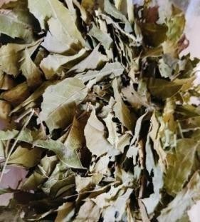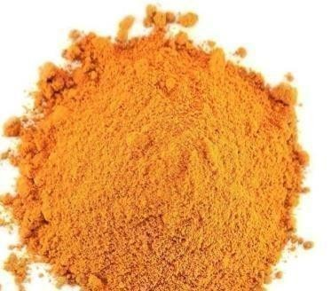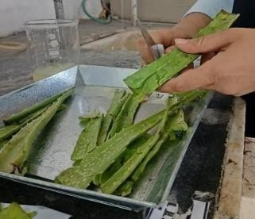

sodium lauryl sulphate, soft paraffin, liquid paraffin was taken from the pharmaceutical lab.

Preparation of Neem Extract – Leaves of the plant were collected and washed thoroughly with distilled water and shade dried for 10 days) Dried leaves were ground into powder form. 20gm powder was- imbibed with 50ml of 90% ethanol for 3hrs, and trafisferred to percolator with addition of 20ml of 90% ethanol for maceration for 7 days with occasional stirring) Finally ethanolic extract was collected and concentrated to get blackish green. Residue. The extra was stored in the airtight container at cool and dark place

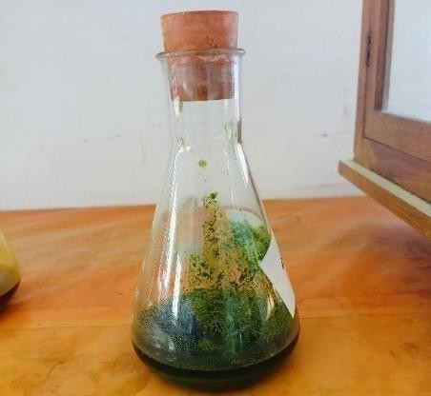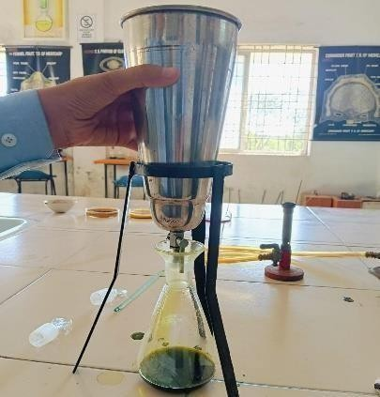

SOLVENT PERCOLATOR

Preparation of Turmeric extract – Dried rhizomes of turmeric were ground and the powder obtained 25 gm powder was imbibed. with 50 ml acetone for

maceration for 7 days with occasional stirring. The extract with crimson red colour was obtained and stored at cool and dark place in air tight container

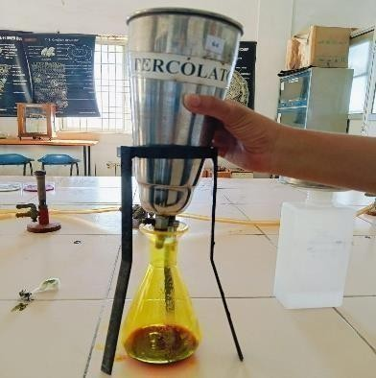

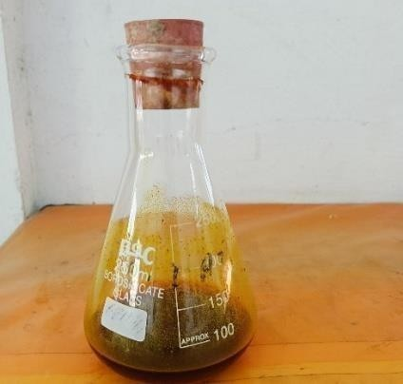

SOLVENTS. PERCOLATOR

**Preparation of Alovera juice** -: The aloe vera leaf was cut at the base of the plant, lower leaf was sliced opened and juice was collected Aloe vera is known for its healing properties and can help reduce itchiness, redness, and inflammation caused by fungal infections. You can apply fresh aloe vera gel directly to the affected area, let it dry, and then wash it off (18)



Evaluation

**Evaluation test for polyherbal ointment:** Phytochemical screening evaluation



Test for alkaloids

Hager's test: 2-3 ml filtrate with few drops Wagner's reagent gives reddish brown ppt ger's test: 2-3 ml filtrate with Hager's reagent gives yellow ppt.



Test for carbohydrates

Fehling's test: Mix Iml Fehling's And 1 ml Fehling's B solutions boil for one minute add agal volume of test solution. Heat in boiling water bath for 5-10 min. first yellow then anck red ppt. is observed.

Jodine test: Mix 3ml test solution and few drops of dilute lodine solution, blue colour appears, it disappears on boiling and reappears on cooling.

# Test for tannin

Acetic acid solution: red colour solution.Lead acetic solution: white ppt.



Test for amino acids

Ninhydrin test (General test): Heat 3 ml T.S and 3 drop 5% Ninhydrin solution in boiling water bath for 10 min. Purple or bluish colour appears.

# Test for deoxysugars (keller-killiani test):

To 2 ml extract, add glacial acetic acid, one drop 5% FeC13 and conc. H2SO4. Reddish brown colour appears at junction of the two liquid layers and upper layer appears bluish green.**Test for protein**

**Biuret test(General test):** To 3 ml T.S. add 4% NaOH and few drop of 1% Ca504 solution. Violet or pink colour apprars.

**Test for proteins containing sulphur**: Mix 5 ml T.S. with 2 ml 40% NaO11 and 2 drop 10% lead acetate solution. Boil mixture. Solution turns or brownish due to Pbi formation.



Test for steroid

Salkowski reaction: To ml extract, add 2ml chloroform and 2 ml conc, H2504. Shake well. Chloroform layer appears red and acid layer shows greenish yellow fluorescence.

Liebermann's reaction: Mix 2 ml extract with chloroform. Add 1-2 ml aceteic anhydride and 2 drop conc.

H2SO4. From the side of test tube, First red then blue and finally green appears

# Measurement of pH:

The pH of natural ointment method determined with the aid of using the use of virtual pH meter. 1gm of ointment dispersed in 10ml of water and kept apart for two hours. Then the pH of the formulations was done using pH meter and the values are reported



RESULT AND DISCUSSION

Phytochemical screening of the extracts was performed and the results were showed in (Table 2). After the was confirmed the presence of alkaloids, flavonoids, carbohydrates, glycosides, saponin and terpinoids

The zone of inhibition (mm) measured in different extraction ratios on Escherichia coli, Staphylococcus aureus were fig.1.and 2 The agar well diffusion was employed to evaluate the

antibacterial efficacy of the extract combination.[4] The diameter of the borer used was 6 millimeter. The combinations having the biggest zone of inhibition were shown. Formulation F3 (6%) showed greater activity against Staphylococcus aureus and Escherchiacoli. Murraya koenigii spreng, T. Erecta (L), Honey have Antibacterial activity. Extraction and phytochemical screening were done.



Conclusion

General ointment containing Aloe vera, Neem and Turmeric was formulated. exhibited broad spectrum anti-bacterial and anti-fungal activity against all

the tested micro- organisms. It was found that bacteria are more sensitive as compared to fungi to all of the ointments. Specifically Aloe ointment is showing more Anti-bacterial and anti-fungal activity than the others. Among the all bacteria tested, E.coli is more sensitive to Aloe ointment. This is because aloe vera might be dissolving lipid content which is present in Gram-ve E.coli. In general fungi are less sensitive than bacteria. But in present study it was observed that fungus Avaris shows more sensitivity to Aloe and Turmeric ointment. In conclusion, the antifungal herbal ointment demonstrates significant potential as a natural alternative for treating fungal infections.



Reference

* 1. 1 Abhijeet p, jui v. Jagtap, Aditi A. Patil Richa N. Joshi B.S kuchekar , “ formulation of antibacterial and antifungal activity of a herbal ointment “journal of chemical and pharmaceutical Reaserch 2010;

2(3) : 182-183

* 1. Gangidi s.,Adepu s, jajala y. Muthyala Sai Krishna and Namala p. "Formulation and antibacterial and antifungal activity of a herbal ointment, world journal of pharmaceutical Reaserch 2024
  2. Liv S. Lona Q. Xu. Y. Wang J, X UZ, Wang L. et al. Assessment of antimicrobial and wound healing effects of brevinin-2Ta against the bacterium Klebsiella pneumoniae in dermally- wounded rub. Oncotarget 2017;
  3. Prabu Seenivasan S, Jayakumar M. Ignucimuthu S. In vitro antibacterial activity of some plant essential oils. BMC Conplement Altern Med. 2006; 6(39):1-8.
  4. Mhatre J. Nagaral S. Kulkarni S. Formulation and evaluation of antibacterial activity of herbal ointment

prepared from crude extracts of aegle maemelos. (bael), Int J Pharmacy Pharm Sci. 2014; 2: 575-579

* 1. Shubhangi E. Sawant. Monali D. Tajane. Formulation and evaluation of herbal ointment containing

Neem and Turmeric extract. Journal of Scientific and Innovative Research 2016; 5(4): 149- 151.

* 1. Alemdar S, Agaoglu S. Investigation of In vitro Antimicrobial activity of Aloe vera juice. Journal

of Animal and Veterinary Advances. 2009: 8(1): 99-102.

* 1. Rajlakshmi G. Damodharan N. Formulation and evaluation of clotrimazole and ichthammol ointment. Int J pharm Bio Sciences, 2010; 1(4): P7-P15.
  2. Chah KF, Eze CA, Emuelosi CE, Esimone CO. Antibacterial and wound healing properties of

methanolic extracts of some Nigerian medicinal plants. J Ethnopharmacol 2006; 104: 164-167.

* 1. Vinoth B. Manivasagaperumal R. Rajaravindran M. Phytochemical analysis and antibacterial activity of Azadirachta indica A Juss. International Journal of Research in Plant Science 2012; 2(3):

50-55.