**FORMULATION AND EVALUATION OF BUCCAL DISPERSIBLE**

**TABLETS OF REPAGLINIDE**

**Miss. Wagh Pranali Sudam, Prof. Lokhane Prajakta Dr. Megha T. Salve.**

Shivajirao pawar college of pharmacy Pachegaon Tal : Newasa , Dist :

Ahilyanagar

# ABSTRACT

Buccal dispersible tablets (BDTs) are an innovative oral drug delivery system designed to enhance drug absorption and patient compliance. These tablets dissolve quickly in the buccal cavity without the need for water, offering an alternative for patients with swallowing difficulties. Repaglinide, a short-acting oral hypoglycemic agent used in the management of type 2 diabetes mellitus, suffers from low bioavailability due to extensive first-pass metabolism. The present study focuses on the formulation and evaluation of buccal dispersible tablets of Repaglinide to enhance its dissolution rate and bioavailability. Various formulations were developed using direct compression techniques, incorporating different concentrations of super disintegrants such as, Sodium Starch Glycolate, and Croscarmellose Sodium. Pre compression parameters, including bulk density, tapped density, angle of repose, and compressibility index, were evaluated to ensure good flow properties of the powder blend. Post-compression evaluations were conducted for hardness, thickness, friability, wetting time, disintegration time, drug content uniformity. The results indicated that formulations containing Sodium Starch Glycolate exhibited the fastest disintegration time and superior drug release profile compared to other super disintegrants. The optimized formulation showed rapid dissolution, achieving significant drug release within the first 10 minutes. Stability studies confirmed that the selected formulation remained stable under accelerated conditions for a specified period. The findings suggest that buccal dispersible tablets of Repaglinide could serve as an effective and convenient alternative for managing postprandial hyperglycemia in diabetic patients

Keyword:- Buccal dispersible tablets, Repaglinide, Super disintegrants, hyperglycemia, Diabetics.

# INTRODUCTION

The pharmaceutical industry has engendered considerable interest making it a major participant in the healthcare industry. The advances and progress made by pharmaceutical industry have greatly contributed in terms of treatment of disease, thereby enhancing the quality of life.[1] Over the time, scientists and researchers in the drug development industries are focusing on alternate routes of administration to add to the potential of approved drug products, or to overcome the drawbacks of the oral route. Although oral route is preferred for administration of drugs, it is associated with some restrictions for example: hepatic first pass metabolism, local GI toxicity and enzymatic degradation within the GI tract. One strategy that has been reasonably successful to circumvent such problems is to deliver drugs systemically via an alternate route of administration such as intranasal (IN), buccal/sublingual, pulmonary, or transdermal (TD).[2] Transmucosal routes of drug delivery which comprise of the mucosal linings of the nasal, rectal, vaginal, ocular, and oral cavity offer excellent opportunities and potential advantages over peroral administration for systemic drug delivery. These advantages include possible bypass of first pass effect, avoidance of pre-systemic elimination within the GI tract and depending on the particular drug, a better enzymatic flora for drug absorption.[3] The sites of drug administration in the oral cavity include the floor of the mouth (sublingual), the inside of the cheeks (buccal) and the gums (gingival).[4] With the advances and progress in biotechnology, hydrophilic high molecular weight therapeutic agents such as proteins and peptides are readily available for therapeutic use. However, when administered by the oral route, these agents suffer from problems such as degradation and poor absorption. To overcome these obstacles and for successful delivery of proteins and peptides, the buccal route of drug delivery has acquired significant attention.[5] In view of the systemic transmucosal drug delivery, the buccal mucosa is the preferred region as compared to the sublingual mucosa. One of the reasons is that buccal mucosa is less permeable and is thus not able to elicit a rapid onset of absorption and hence better suited for formulations that are intended for sustained release action. Further, the buccal mucosa being relatively immobile mucosa and readily accessible, it makes it more advantageous for retentive systems used for oral transmucosal drug delivery. Over the past few decades, the concept of use of bioadhesive polymers to prolong the contact time has gained remarkable attention in transmucosal drug delivery. Adhesion as a process is simply defined as the “fixing” of two surfaces to one another. Bioadhesion may be defined as the state in which two materials, at least one of which is biological in nature, are held together for extended periods of time by interfacial forces. In the pharmaceutical sciences, when the adhesive attachment is to mucus or a mucous membrane, the phenomenon is referred to as mucoadhesion.[6] Thorough and vast research over the past few years has resulted in profound advances in understanding the concepts and aspects of mucoadhesion. To accomplish site-specific drug delivery, a lot of interest has been turned on to the concept of mucoadhesion, which encompasses a pharmaceutical formulation incorporating mucoadhesive hydrophilic polymers along with the active pharmaceutical ingredient (API).

The rationale being that the formulation will be ‘held’ on a biological surface for localized drug delivery and the release of API will be close to the site of action leading to enhanced bioavailability.[7] In the early 1980’s, Professor Joseph R. Robinson at the University of Wisconsin pioneered the concept of mucoadhesion as a new strategy to prolong the residence time of various drugs on the ocular surface. Over the years, mucoadhesive polymers were shown to be able to adhere to various other mucosal membranes. The capability to adhere to the mucus gel layer which covers epithelial tissues makes such polymers very useful excipients in drug delivery.[8] Mucoadhesion is known to increase the intimacy and duration of contact between drug- containing polymer and a mucous surface. It is believed that the mucoadhesive nature of the device can increase the residence time of the drug in the body. The bioavailability of the drug is improved because of the combined effects of the direct drug absorption and the decrease in excretion rate. Increased residence time and adhesion may lead to lower API concentrations and lower administration frequency to achieve the desired therapeutic outcome.[9]

# Advantages of Buccal Drug Delivery System [10-15]

1. The buccal mucosa is relatively permeable with a rich blood supply, robust in comparison to the other mucosal tissues.
2. Bypass the first-pass effect and non-exposure of the drugs to the gastrointestinal fluids.
3. Easy access to the membrane sites so that the delivery system can be applied, localized and removed easily.
4. Improve the performance of many drugs, as they are having prolonged contact time with the mucosa.
5. High patient acceptance compared to other non-oral routes of drug administration.
6. Tolerance (in comparison with the nasal mucosa and skin) to potential sensitizers.
7. Increased residence time combined with controlled API release may lead to lower administration frequency.
8. Additionally significant cost reductions may be achieved and dose-related side effects may be reduced due to API localization at the disease site.
9. As a result of adhesion and intimate contact, the formulation stays longer at the delivery site improving API bioavailability using lower API concentrations for disease treatment.
10. Harsh environmental factors that exist in oral delivery of a drug are circumvented by buccal drug delivery.

# Disadvantages of Buccal Drug Delivery System [16]

1. Limited absorption area- the total surface area of the membranes of the oral cavity available for drug absorption is 170 cm2 of which ~50 cm2 represents non-keratinized tissues, including buccal membrane.
2. Barrier properties of the mucosa.
3. The continuous secretion of the saliva (0.5-2 l/day) leads to subsequent dilution of the drug. 4 The hazard of choking by involuntarily swallowing the delivery system is a concern.

5 Swallowing of saliva can also potentially lead to the loss of dissolved or suspended drug and ultimately the involuntary removal of the dosage form.

# LITERATURE REVIEW

1. **R. Jagadeeshwar Reddy et. al.2013:** Bioadhesion can be defined as a phenomenon of interfacial molecular attractive forces in the midst of the surfaces of biological substrate and the natural or synthetic polymers, which allows the polymer to adhere to biological surface for an extended period of time. Within the oral mucosal cavity, the buccal region offers an adorable route of administration for systemic drug delivery.[17]
2. **Surender Verma et. al.2011:** Buccal drug delivery has gained significant attention and momentum since it offers remarkable advantages. Over past few decades, buccal route for systemic drug delivery using mucoadhesive polymers to significantly improve the performance of many drugs has been of profound interest. This review article is an overview of buccal drug delivery systems encompassing a review of oral mucosa, formulation considerations for buccal drug delivery system, theories and mechanism of mucoadhesion, different mucoadhesive formulations for buccal drug delivery and active ingredients delivered via the buccal route.[18]
3. **Reena Sheoran, 2018:** Buccal drug delivery systems interact with the mucus layer covering the mucosal epithelial surface, and mucin molecules and increase the residence time of the dosage form at the site of absorption. The drugs which have local action or those which have maximum absorption in gastrointestinal tract (GIT) require increased duration of stay in GIT[19]
4. **Srivastava Namita et. al. 2015:** Buccal mucosa is the preferred site for both systemic and local drug action. The mucosa has a rich blood supply and it relatively permeable. The buccal region of the oral cavity is an attractive target for administration of the drug of choice, particularly in overcoming deficiencies associated with the latter mode of administration. Problems such as first-pass metabolism and drug degradation in the gastrointestinal environment can be circumvented by administering the drug via the buccal route. Moreover, rapid onset of action can be achieved relative to the oral route and the formulation can be removed if therapy is required to be discontinued. It is also possible to administer drugs to patients who unconscious and less co-operative.[20]
5. **Krishna Reddy et. al. 2003**: Three unknown impurities and a byproduct in repaglinide bulk drug at levels below 0.1% (ranging from 0.05 to 0.1%) were detected by a simple isocratic reversed-phase high performance liquid chromatography (HPLC) method. These impurities were isolated from crude sample of repaglinide using reversed-phase preparative high performance liquid chromatography. Based on the spectroscopic data (IR, NMR and MS) the structures of these impurities (I, II and IV) and byproduct (III) were characterised

as 4 carboxymethyl-2-ethoxy-benzoic acid (I), 4cyclohexylaminocarbamoylmethyl-2 ethoxy-benzoic acid (II), 1-cyclohexyl-3-[3methyl-1-(2-piperidin-1-yl-phenyl) butyl]-urea (IV) and 1,3-dicyclohexyl urea (III), respectively. Their synthesis and formation is discussed.[21]

# PLAN OF WORK

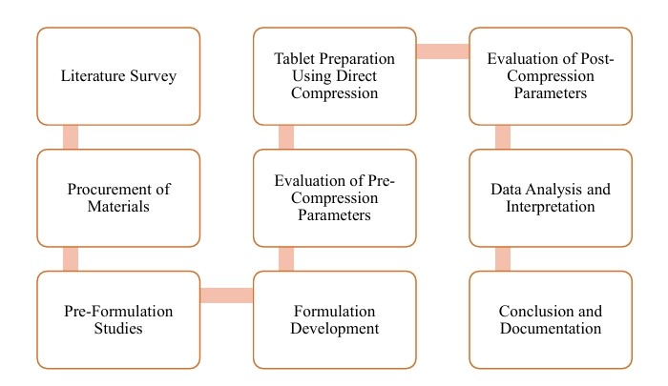

# DRUG PROFILE

Repaglinide is an oral antihyperglycemic agent used for the treatment of non insulindependent diabetes mellitus (NIDDM). It belongs to the meglitinide class of short-acting insulin secretagogues, which act by binding to β cells of the pancreas to stimulate insulin release. Repaglinide induces an early insulin response to meals decreasing postprandial blood glucose levels. It should only be taken with meals and meal-time doses should be skipped with any skipped meal. Approximately one month of therapy is required before a decrease in fasting blood glucose is seen. Meglitinides may have a neutral effect on weight or cause a slight increase in weight. The average weight gain caused by meglitinides appears to be lower than that caused by sulfonylureas and insulin and appears to occur only in those naïve to oral antidiabetic agents. Due to their mechanism of action, meglitinides may cause hypoglycemia although the risk is thought to be lower than that of sulfonylureas since their action is dependent on the presence of glucose. In addition to reducing postprandial and fasting blood glucose, meglitinides have been shown to decrease glycosylated haemoglobin (HbA1c) levels, which are reflective of the last 8-10 weeks of glucose control.[22]

# EXPERIMENTAL WORK

## Preformulation study

Preformulation studies are needed to ensure the development of a stable as well as effective and safe dosage form. It is a stage of development during which the pharmacist characterizes the physic-chemical properties of the drug substances and its interaction with various formulation components. Goals of Preformulation study:

* To determine the necessary physicochemical parameter of a new drug substance.
* To establish its incompatibility with excipients of formulation.[23]

## Formulation Development

**Angle of repose :** The angle of repose (θ) was determined using the funnel method . A funnel was secured on a stand at a fixed height (h) above a graph paper placed on a horizontal surface. The sample was poured until the apex of the conical pile touched the tip of the funnel. The radius r of the conical pile was measured and the angle of repose calculated as follows: θ = tan -1 (h/ r).

**Tapped density :** The tapped density (ρt) was determined by tapping a graduated glass cylinder containing a known weight of granulates for a fixed time period. The tapped density was obtained by dividing the weight of granulate by the minimum volume of granulate attained after tapping. The mean of three determinations was recorded.

**Hausner ratio :** The Hausner ratio, which is an index which indirectly expresses the ease of flow of powder or granulates, was calculated as the ratio of the tapped density to the bulk density (ρt/ρb). Hausner ratio values ~ 1.2 portrays low interparticle friction and good granulate flowability while values >1.6 signifies cohesive properties and poor granulate flowability.

**Carr’s index:** The Carr’s index (C) is used to predict the compressibility and ease of flow of granulate and was calculated as follows: C = (ρt – ρb) / ρt * 100, where ρt is tapped density and ρb is bulk density**.** [24-26]

# Tablet Preparation Using Direct Compression

The superdisintegrants is sodium starch glycolate in varying concentrations (1.5-4.5%) were used to develop the tablets. All ingredients (shown in Table 1) were passed through mesh no 60. All the ingredients were co-ground in a pestle motor for 5 minutes. The mixed blend was compressed into tablets using tablet machine Rimek mini press-1[27]

|  |  |  |  |  |  |  |  |
| --- | --- | --- | --- | --- | --- | --- | --- |
| **Sr. No.** | **Formulation** | **Repaglinide** | **Sodium**  **Starch**  **Glycolate** | **Microcrystalline**  **Cellulose** | **Lactose** | **Magnesium stearate** | **Talc** |
| 1 | F1 | 1mg | 5mg | 50mg | 29mg | 5mg | 10mg |
| 2 | F2 | 1mg | 7mg | 50mg | 27mg | 5mg | 10mg |
| 3 | F3 | 1mg | 9mg | 50mg | 25mg | 5mg | 10mg |
| 4 | F4 | 1mg | 11mg | 50mg | 23mg | 5mg | 10mg |
| 5 | F5 | 1mg | 13mg | 50mg | 21mg | 5mg | 10mg |

# Evaluation of tablets: [28-32]

**Uniformity of weight:** The test was carried out according to the US pharmacopoeia. Twenty tablets, of each formulation were individually weighed and the mean of tablet weights was calculated. Results are presented as mean value± standard deviation (SD).

**Hardness:** The fracture strength, which is defined as the force required breaking a tablet by radial compression was measured with a tablet hardness tester (Monsanto hardness tester)

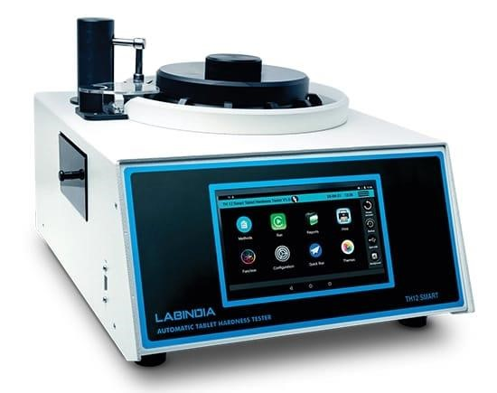

## Fig. hardness Tester

**Friability:** The friability of sample of six tablets ware measured using a Roche Friabilator (Electrolab EF 2, USP). Six pre-weighed tablets were rotated at 25 rpm for 4 minutes. The tablets were then reweighed after removal of fine’s using 60 mesh screens and the percentage of weight loss was calculated. % Friability = (Loss in weight / Initial weight) × 100

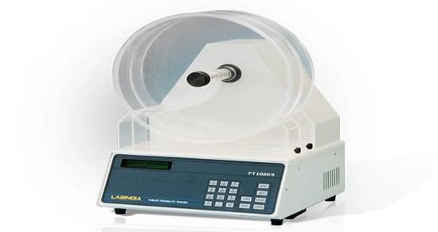

**Fig. Friability Test Apparatus**

## Fig. Friability Test Apparatus

**Wetting time:** A piece of tissue paper folded twice was placed in a small petri dish containing 6 ml of water. A tablet was put on the paper and the time required for complete wetting was measured.

**RESULT AND DISSCUSSION**

## Preformulation study

|  |  |
| --- | --- |
| Colour | White, Crystalline Powder |
| Odour | Odorless |
| Melting Point | 126-128 oC |

## Evaluation of Pre-Compression Parameters

|  |  |  |
| --- | --- | --- |
| 1 | Angle of repose | 25.10 |
| 2 | Bulk density | 0.52 |
| 3 | Tapped density | 00.60 |
| 4 | Hausner ratio | 1.15 |
| 5 | Carr’s Index | 13.33 |

# Evaluation of tablets

|  |  |  |  |  |
| --- | --- | --- | --- | --- |
| Formulation | Weight  Variation  (mg) ± S.D | HARDNESS  (kg/cm2)±S.D | FRIABILIY  (%) | WETTING  TIME (sce)±  S.D |
| F1 | 101.10 ±6.14 | 3.4±0.37 | 0.722 | 68.31±1.87 |
| F2 | 103.50 ±6.14 | 3.1±0.22 | 0.711 | 60.54±1.41 |
| F3 | 99.30 ±3.39 | 3.3±0.40 | 0.689 | 54.68±1.48 |
| F4 | 100.01 ±4.10 | 3.2±0.43 | 0.746 | 57.46±1.67 |
| F5 | 102.33 ±2.11 | 3.6±0.19 | 0.641 | 50.69±1.49 |

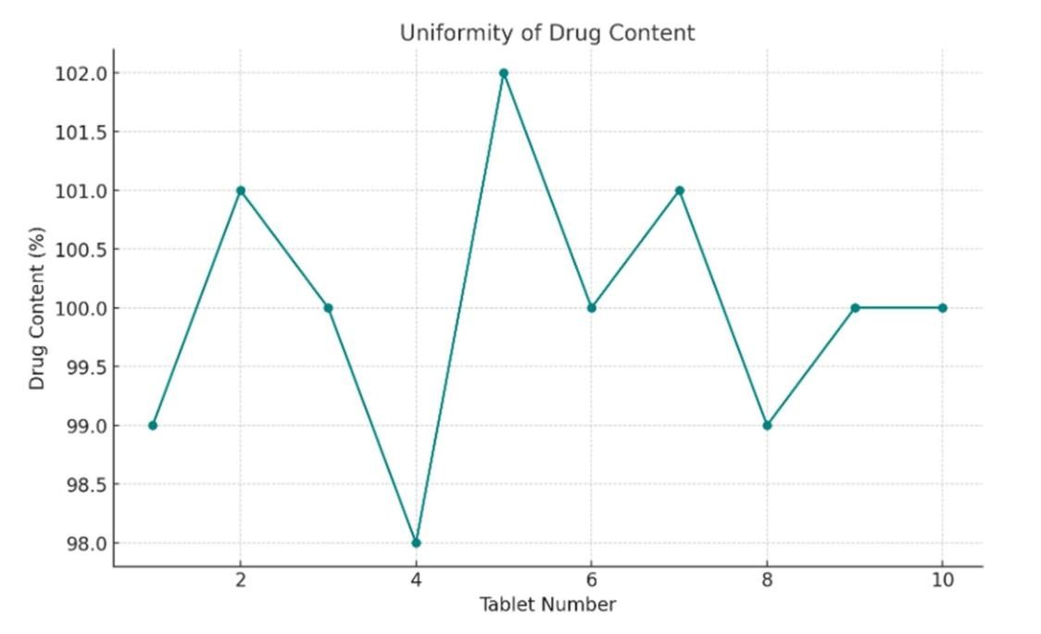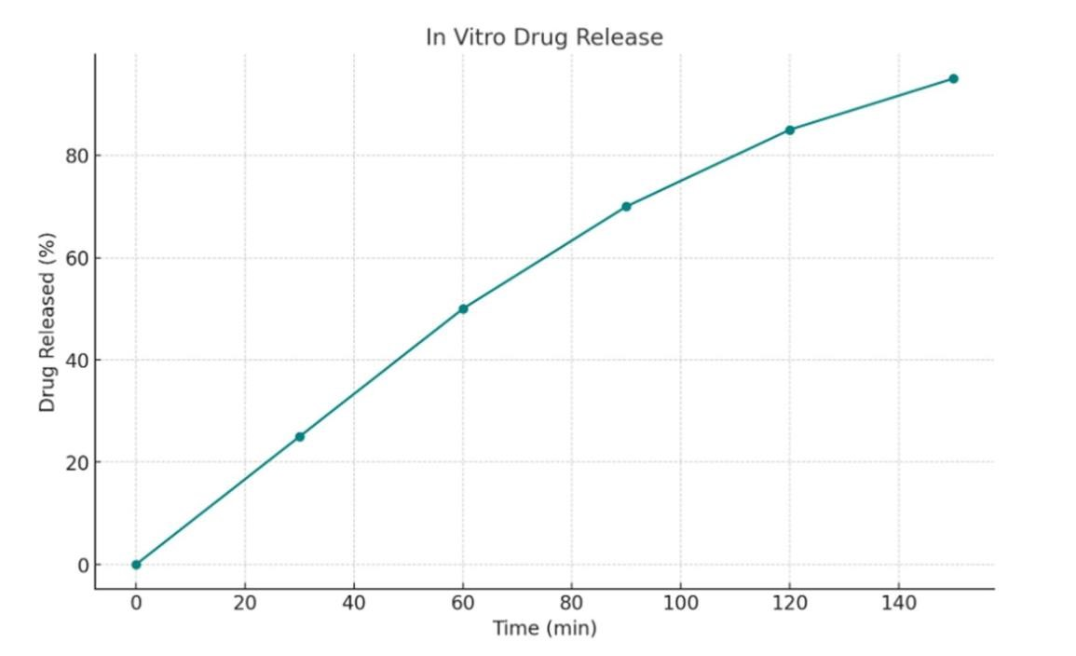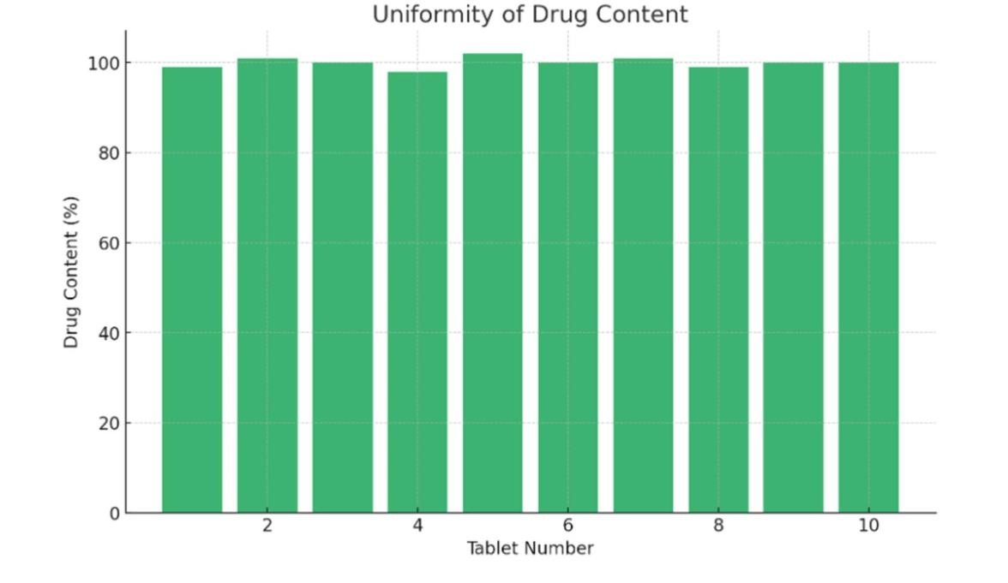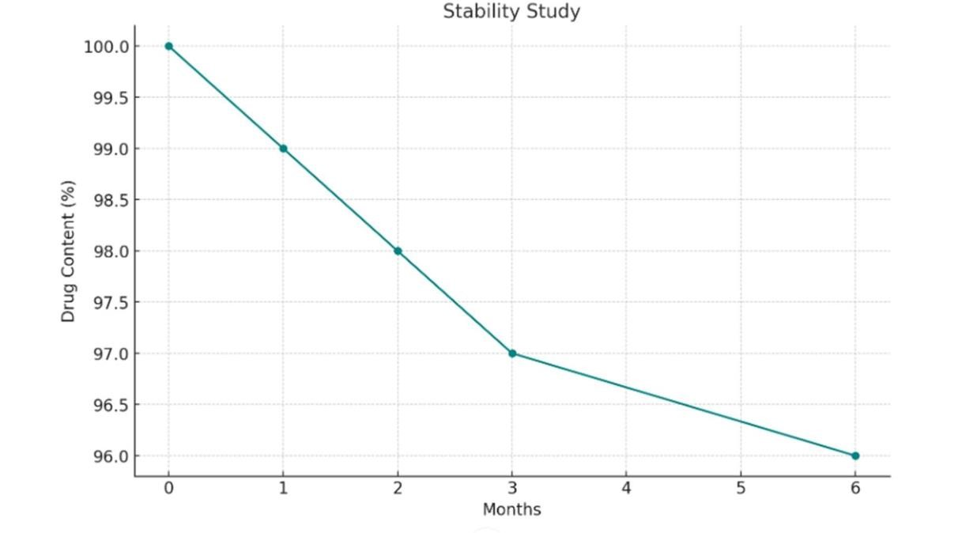

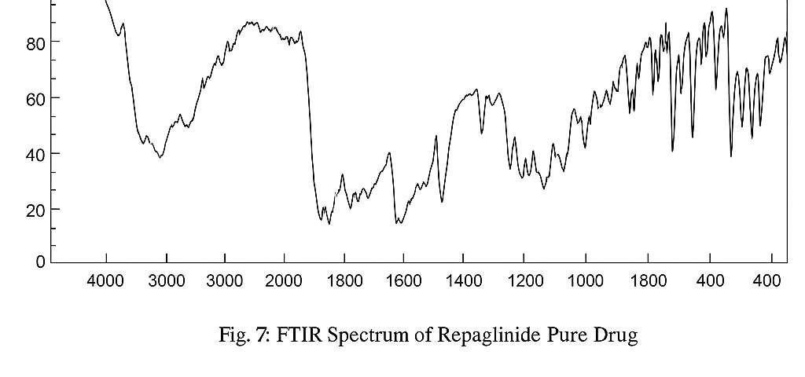

**CONCLUSION :** The present study successfully formulated and evaluated buccal dispersible tablets of Repaglinide using the direct compression method with different superdisintegrants. The optimized formulation exhibited rapid disintegration and enhanced dissolution, ensuring improved bioavailability of Repaglinide by bypassing first-pass metabolism. Among the tested superdisintegrants demonstrated superior performance in terms of disintegration time and drug release profile. Pre-compression parameters confirmed good flow properties of the powder blend, while post-compression evaluations showed that the formulated tablets met pharmacopeial standards for hardness, friability, wetting time. Additionally, stability studies indicated that the selected formulation remained stable under accelerated conditions, confirming its suitability for long-term storage. These findings support the potential of buccal dispersible tablets as a promising alternative to conventional oral dosage forms of Repaglinide, enhancing patient compliance and therapeutic efficacy.

**REFERENCES:**

1. Joseph A. DiMasi et al., The price of innovation: new estimates of drug development costs, Journal of Health Economics 2003; 22: 151-185.
2. Mathias N.R. and Hussain A.M, Non-invasive systemic drug delivery: developability considerations for alternate routes of administration, J. Pharm. Sci. 2010; 99:1-20.
3. Shojaei Amir H, Buccal Mucosa as a route for systemic drug delivery, Journal of Pharmacy and Pharmaceutical Sciences 1998; 1(1):15-30.
4. Hoogstraate Janet A.J. and Wertz P.W., Drug delivery via the buccal mucosa, Pharm Sci Technolo Today 1998; 1(7): 309-316.
5. Rossi Silvia et al., Buccal drug delivery: A challenge already won?, Drug Discov Today Technol 2005; 2(1): 59-65.
6. Smart JD, The basics and underlying mechanisms of mucoadhesion. Adv Drug Deliv Rev 2005; 57: 1556-1568.
7. Andrews Gavin P. et al., Mucoadhesive polymeric platforms for controlled drug delivery, Eur J Pharm Biopharm 2009; 71:505- 518.
8. Schnürch A. Bernkop, Mucoadhesive polymers: strategies, achievements and future challenges, Adv Drug Deliv Rev 2005; 57:1553-1555.
9. Huang Y et al., Molecular aspects of muco-and bioadhesion: Tethered structures and site-specific surfaces, J Control Release 2000; 65: 63-71.
10. Khairnar G.A. and Sayyad F.J., Development of buccal drug delivery system based on mucoadhesive polymer, International Journal of Pharm Tech Research 2010; 2(1): 719 735.
11. Madhav N.V. Satheesh et al., Orotransmucosal drug delivery systems: A review, J Control Release 2009; 140: 2-11.
12. Vyas S.P. and Khar R.K., Controlled drug delivery-concepts and advances. Vallabh Prakashan, first edition, New Delhi, 2002.
13. Bhalodia Ravi et al., Buccoadhesive drug delivery Systems: A review, International Journal of Pharma and Bio Sciences 2010; 1(2): 1-32.
14. Obradovic T. and Hidalgo Ismael J., DRUG ABSORPTION Studies Biotechnology:

Pharmaceutical Aspects, AAPS Press, Vol.7 (2), 2008: 167-181.

1. Junginger H.E. et al., Recent advances in buccal drug delivery and absorption- in vitro and in vivo studies, J Control Release 1999; 149: 149-159.
2. Miller N.S. et al., The use of mucoadhesive polymers in buccal drug delivery, Adv Drug Deliv Rev 2005; 57:1666-1691.
3. Reddy, R. Jagadeeshwar, Maimuna Anjum, and Mohammed Asif Hussain. "A comprehensive review on buccal drug delivery system." Am J Advan Drug Deliv 1 (2013): 300-312.
4. Verma, Surender, et al. "An overview on buccal drug delivery system." International journal of pharmaceutical sciences and research 2.6 (2011): 1303.
5. Sheoran, Reena. "Buccal drug delivery system: A review." Int J Pharm Sci Rev Res 50.1 (2018): 40-46.
6. Namita, Srivastava, and Monga Munish Garg. "Current status of buccal drug delivery system: a review." Journal of Drug Delivery & Therapeutics 5.1 (2015): 34-40.
7. Reddy, KVSR Krishna, et al. "Impurity profile study of repaglinide." Journal of pharmaceutical and biomedical analysis 32.3 (2003): 461-467.
8. Mollar-Puchades MA, Martin-Cortes A, Perez-Calvo A, Diaz-Garcia C (January 2007). "Use of repaglinide on a pregnant woman during embryogenesis". Diabetes, Obesity & Metabolism. 9 (1): 146–7.
9. Chaurasia, Gita. "A review on pharmaceutical preformulation studies in formulation and development of new drug molecules." Int J Pharm Sci Res 7.6 (2016): 2313-2320.
10. Odeku OA, Assessment of Albizia zygia gum as a binding agent in tablet formulations, Acta Pharm., 55, 2005, 263 – 276.
11. Alebiowu G, Itiola OA, Effects of starches on the mechanical properties of paracetamol tablet formulations. II. Sorghum and plantain starches as disintegrants, Acta Pharm., 53, 2003, 1 – 8.
12. Alebiowu G, Adeyemi AO, Influence of starch steeping period on dimensionless values of a paracetamol tablet formulation, Acta Poloniae Pharmaceutica – Drug Research, 66 (3), 2009, 311 – 320.
13. Staniforth J, Powder flow, In: Aulton ME. (ed.), Pharmaceutics – the science of dosage form design. 2 nd Ed., C
14. Sharma S, Gupta GD: Formulation and characterization of fast dissolving tablets of promethazie theolate. Asian journal of pharmaceutics- January-2008.
15. Shahi SR, Agrawal GR, Shinde NV, Shaikh SA, Shaik SS, Somani VG, Shamkuvarand PB, Kale MA: Formulation and In Vitro Evaluation of Oro-Dispersible Tablets of Etoricoxib with Emphasis on Comparative Functionality Evaluation of Three Classes Of Superdisintegrants. Rasayan J. Chem 2008; 1(2); 292-300.
16. Shoukri RA, Ahmed IS, Rehab N. Shamma RN: In vitro and in vivo evaluation of nimesulide lyophilized orally disintegrating tablets. European Journal of Pharmaceutics and Biopharmaceutics 2009; 73: 162–171.
17. Subramanian S, Sankar V, Manakadan AA, Ismailand S, Andhuvan G: Formulation and evaluation of cetirizine dihydrochloride orodispersible tablet. Pak.J.Pharm .Sci April 2010: 239(2).232 235.
18. Kuno Y, Kojima M, Ando S, Nakagami H: Evaluation of rapidly disintegrating tablets manufactured by phase transition of sugar alcohols. Journal of Controlled Release 2005; 105: 16–22.
19. Jain CP, Naruka PS: Formulation and evaluation of fast dissolving tablets of valsartan. International Journal of Pharmacy and Pharmaceutical Sciences JulySep.2009; 1(1).