**DEEP-LEARNING BASED FUNDUS ANALYSIS FOR EARLY DETECTION AND MANAGEMENT OF DIABETIC RETINOPATHY**

1Dr. D. Srujan Chandra Reddy M.Tech.,Ph.D., 2G. Suman,

1Professor, Dept of CSE, PBR VITS, Kavali, AP-524201

1Assistant Professor, Dept of EEE, PBR VITS, Kavali, AP-524201

**ABSTRACT**

Diabetic retinopathy (DR) is a progressive condition that can cause vision loss. It starts out subtly and gets worse with time. It affects approximately 35% of people with diabetes worldwide. According to research, a new case of diabetic retinopathy is diagnosed every few minutes. In its early stages, retinal images are frequently difficult to recognize due to their complexity. In the area of medical imaging, Deep Learning is growing. Convolutional Neural Networks (CNN) and other architectures are used in this study to see how they can be used to accurately detect and classify the stages of diabetic retinopathy. Our approach utilizes publicly available datasets and several deep learning techniques are used to identify and categories the Fundus images into four stages of DR will be compared in this work. Model robustness is enhanced using data preprocessing methods like normalization, augmentation, and segmentation. The models are evaluated using performance metrics like accuracy, precision, recall, F1-score, and Area Under Curve (AUC). The results demonstrate that deep learning models can achieve high classification accuracy, outperforming traditional machine learning methods. Ophthalmologists may find it easier to comprehend model predictions if they are able to gain insight into the regions of interest that are essential for decision-making through visual interpretation of the models. This study underscores the potential of deep learning to revolutionize diabetic retinopathy diagnosis, offering a foundation for future research in integrating multi-modal data and real-world applications.

### **I.INTRODUCTION**

Diabetic Retinopathy (DR) is a progressive eye disease caused by long-term diabetes that damages the blood vessels in the retina, potentially leading to vision impairment or blindness. It is one of the leading causes of vision loss worldwide, affecting millions of people. Early and accurate diagnosis is crucial for effective management and treatment, yet traditional diagnostic methods—such as manual examination of retinal images by ophthalmologists— often require expert interpretation and may not detect the disease in its early stages.

Recent advancements in deep learning, a subset of artificial intelligence (AI), have shown promising results in automating and improving the accuracy of diabetic retinopathy detection. Deep learning models, particularly Convolutional Neural Networks (CNNs) and Transformer-based architectures, can analyze complex retinal images (fundus photography) to identify early signs of DR, such as microaneurysms, hemorrhages, and exudates. These models extract patterns and features that might be imperceptible to human experts, allowing for faster and more reliable diagnosis.

Despite significant progress, challenges remain, including data scarcity, class imbalance, model interpretability, and generalizability across diverse populations and imaging conditions. Addressing these challenges requires interdisciplinary collaboration among ophthalmologists, data scientists, and AI researchers to develop more reliable and ethical AI- driven diagnostic tools.

This study explores the role of deep learning in diabetic retinopathy detection, highlighting different model architectures, datasets, preprocessing techniques, and performance evaluation metrics. The integration of AI in retinal imaging has the potential to revolutionize eye disease detection, improving early intervention strategies and patient outcomes.

Diabetic Retinopathy (DR) is a progressive eye disease caused by diabetes that affects the retina and can lead to severe vision loss if not detected early. Early detection of DR is crucial for timely intervention and treatment, which can help prevent or delay vision impairment. Traditional diagnostic methods, such as manual screening of retinal images, can be expensive, time-consuming, and subject to variability in interpretation.

The challenge is to develop an accurate and efficient method for detecting diabetic retinopathy at an early stage using retinal images (fundus photography). Machine learning and deep learning models have shown promise in automating this detection by analyzing patterns in retinal images.

This project aims to:

1. Develop a model that can classify individuals into the five stages of diabetic retinopathy (no DR, mild, moderate, severe non-proliferative DR, and proliferative DR) using retinal imaging data.

Note: The original text mentions "four stages in Diabetic Retinopathy's disease," but this appears to be an error, as DR is typically classified into five stages.

1. Improve the accuracy and reliability of existing diagnostic methods.
2. Provide a non-invasive and cost-effective solution for early diagnosis.

##### **OBJECTIVE**

* The goal of this study is to develop an efficient deep learning-based model for the early detection of **diabetic retinopathy** using **Xception Net**. Diabetic retinopathy is a progressive eye disease that affects people with diabetes and can lead to vision loss. Early detection is crucial for timely treatment and preventing vision loss.
* Building a deep learning model for the precise and early identification of **diabetic retinopathy** is the main objective of this work. The dataset, neural network (Xception Net), and weight parameters that are learned during training make up the essential parts of any deep learning model. The model is constructed with the metrics to provide good accuracy.
* The model will be tested on the test data after it has been created to determine its accuracy. After comparing accuracy, the diseased image is extracted from the data set. Thus, it is classified into four classes.
* Early detection of **diabetic retinopathy** involves a multifaceted approach, incorporating regular eye exams, blood sugar control, and emerging AI technologies like **Xception Net**. Continued research and advancements in diagnostic tools contribute to improved accuracy, allowing for timely intervention and better patient outcomes.

##### **II.EXISTING SYSTEM:**

Diabetic Retinopathy (DR) is a progressive eye disease caused by long-term diabetes that damages the blood vessels in the retina, potentially leading to vision impairment or blindness. It is one of the leading causes of vision loss worldwide, affecting millions of people. Early and accurate diagnosis is crucial for effective management and treatment, yet traditional diagnostic methods—such as manual examination of retinal images by ophthalmologists— often require expert interpretation and may not detect the disease in its early stages.

Disadvantages of Existing system:

1. Lower accuracy
2. Data Quality
3. Data integration
4. Data interpretability

##### **III.PROPOSED SYSTEM:**

This system will provide early detection, continuous monitoring, and personalized healthcare recommendations to patients with a focus on improving the diagnosis and treatment journey. By leveraging cutting-edge AI models and healthcare integration, the proposed system intends to support both clinicians and patients in making informed decisions regarding Diabetic retinopathy management.

Advantages of Proposed system:

1. Multimodal integration
2. Advanced Deep learning models
3. Higher accuracy
4. Notification system

##### SYSTEM ARCHITECTURE

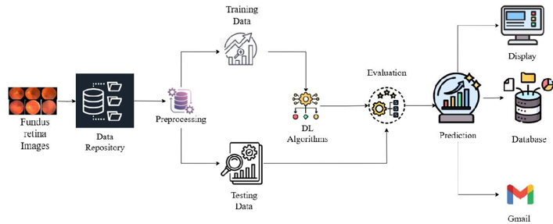

Fig.1: Architecture

1. **User Input**
   * Users upload an retina image along with their name and email.
2. Preprocessing & Prediction
   * The image is resized to 224x224 pixels and converted to a normalized NumPy array.
   * The pre-trained deep learning model (model.h5) processes the image and predicts the Diabetic Retinopathy’s stage.
3. Prediction & Labelling
   * The model returns probabilities for different stages- Mild DR, Moderate DR, Proliferative

-DR & Severe DR.

1. Email Notification
   * The system generates a diagnostic report.
   * A confirmation email with the predicted stage is sent to the user.
2. API Communication & Response
   * The result is returned as a JSON response.

### **IV.RESULTS AND DISCUSSIONS**

Home Page:

When the command is executed in vscode terminal, the home page will be opened. The home page has description about Diabetic retinopathy.

**About Page:** The About Page provides an overview of the website, its purpose, and key features, offering users insight into its functionality and objectives.

###### Predict:

**Before Prediction:** Before prediction, the system processes the uploaded retina image to prepare it for deep learning analysis.

**SAMPLE FUNDUS IMAGES:**

Fig 2:a.mild.png b. moderate.png

Fig 3: a.Severe.png b.proliferative.png

**After Prediction:** After prediction, the system generates and displays the Diabetic retinopathy’s classification result based on the analyzed Fundus image.

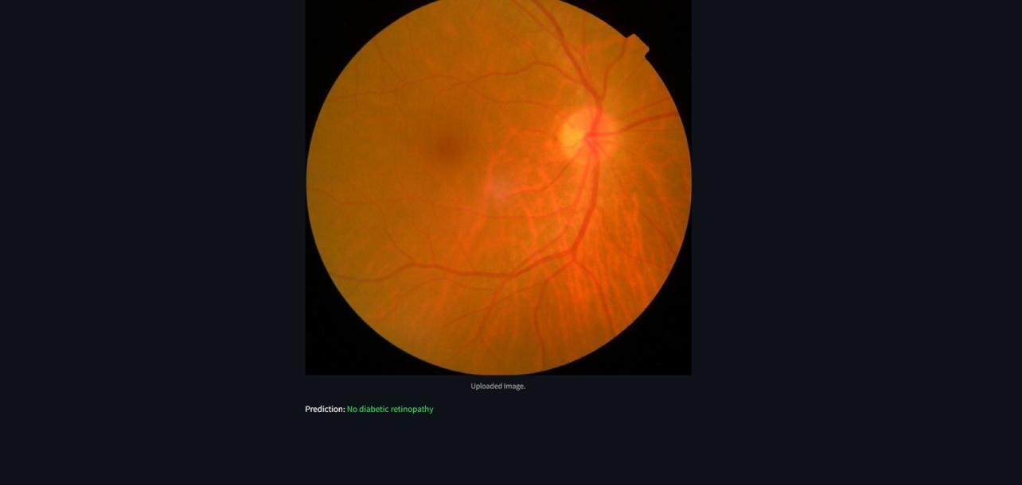

**E-mail Notification:** The system sends an email notification containing the Diabetic Retinopathy's prediction result to the user or healthcare provider.

**V.CONCLUSION**

The development of a Diabetic Retinopathy Prediction System leveraging Deep Learning represents a major advancement in early detection and diagnosis. By employing the architecture and transfer learning, the system effectively analyzes retina images, accurately classifying diabetic retinopathy into distinct stages. It is essential to have this improved diagnostic precision in order to intervene promptly and prevent vision loss. Patients and medical professionals alike will have easy access thanks to the cloud-based deployment and user-friendly Streamlit integration. By optimizing the model's performance through precise hyperparameter tuning and rigorous data preprocessing, healthcare professionals are able to make more confident, well-informed decisions. Additionally, the system will provide email delivery via SMTP and automated report generation to facilitate prompt communication. Upon analysis, a detailed report summarizing the findings will be sent directly to the patient's and/or clinician's email inbox, ensuring timely access to critical diagnostic information. Future enhancements should focus on incorporating multimodal data, such as blood sugar levels, optical coherence tomography (OCT) scans, and comprehensive patient medical histories, to further enhance the system's efficacy. Integrating explainable AI (XAI) is also vital, providing transparent insights into the model's decision-making process, thereby fostering trust in automated diagnostics. In real-world clinical applications, scalability and sustained reliability are ensured by the system's ability to adapt to changing data through regular retraining and continuous monitoring.

#### **VI.FUTURE SCOPE**

The Diabetic Retinopathy Prediction System holds a lot of potential for future developments. A key area for development is the integration of multimodal data, including patient medical history, blood glucose levels, and other clinical test results, to enhance diagnostic accuracy. By combining retina images with additional medical data, the system can deliver more precise and comprehensive predictions. In addition, incorporating real-time monitoring via wearable devices and IoT-based sensors may facilitate early intervention and individualized treatment plans by tracking disease progression. A significant enhancement involves refining the deep learning models, specifically leveraging the Xception Net architecture. Boosting prediction accuracy and reducing misclassification errors, this model excels at feature extraction from retina images. In addition, techniques known as explainable artificial intelligence, or XAI, can be incorporated to provide transparent reasoning for predictions, fostering trust and encouraging adoption among healthcare professionals. Remote diagnostics can also be made easier with cloud-based deployment, making the system accessible to rural and underserved areas. Moreover, the system can be expanded beyond Diabetic Retinopathy detection to identify other ocular diseases, such as glaucoma, macular degeneration, and cataracts. By retraining models on diverse datasets of retinal images and relevant medical records, the platform can evolve into a generalized ocular diagnostic tool. To ensure timely communication with patients, the system will incorporate SMTP functionality for automated email notifications, delivering diagnostic results and follow-up instructions directly to their inboxes. In order to guarantee the system's future scalability, dependability, and clinical relevance, collaborations with ophthalmology clinics and research institutions will further improve the quality of the dataset and make it possible to validate it in the real world.

**REFERENCES**

1. Gulshan, V., et al., “A deep learning system for detecting diabetic retinopathy across the disease spectrum,” Nature Communications, 2021. [https://www.nature.com/articles/s41467-](https://www.nature.com/articles/s41467-021-23458-5) [021-23458-5](https://www.nature.com/articles/s41467-021-23458-5)
2. Gargeya, R., and Leng, T., “Automated Identification of Diabetic Retinopathy Using Deep Learning,” Ophthalmology, 2017. <https://www.ncbi.nlm.nih.gov/pmc/articles/PMC5961805/>
3. Abramoff, M. D., et al., “Improved Automated Detection of Diabetic Retinopathy on a Publicly Available Dataset Through Integration of Deep Learning,” JAMA, 2016. <https://jamanetwork.com/journals/jama/fullarticle/2588763>
4. Reddy, G. T., and Khanna, P., “A Survey on Deep-Learning-Based Diabetic Retinopathy Classification,” Diagnostics, 2022. <https://pmc.ncbi.nlm.nih.gov/articles/PMC9914068/>
5. Fong, D. S., Aiello, L., Gardner, T. W., King, G. L., Blankenship, G., Cavallerano, J. D., ... American Diabetes Association. (2003). Diabetic retinopathy. Diabetes care, 26(suppl_1), s99- s102.
6. Qiao, L., Zhu, Y., & Zhou, H. (2020). Diabetic retinopathy detection using prognosis of microaneurysm and early diagnosis system for non-proliferative diabetic retinopathy based on deep learning algorithms. IEEE Access, 8, 104292-104302.
7. Sisodia, D. S., Nair, S., & Khobragade, P. (2017). Diabetic retinal fundus images: Preprocessing and feature extraction for early detection of diabetic retinopathy. Biomedical and Pharmacology Journal, 10(2), 615-626.