Investigation of Drilling-Induced Delamination in Glass Fiber Reinforced Plastic (GFRP) Composites
A.Saravana Kumar
Department of Mechanical Engineering
Bharath Institute of Higher Education and Research
abstarct
Delamination is a critical challenge encountered during the drilling of Glass Fiber Reinforced Polymers (GFRPs), primarily due to their non-homogeneous and anisotropic nature. GFRPs are widely used in advanced structural applications because of their lightweight properties, high modulus, and superior specific strength. This study focuses on examining the influence of various machining parameters on the deformation observed in drilled holes. Drilling is particularly sensitive in composite materials due to their tendency to delaminate under mechanical stress, making it essential to accurately detect and quantify delamination.
A full factorial experimental design was employed on GFRP laminates of 5 mm and 10 mm thickness, using High Speed Steel (HSS) and Carbide drill bits with diameters of 5 mm and 10 mm. Drilling was performed at spindle speeds of 750, 1000, and 1250 rpm, and feed rates of 0.15, 0.18, and 0.2 mm/rev. Post-drilling, the holes were imaged using a vision system, and MATLAB software was utilized to determine the number of pixels representing the deformed regions. The actual hole diameters were calculated by correlating pixel count with pixel dimensions, and the damage factor was subsequently computed.
The optimization of machining parameters was achieved through the Taguchi method. The results indicate that drill bit diameter is the most significant factor influencing delamination at the hole entry, while spindle speed and feed rate have a greater impact on delamination at the hole exit.
Key words: GFRP, Delamination, Taguchi method, MATLAB
1. Introduction
Glass Fiber Reinforced Polymers are used in many structural applications starting from automobiles, marines, and aircraft and to space vehicles due to its light weight, higher strength, high specific stiffness, low thermal expansion and stability over conventional metals and alloys. Fastening of materials is so important if it is used in constructions. But making holes in GFRP is equally challenging because of its anisotropic nature. Fiber breakage, matrix cracking, fiber pull out and delamination are the popular problems during drilling of FRP’s. Delamination[1] can be defined as the extended diameter of the hole beyond the intended diameter of the hole. At the entrance the tool should machine a thick layer and at the exit it should machine relatively a thin layer. Because of the above reasons the mechanism differs at the entrance and exit of the holes, and they are designated as peel-up and push-up delamination respectively.
R.Raja et al. [1] conducted experiments on GFRP composite materials with three different drill bits namely twisted drill bit(HSS), brad drill bit(HSS) and single point ceramic drill bit (cemented carbide coated HSS) using a semi automatic drilling machine. Three input factors (speed, feed and drill bit) with three levels used for the experimental work and they found that higher spindle speed and lower feed rate will result in minimized delamination. Birhan Isik et al. [2] carried out drilling tests using carbide bits of 8 mm diameter and investigated the damage factor both at the entrance and exit of the hole. Carbide cutting tools were used with three different point angles and three different flute numbers. Duncan test was used to identify to find that which groups were significantly different from other groups. It was concluded that higher speed, lower feed and narrow cutting angle are making lesser deformation in drilling. Murthy.B.R.N et al. [3] integrated Taguchi method and RSM for process parameter optimization and to indicate the value of response. In addition to speed and feed, drill diameter, material thickness and drill point angle are also used as input factors in three levels. The influence of process parameters on thrust force and torque was analyzed and they recommended higher spindle speed for machining of GFRP when using solid carbide drill. Murthy.B.R.N et al. [4] concluded that the drill angle has major influence on thrust force and surface roughness in the drilling of GFRP composites and material thickness, volume fraction, speed and feed are having very less influence. C.C.Tsao et al. [5] used candle stick drill for drilling woven WFC200 fabric carbon fiber / epoxy matrix. Correlation between the spindle speed, feed rate and drill diameter with the induced thrust force and surface roughness was studied in the experimental work. RBFN was more effective than multi-variable regression analysis for the evaluation of thrust force and roughness. R.A.Kishore et al. [6] studied the residual strength of unidirectional glass fiber reinforced epoxy composite using Taguchi method. Holes were drilled in GFRP composites using carbide drill bits of three different drill point geometries and residual strength of holes was tested in universal testing machine. It was concluded that drilling induced-damage at higher cutting speeds severely affects the residual tensile strength of drilled holes. K.Palanikumar [7] used grey relational analysis for optimization of drilling parameters with multiple performance characteristics such as thrust force, work piece surface roughness and delamination factor. He found that grey relational analysis technique converts the multiple performance characteristics into single performance characteristics and it is also simplifies the optimization process. T.N.Valarmathi et al. [8] used design of experiments method and response surface methodology (RSM) to study the influence of cutting conditions on thrust force in drilling of particle board composite panels. They used different point angle carbide twist drill bits in addition to the cutting parameters like spindle speed and feed for the experimental work. Mathematical modeling was developed in RSM to know the effect of interaction between the input parameters. Study revealed that narrow point angle, low feed rate and high spindle speed minimize the thrust force in drilling. Faramarz Ashenai Ghrsemi et al. [9] were studied the effect of drilling parameters on the drilling thrust force and delamination using analysis of variance method. A full factorial experiment was conducted by taking spindle speed, feed and drill point angle as input parameters. A digital scanner was used to measure the drilled hole and the delamination was computed. It was observed that minimum thrust force was experienced at lesser feed and higher speed according to the selected input values. But the delamination was minimum in higher values of feed and spindle speed.
2. Experimental Work
Glass fiber reinforced plastic composite was fabricated by hand layup method in the dimension of 300 x 300 mm with two different thickness of 5 mm and 10 mm. E glass fiber was used with polyester epoxy resin and polyester hardener to make mat type laminates in which the alternate layers arranged in 90 deg. High speed steel drill bits were commonly used for many materials because of their toughness and durability. Carbide drill bits having the advantage of increased tool life and reduced wear over HSS. It retains the cutting edge at very high machining temperature. Carbide and HSS twisted drill bits having diameter of 5 mm and 10 mm with 2 flutes, and a point angle of 118° were used in the present work. CNC vertical drilling machine (BFW VAYU BMW 51 TC24) was used to perform the drilling operation. The work piece was fixed on the work table having T slots using bolts and plain slot clamps (Fig. 1). Five factors (thickness of work piece, drill bit material, diameter of drill bit, spindle speed and feed) were considered for the experimental work. Various factors and levels are listed in Table 2. Full factorial experiment with 72 combinations of machining parameters was conducted with two trials. Delamination on entry as well as exit side was studied using taguchi’s method.
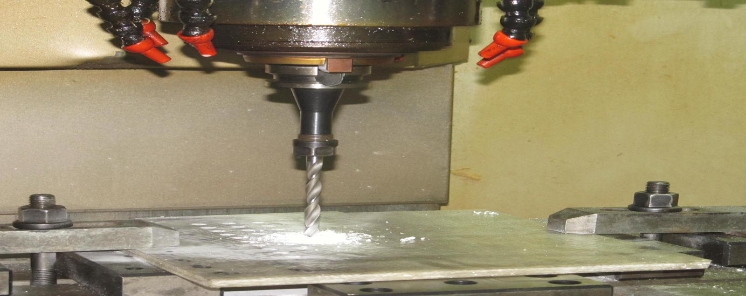
Fig. 1 Drilling of GFRP in CNC Drilling Machine
The images of holes were captured by Soliton M211_CCL30 camera having a resolution of 2048 x 1536 pixels. (Pixel dimensions 3.2*3.2 µm). Diffuse front lighting of monochrome red color was used for this purpose (Fig.2). Diffuse on-axis lights used for flat samples, and are particularly effective at enhancing differentially angled, textured, or topographic features on relatively flat objects. To be effective, diffuse lights require close proximity to the sample.
Table 2 Machining Parameters
Machining Parameters | Levels
Work piece Thickness (mm) | 5, 10
Tool material | HSS, Carbide
Tool diameter (mm) | 5, 10
Speed (rpm) | 750, 1000, 1250
Feed (mm/rev) | 0.15, 0.18, 0.2

The images of holes were captured by Soliton M211_CCL30 camera having a resolution of 2048 x 1536 pixels. (Pixel dimensions 3.2*3.2 µm). Diffuse front lighting of monochrome red color was used for this purpose (Fig.2). Diffuse on-axis lights used for flat samples, and are particularly effective at enhancing differentially angled, textured, or topographic features on relatively flat objects. To be effective, diffuse lights require close proximity to the sample.

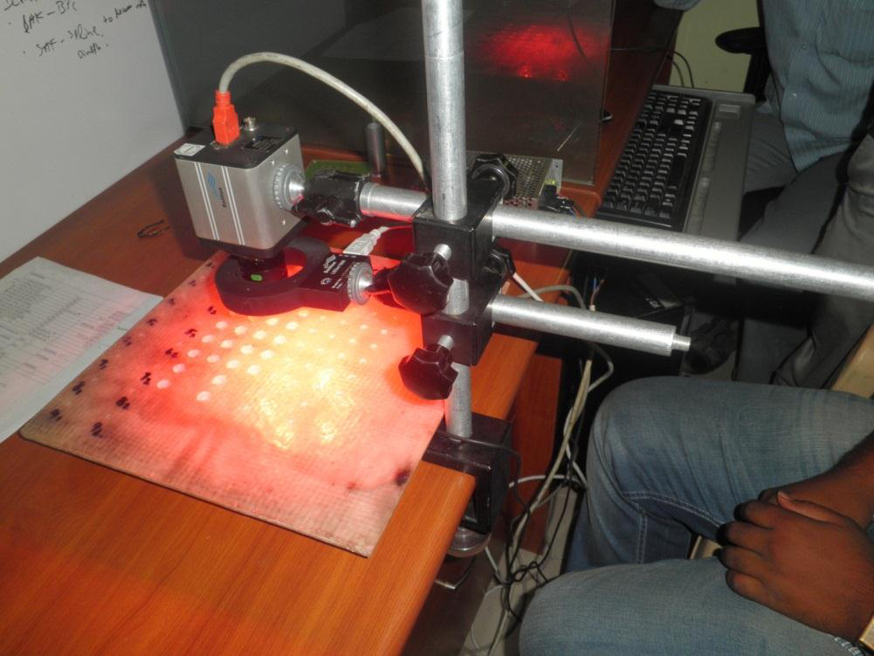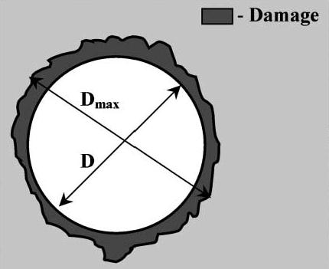
Fig.2 Image capturing set up Fig. 3 Delamination in hole
Images of 144 holes were taken on both entry and exit sides in order to study the nature of delamination. MATLAB program was used calculate number of pixels from the captured image. The diameter of deformation was calculated by multiplying the size of pixel (3.2*3.2 µm) with the number of pixels. Delamination factor can be calculated by the ratio between actual diameter of hole created and indented diameter of the hole. Delamination in a drilled hole is represented in Fig. 3.
F_{d} = Dmax / D
Where F_{d} = Delamination factor; Dmax = Actual diameter / deformed diameter of hole
D = Indented diameter of hole
3. Analysis by Taguchi Method
Taguchi defines the quality of a product [3] in terms of the loss imported by the product to the society from the time the product shipped to the customer. The overall objective of the method is to produce high quality product at lowest cost to the manufacturer. This method is useful in determining that how different parameters affecting the mean and variance of a process performance. The deviation in the performance characteristics from the target value is used to define the loss function for the process. Uncontrollable factors [3], which cause the functional characteristics of a product to deviate from the target values, are known as noise factors. In taguchi method the term signal represents the desirable value (Mean) for the output characteristic and the term noise represents the undesirable value (Standard Deviation) for the output characteristic. Therefore the S/N ratio is the ratio between mean to standard deviation.
Signal-to-noise ratio (S/N ratio) need to be calculated for each experiment to determine the effect of each variable on the output. S/N ratio can be calculated in three different categories namely, Larger the better, Nominal the better and Smaller is the better. Since the objective of this work is to minimize the delamination factor, smaller is the better is selected. Minitab 15 software was used to analyze the impact of input parameters on the formation of delamination. For both entry and exit sides of From S/N values, response tables were created. The response table helps to find the ranking of input factors, contributing the formation of delamination. Average of the S/N value for all input parameters at each level was calculated. Then the difference (Delta - Δ) between the maximum and minimum values of this average for each input value is also calculated. These values were tabulated in Table 3 and Table 4. The order of contribution in the formation of delamination is ranked with the help of Delta (Δ) as shown in the response tables.
Table 3 Response table for S/N ratio at Entry
Level | Work piece  Thickness  (mm) | Tool  Material | Tool  Diameter  (mm) | Speed  (rpm) | Feed  m/rev)
1 | -2.528 | -2.552 | -2.608 | -2.435 | -2.351
2 | -2.385 | -2.362 | -2.306 | -2.342 | -2.498
3 |  |  |  | -2.594 | -2.522
Delta  (Δ) | 0.143 | 0.191 | 0.303 | 0.252 | 0.171
Rank | 5 | 3 | 1 | 2 | 4

From the table 3, the order of contribution in the formation of delamination on the GFRP material are tool diameter and spindle speed, followed by tool material, feed and thickness of work piece at the entry side of hole. From table 4, the most important factors which are responsible for the delamination at exit are tool diameter and feed, followed by tool material, work piece thickness and feed respectively. With the help of Minitab software the main effect plot for SN ratios was drawn for both sides of holes. By taguchi’s method optimized values can be found from the SN ratio plot. From Fig. 4, the optimum values for lesser delamination at entry are 1000 rpm speed, 0.15 mm/rev feed rate with 10 mm carbide drill bit.
Table 4 Response table for S/N ratio at Exit
Level | Workpiece  Thickness  (mm) | Tool  Material | Tool  Diameter  (mm) | Speed  (rpm) | Feed  (mm/rev)
1 | -2.980 | -3.287 | -2.784 | -3.005 | -2.761
2 | -3.277 | -2.970 | -3.474 | -3.081 | -3.262
3 |  |  |  | -3.300 | -3.363
Delta  (Δ) | 0.297 | 0.316 | 0.690 | 0.296 | 0.602
Rank | 4 | 3 | 1 | 5 | 2

Experimental work indicates the optimized values for at delamination at exit as 750 rpm speed, 0.15 mm/rev feed and 5mm carbide drill bit.
Fig.4 Main effect plot for S/N ratio at Entry Fig.5 Main effect plot for S/N ratio at Exit
4. Conclusion
GFRP composite with two different thicknesses were fabricated and the effect of various machining parameters was studied in this work. Results revealed the following conclusions.
- Delamination can be reduced with lower feed rate.
- Carbide drill bit gives better quality hole than HSS drill bit.
- Thickness of work piece, cutting speed and tool diameter are to be selected properly to control the deformation in hole.
- This work can be extended with different types of tools by varying the point angle, number of flutes and effect of these parameters on the quality of holes such as delamination and surface roughness can be studied.
Reference
[1] R.Raja, G.Chandramohan, Sabitha Jannet, Deepak Alexander, Delamination Analysis in
Drilling of Glass Fiber Reinforced Plastics (GFRP) by Special Drill Bits, European Journal of Scientific Research Vol. 83 No.1 (2012) 121-128.
[2] Birhan Isik, Ergun Ekici, Experimental Investigations of Damage Analysis in Drilling of Woven Glass Fiber Reinforced Plastic Composites, International Journal of Advanced Manufacturing Technology, 49 (2010) 861-869.
[3] Murthy.B.R.N, Lewlyn L.R. Rodrigues and Anjaiah Devineni, Process Parameter Optimization in GFRP Drilling through integration of Taguchi Response Surface Methodology, Research Journal of Recent Sciences, Vol 1(6), (2012) 7-15.
[4] Murthy.B.R.N, L.L.Raj Rodrirues, N.Yagnesh Sharma, D.Anjaiah, Influence of process parameters on the quality of hole in drilling of GFRP composites – An Experimental Investigation using DOE, International Conference on Mechanical and Electrical Technology, 2010, pp 87-90.
[5] C.C.Tsao, H.Hocheng, Evaluation of thrust force and surface roughness in drilling composite material using Taguchi analysis and neural network, Jounal of Material Processing Technology, 203 (2008) 342-348.
[6] R.A.Kishore, R.Tiwari, A.Dvivedi, I.Singh, Taguchi Analysis of the residual tensile strength after drilling in Glass Fiber Reinforced Epoxy Composites, Materials and Design, 30 (2009) 2186-2190.
[7] K.Palanikumar, Experiment Investigation and optimization in drilling of GFRP composites, Measurement, 44 (2011) 2138-2148.
[8] T.N.Valarmathi, K.Palanikumar, B.Latha, Measurement and analysis of thrust force in drilling of particle board (PB) composite materials, Measurement, 46 (2013) 1220-1230.
[9] Faramarz Ashenai Ghrsemi, Abbas Hyvadi, Gholamhassan Payganeh, Nasrollah Bani Mostafa Arab, Effects of drilling parameters on delamination of glass epoxy composites, Australian Journal of Basic and Applied Sciences, 5 (12), (2011) 1433-1440.

