**A Study on the Causes and Effects of Emissions in the Indian Aviation Sector**

A.Saravana Kumar

Department of Mechanical Engineering

Bharath Institute of Higher Education and Research

**Abstract.**

The Indian aviation sector is among the fastest-growing industries globally. Over the past decade, it has experienced an annual growth rate of 4.4%, with projections indicating a rise to 4.8% in the coming decades. Aiming to handle 450 million passengers by 2020, India is on course to become the world’s third-largest aviation market by 2035. While the sector significantly contributes to economic development and social connectivity, it also poses serious environmental challenges, particularly in relation to climate change and air pollution.

This paper highlights the key regulatory and environmental concerns arising from aviation emissions in India and their impact on air quality. Emissions are categorized based on the phase of flight—take off, approach, and landing—each contributing varying levels of toxic pollutants. These emissions disperse through atmospheric winds and interact with clean air, resulting in the formation of harmful substances such as Carbon Dioxide (CO₂), Nitrogen Oxides (NOₓ), Carbon Monoxide (CO), Hydrocarbons (HC), Sulphur Oxides (SOₓ), and Particulate Matter (PM₁₀ and PM₂.₅), affecting both the lower and upper troposphere.

With the implementation of effective environmental regulations and governmental policies, there is a strong potential to substantially reduce the aviation sector’s emissions and their adverse impact on air quality by 2035.

**Keywords:** aviation, air quality, emission, pollution

Introduction

Indian aviation sector has witnessed a remarkable growth story in the last decade with robust growth in passenger and cargo traffic, huge jump in the number of aircrafts operating in the country, an impressive increase in the non-scheduled operators, surge in investment in the airport infrastructure, rapid rise in the number of operational airports, modernization and augmentation of capacities at various metro and non-metro airports and much more.

Environmental Impact

The environmental impact of aviation occurs because aircraft engines emit heat directly and noise, and particulates and gases which contribute to climate change and global dimming. Despite emission reductions from automobiles and more fuel-efficient and less polluting turbofan and turboprop engines, the rapid growth of air travel in recent years contributes to an increase in total pollution attributable to aviation.

Global aviation contributes to climate change by changing the composition of atmospheric gases in both the lower stratosphere and higher troposphere. The principal emissions from aviation combustion processes comprise CO2and water vapor with a share of approximately 70% and a little less than 30% respectively. The remainder consists of NOx, CO, SOx, Volatile Organic Compound (VOC), particulates and other trace components including HAPs. Ozone is not emitted directly into the air but is formed by the reaction of NOx and VOC in the presence of heat and sunlight. The vast majority of emissions (90%) occur during the cruise cycle, with the exception of CO and VOC, for which the share is 30 % on the ground and 70% on higher altitudes.

A government greenhouse gas emission inventory for India shows that the transportation sector contributed 8.2%, 138.85Million tone (Mt) to the total national CO2emissions in 2007. Transportation emissions were composed of 87.3% (121.21 Mt) from road activities, 7.3% (10.12 Mt) from aviation, 4.3%(6.1 Mt) from railways and 1.1% (1.4 Mt) from marine navigation. Emissions from aviation have more than trebled since 1994, while the increase from road transportation is less than double and almost negligible from marine navigation and railways. However, this emission inventory only includes domestic emissions, and international bunker emissions have been estimated only for information purposes. The estimated CO2emissions from international aviation of domestic carriers are 3.3 Mt. In order to get the full picture of CO2emissions from aviation emissions in India, one has to consider international bunker emissions also from international airlines.

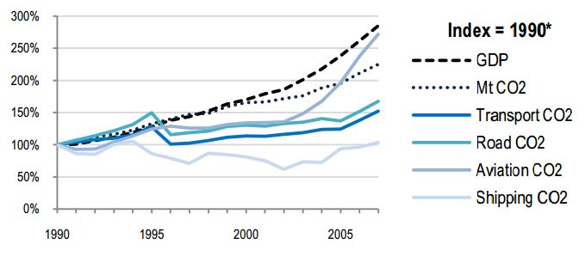

**Fig.1 CO2 emission trends in Indian transportation from(ITF) 1990-2007**

Source: ITF 2010, reducing transport greenhouse gases. Trend & data.

**CAUSES AND EFFECTS**

In addition to its contribution to climate change, aviation has a number of other impacts, most notably on ambient air quality and subsequently on public health. The major air pollutant from aircraft operations is NOx and to a considerably minor degree CO, SOx, VOC and PM, while Ozone is formed indirectly by the reaction between NOx and VOC. Most air quality assessments and emission inventories focus on aircraft emissions released during the landing and takeoff cycle (LTO) of an aircraft below 3000 feet, although 90% of emissions occur at the cruise cycle. Emissions also arise from various activities concerning ground transportation and power generation at the airport.

The resilience of the ecosystems is likely to be disturbed in the future due to abrupt climatic change which could appear in the form of floods, drought, wildfires, ocean acidification etc., inducing further loss of biodiversity and the earth’s latent capacity for mitigation and regeneration.The rise in temperature, change in precipitation patterns, sea level rise, melting of snow cover and mountain glaciers, coastal erosion and occurrence of health hazards and disaster events are perceived as the visible impacts of climate change.

An overview of public health risks for people that are affected by exposure to aviation-related pollutants can be given in table 1.

Table 1 Effects caused by pollutants

|  |  |
| --- | --- |
| POLLUTANT | HEALTH EFFECT |
| CO (Carbon Monoxide) | * Cardiovascular effects |
| HC (Unburned Hydrocarbons) | * Eye and Respiratory tract infection. * Headache * Dizziness * Memory impairment |
| NOX (Nitrogen Oxides) | * Lung irrigation |
| O3 (Ozone) | * Pulmonary inflammation * Increased susceptibility to respiratory infection. |
| PM (Particulate Matter) | * Premature mortality * Changes in lung function * Aggravation of respiratory and cardiovascular disease. |

The following are the main dimensions/impacts of climate change and some of these are explained in brief in the sub- sections which follow – Temperature, Rainfall (Precipitation), Sea Level Rise, Health, Agriculture, Coastal Erosion, Biodiversity Loss, Storm/Storm Events, Soil Moisture Availability, Sea Surface Temperature.

**Table 2 Air quality status of Indian cities for 2016, 2017, 2018**

**Annual average [µg/m3]**

|  |  |  |  |  |  |  |  |  |  |
| --- | --- | --- | --- | --- | --- | --- | --- | --- | --- |
| **City** | 2016 | | | 2017 | | | 2018 | | |
|  | **SO2** | **NO2** | **PM10** | **SO2** | **NO2** | **PM10** | **SO2** | **NO2** | **PM10** |
| Hyderabad (GH) | 5 | 24 | 79* | 5 | 29 | 86* | 4 | 28 | 79* |
| Delhi (DMC) | 5 | 55* | 261* | 5 | 57* | 222* | 5 | 59* | 237* |
| Bangalore (BBMP) | 14 | 31 | 89* | 16 | 29 | 94* | 14 | 28 | 121* |
| Mumbai | 4 | 19 | 97* | 5 | 35 | 119* | 5 | 20 | 117* |
| Chennai | 9 | 15 | 59 | 12 | 19 | 65* | 12 | 21 | 57 |
| Coimbatore | 5 | 27 | 78* | 4 | 33 | 86* | 3 | 27 | 68* |

*Concentration exceeding NAAQS of 50µg/m3 for SO2, 40µg/m3 for NO2, and 60µg/m3 for PM10 for Residential/industrial/other area & 20µg/m3 for SO2, 30µg/m3 for NO2, and 60µg/m3 for PM10 for ecological sensitive area.

Climate change has the potential to create a wide range of economic impacts. In all likelihood all sectors of the economy will be affected. Some impacts will gradually affect economic processes, such as the effect of increasing temperature on energy demand, whereas others may come as extreme events, such as sudden floods or forest fires. Impacts may be either negative orpositive. For example, agriculture may become more productive or tourism may flourish in areas experiencing higher or lower temperatures. However, in a global level, thenegative impacts will generally outweigh the economic benefits. Beside industry specific impacts, the economy as a whole may be at risk in certain areas due to an increase in sea level and an increase in runoff by rivers. Coastal zones usually contain large human populations and a high concentration of economic activities. Flooding and extreme storm events may seriously disrupt economic activities and cause loss of produced capital. The same is true for areas adjacent to major river systems which may be subject to flooding when precipitation and overland flow increases.

Assessing the impact of climate change faces a fundamental challenge of complexity. The set of mechanisms through which climate may influence economic outcomes, positive or negative is extremely large and difficult to investigate. For example, a decrease in agricultural output or value added products may be induced by climate change. However, climate change is only one driver among many that will shape agriculture in future decades. Other factors, such as technological developments, socio-economic factors or other environmental issues could have a similar large impact.

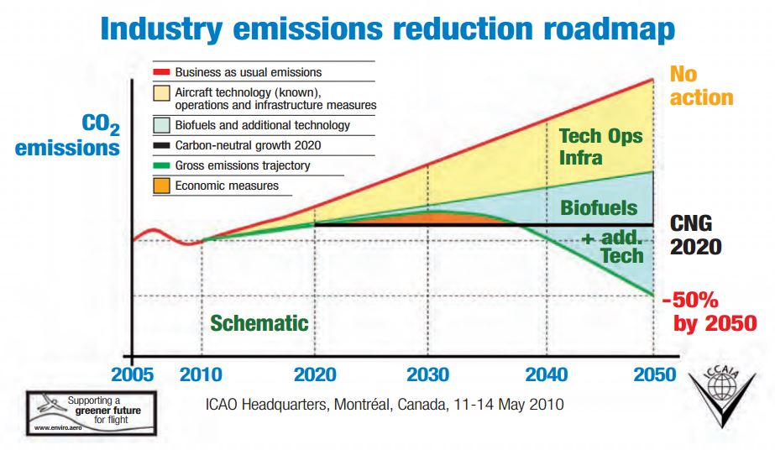

**Fig. 2 CO2 emission reduction measures over time**

**CONCLUSION**

Measures can be taken to reduce effects of emission caused by aviation sector of India. Such as,

There is significant potential to improve efficiency of operational practices in India. This pertains to air traffic management, airport congestion, route optimization etc. Furthermore, a fragmented airspace is inefficient and automated technologies and procedures, based on satellite data-links as also proposed under Future Indian Air Navigation System (FIANS) Master Plan implementation needs to be expedited.

A carbon tax/emission charge on cruise emissions of domestic flights with a proportionally higher rate on short-haul flights can encourage a modal shift to railways and buses. However, it needs to be examined whether travelers divert to automobile or bus/railway and what the overall environmental impact would be like.

A harmonization of VAT on domestic fuel among different states can discourage fuel tankering. Further, an introduction of a permissible maximum fuel load on board can limit fuel tankering. However, it needs to be studied whether this is legally and technically feasible.

Knowledge accumulation and information diffusion in India has to be fostered among aviation stakeholders through collaborations and partnerships, such as for instance the Asia and South Pacific Partnership to Reduction Emissions (ASPIRE).

Integrated approach: supply side comprising technology and operational practices; additional aspects of business strategies and models, demand management, customer behavior, air transport management, airport management, research management, and regional and industrial planning.

End user awareness should to be raised to contain the growing demand. Voluntary emission reduction schemes by offsetting mechanisms should be introduced by the airlines.

References

[1] Aviation Environment Unit, DGCA (India), AviationEnvironmental Best Practices, at U.S.–India Aviation Partnership Summit in December 2009, cited in the presentation (2009).

[2] Centre for Asia Pacific Aviation (CAPA), Preparing for Long Term Growth of IndianAviation. New Delhi, (2010).

[3] ICAO 2010, Environmental Report,(2010).

[4] Information on <http://www.icao.int/icao/en/m_about.html>

[5] International Civil Aviation Organization, Report of the Committee on Aviation Environmental Protection, Sixth Meeting, Montreal, Canada, (2004).

[6] ICAO, 2009, Measures Adopted by Civil Aviation Sector in India presented at High-Level Meeting on International Aviation and Climate Change, Montreal.(2009).

[7] P. D. Bahukhandi, Global Aviation Fuel Scenario and CSR presentation on 30th July (2010).

[8] Transport & Environment 2010, Grounded, How ICAO failed to tackle aviation and climate Change and what should happen now, Brussels, (2010).

[9] World Economic Forum 2011, Policies and collaborative Partnership for Sustainable Aviation, Geneva, (2011).

[10] Ministry of environment, Government of India.(2012).

[11] Central Pollution Control Board, Ministry of Environment and Forests (India). Air Quality Monitoring, Emission Inventory and Source Apportionment Study for Indian Cities, (2011).

[12]S. Solomon, D. Qin, M. Manning, Z. Chen, M. Marquis, K.B. Averyt, M. Tignor, and H.L. Miller, IPCC, Changes in Atmospheric Constituents and in Radioactive Forcing, in Climate Change, Cambridge University Press, UK and New York, 129, (2009).

[13]CII & NCAER, The future of civil aviation in India Structure, policy, regulation andinfrastructure. New Delhi: IDFC, (2000).

[14] Chapter 2, Table 2.1 of NAAQS Report, CPCB (2012).