**Developing Real-Time Point Status Monitoring Systems Using Wireless Sensor Networks for Locomotive Speed Control**

**1Vipin Suresh, 2Meet Bhatt, 3Atharv Pol, 4Gaurav Kamble, 5Dr.Sunil Chavan\***

*Department of Electrical Engineering, Smt. Indira Gandhi College of Engineering, Ghansoli, Navi Mumbai, affiliated to the University of Mumbai.*

**ABSTRACT**

The project highlights the technology that prevents train collisions using the distance measurement between trains on the line. The KAVACH system consists of RFID readers in locomotives plus radio frequency communication that transmits the data to the TCAS (Train Collision Avoidance System) at the station and the locomotive cabs. The report states one constraint of the current KAVACH system is that it cannot fetch the data for trains on loop or diversion tracks. To resolve this, the project proposes an upgraded system that uses sensors for detecting whether a train is on diversion or mainline track. This information will then be sent to the locomotive cabin and displayed on the dashboard as messages to take necessary actions. This project substitutes radio communication with WiFi-based wireless data transmission in SIMPLEX communication, where one ESP32 microcontroller is the transmitter while another one is the receiver. This is intended to improve railway safety by delivering real-time track information to locomotive operators, thereby saving them from accidents like the one that happened in Balasore.

***Keywords – KAVACH, RFID, loop line, ESP32 Microcontroller***

**INTRODUCTION**

It is a project that develops advanced systems of a train collision prevention system that would enhance the existing KAVACH technology used in Indian Railways. This is mainly done to further the scope of railway safety improvements, which currently have limitations in collision avoidance systems.

The main principle of this technology is to measure the distance between trains using a single line and prevent the trains from colliding by using RFID readers installed in locomotives to gather and transmit data over radio frequencies through respective equipment installed at the railway stations as well as the Train Collision Avoidance System (TCAS) and cab relays in the locomotive cab so that the train operators can know the leading distance between trains and act accordingly in case of problematic situations.

The existing KAVACH system has a major limitation of not being able to track the trains on their loop or diversion tracks. This also played a considerable role in the Balasore incident.

Thus, we have proposed a system that identifies the diversion or track type of the train using extra sensors and sends this critical information to the locomotive cabin that directly translates into the dashboard for operators to take decisions as appropriate actions.

This system adds one more innovative approach: it replaces traditional electromagnetic wave radio communication with WiFi for wireless data transmission. It uses a SIMPLEX communication system provision in such a way that one ESP32 microcontroller acts as a transmitter and another as a receiver.

Thus, a further enhanced system would efficiently provide real-time track details directly to locomotive operators and prevent accidents or errors in operation through time-sensitive information.

**METHODOLOGY**

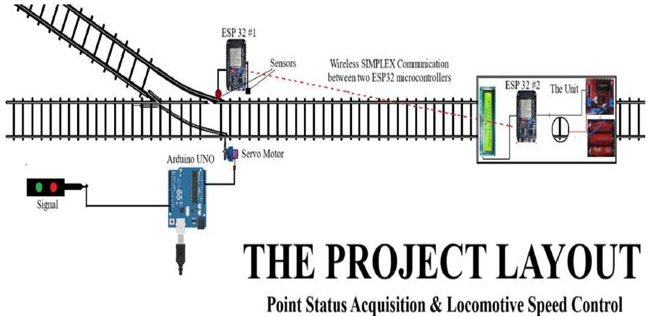

***Fig.1: The Project Layout***

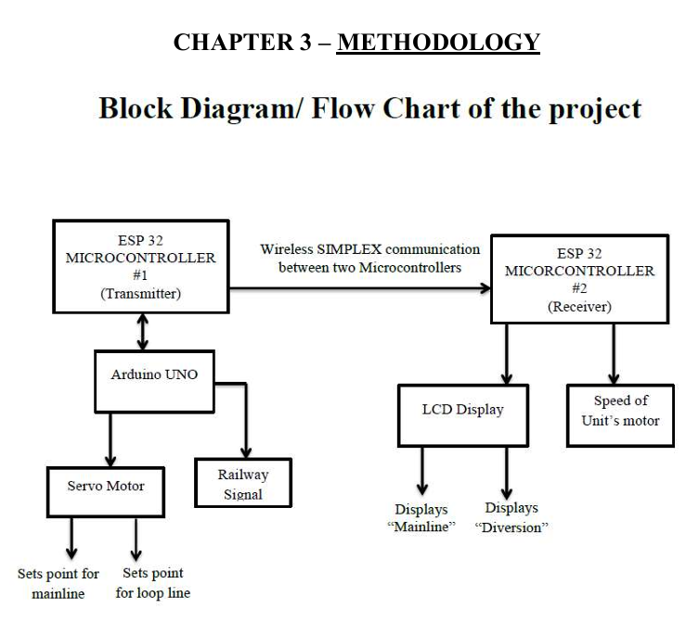

***Fig.2: Block Diagram / Flow Chart of Project***

**Point Status Detection:-**

This system, which can obtain data from track switches (points) and trains in real-time, uses sensors (infrared and ultrasonic).

**Data Transmission:-**

ESP32 #1 reads the sensor data from the moving unit representing a rail locomotive and wirelessly sends the same data to a Wi-Fi station ESP #2. Communication is simply done over Wi-Fi within SIMPLEX type of communication.

**Speed Control and Display:-**

Depending on the data from the sensor, ESP32 #2 either maintains the current speed of the unit or lets the unit drop in speed if the situation calls for it. This data was then positioned to show on an LCD screen in the train driver’s cabin.

**Point Setting and Signalling:-**

We use an Arduino UNO to measure the current point and adjust the signal. It commands a servo motor at that point to set its position. LEDs are activated according to point position.

**Data Processing and Action:-**

ESP32 #1 sends a command '1' to ESP32 #2 when the sensor data satisfies given conditions. As soon as the command comes, the speed is controlled and displayed on the LCD.

**Block Diagram Implementation:-**

This project uses a block diagram that shows how the components are connected with each other. It illustrates, throughout, the two ESP32 microcontrollers that are helpful for handling the transmitting and receiving, and an Arduino UNO manages the position of the point and the signals.

**DISCUSSION**

**1. Modern KAVACH Technology:-**

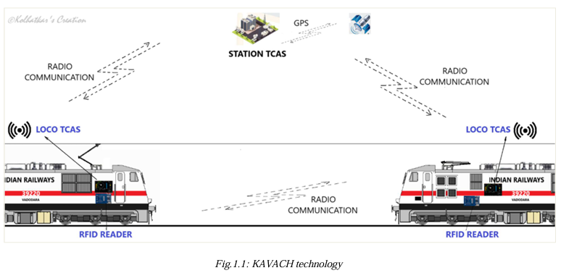

***Fig.3: KAVACH TECHNOLOGY***

Uses RFID readers and radio wave communicators. It follows the prevent-collision system for automobiles approaching each other.

**2. The Current Framework: Its Limits:-**

No visibility of trains on diversion or loop tracks. KAVACH is also part of the Balasore train accident story.

**3. Suggested Enhancements:-**

The second component of the proposed safety system is position-tracking sensors that will monitor trains throughout their journey including in the mainline, loops etc. Send real-time data to the locomotive cabin. It should be displayed in the locomotive's dashboard what is the operational status.

**4. Upgrade of Communication Technology:-**

The current framework, however, needs to upgrade its communication system from radio to Wi-Fi technology. Use SIMPLEX communication. An ESP32 microcontroller should be used for both the transmission and receiving processes.

**5. Safety Implications:-**

The system shows promise for stopping railway calamities like Balasore. It helps the loco pilot to gather information that is required for making better decisions.

**6. Methodology and perpetration:-**

-A methodical representation of the system design with inflow details will be handed.

- Combination of tackle factors.

- Software development and programming.

**7. Advantages and Limitations:-**

- The system remains reliable during all types of adverse weather conditions.

- A similar system decreases the possibility of an outfit breakdown at a single point. Problems that might occur while operating in the field live.

**8. Future Scope and Potential Applications:-**

- A wider railway infrastructure line presents itself as a future opportunity for business expansion.

- Possibilities for integration with existing railway safety systems.

**LITERATURE REVIEW**

***Point Switching Concept:-***

The track change process is done by making use of a movable piece of rail that helps to determine the direction/path of the train.

For example, the figure shown is an example of the point set for the straight path. For this, the movable piece of the rail cleared the path for the left main rail so that the wheel moves safely to the dedicated path (straight as shown here).

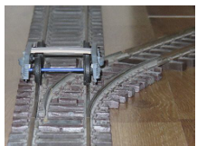

***Fig.4: Straight Path (Isometric View)***

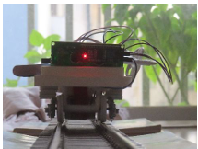

***Fig.5: Straight Path (Front View)***

In cases where a point is set for diverting traffic onto a branch line or loop line, the movable rail is swung in the opposite direction in order to clear the right main rail's path and allow the wheel to divert safely.

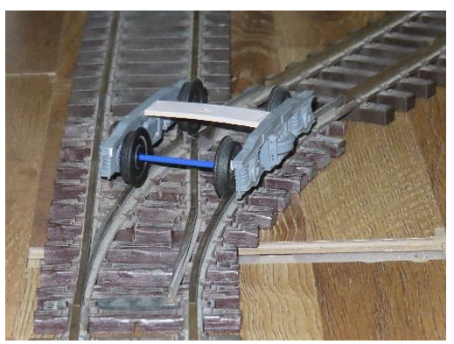

***Fig.6: Diversion Path (Isometric View)***

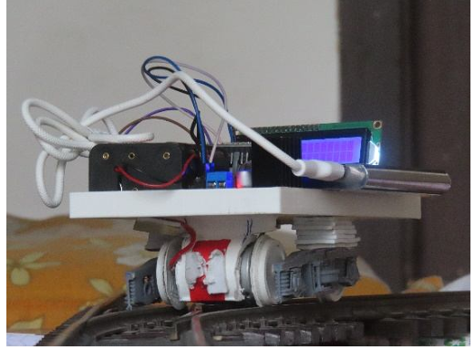

***Fig.7: Diversion Path (Front View)***

***Need for this system:-***

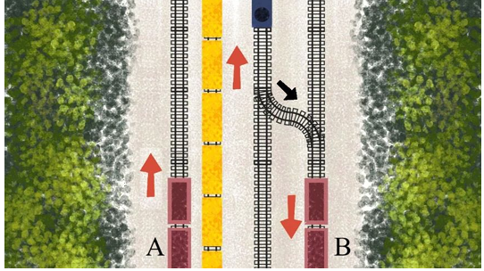

***Fig.8: 2d View of Balasore Incident***

The three trains suffered extensive damage, and the cause of the disaster—sometimes given to lack of synchronization between signals and the related points—wiped out many human lives in a horrible and unexplained June 2023 event in the Odisha area. Aside from the dire physical damage, the traffic was set for the loop despite the green signal. The blue train was designed to be shown in the diagram given, following a straight path crossing the yellow train going in the opposite direction. On the loop line, trains A and B rested still on account of the terrible environmental situations. The blue line train turned to the loop line at a speed of 130 km/h and crashed into train B. This collision resulted in the blue rail train being totally offline and the yellow train being partially offline. This event occurred beyond the limits of Kavach technology, as it did not foresee the peril since the trains operated on multiple tracks.

***Our innovation:-***

Developing a cutting-edge technology that enables point detection by sensors regardless of signal status. As the train approaches a switch point, the locomotive seamlessly receives real-time information about the point status on its dashboard. If necessary, the system will autonomously regulate and decelerate the train speed to prevent any potential mishaps.

**APPARATUS**

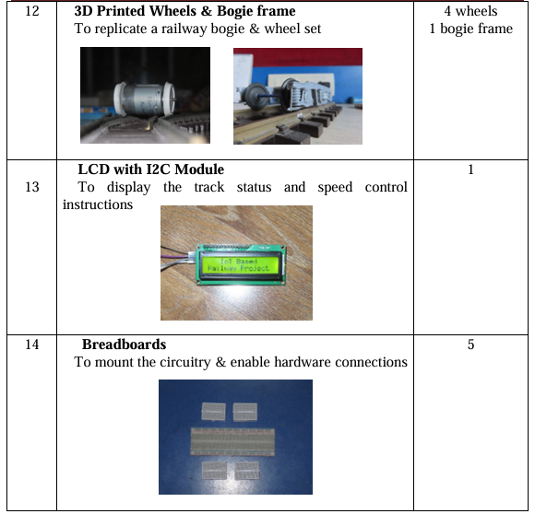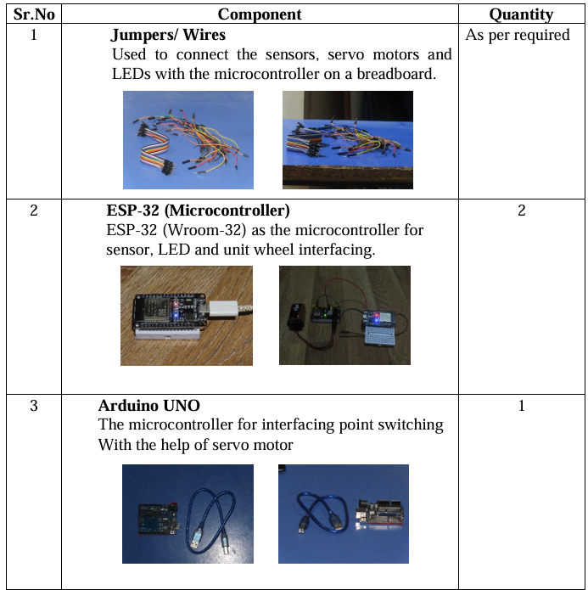

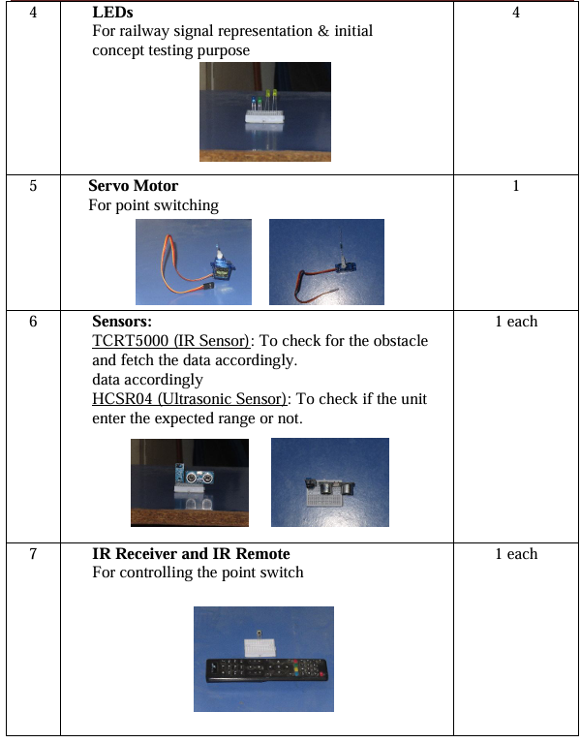

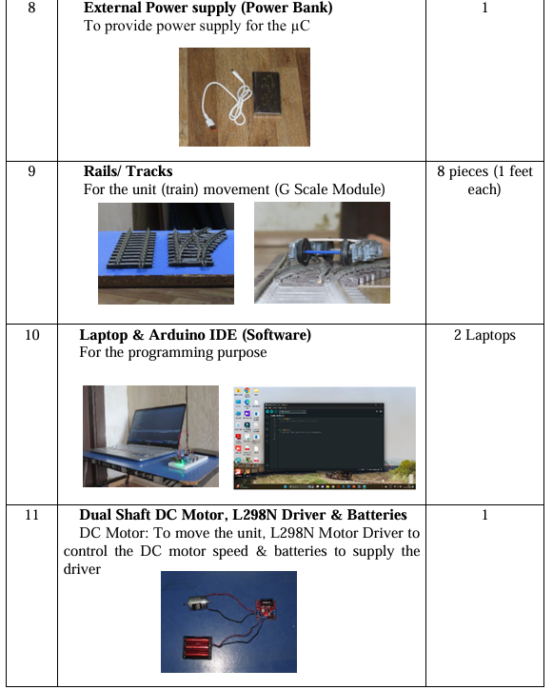

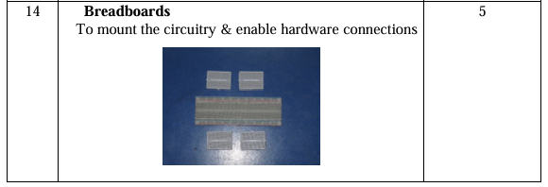

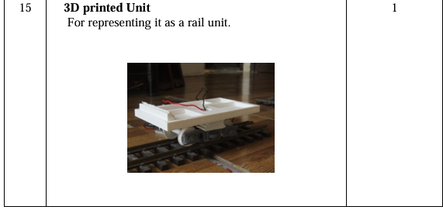

**ARDUINO CODES**

***The Code for Controlling the Point & Signal:-***

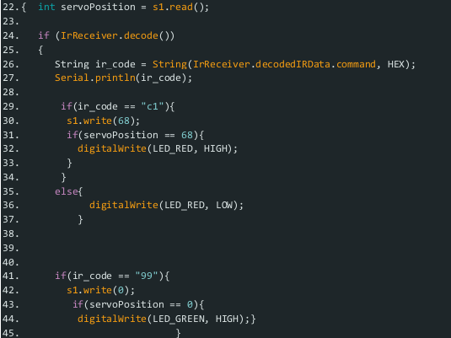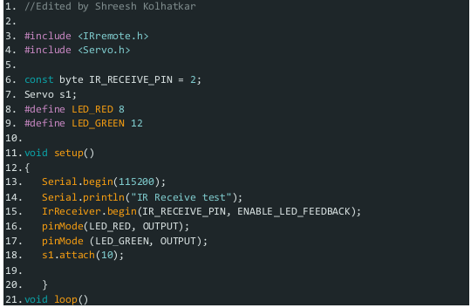

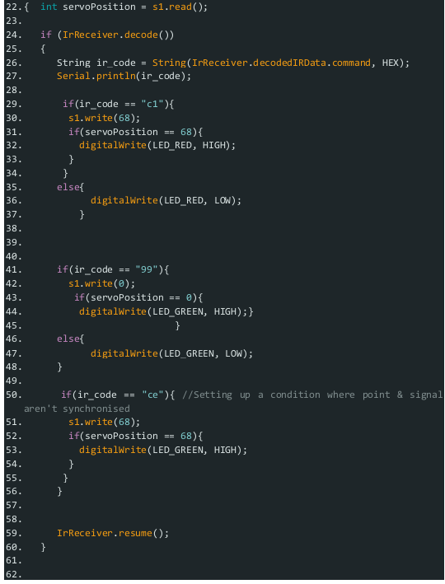

***The Transmitter Code:-***

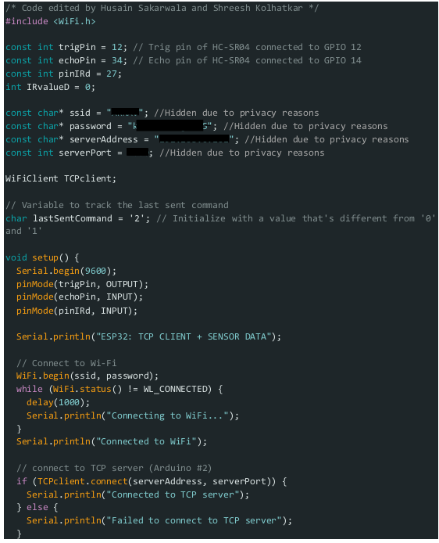

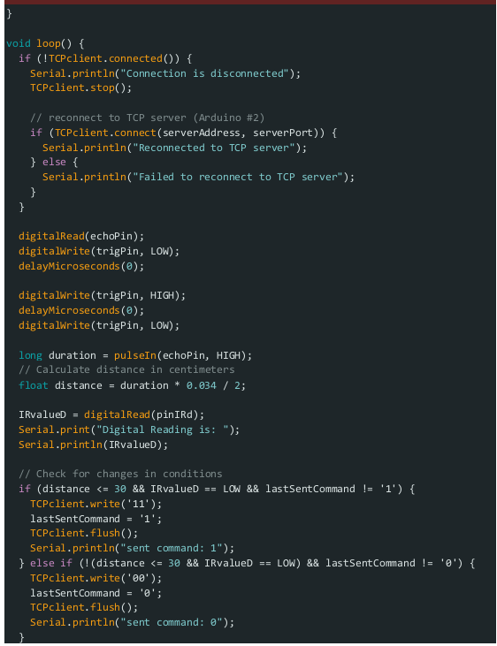

***The Receiver Code:-***

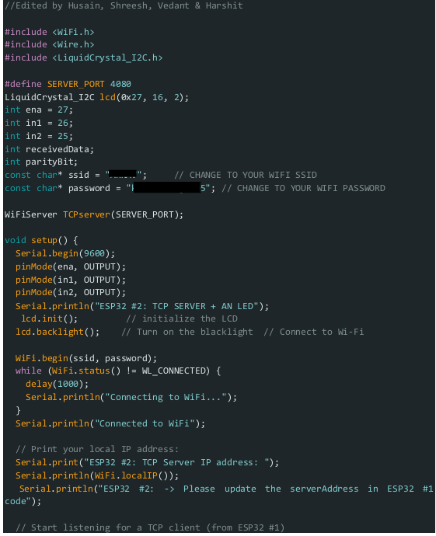

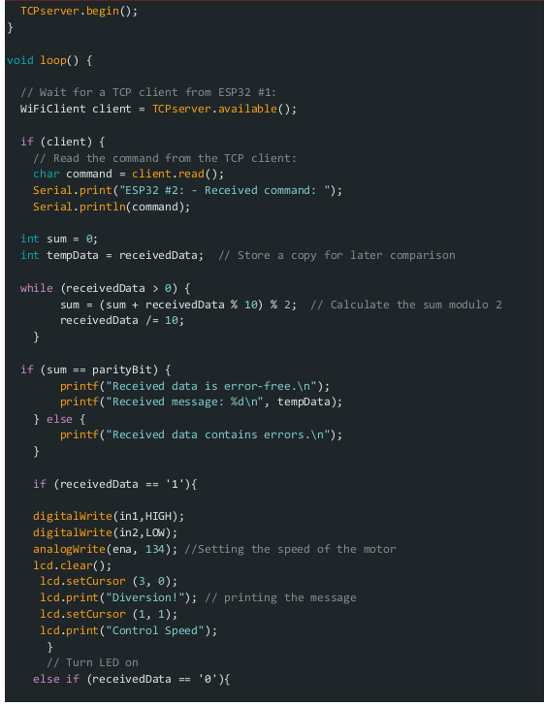

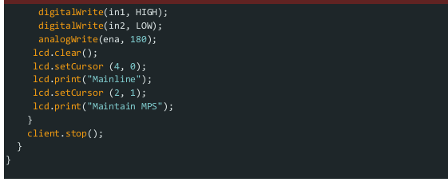

**RESULTS**

**Process Model Specification:-**

The sensors (infrared & ultrasonic) acquire the data of the point & check the proximity of the train. This data is read by the ESP32 #1 and is wirelessly sent to another ESP32 #2 that is placed on the moving unit that represents a rail locomotive. Based on this sensor data, the ESP32 #2 helps maintain the current unit speed or reduces it if necessary. This data is displayed accordingly on the LCD.

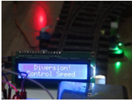

***Fig.9: If point is set for diversion***

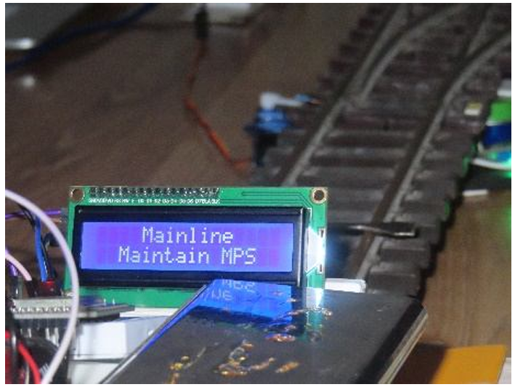

***Fig.10: If point is set for mainline***

The communication is done over WiFi that follows SIMPLEX type of communication.

**Point Switching & Signaling;-**

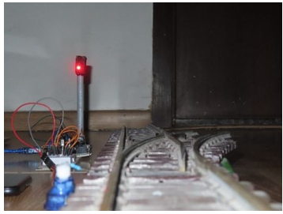

***Fig.11: Signal for Diversion***

In the real world, the signal is always determined by the status of the point. The section engineer sets the point from his control panel, & accordingly, the line is given the signal. Here as well in our project, we have tried to imitate this scenario using LEDs, a servo motor, and some basic programming. The point is switched remotely by an IR remote, and accordingly, the signal is shown. As you can see in the figure, the line is given a red signal since the point is currently set for the diversion. Thus, no train can make use of the mainline, and it will be undergoing a track change.

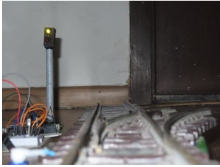

***Fig.12: Signal for Mainline***

In the above figure, the signal is green, which means the mainline is given a clearance. The point is set for the mainline, which means no train will undergo the diversion and will be moving straight.

This switching of the point is controlled by a servo motor. The turning ON of the red & green LED depends on the movement of the servo, which is programmed using Arduino.

***Wireless Communication between ESP32 Microcontrollers:-***

Not always can the projects be executed having two microcontrollers connected together. Thus, a wireless communication is established between the two ESP32 microcontrollers where 1 ESP32 reads the data collected from the sensor & the other ESP32 performs further actions based on the command sent by the 1st ESP32. Both these ESP32s are connected using a Wi-Fi network. For an experimental basis, a simple task of LED blinking is carried out based on the data acquired by the ultrasonic and infrared sensors. The concept is the LED will turn ON only when the object is sensed by both the ultrasonic and the infrared sensors. Else, the LED will remain OFF.

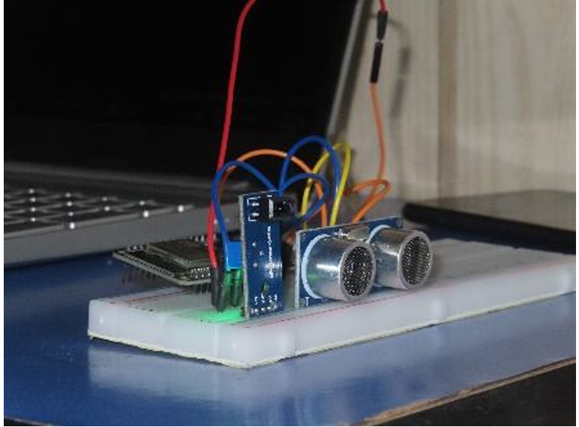

***Fig.13: Transmitter Side***

As seen in the above figure, the transmitter side has ultrasonic & infrared sensors connected to an ESP32. This ESP32 will read the sensed data and will send command “1” or “0” based on the data.

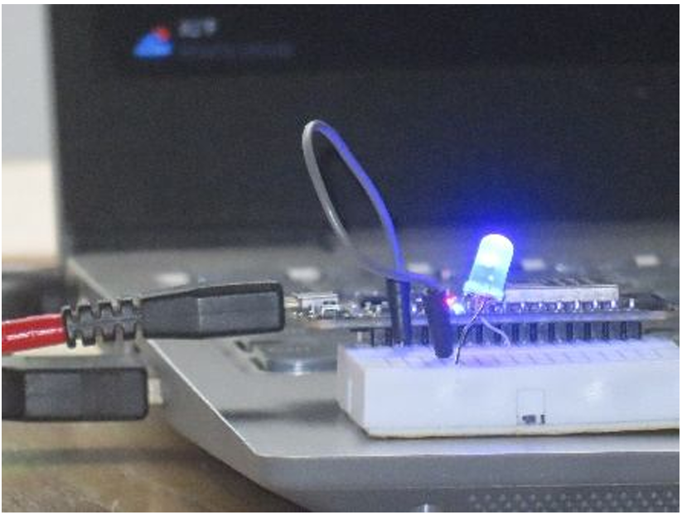

***Fig.14: Receiver Side***

The above figure shows the receiver end of this experiment where the LED is connected. This LED is connected to the 2nd ESP32 and, based on the received command “1” or “0”, will turn ON or will remain OFF, respectively.

**CONCLUSION**

The proposal overcomes KAVACH technology limitations through real-time detection of points with ESP32 microcontrollers that use wireless communication. Detection devices that include infrared sensors with ultrasonic sensors enable precise track switching point observation to detect mainline and diversion track conditions. The Wi-Fi-based SIMPLEX wireless communication system ensures efficient data exchanges between transmitter and receiver units that provide essential track position data for locomotive cabins.

Track operators benefit from better situational awareness capability thanks to this improvement which also decreases the risk of incidents such as the Balasore accident caused by limited tracking of loop line activity by traditional systems. The proposed setup shows affordability alongside scalability and it adapts well to current safety frameworks to deliver a stronger collision warning system in railway operation. The system can be improved through full-duplex communication technology along with AI decision algorithms to enhance its reliability and adaptability to different railway conditions alongside wide-scale testing protocols.

**REFERENCES**

* Akyildiz, I. F., Su, W., Sankarasubramaniam, Y., & Cayirci, E. (2002), “A survey on sensor networks”, *IEEE Communications Magazine*, 40(8), 102-114.
* KAVACH System Overview. (n.d.). Retrieved from [Indian Railways Official Website](https://www.indianrailways.gov.in/).
* Stojanovic, J., & Stojanovic, M. (2015). “Real-time monitoring of railway systems using wireless sensor networks”, *Journal of Rail Transport Planning & Management*, 5(1), 1-10.
* R. K. Gupta, & S. K. Jain (2016), “Safety in Railway Operations: A Review” *International Journal of Engineering Research and Applications*, 6(5), 1-5.