**AI THERAPIST: ARTIFICIAL INTELLIGENCE FOR MENTAL HEALTH SUPPORT**

**Abinesh M, Student III Year (Computer Science), Rathinam College of Arts and Science, Coimbatore -21, abinesh1530@gmail.com**

[Abinesh1530@gmail.com](mailto:Abinesh1530@gmail.com)

**Ganapathiram N, Assistant Professor, Department of Computer Science, Rathinam College of Arts and Science,**

Coimbatore – 21, Tamil Nadu, India

# ABSTRACT

The emergence of Artificial Intelligence in the field of mental health is transforming traditional approaches to therapy and emotional support. AI Therapist explores the integration of natural language processing, emotion detection, and conversational AI to provide accessible, scalable, and empathetic mental health support. The paper examines current technologies, discusses potential benefits and limitations, and proposes an AI-based mental wellness companion system capable of understanding and responding to emotional states in real-time. As mental health becomes a global concern, AI has the potential to bridge the gap between need and availability while complementing traditional therapy.

Keywords: AI therapy, Emotion detection, Mental health chatbot, Natural language processing, Digital psychology, Conversational AI

# 1. INTRODUCTION

Mental health challenges affect millions globally, yet access to quality support remains limited. Traditional therapy, while effective, is often costly, time-bound, and stigmatized. With advancements in AI, there is an opportunity to create emotionally intelligent systems that offer supportive conversations, mood tracking, and coping mechanisms 24/7. This paper introduces "AI Therapist" — a virtual companion designed to support mental health through continuous, private, and judgment-free interactions.

# 2. LITERATURE SURVEY

Several technologies and research projects have laid the groundwork for AI in mental health care:

**1**. Woebot: A chatbot developed by Stanford psychologists using Cognitive Behavioral Therapy (CBT) principles to assist users in managing anxiety and depression. It engages users in daily check-ins and mental exercises.

**2.** Wysa: An AI-based mental wellness app using evidence-based techniques like CBT and mindfulness. It offers anonymous support and tracks user emotions over time.

**3. Ellie by USC ICT:** A virtual human interviewer that can detect non-verbal cues such as facial expressions and vocal tone to assess PTSD and depression.

**4. Academic Studies:** Research shows AI tools can reduce psychological distress, especially in individuals hesitant to seek traditional therapy. However, concerns persist regarding emotional accuracy, privacy, and ethical considerations.

These developments highlight the growing role of AI as a complementary tool for mental health management.

# 3. PROPOSED SYSTEM

The proposed AI Therapist system is an Android-based mobile application integrated with an AI backend for real-time emotional support. Built using Java (front-end) and Python (back-end), it utilizes pre-trained NLP models, emotional analysis tools, and secure cloud storage. The AI can engage in empathetic conversations, detect user mood through voice and text, and provide personalized coping strategies.

**KEY FEATURES:**

* **Emotion Recognition:** Analyzes tone, text sentiment, and facial expressions to assess mood.
* **Daily Check-Ins:** Prompts users with mood trackers and reflection questions.
* **Conversational Support:** Uses fine-tuned language models to simulate therapeutic dialogue.
* **Resource Library:** Offers meditations, affirmations, and wellness exercises.
* **Emergency Alerts:** Identifies signs of emotional distress and prompts emergency contact options.

**FUNCTIONAL** **COMPONENTS**:

1. **Data Collection:** Collects data such as voice recordings, photos, videos, and text messages from social platforms and personal devices.
2. **Voice Synthesis**: Utilizes deep learning models like Tacotron and WaveNet to clone the voice.
3. **Chatbot Engine**: A GPT-like model trained on the individual’s text history and writing style.
4. **Personality Engine**: Predicts emotional tone and language based on stored memory logs and interaction patterns.
5. **Privacy Control:** Secured access and encryption to ensure ethical use and data protection.

# 4. SOFTWARE IMPLEMENTATIONS

The application is developed using:

* **Android Studio (Java)** for the mobile interface
* **Python (Flask/TensorFlow)** for AI and emotional detection
* **Firebase** for real-time data storage
* **Hugging Face Transformers** for conversational AI
* **Affectiva API** for emotion recognition from voice/facial data

**ACTIVITION FLOW :**

1. User logs in and completes emotional profile.
2. The app initiates daily check-ins.
3. Based on user input, AI offers responses or activities.
4. Emergency flags are raised if critical emotional states are detected.

# 5. MODULE DESCRIPTION

**5.1 User Onboarding and Profile Creation**

Collects emotional history and preferred coping styles for customized support.

**5.2 Conversational Engine**

Processes user input to generate empathetic, human-like responses.

**5.3 Emotion Detection Module**

Analyzes voice, text, and (optionally) facial input for mood tracking.

**5.4 Wellness Library Module**

Offers guided sessions for breathing, mindfulness, journaling, etc.

**5.5 Security and Privacy Module**

Ensures encrypted communication and user consent for data use.

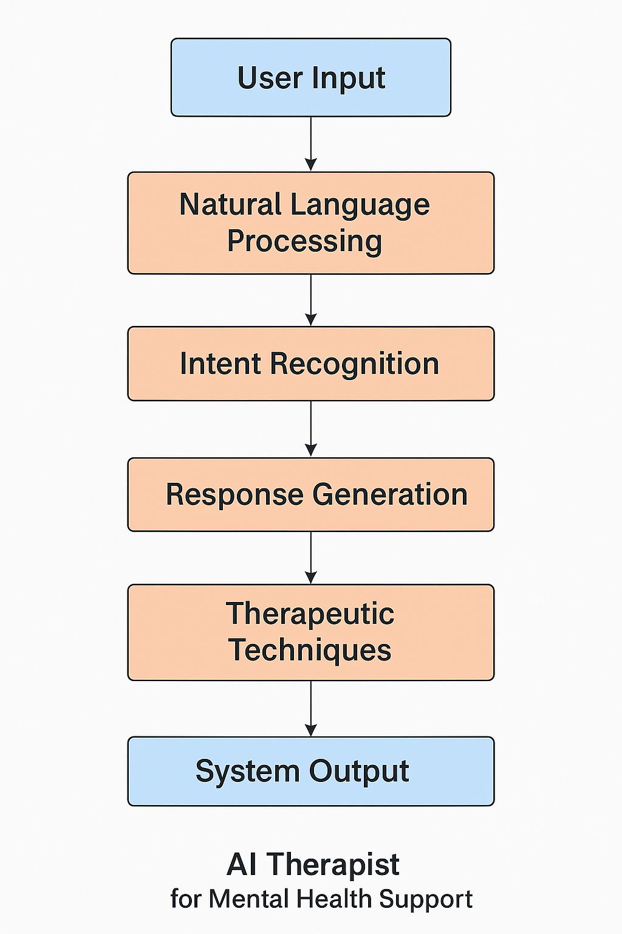

# 6. CONCLUSION

AI Therapist is a step toward making mental health support more inclusive, affordable, and continuous. While it cannot replace human therapists, it serves as an essential first line of support and a supplement to professional care. The ethical design and user privacy are at the core of the system. As AI evolves, its role in mental health care will become increasingly impactful, especially in underserved communities and crisis scenarios.

# REFERENCES

[1] Woebot Health. (2022). [https://woebothealth.com](https://woebothealth.com/)

[2] Wysa. (2023). [https://www.wysa.io](https://www.wysa.io/)

[3] USC Institute for Creative Technologies. (2021). [https://ict.usc.edu](https://ict.usc.edu/)

[4] Affectiva Emotion AI. (2023). [https://www.affectiva.com](https://www.affectiva.com/)

[5] OpenAI. GPT-4 Technical Report. <https://openai.com/research/gpt-4>

[6] Hugging Face. (2023). <https://huggingface.co/transformers>

# ACKNOWLEDGMENT

This project is the outcome of dedicated research and development carried out in the Department of Information Technology under the DBT Star College Scheme. The author expresses sincere gratitude to the Department of Biotechnology (DBT), Ministry of Science and Technology, Government of India, New Delhi, and the Department of Information Technology, Rathinam College of Arts and Science, Coimbatore, for their continued support and encouragement.

# AUTHOR BIOGRAPHY

# Abinesh M is a final-year B.Sc. Computer Science student at Rathinam College of Arts and Science, passionate about AI Therapist For Mental Health Support. His project "AI Therapist" reflects his commitment to building compassionate tech solutions for real-world challenges. He can be reached at [abinesh1530@gmail.com](mailto:abinesh1530@gmail.com).