Mohd. Suleman , Dr. Vishal Shrivastava, Dr. Akhil Pandey 1B.Tech. Scholar, 2,3Professor, 4Assistant Professor

Department of Information Technology, Arya College of Engineering & I.T., Jaipur, India [sulemanpathan627@gmail.com,](mailto:sulemanpathan627@gmail.com) vishalshrivastava.cs@aryacollege.in, [3akhil@aryacollege.in](mailto:3akhil@aryacollege.in)

**Abstract**: The emergence of interconnected medical devices has ushered in a transformative phase in patient care and data analytics, coinciding with the convergence of technology and healthcare. However, this digital transition presents a formidable challenge: cybersecurity. This paper delves into the intricate relationship among healthcare, technology, and cybersecurity, emphasising the vital link between quality, compliance, and security. It investigates the complex array of issues stemming from vulnerabilities, data privacy concerns, and new threats. Strategies to address these challenges include security by design, vulnerability management, and comprehensive incident response planning. Real-world case studies illustrate the tangible benefits of enhanced cybersecurity measures. The analysis anticipates future trends in healthcare cybersecurity, such as quantum-safe encryption and zero-trust frameworks. Furthermore, it proposes a blockchain-based secure IoT solution that utilises Device Identity Management and a deep learning approach on the blockchain for secure data transmission in IoT-enabled healthcare environments. The paper underscores the importance of collaboration and continuous adaptation in safeguarding the digital landscape of healthcare. It concludes with a call to action, urging all stakeholders to unite in the relentless pursuit of patient safety, data integrity, and reliability in the era of connected healthcare.

**Keywords**: Cybersecurity, Cyber-attacks, Internet of Things, Machine Learning, Deep Learning, Blockchain.

# INTRODUCTION

The increasing adoption of the Internet of Things (IoT) has brought about a notable transformation in the healthcare industry. The digital revolution is reshaping patient care, diagnosis, and treatment, offering unprecedented opportunities to enhance patient experiences and improve health outcomes. Connected medical devices, equipped with sensors and data-sharing functionalities, are becoming increasingly prevalent and play a crucial role in the healthcare ecosystem.

The challenges of cybersecurity in the Internet of Things (IoT) era, especially concerning the safeguarding of quality and compliance in connected medical devices, present a significant concern that requires immediate focus. As medical devices evolve into interconnected systems, they become susceptible to various threats, including data breaches and privacy infringements, as well as more alarming scenarios that jeopardise patient health and safety.

This paper aims to thoroughly examine the evolving relationship among cybersecurity, technology, and healthcare. It serves as a prompt to delve into the complexities and implications of the IoT-driven transformation in healthcare, highlighting the essential function of cybersecurity in ensuring the integrity of medical devices. In an era characterised by continuous data exchange between devices, healthcare providers, and patients, cybersecurity transcends mere data

protection; it emerges as a vital protector of individual lives and overall health.

This research embarks on a comprehensive exploration to clarify the numerous challenges posed by cybersecurity in connected medical devices. It also investigates the intricate relationships among quality, compliance, and cybersecurity, underscoring the interdependence of these fundamental aspects of the healthcare sector. As we navigate through this vital topic, the study will analyse the prevalence of cyberattacks and their extensive implications, emphasising the

critical necessity for vigilance and preparedness.

Our analysis also focuses on the regulatory landscape that oversees cybersecurity for medical devices. We will discuss how the evolving legislative frameworks and industry standards are impacting the requirements of manufacturers and other stakeholders within the healthcare ecosystem. Additionally, this article offers insights into strategies and best practices for mitigating cybersecurity risks associated with connected medical devices. It explores the role of risk assessment, continuous monitoring, and timely updates in enhancing the cybersecurity protections of these devices.

As we look to the future, we explore emerging advancements that could fundamentally reshape the cybersecurity of medical devices. Our analysis focuses on the potential of machine learning and blockchain to enhance the identification and prevention of threats. Additionally, we examine how regulatory approaches may evolve in response to the shifting healthcare environment influenced by the Internet of Things (IoT). The significance of these considerations is heightened as we address cybersecurity challenges in the IoT era. The intersection of technology and healthcare presents unparalleled opportunities for saving lives, yet it also imposes a profound responsibility to ensure the safety and quality of the interconnected medical devices that are essential for preserving life. In an era where data and technology are deeply intertwined with human well-being, this article calls upon all stakeholders—including manufacturers, regulators, healthcare providers, and patients—to collaboratively secure the future of connected

healthcare.

# THE INTERNET OF THINGS (IOT)

The Internet of Things (IoT) is a transformative element in the healthcare sector, revolutionising the methods of patient care delivery, monitoring, and management. IoT refers to a system of interconnected physical devices, such as machinery, vehicles, buildings, and other objects, all equipped with sensors, software, and network connectivity. This technology is heralding a new era in healthcare characterised by enhanced patient outcomes, improved operational efficiency, and data-informed decision-making. Leading this transformation are medical devices with IoT capabilities, which encompass ingestible sensors, wearable fitness trackers, smart insulin pumps, and remote patient monitoring equipment. These devices are equipped with sensors that collect a variety of data, including vital signs and medication adherence, transmitting this information to healthcare providers, patients, or caregivers. The continuous stream of data allows medical personnel to monitor patients from a distance, identify warning signs, and implement preventive measures, ultimately reducing hospital readmissions and significantly improving overall patient care.

Managing chronic illnesses represents one of the most promising applications of IoT in the healthcare sector. Devices equipped with IoT technology can significantly assist individuals suffering from chronic conditions such as diabetes, hypertension, or cardiovascular diseases. For instance, a continuous glucose monitoring system can transmit glucose levels directly to a mobile application for patients with diabetes. This application can alert both the patient and their healthcare provider if blood sugar levels fall outside the acceptable range, facilitating timely intervention and reducing

the likelihood of adverse outcomes.

The advancement of telemedicine and remote patient monitoring has been significantly enhanced by the Internet of Things (IoT). Telehealth services utilising IoT facilitate secure communication and video consultations between patients and healthcare providers. Devices such as blood pressure monitors, spirometers, and pulse oximeters serve as examples of remote monitoring tools that collect patient data and transmit it securely to healthcare professionals. This development not only enhances access to medical care, especially in underserved areas, but also allows for more

frequent and personalised monitoring of patient health.

The data generated by IoT-enabled medical devices can greatly enhance predictive analytics. Machine learning algorithms can analyse this data to identify trends and anticipate health-related events. For example, predictive analytics can help identify patients who require adjustments to their medication or those at risk of hospital readmission. Additionally, IoT data can facilitate personalised medicine, allowing treatment plans to be customised according to

individual patient health information.

Through ongoing surveillance, remote patient management, predictive analytics, and customised treatment, the Internet of Things (IoT) is undeniably revolutionising the healthcare sector. As technology advances, the integration of IoT within healthcare systems is anticipated to grow, leading to a new era of patient-focused, data-informed healthcare that could enhance outcomes and elevate the quality of care.

# REVOLUTIONISING PATIENT CARE WITH IOT IN HEALTHCARE

The Internet of Things (IoT) is experiencing rapid growth and is pivotal to the significant transformation taking place in the healthcare sector. Connected devices, sensors, and data-driven insights are heralding a new age in healthcare,

revolutionising the delivery, monitoring, and management of patient care. The rise of IoT in healthcare signifies a profound change in service provision, rendering it more focused on patients, effective, and efficient. This development is not merely a technological trend but an essential component of contemporary healthcare systems.Connected Medical Devices: Enhancing Patient Monitoring

The medical device sector significantly showcases the influence of the Internet of Things (IoT). These devices, equipped with sensors and wireless communication capabilities, encompass a wide array of innovations. They collect vital health data and transmit it in real-time, including wearable fitness trackers, smart insulin pumps, and remote patient monitoring systems. This data is available to both patients and healthcare providers, facilitating continuous health issue monitoring and enabling timely interventions when required. Consequently, ongoing monitoring supplants sporadic treatment, enhancing patient outcomes and reducing healthcare costs.

## Improving Chronic Disease Management

The Internet of Things is significantly impacting the management of chronic illnesses. Devices equipped with IoT technology can provide continuous data streams to assist patients suffering from conditions such as diabetes, hypertension, or heart disease. For example, a diabetic individual might utilise a continuous glucose monitor that transmits glucose readings to a mobile application. This application can alert both the patient and healthcare provider if glucose levels fall outside the acceptable range, facilitating timely intervention and minimising the risk of complications.

## Telemedicine and Remote Patient Monitoring

Telemedicine and remote patient monitoring have accelerated due to IoT. IoT-based Telehealth services provide secure communications and video consultations between patients and healthcare professionals [15]. Blood pressure cuffs, spirometers, and pulse oximeters are examples of remote monitoring devices that gather patient data and securely communicate it to healthcare professionals. This not only improves access to treatment, particularly in poor regions but also makes it possible to monitor patients' health more often and individually, enabling earlier interventions.

## Predictive Analytics and Personalised Medicine

Predictive analytics holds significant promise for the vast amounts of data generated by IoT-enabled medical devices. This data can be processed using machine learning algorithms to identify trends and predict health-related events. For example, predictive analytics can help determine which patients may require adjustments to their medication or are at risk of hospital readmission. Furthermore, IoT data can facilitate personalised medicine, allowing for treatment plans tailored to the specific health information of individual patients, leading to more effective and accurate therapies.

## Challenges and Considerations

While the integration of IoT in healthcare is promising, it also presents certain challenges. Given the sensitive nature of health information, ensuring data security and protecting patient privacy are paramount. It is crucial to implement robust cybersecurity measures and adhere to regulations such as the Health Insurance Portability and Accountability Act (HIPAA). Furthermore, the need for seamless data communication among various IoT platforms and devices to provide comprehensive patient care continues to pose interoperability issues.

In conclusion, the expansion of IoT within the healthcare sector is leading to a new era of data-driven, patient-focused healthcare services. As IoT technology continues to evolve, its incorporation into healthcare systems is anticipated to rise. This advancement is designed to provide advantages to patients, healthcare providers, and society as a whole by improving patient outcomes, elevating care standards, and transforming healthcare into a more proactive and efficient endeavour.

# THE INTERSECTIONALITY OF QUALITY, COMPLIANCE AND CYBERSECURITY IN HEALTHCARE

The intersection of quality, compliance, and cybersecurity has become increasingly critical in the evolving landscape of healthcare. As the industry undergoes digital transformation and adopts Internet of Things (IoT) technologies, ensuring

the integrity of patient data, the quality of care, and adherence to regulations is more essential than ever.

## Quality in Healthcare: A Fundamental Imperative

The safety of patients and the achievement of favourable outcomes are contingent upon the essential foundation of quality in healthcare. Beyond enhancing patient satisfaction, high-quality care also reduces medical errors, complications, and healthcare costs. In the context of the Internet of Things (IoT), quality extends beyond traditional healthcare practices to encompass the reliability and precision of connected medical devices, as well as operations driven by data.

## Compliance: Navigating Regulatory Frameworks

Compliance with regulatory standards is mandatory in the healthcare sector. Regulatory bodies such as the Food and Drug Administration (FDA) in the United States and the European Medicines Agency (EMA) in Europe enforce stringent regulations to ensure patient safety, data protection, and the efficacy of medical devices and treatments. Adhering to these standards is essential from both ethical and legal perspectives.

## Cybersecurity: Safeguarding Patient Data and Devices

In the era of the Internet of Things, cybersecurity serves as the crucial link between quality assurance and regulatory compliance. The proliferation of medical device connectivity, coupled with the digital storage of sensitive patient data, expands the potential for cyberattacks. Beyond compromising patient confidentiality, a security breach could lead to physical harm if essential medical devices are impacted.

## The Complex Nexus of IoT Devices

Considering the interplay of these three components reveals the complexity involved. Contemporary healthcare relies on interconnected medical devices, which can be compromised if not designed with cybersecurity considerations. The presence of vulnerabilities may lead to data manipulation or errors, jeopardising the quality of care provided. Furthermore, neglecting cybersecurity protocols could adversely affect the standard of care due to possible legal

consequences and damage to reputation.

## Mitigating Risks and Ensuring Synergy

Healthcare organisations must adopt a holistic approach to effectively navigate this challenging phase. This process begins with an in-depth risk assessment that identifies potential vulnerabilities in medical devices and data management practices. Regular risk assessments are crucial to stay ahead of emerging threats. It is imperative to establish robust cybersecurity protocols, such as encryption, access controls, and intrusion detection systems. Additionally, healthcare companies should invest in training programs to inform employees about cybersecurity risks and regulatory obligations.

## Compliance by Design

It is essential to consider compliance during the design and development phases of medical devices and healthcare systems, rather than treating it as an afterthought. This approach, commonly referred to as 'compliance by design,' ensures that safety and dependability are integrated into healthcare technology from the very beginning.

## Continuous Monitoring and Improvement

This ecosystem necessitates ongoing monitoring and advancement. Healthcare organisations must adjust in response to the rapidly evolving cybersecurity threats. To ensure sustained compliance and quality assurance, it is essential to conduct regular audits and assessments.

In summary, the intersection of quality, compliance, and cybersecurity in modern healthcare is complex and essential. IoT technologies offer unprecedented opportunities for enhancing patient care and outcomes, yet they also introduce

new challenges.

Healthcare organisations must take proactive measures to tackle cybersecurity threats, integrate compliance into their operations, and prioritise the quality of patient care alongside supporting technologies in order to deliver optimal care.

Achieving a balance among these three elements is essential for the ethical and responsible advancement of healthcare in the digital age.

# METHOD

This approach involves a blockchain-secured Internet of Things framework that functions in two stages: the initial stage focuses on identity management and authentication, while the second stage employs a blockchain-governed deep learning method to ensure secure data transmission within a healthcare system enabled by IoT.

The system is designated as 'ChainCare Protect'. Blockchain serves as a decentralised and tamper-proof ledger system that can improve security, ensure data integrity, facilitate data sharing, enable smart contracts for automation, authenticate device identity, secure supply chains, promote decentralisation, utilise quantum-resistant cryptography, support consortium chains, and manage access control within the healthcare IoT ecosystem.

Consequently, this approach (BI-MODAL Blockchain technology) will provide a strong digital solution to address cyber threats in the Internet of Things (IoT) within the healthcare sector. Illustrated in Figures 1 and 2 below are the identity management framework and the deep learning architecture designed for secure data transmission and threat detection.

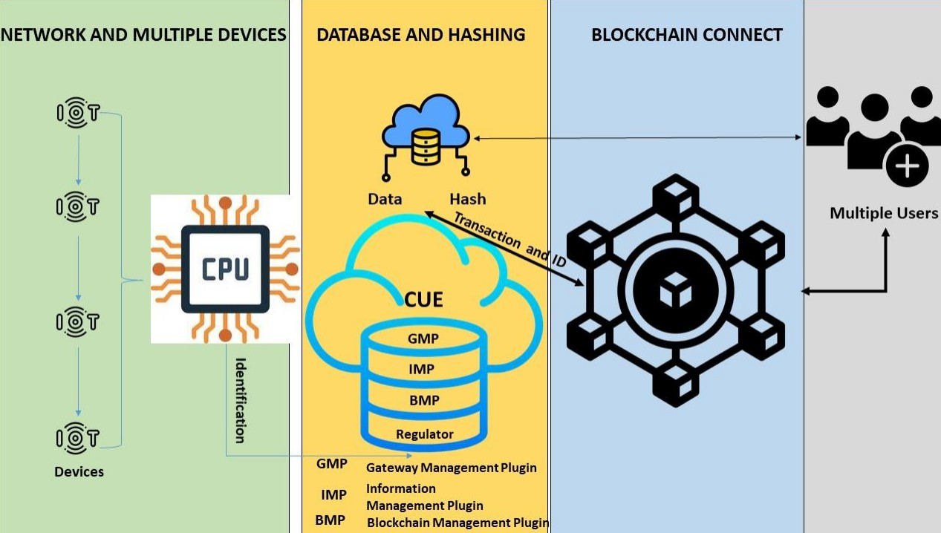

Fig. 1 ChainCare Blockchain Identity Management Framework

1. CYBERSECURITY CHALLENGES IN CONNECTED MEDICAL DEVICES

The incorporation of Internet of Things (IoT) technology in the healthcare sector has initiated a new era characterised by unparalleled connectivity and data-driven patient care, alongside a rise in cyber threats. In 2022, healthcare organisations globally experienced an average of 1,463 cyberattacks per week, marking a 74% increase from 2021, as reported by Check Point Research. In the United States, healthcare entities faced an average of 1,410 cyberattacks weekly per organisation, reflecting an 86% rise compared to the previous year. Nevertheless, this advancement also

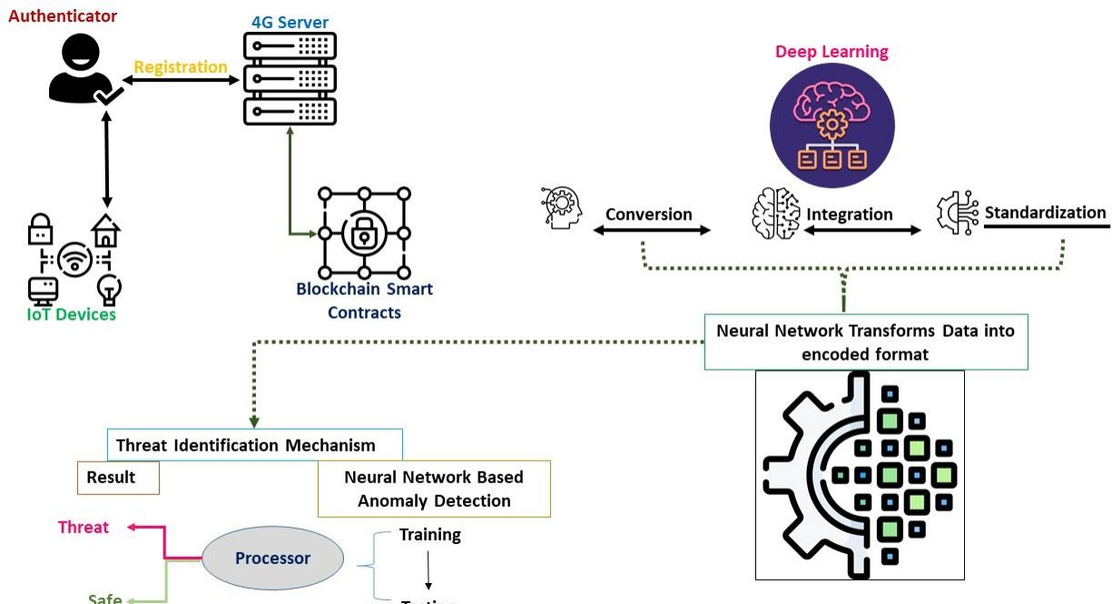

Fig. 2 Deep Learning Framework for Data Transmission and Threat Identification

introduces numerous cybersecurity challenges, especially concerning connected medical devices. For the third consecutive year, US healthcare organisations have been the most affected by data breaches, recording 344 breaches in 2022, according to the Identity Theft Resource Center (ITRC) 2022 Data Breach Report.

Medical devices such as insulin pumps, pacemakers, diagnostic tools, and wearable health monitors are increasingly susceptible to cyber threats, which pose serious risks to patient safety and data security. It is crucial to comprehend and tackle these issues to maintain the integrity of healthcare systems.

* 1. Weaknesses in Product Design: The design of interconnected medical devices presents significant cybersecurity challenges. Numerous devices are susceptible to attacks due to a lack of robust cybersecurity features incorporated from the outset. Manufacturers must prioritise security from the beginning by implementing encryption, access controls, and secure authentication mechanisms.
  2. . Data Privacy: Medical devices that are interconnected generate and transmit a substantial amount of sensitive patient information. Safeguarding the privacy of this data is a challenging endeavour. Unauthorised access to medical records not only infringes upon patient confidentiality but also heightens the risk of identity theft and other illicit activities.
  3. While remote access to medical equipment can offer significant advantages to healthcare providers, it also presents opportunities for malicious individuals to exploit this access. Cybercriminals may interfere with essential medical devices, manipulate their functions, or gain unauthorised entry to these systems.
  4. Software Vulnerabilities: Medical equipment often relies on software to function. Cybercriminals may exploit weaknesses in software that is outdated or lacks necessary patches. While essential, maintaining regular software updates and managing patches can pose significant challenges in healthcare environments.
  5. Insider Threats: Cybersecurity risks can arise from within the organisation, not solely from external sources. Insider threats pose significant risks, whether they are intentional or accidental. To mitigate these threats, healthcare organisations should implement strict access controls and monitor employee activities.
  6. The complexities of medical device supply chains present significant challenges in ensuring the security of each component. To prevent vulnerabilities from infiltrating the ecosystem, manufacturers are required to assess and secure every link within their supply chain.
  7. Adhering to Regulatory Standards: Complying with the requirements set forth by the FDA or EMA can pose significant challenges. The process of product development and ongoing maintenance is further complicated by the necessity to ensure that associated medical devices conform to cybersecurity regulations.
  8. Outdated Systems: Healthcare institutions often utilise obsolete software and aging medical devices that lack modern security protocols. These systems are especially vulnerable to cyberattacks and can be challenging to update or adequately secure.
  9. Insufficient Awareness and Training: Many healthcare professionals may not be fully aware of the various cybersecurity threats or may lack adequate training to identify and respond to potential attacks. It is crucial to enhance awareness and provide ongoing training.

**10**The landscape of cybersecurity threats is constantly evolving. New attack methods and vectors are perpetually being created. To address these shifting risks, healthcare organisations must stay vigilant and adaptable.

# REGULATORY FRAMEWORKS AND STANDARD FOR CYBERSECURITY IN MEDICAL DEVICES

Ensuring the security of interconnected medical devices is paramount in the rapidly evolving landscape of healthcare technology. Manufacturers, healthcare providers, and various stakeholders are required to adhere to stringent protocols and standards established by regulatory bodies worldwide to safeguard patient safety and data integrity. These regulations, with a particular focus on cybersecurity, provide guidelines for the design, development, implementation, and upkeep of connected medical devices. In this context, we examine several key standards and regulatory frameworks that shape this vital aspect of healthcare cybersecurity.

## Food and Drug Administration (FDA) - United States

* + - The FDA is pivotal in overseeing the regulation of medical devices within the United States. The agency has provided guidelines and recommendations to manufacturers concerning the cybersecurity of these devices.
    - The FDA underscores the importance of both pre-market and post-market evaluations, mandating that manufacturers identify and address cybersecurity risks during the entire lifecycle of a device.

## European Medicines Agency (EMA) - European Union

* + - Within the European Union, the European Medicines Agency (EMA) is responsible for the regulation of medical devices under the Medical Device Regulation (MDR) and the In Vitro Diagnostic Regulation (IVDR).
    - These regulations encompass stipulations concerning the cybersecurity of medical devices. Manufacturers are required to establish security protocols to safeguard patient information and ensure the proper functioning of the devices.
    - Adhering to international standards, including ISO 13485 for quality management systems, is crucial for manufacturers aiming to obtain CE marking for their devices.

## International Electrotechnical Commission (IEC

* + - The International Electrotechnical Commission (IEC) is a worldwide organisation that formulates international standards for various technologies, encompassing medical devices and healthcare technology.
    - IEC 62304, titled 'Medical Device Software - Software Life Cycle Processes,' establishes a framework for the development and ongoing maintenance of software used in medical devices, incorporating aspects of cybersecurity.
    - IEC 80001-1, titled 'Application of Risk Management for IT Networks Incorporating Medical Devices,' focuses on the management of cybersecurity risks within healthcare delivery organisations.

## National Institute of Standards and Technology (NIST) - United States

* + - The National Institute of Standards and Technology (NIST) has created cybersecurity frameworks and guidelines that are extensively utilised both within the United States and internationally.
    - The NIST Cybersecurity Framework offers an extensive array of guidelines for organisations to effectively manage and mitigate cybersecurity risks, including those related to connected medical devices.
    - NIST Special Publication 800-183, titled 'Networks of Things,' emphasises the importance of securing Internet of Things (IoT) devices, particularly medical devices, within the larger framework of IoT ecosystems.

## Health Insurance Portability and Accountability Act (HIPAA) - United States

* + - Although HIPAA mainly focuses on the privacy and security of health information, it is significantly pertinent to interconnected medical devices.
    - Entities covered by HIPAA, along with their business associates, are required to maintain the confidentiality, integrity, and availability of protected health information (PHI) that is processed or stored by interconnected medical devices.

## ISO Standards

* + - The International Organisation for Standardisation (ISO) has released multiple standards concerning cybersecurity for medical devices.
    - ISO 14971 offers recommendations for managing risks associated with medical devices, encompassing cybersecurity risks.
    - ISO 27001, a component of the ISO 27000 series, provides a structured approach for the establishment, implementation, maintenance, and ongoing enhancement of an information security management system (ISMS), encompassing elements of cybersecurity.

## Regional Regulatory Bodies

* + - In addition to the FDA and EMA, numerous countries and regions possess their own regulatory authorities and standards concerning the cybersecurity of medical devices. Manufacturers are required to manoeuvre through a complicated array of regulations to achieve compliance across different markets.

Adhering to these regulatory frameworks and standards is a challenging yet crucial responsibility for manufacturers of connected medical devices. This process requires thorough risk evaluations, secure design and development methodologies, continuous monitoring, and prompt action against new cybersecurity threats. Compliance is vital not only for protecting patient data and safety but also for maintaining the trust and confidence of healthcare providers and patients within the digital healthcare environment.

# MITIGATING CYBERSECURITY RISKS IN CONNECTED MEDICAL DEVICES

With the growing dependence of the healthcare sector on interconnected medical devices, it is essential to address cybersecurity risks effectively. Although these devices provide various advantages, they are vulnerable to cyber threats that can endanger patient safety, breach confidential information, and interfere with healthcare services.

Addressing these risks is a continuous and complex endeavour that requires the collaboration of multiple parties, such as manufacturers of medical devices, healthcare professionals, regulatory bodies, and cybersecurity specialists. Below are essential strategies and best practices for reducing cybersecurity risks associated with connected medical devices:

## Security by Design

* + Adopt a security-centric methodology throughout the design and development stages of connected medical devices, which encompasses threat modelling, risk evaluations, and the integration of security measures from the beginning.
  + Treat security as an essential design principle rather than a mere supplementary feature. This encompasses encryption, secure authentication, access controls, and secure boot mechanisms.

## Vulnerability Management

* + Implement procedures to detect and resolve vulnerabilities in the hardware and software elements of medical devices. Consistently update and apply patches to devices to reduce the risk associated with known vulnerabilities.
  + Establish a comprehensive vulnerability disclosure program that enables security researchers and end-users to report possible vulnerabilities.

## Access Control and Authentication

* + Establish stringent access controls to guarantee that only authorised personnel are permitted to engage with medical devices. Employ robust authentication methods, including multi-factor authentication (MFA).
  + Minimise the visibility of device interfaces and data to decrease the potential attack surface.

## Secure Communication

* + It is essential to encrypt the data exchanged between interconnected medical devices and healthcare systems utilising robust cryptographic protocols, ensuring the protection of data both during transmission and while stored.
  + Establish secure communication channels to mitigate the risk of man-in-the-middle attacks.

## Security Updates and Patch Management

* + Establish a clearly defined procedure for the distribution of security updates and patches to interconnected medical devices, as timely management of patches is essential for mitigating known vulnerabilities.
  + Explore methods for implementing remote updates that ensure both efficiency and security.

## Incident Response Planning

* + Create and consistently revise an incident response plan that details the procedures for addressing cybersecurity incidents. It is essential to ensure that all relevant parties, including healthcare professionals and device users, are informed about the plan.
  + Implement routine drills and tabletop simulations to evaluate the efficacy of the incident response strategy.

## User Training and Awareness

* + Educate healthcare professionals, device operators, and personnel on cybersecurity best practices and the secure utilisation of connected medical devices. Enhance understanding of the potential risks linked to these devices.
  + Users are urged to immediately report any irregular device behaviour or potential security incidents.

## Regulatory Compliance

* + Remain informed about the regulatory standards concerning cybersecurity for medical devices, including those established by the FDA, EMA, and other regional governing bodies. Verify that devices adhere to these regulations.
  + Get ready for regulatory evaluations and audits concerning cybersecurity.

## Vendor Risk Management

* + Assess and consistently oversee the cybersecurity protocols of third-party vendors and suppliers supplying components for medical devices. Confirm their compliance with security standards and adherence to best practices.

## Continuous Monitoring

* + Deploy ongoing monitoring systems capable of identifying anomalies and potential security risks in real time. Such systems facilitate the timely detection and response to emerging threats.

## Collaboration and Information Sharing

* + Engage with industry colleagues, regulatory bodies, and cybersecurity organisations to exchange threat intelligence and best practices. Collaborative initiatives can enhance the overall security framework.

## Ethical Hacking and Security Testing

* + It is advisable to engage in ethical hacking and security testing, including penetration testing and vulnerability assessments, to proactively detect and address vulnerabilities.

Addressing cybersecurity threats in interconnected medical devices is a continuous obligation that necessitates alertness, flexibility, and cooperation throughout the healthcare ecosystem. By implementing these strategies and best practices, healthcare organisations can minimise vulnerabilities, improve patient safety, and maintain the integrity and reliability of their digital healthcare systems.

# FUTURE TRENDS AND INNOVATION

The realm of cybersecurity in healthcare is constantly changing, influenced by the growing intricacy of interconnected medical devices, the shifting nature of threats, and the necessity to safeguard patient safety and data confidentiality. Looking ahead, numerous trends and advancements are set to influence how healthcare organisations and medical device manufacturers tackle cybersecurity.

## Zero Trust Architecture (ZTA)

The Zero Trust model is a developing cybersecurity framework that operates on the principle that no entity, regardless of its location within or outside the network, is inherently trustworthy. This approach mandates rigorous identity verification and ongoing surveillance of all users and devices. In the healthcare sector, Zero Trust Architecture (ZTA) can facilitate the assurance that only authorised individuals and devices are permitted to access essential medical information and connected devices, thereby minimising the likelihood of unauthorised access.

## Artificial Intelligence (AI) and Machine Learning (ML)

Artificial Intelligence and Machine Learning are progressively utilised in cybersecurity to identify and address threats instantaneously. These technologies are capable of processing extensive datasets to recognise irregularities and possible security breaches. In relation to interconnected medical devices, AI and ML can improve threat detection and forecasting, enabling healthcare organisations to remain proactive against cyber threats.

## Blockchain for Data Security

The adoption of blockchain technology, recognised for its unchangeable nature and transparency, is increasingly being embraced in the healthcare sector to safeguard patient records and medical information. This study elucidates how healthcare organisations can maintain the integrity and authenticity of patient data while safeguarding it from unauthorised alterations.

## Device Identity and Attestation

Creating a robust device identity and confirming device attestation (validating the device's integrity) is essential in the realm of interconnected medical devices. Advances in device identity management can assist in thwarting unauthorised

or compromised devices from gaining access to healthcare networks.

## Software-Defined Perimeter (SDP)

The Software-Defined Perimeter (SDP) is a security framework that establishes a dynamic 'perimeter' around each user or device, permitting access solely to authorised resources. This methodology can improve the security of medical device networks by decreasing the attack surface and mitigating the risk of lateral movement by cybercriminals.

## Quantum-Safe Cryptography

The emergence of quantum computing poses a potential threat to conventional encryption techniques. Quantum-safe cryptography is specifically developed to resist quantum-based attacks. It is imperative for healthcare organisations to evaluate the adoption of quantum-safe encryption to safeguard patient information and communication between devices.

## Collaborative Threat Intelligence Sharing

Exchanging threat intelligence and working together with other healthcare organisations and industry partners is essential for remaining aware of new threats. Such collaborative initiatives can facilitate the prompt identification and reduction of novel cyber threats aimed at connected medical devices.

## Regulatory Evolutions

Regulatory agencies are anticipated to further develop their cybersecurity mandates for medical devices. Manufacturers will be required to adjust to emerging standards and protocols. The focus on cybersecurity by regulatory authorities is projected to persist as a primary concern, underscoring the growing significance of this matter.

## Privacy-Preserving Technologies

Emerging technologies that prioritise privacy, including federated learning and homomorphic encryption, are being developed to safeguard patient data while facilitating collaborative research and analysis. These innovations allow healthcare organisations to extract valuable insights from data without compromising sensitive patient information.

## Enhanced User Training and Awareness

Cybersecurity training and awareness initiatives for healthcare personnel and device users will persist in their development, highlighting the significance of maintaining cybersecurity hygiene. This will enable individuals to identify and report security incidents, thereby aiding in the prevention of attacks.

The landscape of cybersecurity in healthcare for interconnected medical devices is characterised by ongoing innovation and adaptation. As technology progresses, healthcare organisations and device manufacturers must remain alert, investing in cutting-edge security protocols and fostering collaborative initiatives to safeguard patient safety and privacy. The persistent integration of healthcare and technology necessitates a proactive and visionary strategy towards cybersecurity to secure the future of healthcare services.

# CONCLUSION

In a time when healthcare and technology are increasingly intertwined, the cybersecurity of interconnected medical devices serves as a guardian at the forefront of patient safety and data protection. This article has shed light on the diverse challenges and effective strategies that characterise this crucial field. As the healthcare sector continues to adopt the Internet of Things (IoT) and undergo digital transformation, it recognises that cybersecurity is not simply an element; it is the foundation upon which patient trust and the integrity of healthcare systems are built. The future is filled with significant potential, including Zero Trust Architectures and the revolutionary capabilities of artificial intelligence, blockchain, and quantum-safe cryptography. The ChainCare Protect proposed in this study addresses identity protection and data transmission, while also highlighting the emerging threats and vulnerabilities that require ongoing vigilance. In this continuous effort to protect the digital landscape of healthcare, collaboration stands out as a

source of optimism. All stakeholders within the healthcare ecosystem—manufacturers, providers, regulators, and cybersecurity professionals—must come together in a collective commitment to prioritise cybersecurity by design, cultivate a proactive security culture, and exchange threat intelligence.

The regulatory environment is set to progress, underscoring the increasing importance of cybersecurity. Healthcare organisations and manufacturers are required to comply with current standards while also preparing for and adjusting to future regulations. Proactive cybersecurity strategies will be characterised by ethical hacking and ongoing monitoring.

In concluding this study, we acknowledge that the future of cybersecurity in healthcare is a collaborative effort, characterised by a blend of innovation, resilience, and commitment. This endeavour focuses on safeguarding patient safety, maintaining data privacy, and ensuring the reliability of healthcare systems. It represents an unyielding quest to fortify the digital landscape that promises enhanced healthcare for everyone. Within the interconnected realm of healthcare, where technology and humanity converge, cybersecurity serves as the protector of a more promising and healthier future. Although the challenges we face are significant, our resolve to address them is equally strong. As we advance into this digital era of healthcare, we do so with a steadfast conviction that through teamwork, innovation, and unwavering commitment, we can establish a safer, more resilient, and patient-centred healthcare environment for future generations.

**REFERENCES**

1. J. Smith, "AI-Driven Diagnostics," *Journal of Medical Innovation*, vol. 15, no. 4, pp. 45-60, 2021.
2. R. Brown et al., "Blockchain in Healthcare," *Global Health Informatics Review*, vol. 9, no. 2, pp. 32-40, 2020.
3. T. Lee, "Telemedicine Lessons from the Pandemic," *Healthcare Today*, vol. 12, no. 1, pp. 10-20, 2022.
4. M. Green, "Wearable Devices and Chronic Disease," *Tech for Health Journal*, vol. 7, no. 3, pp. 50-55, 2019.
5. IEEE Standards Association, "Data Security Best Practices in Healthcare," 2022.
6. P. White, "Ethics of AI in Medicine," *Bioethics Quarterly*, vol. 18, no. 2, pp. 25-35, 2021.