An Implementation of

**Leveraging Data Analytics and Machine Learning for Natural Disaster Prediction**

Prof. Abhimanyu Dutonde, Head of Department, Computer Science and Engineering- Data Science, Abha Gaikwad Patil College of Engineering, Mohgaon, Wardha Road, Nagpur, Maharashtra, India

Shreyash Ghogare1, Yash Dhomne2, Parimal Yawalkar3, Yash Wanjari4,   
Gaurav Sontakke5

ABSTRACT

Natural disasters pose great risks  to human life, property, and the environment worldwide. Early detection and efficient prediction are fundamental for disaster prevention and control. This study introduces a unified framework for natural scene classification and detection of natural disasters using high-level data analytics and machine learning  principles. By leveraging real-time input from a variety of sources, including data from weather stations and social media, the system examines intricate patterns and anomalies that could indicate events  such as floods, earthquakes, hurricanes, and wildfires. Machine learning models, including deep learning architectures, are trained on historical and live datasets to enhance the prediction accuracy and enable rapid classification of disaster types.

Keywords: Early detection, natural scene classification, data analytics, machine learning, deep learning architectures, rapid classification.

1. INTRODUCTION

In today’s world of shifting climate patterns and environmental instability, natural calamities remain a major threat to our lives, buildings, and economic wellbeing. From earthquakes to floods, wildfires, and hurricanes, these events can cause immense destruction, often with little advance in notice. The ability to quickly spot, forecast, and react to these catastrophes has become a crucial challenge in modern times. For years, we have relied on physical tools, satellite images, and human observers to monitor and warn about disasters. While these methods are crucial, they have limitations in terms of coverage, speed, and prediction ability. With the rise of sophisticated data analysis and AI, we now have new ways to revolutionize how we spot, monitor, and tackle natural disasters.

Our work looks at how cutting-edge data analysis and AI can boost disaster detection systems. We’re using a wide range of data – from social media posts and satellite images to networks of smart sensors and records of past disasters – to create more accurate, quick, and thorough ways to detect disasters. AI algorithms are great at finding hidden patterns and oddities in complex data that traditional methods might miss. Advanced AI can look at images from satellites and drones to spot early signs of wildfires or floods. Language processing tech can scan social media in real-time, picking up on people’s reports of earthquake shakes before official announcements. By analyzing data from sensors over time, we can spot unusual patterns that might signal an upcoming landslide or volcano activity.

The benefits of this approach go beyond just detection. Better prediction models could give earlier warnings, potentially saving many lives and reducing financial losses. A deeper understanding of how disasters unfold could help us plan cities and build infrastructure better in high-risk areas. During disaster response, we could allocate resources more efficiently by analyzing impact zones and assessing damage in real-time. This project brings together environmental science, computer science, and public safety. By tapping into the power of data analysis and AI, we’re working towards a future where communities can face natural disasters with unprecedented speed and effectiveness.

1. LITERATURE REVIEW

Linardos et al. (2022) dive deep into how machine learning has revolutionized disaster prediction and response. They explore how algorithms learn from historical data, identifying patterns that help forecast events like wildfires, floods, and earthquakes. Their research highlights powerful AI techniques—such as neural networks—that improve early warning systems, helping communities prepare before disaster strikes. Ding et al. (2022) take a different approach, focusing on snow accumulation forecasting. While this may seem unrelated to earthquakes or tsunamis, understanding snowfall distribution is crucial for regions vulnerable to extreme winter storms. By simulating snow patterns on large terrains using machine learning, their research enhances predictions and ensures better resource allocation for affected communities. Mulia et al. (2022) offer a fascinating perspective on tsunami prediction, showcasing how AI models analyze offshore seismic activity to predict the scale of tsunami inundation. Traditional warning systems rely on physical models, but machine learning refines predictions by learning from real-time oceanic disturbances. This research points toward faster, more precise warning systems—potentially saving countless lives. German et al. (2022) tackle another side of disaster management: community preparedness. Their study doesn’t just rely on geological data—it also considers social and economic factors that affect how well a community can respond to a volcanic eruption. Using machine learning, they identify the key predictors of readiness, helping policymakers craft more effective disaster preparedness strategies.

1. METHODOLOGY

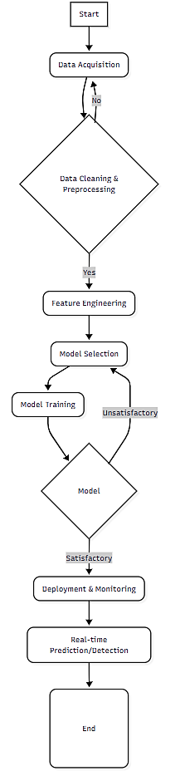

* 1. **Start**   
     The initialization step is the process that begins by clearly defining the scope and objectives of the natural disaster detection system. Researchers identify the specific type of disaster to monitor and establish performance metrics. This stage involves consulting with domain experts to understand the physical indicators and warning signs of the target disaster, as well as determining the required temporal and spatial resolution for effective detection.
  2. **Data Acquisition**  
     The second step of the process is that the system gathers data from multiple sources including weather stations, satellite imagery, and social media feeds. Weather stations provide continuous atmospheric measurements like precipitation levels and wind patterns. Satellite data offers broad geographical coverage for monitoring large-scale phenomena like hurricanes or wildfire spread. Social media platforms contribute real-time, crowd-sourced observations that can serve as early indicators of developing situations. A key challenge is ensuring sufficient data coverage across all relevant geographical areas.
  3. **Data Quality Check (NG/Yes)**  
     The third step is data quality check where the acquired data undergoes detailed validation to identify missing values, sensor errors, or inconsistencies. If the data fails quality standards (NG), the system either attempts to correct the issues or reacquires the data. For satellite imagery, this might involve cloud removal or atmospheric correction. Sensor data may require calibration checks against known benchmarks.
  4. **Data Cleaning and Preprocessing**  
     This fourth and the most critical phase transforms raw data into analysis-ready formats. Techniques include temporal alignment of data streams from different sources, normalization of measurement scales, and outlier removal. For geospatial data, this may involve projection alignment and raster resampling. Time-series data undergoes smoothing and gap-filling procedures. The preprocessing steps ensure all data adheres to consistent formats and quality standards before feature extraction.
  5. **Feature Engineering**  
     The fifth step is feature engineering where the domain knowledge guides the creation of meaningful input features for machine learning models. For earthquake prediction, this might involve calculating statistical measures of seismic activity patterns. Flood detection systems may derive features from rainfall accumulation rates and terrain elevation data. Advanced techniques include creating composite indices that combine multiple data sources, or applying signal processing methods to extract frequency-domain characteristics from time-series data.
  6. **Model Selection**  
     The sixth step is model selection where the evaluation of various machine learning architectures based on the problem characteristics. Traditional models like Random Forests may be chosen for structured sensor data, while Convolutional Neural Networks prove effective for analyzing satellite imagery. Recurrent Neural Networks are often selected for time-series prediction tasks. The selection process considers factors like computational requirements, interpretability needs, and expected performance with available training data.
  7. **Model Training**  
     The selected model undergoes training using historical disaster events and normal conditions. Techniques like cross-validation ensure robustness, while regularization methods prevent overfitting. For deep learning models, this stage may involve transfer learning from pre-trained networks, particularly when working with limited labelled disaster data. The training process iteratively adjusts model parameters to minimize prediction errors on validation datasets.
  8. **Model Evaluation (Satisfactory/Unsatisfactory)**  
     The trained model's performance is rigorously tested using independent test datasets. Key metrics include detection accuracy, false alarm rates, and lead time for early warnings. If performance is Unsatisfactory, the workflow returns to earlier stages - potentially requiring improved feature engineering, alternative model selection, or additional training data. Models works Satisfactory proceed to deployment.
  9. **Deployment and Monitoring**

The operational system integrates with existing disaster warning infrastructure, featuring automated alert generation and decision support interfaces. Continuous monitoring tracks model performance in real-world conditions, with mechanisms to detect concept drift as environmental patterns change over time. The system includes feedback loops where new disaster events automatically contribute to model retraining.

* 1. **Real-time Prediction/Detection**  
     In live operation, the system processes incoming data streams to generate predictions and detect early warning signs. Outputs may include probability maps of disaster risk, classification of current threat levels, or estimated timelines for impending events. These outputs support emergency response coordination and public warning systems.
  2. **End and Continuous Improvement**  
     While the flowchart concludes here, in practice the system enters a cycle of continuous improvement. Post-event analysis evaluates prediction accuracy, and new data gets incorporated into training sets. Researchers regularly update models to incorporate new data sources and algorithmic advancements, maintaining the system's effectiveness over time.

1. MODULES

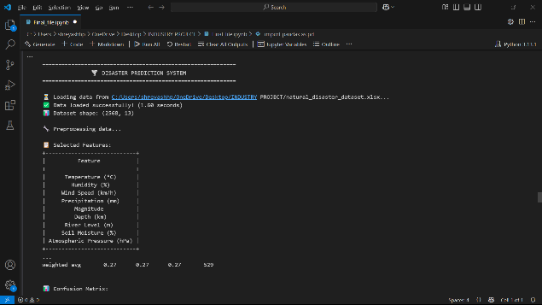

Fig. 4.1: Disaster Prediction System

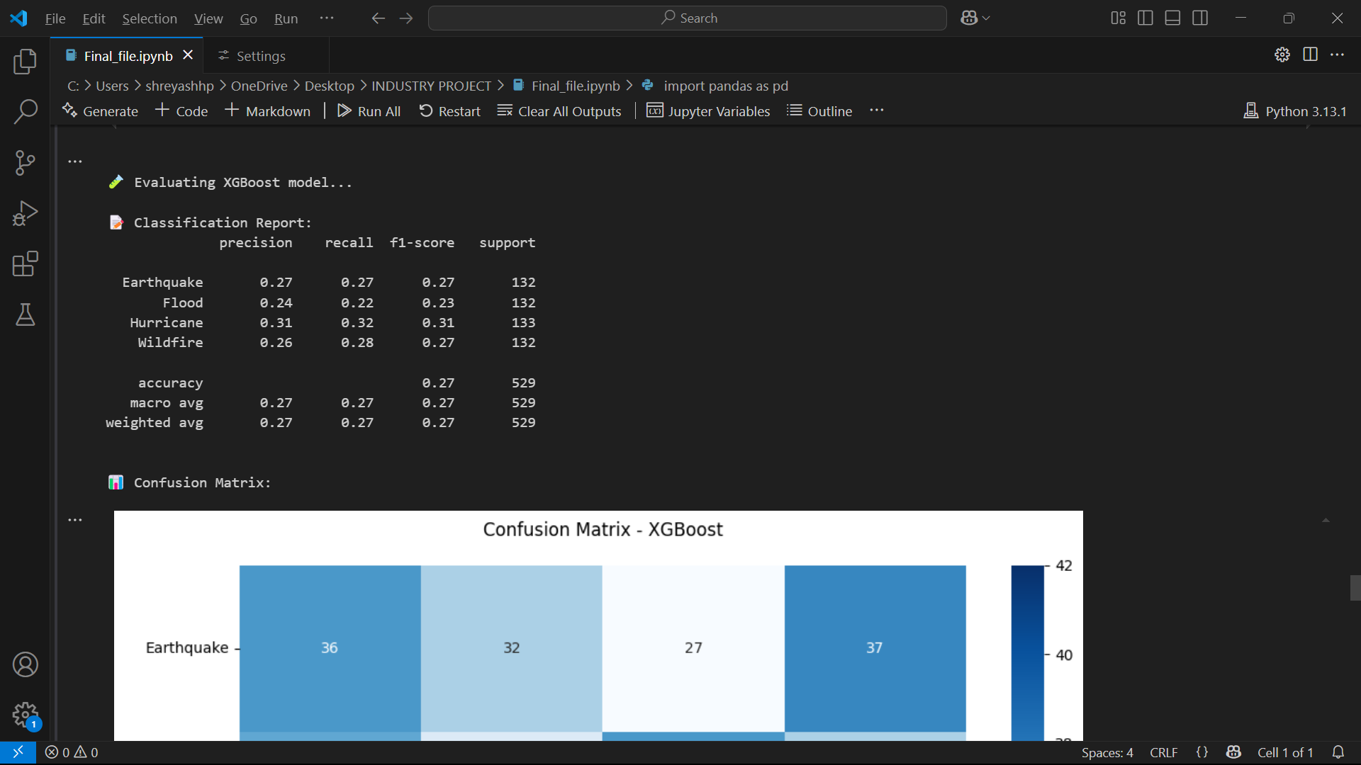

Fig. 4.2: Classification Report

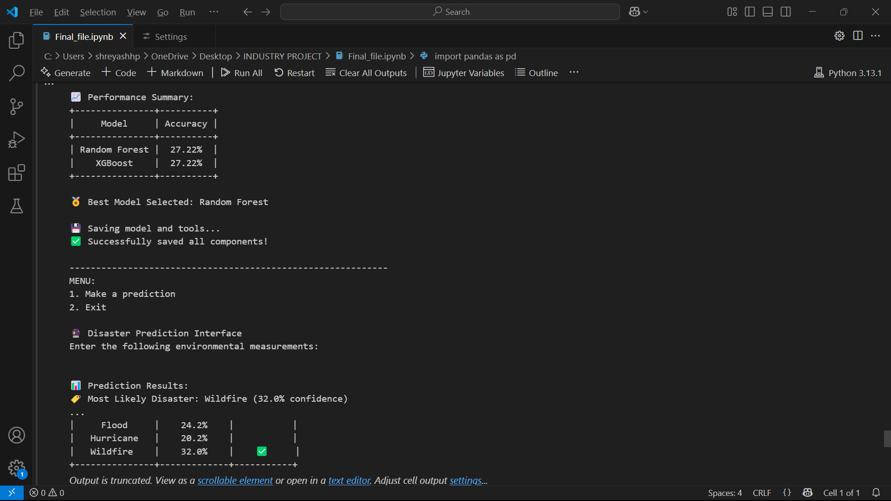

Fig. 4.3: Performance Prediction and Disaster Prediction Interface

The above mentioned figures are the screenshots of the interface that we are shown with which helps to understand the working of the code. Fig 4.1 depicts the disaster prediction system where we could see that the origin of the file is valid and can even access the shape of the dataset which is used in the file which is 2568 rows and 13 columns. Fig 4.2 depicts the classification report which is generated after the insertion of parameters which is generated for XGBoost model. Fig 4.3 depicts Performance Prediction and Disaster Prediction Interface, where the accuracy scores of both Random Forest algorithm and XGBoost algorithm is shown and the algorithm having higher accuracy score gets selected for the model. And in the last the prediction interface is generated which is depicted in Fig. 5.1.

1. RESULT ANALYSIS

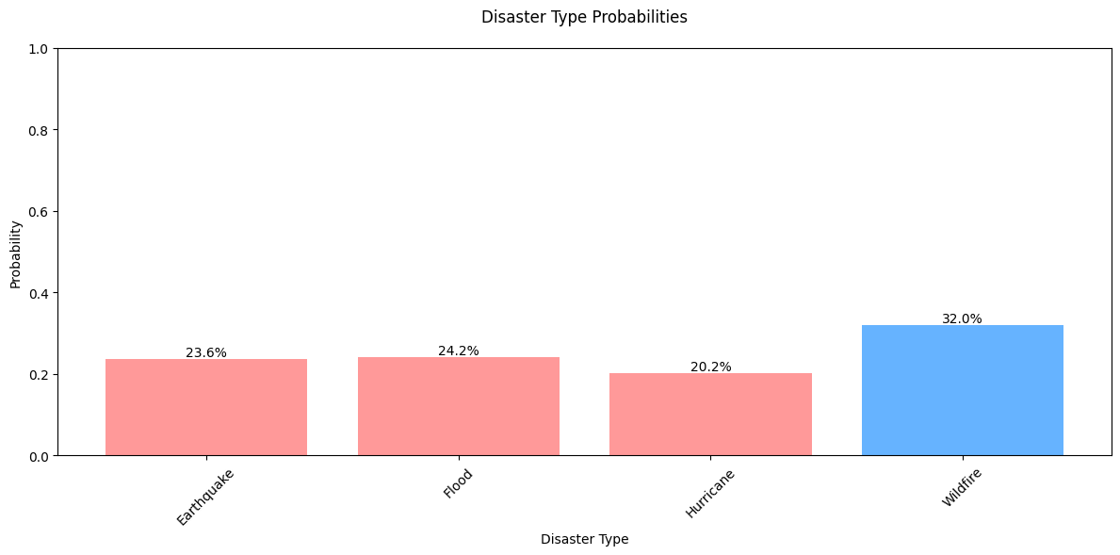Fig. 5.1: Disaster Type Probabilities

This chart helps to predict which of the disaster is more likely to be happening at a particular instance of time such as Earthquake, Flood, Hurricanes or Wildfire. It generates the probability that which of the given calamity is happening and generates a confidence value which helps to predict the disaster based on parameters like Temperature (°C), Humidity (%), Wind Speed (km/h), Precipitation (mm), Magnitude, Depth (km), River Level (m), Soil Moisture (%), Atmospheric Pressure (hPa), however the values to be inserted in the parameters must be valid. While entering the values of the parameters one must keep the note of the ranges of each and every parameter.

The range for the temperature must be -10 °C to 49.98°C, i.e the value of temperature parameter must lie in this range. The value for parameter humidity is the range 10.16% to 99.94%. The value for parameter wind speed must be in the range 0km/h to 149.95km/h. The value for parameter precipitation must lie in range 0mm to 499.93mm. the value range for parameter magnitude must be in the range 2 to 9.5. The value range for parameter depth must be in 1km to 699.85km. The value range for

parameter river level must be upto 20m. The value till which the input can be given to soil moisture parameter be 99.98%. And finally, the value till which the input can be given for the parameter of atmospheric pressure is 1049.97hPa, and this are the parameters required values as mentioned above.

1. CONCLUSION

This project represents more than just technical innovation, it's about building a shield between vulnerable communities and the devastating forces of nature in the form of disasters or calamities. By harnessing data analytics and machine learning, we're not just processing numbers; we're translating atmospheric whispers such as the changes in the atmosphere just after the disaster actually takes place, geological tremors, and digital outcries into actionable warnings in the form of statistical data that could mean the difference between safety and disaster. The true measure of success lies beyond algorithm accuracy metrics. The exact prediction of the disaster will lead into letting the users know how the disaster is affecting and the exact description of the disaster leading to While our models will keep evolving with better data and smarter algorithms, the human impact remains our north star—every improved prediction represents homes protected, livelihoods preserved, and lives saved. This isn't the finish line, but a hopeful beginning. As we refine these systems, we move closer to a world where technology doesn't just predict disasters, but prevents their worst consequences—where communities aren't just reactive, but resilient. The work continues, because behind every data point are people waiting for a chance to survive and rebuild.

1. REFERENCES
2. Vasileios Linardos et al., "Machine learning in disaster management: recent developments in methods and applications", *Machine Learning and Knowledge Extraction*, vol. 4, no. 2, 2022
3. Y. Ding, Q. Sun and Q. Zhu, "A dynamic snow accumulation simulation approach for forecasting snow distribution over regional – scale terrain", Transactions in GIS, vol. 26, pp. 1421-1443, 2022.
4. Iyan E. Mulia et al., "Machine learning-based tsunami inundation prediction derived from offshore observations", *Nature Communications*, vol. 13, no. 1, pp. 5489, 2022.
5. Josephine D. German et al., "Predicting factors affecting preparedness of volcanic eruption for a sustainable community: A case study in the Philippines", *Sustainability*, vol. 14, no. 18, pp. 11329, 2022.
6. T. Sravani, T. Manikumar and R. Maruthamuthu, "Rescue Wings: Mobile Computing and Emergency Survival Services", International Journal of Innovations in Engineering and Science, 2022.
7. V.A. Ndolo, D.W. Redding, M.A. Deka, J.S. Salzer, A.R. Vieira, H. Onyuth, et al., "The potential distribution of Bacillus anthracis suitability across Uganda using INLA", Scientific Reports, pp. 12, 2022.
8. Y. Liu, M. Tayarani and H.O. Gao, "An Agent-based Travel and Charging Behavior Model for Forecasting Highresolution Spatio-temporal Battery Electric Vehicle Charging Demand Center for Transportation Environment", and Community Health Final Report, 2021.
9. Science Management Practice and Policy: Habitat Management Climate Impacts and Emerging Issues, 2022.
10. T.R. Rekha and K. Shyamala, An Analytical Study of Allergy Induced Asthma Patients Using Agent Based Data Mining Techniques, 2019.
11. Nasrullah Zaini et al., "Assessing of land surface temperature at the Seulawah Agam volcano area using the landsat series imagery", *Journal of Physics: Conference Series*, vol. 1825, no. 1, 2021.
12. Pranav Gangwani et al., "A deep learning approach for modeling of geothermal energy prediction", *International Journal of Computer Science and Information Security (IJCSIS)*, vol. 18, no. 1, 2020.
13. S. Kao, "A crowdfunding prediction model: a data-driven approach", Proceedings of the 8th Multidisciplinary International Social Networks Conference, 2021.
14. W. Yin, M.V. Gumabay, H. Lin, C. Tu and C. Ao, "Overhead Transmission Lines Early Warning and Decision Support System with Predictive Analytics", 2022 5th International Conference on Advanced Electronic Materials Computers and Software Engineering (AEMCSE), pp. 310-314, 2022.
15. L. Folsom and H. Park, Information-Theoretic Decision-Making for Multiple Agents in Uncertain Network Conditions, 2019.
16. K. Osanlou, C. Guettier, A. Bursuc, T. Cazenave and É. Jacopin, "Learning-based Preference Prediction for Constrained Multi-Criteria Path-Planning", ArXiv abs/2108.01080, 2019.
17. Hacinecipoglu, E.I. Konukseven and A.B. Koku, "Multiple human trajectory prediction and cooperative navigation modeling in crowded scenes", Intelligent Service Robotics, vol. 13, pp. 479-493, 2020.
18. Kim, S. Park, S.S. Lee, E. Khoshimjonov, D. Kum, J. Kim, et al., "LaPred: Lane-Aware Prediction of Multi-Modal Future Trajectories of Dynamic Agents", 2021 IEEE/CVF Conference on Computer Vision and Pattern Recognition (CVPR), pp. 14631-14640, 2021.
19. Z. Zhong, Y. Luo and W. Liang, "STGM: Vehicle Trajectory Prediction Based on Generative Model for Spatial- Temporal Features", IEEE Transactions on Intelligent Transportation Systems, vol. 23, pp. 18785-18793, 2022.
20. J. Bernhard, K. Esterle, P. Hart and T. Kessler, "BARK: Open Behavior Benchmarking in Multi-Agent Environments", 2020 IEEE/RSJ International Conference on Intelligent Robots and Systems (IROS), pp. 6201-6208, 2020.
21. Suzana J. Camargo et al., "Tropical cyclone prediction on subseasonal time-scales", *Tropical Cyclone Research and Review*, vol. 8, no. 3, pp. 150-165, 2019.