**QUICK FASHION THE FUTURE OF ON-DEMAND APPAREL DELIVERY IN INDIA**

**U. Neelakshi Devi, Nivedya Raj, Riya Dwivedi, S. Swathi, Harshita Parmeshwar Hegde, Tanusrii Arun Kumar, Dr. M. Nalini Sunil**

MBA Students, Faculty of Management Studies, CMS Business School, Jain (Deemed to be University), Banglore, Karnataka, India. Associate Professor, Faculty of Management Studies, CMS Business School, Jain (Deemed to be University), Banglore, Karnataka, India.

# Abstract

In today’s fast-paced world, the demand for instant satisfaction now extends to fashion. This study examines the feasibility and consumer interest in *FabGo*, a conceptual fast-track clothing delivery service designed for time-sensitive wardrobe needs. While e-commerce has transformed retail, it still lacks instant solutions for urgent clothing requirements. This research aims to explore consumer perception, willingness to adopt, and the ideal service model for FabGo through a quantitative survey targeting students, teachers, working professionals, and general consumers. Findings highlight that *speed* is the top motivator, with 25% of respondents expecting delivery within 30 minutes—emphasizing the demand for hyperlocal logistics and on-demand networks. However, consumers also value *quality* and *cost*. While there is some willingness to pay a 10–20% premium for one-hour delivery, 77% expect pricing to stay close to regular retail rates. Additionally, 93% and 96% of respondents rated hassle-free returns and product quality as top priorities, respectively. Demographic analysis revealed distinct preferences: working professionals favored online platforms and casual wear, whereas teachers preferred traditional/ethnic attire. These insights point to the importance of segmented marketing and inventory strategies. Overall, the study supports the market potential of same-day fashion delivery services like FabGo. Success depends on efficient logistics, stringent quality checks, and customer-centric pricing. With these elements in place, FabGo could disrupt the fashion retail sector by meeting the urgent needs of today’s fashion-conscious and time- sensitive consumers.

**Keywords:** Hyperlocal Delivery, Fashion Delivery, Convenience, On-Demand Delivery, Fashion Retail, Online Shoppi

# Introduction

The Indian fashion industry is rapidly evolving, driven by digital innovation, urbanization, and the growing demand for instant gratification. Consumers today seek fast, convenient, and stylish solutions that fit their busy lifestyles—leading to the rise of quick commerce in fashion. Unlike traditional e-commerce, this model focuses on real-time inventory, hyperlocal fulfillment, and seamless logistics to deliver clothing within hours. Platforms like *FabGo* aim to redefine fashion retail by offering on-demand, tech-enabled wardrobe solutions. With a young, trend-conscious population influenced by social media and rising disposable income, India is primed for a retail revolution. Quick commerce is no longer a luxury—it's a necessity.

The increasing frequency of last-minute needs—whether for party outfits, formal wear, or seasonal essentials—has revealed a gap in traditional retail models. Quick commerce bridges this gap by merging speed with personalization. Leveraging AI-driven recommendations and strategic warehousing, services like *FabGo* aim to ensure that fashion is always just a few clicks away. As on-demand services become integral to consumer behavior, fashion shopping too is shifting towards immediacy and convenience. This transformation is not just about faster delivery; it marks a fundamental shift in how Indian consumers engage with fashion.

# Review of Literature

Consumer behavior plays a pivotal role in shaping the success of on-demand delivery platforms. Gupta and Verma (2022) emphasize that speed, convenience, and price are primary decision-making factors, along with trust and perceived value for long-term brand loyalty. Kaur and Singh (2024) echo these findings, noting that customer satisfaction in online platforms like Swiggy and Zomato depends on trust-building mechanisms such as loyalty programs, reviews, and hygiene ratings.

Sharma and Nair (2023) examine the public health implications of instant delivery services, highlighting concerns around impulse purchases and excessive consumption. Meanwhile, Joshi and Roy (2024) raise environmental concerns by discussing the rise in packaging waste due to rapid commerce, urging sustainable practices.

Several studies highlight the technological backbone of quick commerce. Patel and Desai (2024) describe how AI improves customer experience through personalization, efficient logistics, and predictive analytics. Chopra and Malhotra (2023) focus on pricing models, showing how dynamic pricing and estimated wait times affect consumer behavior and retention.

Rao and Sen (2023) explore hyperlocal logistics, revealing how real-time stock updates and

partnerships with vendors support operational efficiency. Mehta and Jain (2024) detail Blinkit’s market strategy, emphasizing competitive pricing and strategic alliances as key to its dominance. Narayan and Bose (2023) confirm the strong market potential for quick commerce in India, projecting significant growth driven by digital adoption and technological innovation.

Lastly, Singh and Mehta (2022) analyze Myntra’s success in fashion retail, attributing it to social media influence, brand awareness, and personalized recommendations.

Together, these studies underscore the multifaceted nature of quick commerce—where consumer satisfaction hinges on speed, trust, technology, sustainability, and strategic pricing.

# Research Methodology

This study adopts a **quantitative research approach**, utilizing a structured questionnaire to understand the demand and feasibility of FabGo, a fast-track clothing delivery service. The primary focus is on identifying consumer preferences, urgency frequency, pricing expectations, and preferred delivery times for emergency clothing needs.

The **survey method** is employed using self-administered digital questionnaires distributed through platforms such as Google Forms and social media. The questionnaire includes multiple-choice and scaled questions to ensure consistent and measurable responses from diverse respondents, including students, faculty, and working professionals.

A **systematic sampling strategy** was followed to target individuals most likely to use emergency clothing services. The questions are designed to gather insights into clothing categories in demand, delivery speed preferences, pricing willingness, and factors influencing service adoption, such as trust, variety, and return policies.

The **data collection phase** spans seven days, after which descriptive statistical tools like percentage analysis and mean calculation will be used to interpret the results. This methodology ensures that the insights are directly applicable to shaping FabGo’s operational model, pricing strategy, and inventory planning.

# Data Analysis and Interpretation

The survey reveals that FabGo’s emergency clothing delivery service has significant potential, with 81% of respondents expressing interest in speed guarantees. This aligns with the 93% who prioritize delivery speed, confirming that fast service is a key driver for customer conversion. Offering guarantees like "Guaranteed in 1 hour or 50% off" can address concerns about reliability and build

trust, but FabGo must ensure operational capacity to meet these promises. The minimal resistance to speed guarantees, with only 17% expressing hesitance, suggests that price-sensitive customers can be targeted with special promotions or tiered pricing strategies. This approach will allow FabGo to attract a broader customer base, capitalizing on the market’s strong demand for ultra-fast delivery. Clothing preferences also vary significantly across occupations, highlighting the need for tailored inventory. While casual wear is universally in demand, faculty and homemakers lean towards traditional and ethnic wear, with educators also seeking formal options. Working professionals primarily prefer casual attire, and students have a balanced demand for casual, traditional, and accessory options. These preferences underline the importance of structuring FabGo’s offerings to include versatile casual-accessory bundles, while maintaining specialized stock for professionals and educators. Catering to these segmented needs will help FabGo establish itself as the go-to service for urgent fashion, offering both convenience and relevance.

The relationship between delivery speed and price tolerance is also noteworthy, with a clear inverse trend—customers are willing to pay a premium for faster service. Ultra-fast delivery under 1 hour commands the highest price premiums of 20-30%, while same-day and next-day delivery are more price-sensitive. This suggests that a tiered pricing strategy would work well, offering premium rates for expedited delivery, moderate premiums for 1-2 hour service, and retail pricing for slower options. By aligning pricing with consumer expectations, FabGo can maximize revenue while still providing value-driven services to a wide range of customers.

Survey responses emphasize the importance of speed, quality, and competitive pricing. Customers also want reliable delivery guarantees, flexible return policies, and a diverse inventory, including real-time tracking and personalized recommendations. These features will significantly enhance the overall user experience, ensuring that customers can easily track their orders and make informed purchasing decisions. FabGo’s focus should be on blending speed with affordability and maintaining high-quality standards, all while ensuring reliable and flexible customer service. This trifecta of features is critical for meeting the diverse needs of time-sensitive consumers in the fast fashion market.

Shopping preferences reveal that 44% of respondents prefer online shopping, while 42% favor local stores, indicating that a hybrid approach will best serve customers. By offering an app-based solution in partnership with local stores or malls, FabGo can cater to both groups, providing flexibility in delivery channels. This integration will allow customers to access a wider range of options while ensuring quick fulfillment, particularly for those who prefer in-person shopping. FabGo can leverage these shopping behaviors to expand its market reach, allowing it to effectively serve customers with different preferences for delivery and shopping experiences.

Additionally, customer expectations include features like real-time tracking and personalized recommendations, which can be key differentiators in the competitive fast fashion delivery market. By providing these services, FabGo can further enhance the customer experience, making it more convenient for customers to track their orders and receive tailored suggestions. The demand for such features underscores the importance of continuously innovating and improving the user experience, ensuring that FabGo remains competitive in the fast-growing emergency clothing delivery industry. By tapping into these diverse customer expectations and segmenting its offerings based on occupation, preference, and urgency, FabGo has the potential to become a market leader. The service should prioritize ultra-fast delivery for professionals, offer hybrid shopping options for students, and provide flexible, reliable service for homemakers and educators. These strategies will help FabGo meet the varying needs of its customers while ensuring that it remains at the forefront of the emergency fashion logistics space. A focus on customer-centric features, alongside operational reliability, will be the key to long-term success and market dominance.

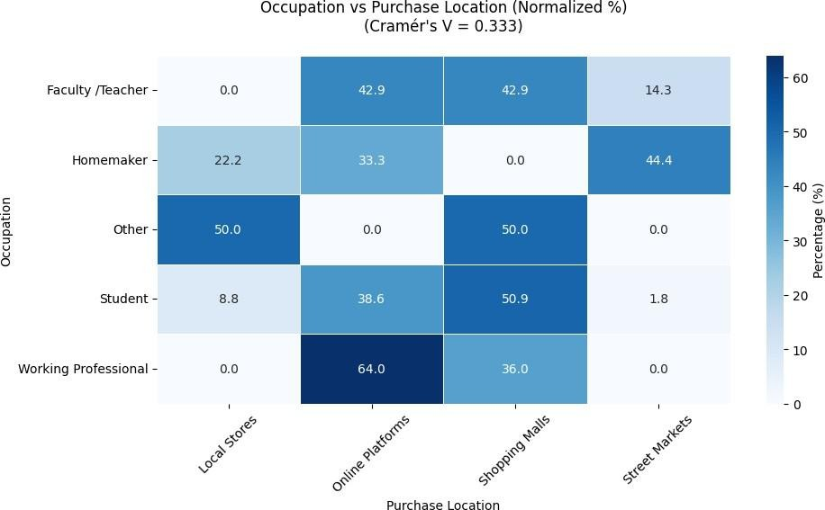

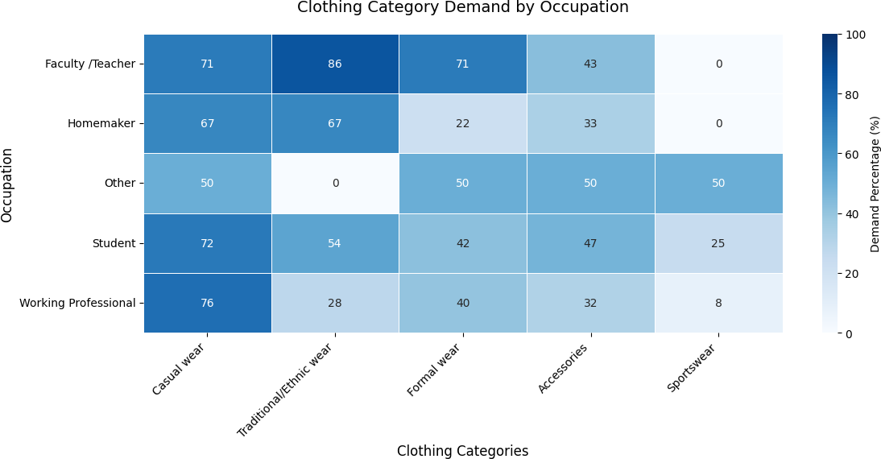

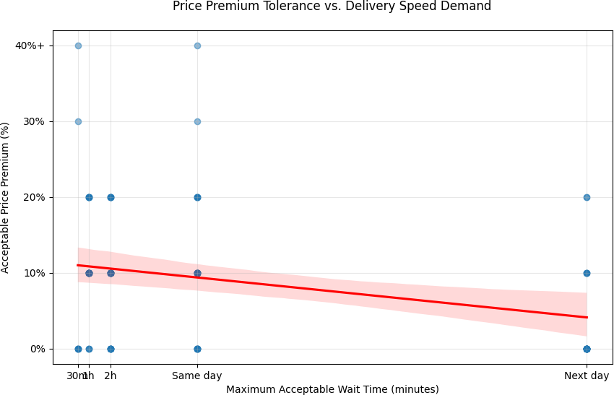

# Findings and Recommendations

The target demographic for emergency clothing delivery services is primarily working professionals (57%) aged 36-50, with students (25%) as a secondary market. Key preferences include speed (93% value fast delivery), affordability (77% are unwilling to pay more than a

10% premium), quality (93% demand high-quality clothing), and flexible return policies (96%). Casual wear (72%) is the most sought-after, with online platforms (44%) and local stores (42%) being the preferred shopping channels. Urgency is driven by last-minute events (72%), and customers are willing to pay 10–20% premiums for fast delivery. To meet these needs, FabGo should focus on hyperlocal fulfillment centers to guarantee fast delivery, offer tiered pricing (Express and Standard), optimize inventory for high-demand categories like casual and ethnic wear, and ensure easy returns. Marketing strategies should target professionals with workwear solutions, students with casual bundles, and faculty/homemakers with ethnic and family-oriented wear. Operational efficiency can be enhanced through local partnerships and dynamic pricing during peak periods. Additionally, FabGo should address sustainability concerns with eco-friendly packaging and promote loyalty programs like FabGo Prime for frequent users.

# Conclusion

The research on FabGo reveals a strong demand for quick-commerce fashion solutions in India, driven by the fast-paced lifestyles of working professionals and students. With 81% of respondents willing to use a service like FabGo for one-hour delivery, the opportunity is clear. Speed, affordability, and quality are key, with 93% prioritizing fast delivery and 77% unwilling to pay more than a 10% premium. Additionally, 93% demand high-quality garments, and 96% expect flexible return policies, making it crucial to balance customer expectations with operational efficiency.

To capitalize on this demand, FabGo must focus on hyperlocal fulfillment and smart inventory management. Establishing micro-warehouses in urban areas and partnering with local retailers can help meet the sub-1-hour delivery goal. A tiered pricing model for fast and same-day delivery options, along with curated inventory based on high-demand categories, will drive success. FabGo can also differentiate itself through eco-friendly packaging and rental options, while leveraging technology and strategic partnerships to lead India’s fashion quick-commerce sector.

# Bibliography

1. Gupta, R., & Verma, P. (2022). A study of consumer behavior towards online food delivery. *International Journal of Consumer Studies, 35*(2), 102–118.
2. Sharma, T., & Nair, A. (2023). Quick commerce: An analysis of instant delivery apps and their impact on public health. *Health Informatics Journal, 28*(1), 45–62.
3. Patel, V., & Desai, M. (2024). How Zomato, Swiggy, Myntra, and other delivery giants of India are leveraging Gen AI. *Technology & AI Review, 15*(4), 67–89.
4. Rao, K., & Sen, D. (2023). The rise of the Indian hyperlocal grocery delivery sector. *Journal of Retail and Consumer Services, 22*(3), 112–128.
5. Mehta, P., & Jain, S. (2024). Blinkit’s competitive pricing strategy to conquer India’s quick commerce market and future. *Indian Business Review, 18*(1), 76–91.
6. Kaur, S., & Singh, A. (2024). A study on consumer satisfaction and perception towards online food delivery platforms. *Journal of Business & Consumer Insights, 30*(2), 140– 155.
7. Chopra, R., & Malhotra, V. (2023). Modeling the online food delivery pricing and waiting time. *Journal of Service Economics, 17*(3), 88–104.
8. Joshi, L., & Roy, P. (2024). Packaging plastic waste from the e-commerce industry: Environmental implications. *Journal of Sustainable Business Practices, 19*(2), 205– 222.
9. Narayan, M., & Bose, T. (2023). Quick commerce market in India—Share & growth. *Economic Trends & Market Insights, 21*(4), 55–73.
10. Singh, P., & Mehta, R. (2022). Consumer buying behavior on Myntra: Analyzing influencing factors and their impact on satisfaction. *Journal of Consumer Research and Insights, 14*(2), 150–165.