A Review on Utilization Potential of Hazardous Jarosite Waste as a Construction Material in Civil Engineering
Dilip Sadhav¹, Chaitali Gangwal², Chaitanya Mishra³
¹Student, Department Of Civil Engineering Oriental University, Indore (M.P.) ²Assistant Professor, Department Of Civil Engineering Oriental University, Indore(M.P.) ³AssociateProfessor, Department Of Civil Engineering Oriental University, Indore (M.P.)

ABSTRACT

Today, the development of any country is reflected with its industrialization growth. Various processes such as industrial, mining, municipal, agricultural and many more are involved in the generation of large extents of their waste and by-products. The enhancement and advancement in solid waste management is a general trend of today’s development of alternative ways to exploit these wastes into construction materials in addition to traditional materials like tiles, bricks, blocks, concrete, aggregates, ceramics, cement, soil, and paint. Attempts are also being made to utilize these wastes as filler in embankment design, as sub-base and base layers in road construction. Jarosite is a solid waste remain during the hydrometallurgical operations involved in the extraction of zinc from the lead-zinc smelter. It contains heavy metals and toxic elements more than the permissible limits that are preferred for safe disposal. Thus, its disposal remains a universal problem concerning environmental issues. In the past few decades, numerous researchers have explored the possibility to reduce, reuse and recycle (3-R) of jarosite waste to some extent.

INTRODUCTION

Currently, industrialization evolution is synonyms of any developing country, which moves on the way to become a developed country. But, advances in this process leads to engendering large extent of waste and by-products. Due to the environmental concerns, there is a vital need that all types of industrial sectors take care for safe disposal of the pollutants generated in any form of waste such as solid, liquid or gaseous state; as well as pay attention to the effective and economical management of waste [1]. Worldwide, about 20 billion tons of total wastes are produced, wherein about 12 billion tons of wastes are produced from industrial progression, 4 billion tons produced in the form of municipal solid wastes (MSW), and the remaining 4 billion tons cover natural wastes in the form of organic as well as inorganic [2]. For, the disposal of the waste, the land disposal method is one of the widely adopted conventional methods, but due to the large production of wastes, the requirement of more precious land rises, thus the scarcity in land arises mostly. For solving this precious land scarcity problem, the waste management is a general trend today.

COMPOSITION

Materials

For the stabilization/solidification (S/S) of jarosite waste, the different-different compositions of pozzolanic material (GGBS) and a pozzolanic reaction activator (hydrated lime) along with jarosite waste, were used and have been discussed in subsequent subsections.

Jarosite

Jarosite is a solid waste produced from hydrometallurgy operations involved in extraction of Zinc metal, in which, initially the zinc ore concentrate (contains ~ 50 % zinc) is roasted and then exposed to leaching operation where iron residual (jarosite) is produced as a waste [4-6]. In the present study, Jarosite is acquired from Hindustan zinc limited, Udaipur, Rajasthan (India) and a photograph of jarosite is shown in

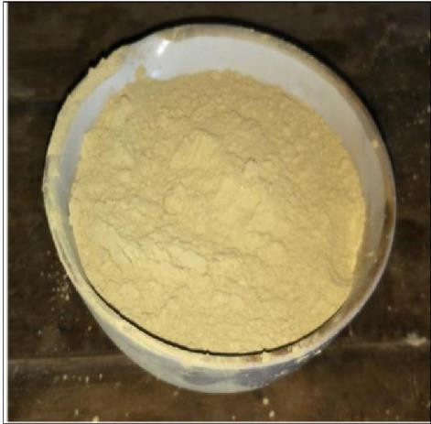
Figure 2.1.

Figure 2.1 A photograph of jarosite

On the basis of American Society for Testing and Materials (ASTM) the jarosite texture was found as silty, clayey loam and is yellowish-brown in color (Figure 2.1). The particle size distribution was conducted in accordance with ASTM D6913-04 (sieve analysis)
[54] and ASTM D422-63 (hydrometer analysis) and presented in Figure 2.2. [55]. The consistency limits such as liquid limit, plastic limit, and plasticity index of jarosite were determined as per ASTM D4318-10 [56
Properties
Geotechnical | Values | Chemical compositions | Values (%)
Liquid limit (%) | 54 | Silica (SiO2) | 7.73
Plastic limit (%) | 32 | Alumina (Al2O3) | 8.98
Geotechnical | Values | Chemical compositions | Values (%)
Plasticity index (%) | 22 | Calcium oxide (CaO) | 4.92
Specific gravity | 2.77 | Iron oxide (Fe2O3) | 32.11
Silt size (%) | 85 | Potassium oxide (K2O) | 0.76
Clay size (%) | 15 | Magnesium oxide (MgO) | 1.80
Maximum dry density (Mg/m³) | 1.13 | Zinc oxide (ZnO) | 9.07
Optimum moisture content (%) | 42 | Total sulfur (SO3) | 31.80
Hydraulic conductivity (cm/sec) | 1.75*10⁻³ | Lead oxide (PbO) | 1.91
Texture | Clayey silt | Sodium oxide (Na2O) | 0.63
pH | 6.87 | Sodium oxide (Na2O) | 0.63
Differential free swell Index (%) | 18 | Sodium oxide (Na2O) | 0.63

Ground granulated blast furnace slag (GGBS)
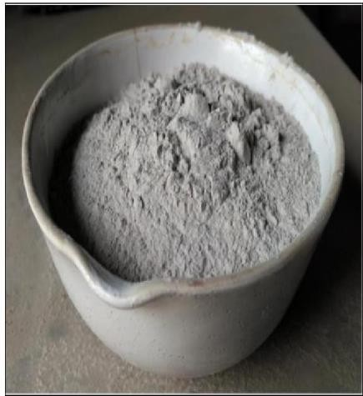
Ground granulated blast furnace slag (GGBS) is a derivative of the iron manufacturing. In this study, the GGBS (specific gravity of 2.73) is obtained from Krishna Udyog, Burdwan, West Bengal, India (Figure 2.3). The particle size distribution chart and chemical composition of GGBS are presented in Figure 2.2 and Table 2.2 respectively.

Figure 2.3 A photograph of ground granulated blast furnace slag Table Chemical properties of GGBS
Chemical Composition | Value (%)
Silica (SiO2) | 34.17
Alumina (Al2O3) | 18.36
Calcium oxide (CaO) | 33.78
Iron oxide (Fe2O3) | 0.80
Magnesium oxide (MgO) | 8.82
Total sulfur (SO3) | 2.91

Hydrated lime
The hydrated lime [Ca(OH)2], used as a cementitious material in the study, was obtained commercially. The specific gravity was found to be 2.48. Hydrated lime is derived from quicklime by reacting with water. Hydrated lime is mostly used in the stabilization applications. The photograph of lime is shown in Figure 2.4 and the chemical composition is presented in Table 2.3.

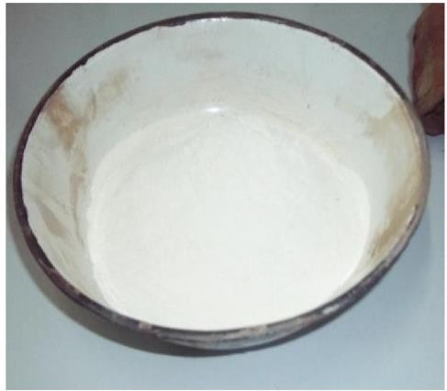

Figure 2.4 A photograph of hydrated lime p Table 2.3 Chemical properties of hydrated lime
Chemical Composition | Value (%)
Silica (SiO2) | 4.29
Alumina (Al2O3) | 1.48
Calcium oxide (CaO) | 71.46
Iron oxide (Fe2O3) | 0.27
Magnesium oxide (MgO) | 15.48
Total sulfer (SO3) | 4.56
Lead oxide (PbO) | 0.47
Sodium oxide (Na2O) | 0.03

3Testing Methodology
A number of laboratory studies namely Strength (Unconfined compressive and Split tensile strength tests), Durability (Freezing-Thawing study), Mineralogical and Morphological (X-Ray Diffraction (XRD) & Scanning electron microscope (SEM) corresponding to Energy-dispersive X-ray spectroscopy (EDX) tests) and Leachate have been carried out on jarosite waste stabilized with GGBS and lime. The objective of the present study is to find out the influence of pozzolanic material (GGBS) and an activator (hydrated lime) on the characteristics of stabilized jarosite to be used as a constructional material in Civil Engineering. The GGBS has been added at a rate of 10, 20, 30 and 40% by weight of dry jarosite. For all the compositions of the jarosite-GGBS mixture, the lime content varies as 2.5, 5.0, 7.5 and 10% by weight of jarosite. Jarosite brought from the zinc industry was firstly dried in an oven for 24h at 105 °C, and after that was grinded to break all lumps. Figure 2.5 illustrate the flow diagram of testing methodology adopted.

Untrated Jarosite waste

In untreated jarosite GGBS blanded at a rate of 10, 20, 30 and 40% by weight of dry jarosite and the proportions of GGBS selected based on the highest Maximum dry density obtained from compaction test.
After selection of an appropriate proportion of GGBS, the jarosite- GGBS blends was further mixed with hydrated lime varies at 2.5, 5.0, 7.5 and 10%
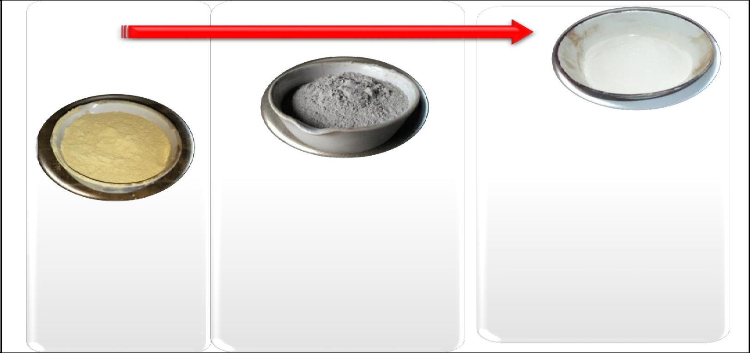
by weight of dry jarosite and by use of compaction parameters (MDD & OMC) for performing all the tests.

Figure 2.5 Flow diagram illustrates the methodology adopted

MANUFACTURINGPROCESS

To prepare the samples of jarosite-lime or jarosite-GGBS-lime blends for various tests, firstly, the compaction tests were conducted to find out the compaction parameters (maximum dry density (MDD) and optimum moisture content (OMC)) of all the blends. Afterward, all the samples were compacted at MDD and OMC, and respective studies were performed.

RESULTS AND DISCUSSION

This chapter describes the experimental studies conducted in laboratory along with their results and discussions. The experimental studies includes, Compaction (Mini compaction mold), Strength (Unconfined compressive and Split tensile strength tests), Durability (Freezing-Thawing study), Mineralogical and Morphological (XRD & SEMEDX tests) and Leachate (TCLP-ICP) have been carried out on jarosite waste stabilized with GGBS and lime.

Compaction Study

In the methodology section discussed in Chapter 2, The Mini Compaction Mould, advanced by Sridharan and Sivapullaiah [60], was used for evaluation of compaction parameters such as Maximum dry density (MDD) and Optimum moisture content (OMC).

Effect of GGBS on compaction parameters
The variations in the moisture content and dry density of jarosite blended with varying percentage of ground granulated blast furnace slag (GGBS) (10, 20, 30 and 40% by weight of dry jarosite) are shown in Figure 3.1 (a). It was observed that the MDD and OMC of the jarosite were 1.13 Mg/m³ and 42% respectively, which changed after blending with GGBS and a decrease in the OMC and an increase in the MDD were observed with up to 30% GGBS.

With further increase in GGBS content (40%), an increase in the OMC and a decrease

in the MDD were observed. The variations in the MDD and OMC of jarosite blended with varying percentage of GGBS are shown in Figure 3.1 (b).

Effect of lime and GGBS on compaction parameter

All the jarosite-GGBS mixtures with different GGBS content were further blended with varying percentage of hydrated lime i.e., 2.5, 5.0, 7.5 and 10%. The minimum lime percentage required for jarosite stabilization was 2.5% and was determined by using Eades and Grim test method (ASTM C977-18 [82a]), whereas, 5, 7.5 and 10% of lime content were also used, based on the international experiences with soil-lime stabilization [82b]. The variations in the OMC and MDD for various blends of jarosite, lime and GGBS are shown in Figures 3.2 to 3.5 and it is observed that after addition of lime in GGBS amended jarosite, an increase in the OMC and a decrease in the MDD was observed. This happened due to the lower specific gravity of lime compared with jarosite and GGBS, hence, higher moisture content is required to lubricate the particles of the composite mix to attain its MDD and OMC. Furthermore, the higher percentage of moisture content helped in acceleration of the pozzolanic reactions (more agglomeration formed); thus, adding of hydrated lime (active calcium) with GGBS (active siliceous)

Effect of the GGBS on jarosite-GGBS mixture

A series of Unconfined Compressive Strength (qu) and split tensile strength (qt) tests were carried out on jarosite-GGBS mixtures to study the influence of GGBS on the strength characteristics for different curing period, and the outcomes are presented in Figure 3.6. It is observed from Figure 3.6 that both the strength characteristics of jarosite (UCS (qu) and split tensile strength (qt)) increase with the increase in GGBS content up to 30%. By further adding of GGBS, i.e. 40%, a significant reduction occurs in both, UCS (qu) and split tensile strength (qt). The variations observed in strength characteristics are due to increase in pozzolanic content (GGBS) and alteration in the mechanical properties of the GGBS mixtures (compaction parameters).

From Table 3.1, it is also justified that with the increase in GGBS content, the compaction parameters (MDD and OMC) are observed to vary. With up to 30% GGBS, the MDD increases and the OMC reduces as compared to jarosite alone, which is possibly the reason for the improvement in the strength characteristics because of mechanical alternation in the particles of GGBS and jarosite. However, at 40% GGBS, it is observed that the MDD decreases and the OMC increases. Hence, the strength also reduces. It is also clear from Figure 3.6 that with an increase in curing period such as 7, 28, 60 and 90 days, the strength also increases because the pozzolanic material (GGBS) has self.
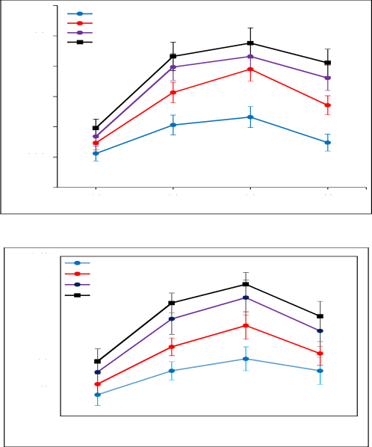

Conclusion

In the universe, nothing is completely waste; whether it is above or below the earth surface. For saving the energy, economy and environment, the potential to reduce, reuse, recycle and reclaim of wastes becomes a global environmental concern. There should be an urgent need to take proper attempt to convert the WASTE into WEALTH, otherwise the nature possibly will convert the WEALTH into WASTE. Thus there is an urgent need to conduct extensive research and development work for optimizing the usage of current technology and exploring novel applications for a sustainable waste management with social and economic benefits. Stabilization of any waste is a process in which an additive/reagent is employed to reduce the toxic nature by changing its toxic constituents into a more stable form to diminish the contaminant migration rate, thus reduce the level of toxicity. In this study, hazardous jarosite waste is treated with different percentage of GGBS and lime, on that stabilized jarosite is suitable to be used in various applications in eco-friendly manner. Based upon this study the following conclusions are drawn:

  - The unconfined compressive strength and split tensile strength both were increases significantly with an increase in GGBS and lime content along with curing period respectively.
  - The unconfined compressive strength (UCS) ≈ 11 Mpa and split tensile strength ≈ 680 kPa were observed at 90 days curing with 30% GGBS and 10% lime content.

  - Satisfactory durability characteristic of stabilized jarosite (Freeze-Thaw) was observed with very small loss in strength and weight i.e. UCS strength loss ≈ 14.20% and weight loss ≈ 6.20% at 28 days curing with 30% GGBS and 10% lime content.
SEM and XRD results also demonstrate the development of particles agglomeration upon addition of GGBS and lime leading to increase in strengths (compressive and tensile) and development of a durable product
    - Before and after the durability study, the stabilized jarosite has acceptable TCLP characteristic. The, heavy metals and toxic elements present in the hazardous jarosite got immobilized and observed within the permissible limits as suggested by the USEPA.
    - Relationships between UCS (qu) or split tensile strength (qt) with various GGBS content (G), lime content (L) and curing period (t) have been proposed, which will help the engineer or user to choose the optimum amount of GGBS and lime against targeted compressive or tensile strength of jarosite-GGBS-lime blends.
    - A unique scalar ratio, qt/qu (independent of lime content, GGBS and curing period) has been formulated that will enhance the possibility to concentrate on any one strength, tensile or compressive, and estimate the other one.
    - Jarosite stabilized with 30% GGBS and 10% lime has satisfactory strength to be used in sub base or subgrade, and base course for both types of pavement.

    - A solidified, durable, immobilized, economical brick has been developed which fulfills the requirement of minimum compressive strength (> 3.5 MPa) and water absorption limits (< 20%) as per Indian Standards for unfired bricks (IS 12894- 2002).
Thus, the present investigation contributes in the making of stabilized jarosite material (cement free), which is sufficiently durable, stronger, immobilized (heavy and toxic metals), and cheaper from the conventional material. This is also cheaper than the existing knowhow in literature (jarofix). Furthermore, this novel stabilized material is practically viable, i.e. can be used in various applications of civil engineering

Limitation of Present Study and Scope for Future Work

In the current study of jarosite waste, it is observed that the safe management of hazardous zinc residual waste with incorporation of other wastes additives to prevent the environmental pollution is feasible.
However, the present study is limited to laboratory only and it will be prime need to cross check these laboratory parameters with field conditions.
The extensive generation of jarosite waste in the process of industrial production of zinc is a universal problem. From current research scenario on jarosite, it is observed that the seriousness in bulk consumption and utilization of jarosite waste is still insufficient. The solidification/stabilization (S/S) of jarosite is an auspicious method in which the addition of a binding agent encapsulates and diminishes the mobility of heavy and toxic waste elements. The long term binding of such toxic elements reduces the permeability and contamination leaching rate, thus potentially allows the safe land disposal of waste. The scope of present study for future work is summarized as follow:
- Further research on the utilization of various waste materials along with jarosite and their viability in perspective of long-term durability, strength and environmental impact of stabilized/solidified jarosite composite.

