# DOCUMENT VERIFICATION

Mrs. T Esther & K.Deepika Rani & M.Abisornam & S. Deepika

Mrs. T Esther [esthernoah33@gmail.com](mailto:esthernoah33@gmail.com)

K.Deepika Rani

Deepikaranideeepika4@gmail,com

M.Abisornam [abisornam16@gmail.com](mailto:abisornam16@gmail.com)

S.Deepika selvarajdeepika20@gmail.com

Sri Shakthi Institute of Engineering and Technology, Coimbatore.

Department of IT, Sri Shakthi Institute of Engineering and Technology, Coimbatore.

## Abstract:

## Document forgery and manual verification delays are critical challenges in sectors like education, employment, and governance in India. To overcome these, a digital Document Verification System has been developed, offering a secure, automated, and efficient way to validate identity and official documents. The system uses Optical Character Recognition (OCR) to extract text from uploaded images or scanned files and verifies it against predefined patterns or databases. Built with Node.js for backend logic and HTML/CSS for an accessible frontend, the platform supports seamless document uploads, real-time processing, and feedback generation. It enables institutions, HR departments, and public services to detect tampered or invalid documents quickly. The platform provides a role-based login system for students, employees, and verification officials. Key features include discrepancy highlighting, validation status tracking, and audit history. Users receive prompt feedback on whether documents are authentic, require resubmission, or need manual review. This initiative reduces fraud, increases transparency, and simplifies verification workflows. By integrating intelligent automation and secure data handling, the system enhances compliance, saves time, and supports trustworthy decision-making in high-stakes documentation processes.

## Keywords:

OCR, Automated Verification, Document Forgery Detection, Real-Time Text Extraction, Validation Tracking, Discrepancy Highlighting, Secure Upload, Role-Based Access, Fraud Prevention, Authentication, Compliance, Audit Logs, Scalable System, Node.js Backend, HTML/CSS Frontend.

## Introduction:

**" Every vindicated document is a step toward trust and translucency. Streamlining document verification is not just about authentication; it's about empowering individualities and institutions to move forward with confidence and security."**

Ensuring dependable document verification is essential for erecting a secure digital ecosystem, where individuals can access services, rights, and opportunities without gratuitous walls. In numerous regions, the lack of secure and effective verification processes leads to detainments, fraud, and inequality, particularly affecting those from underrepresented or underserved communities. Addressing these challenges is pivotal for fostering a more inclusive and dependable society. This action introduces a robust Document Verification Platform designed to simplify and secure the authentication process. At its core, the system leverages advanced technologies like OCR( Optical Character Recognition) and pattern recognition to validate crucial identification documents, including Voter IDs, Driving Licenses, and Portion Cards. The platform cross-verifies critical fields, such as name, date of birth, and print placement, to ensure authenticity and reduce the threat of phony. To support this, a secure stoner authentication module ensures that only vindicated druggies can pierce or upload sensitive documents. The platform also provides real-time verification analytics, enabling institutions and agencies to cover and act upon document fraud or mismatches immediately. With easy sign- up and login capabilities, the system remains intuitive for both tech- expertise and first- time druggies. The result is also equipped with a stoner dashboard where individuals can track the status of their document verification, admit instant cautions, and get guidance for resubmission if required. For directors, the system offers detailed perceptivity and logs, perfecting translucency and responsibility. By partnering with government agencies, NGOs, and private institutions, the design extends its reach to ensure that remote or marginalized communities profit from secure document confirmation. In doing so, it builds a foundation of trust, enabling better access to education, healthcare, employment, and social services. Through this action, every vindicated document becomes part of a broader charge to ensure fairness, translucency, and accountability in an increasingly digital world.

# DOCUMENT VERIFICATION (outline)

**Sign in page**

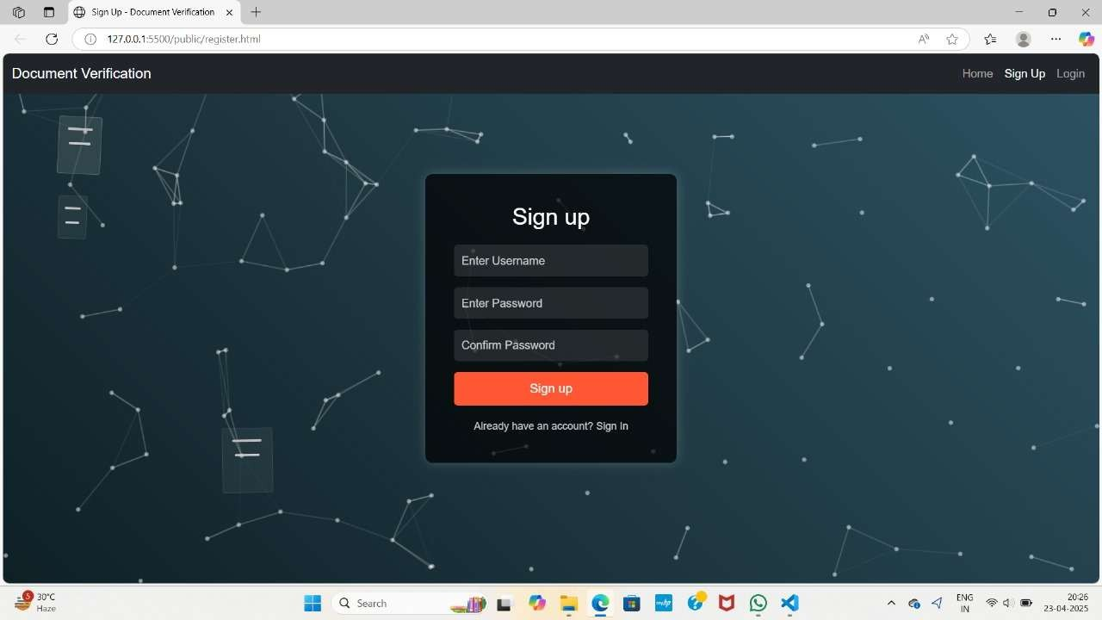

**Home Page**

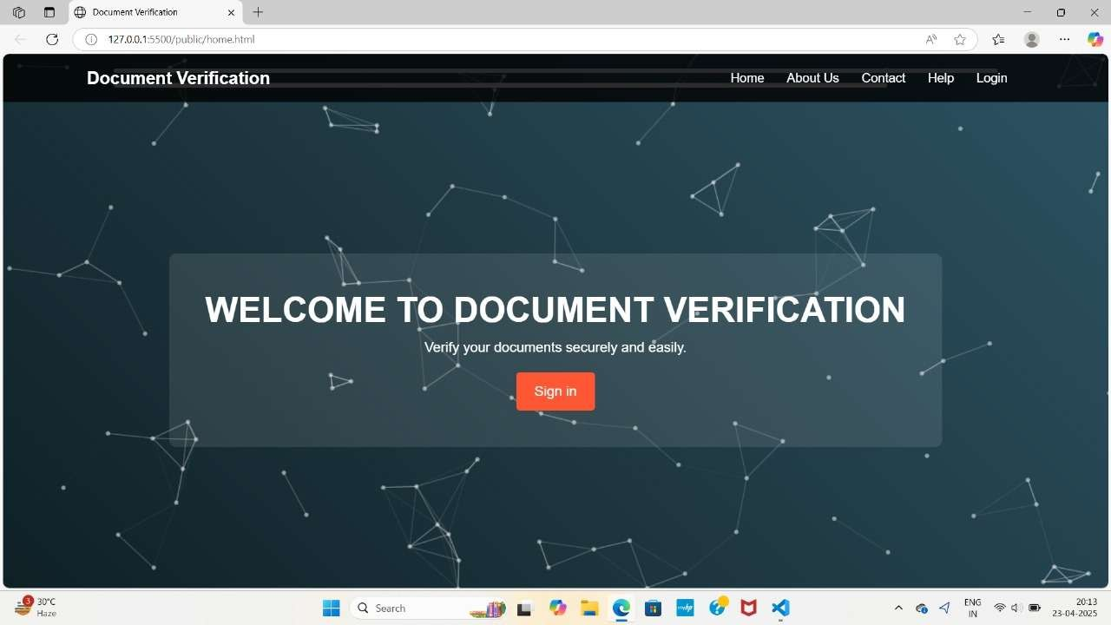

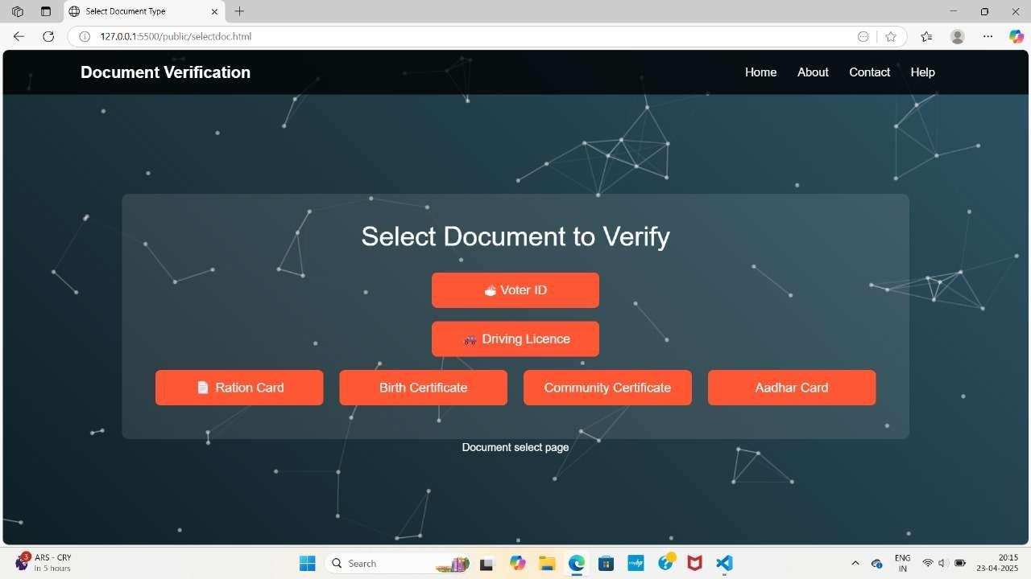**Selecting Document Type**

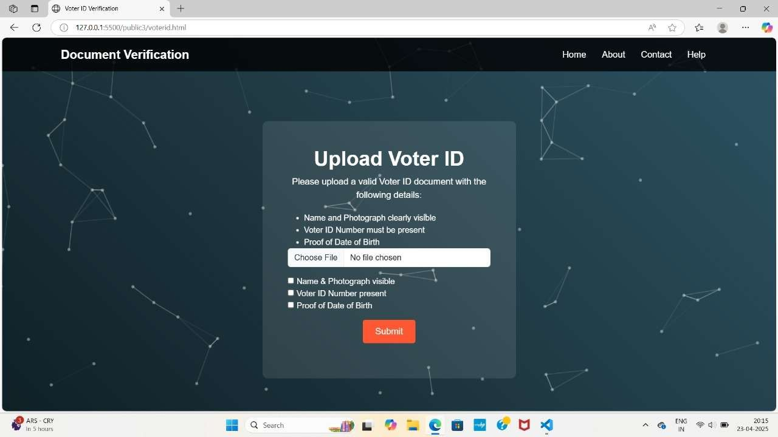**Uploading the voter ID page**

#### **Driving Lic****ence page**

#### **Upload Ration Card Page**

#### 

#### 

#### **Community Certificate Verification**

**Birth Certificate Verification**

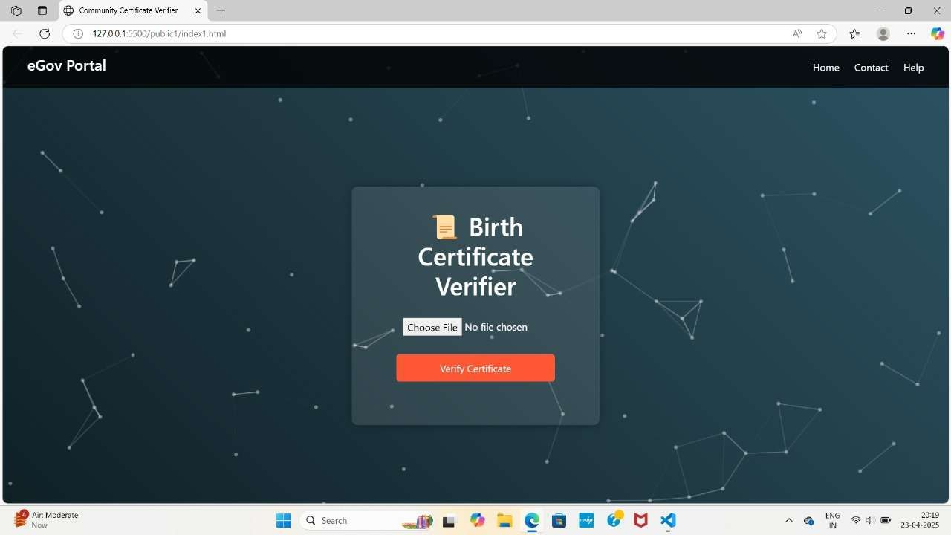

#### 

**Aadhar card verification**

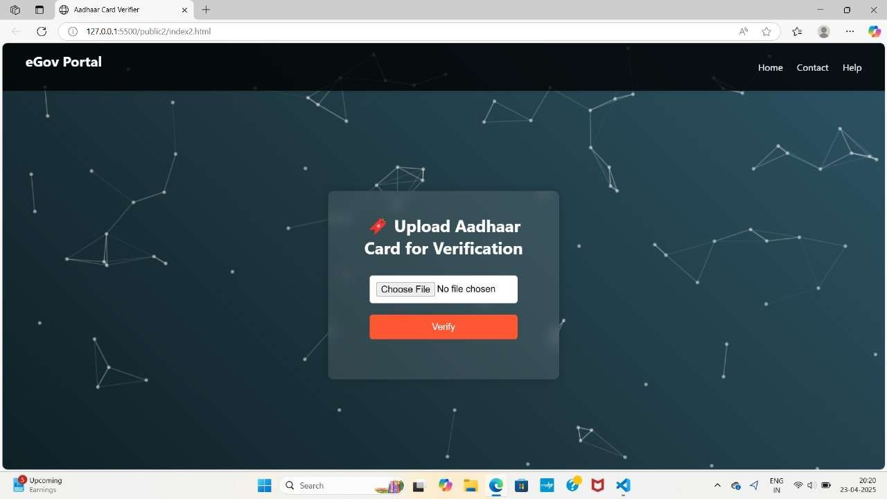

**Proposed Method**

1. Secure Document Upload and Storage The system enables users to upload essential identification documents—such as Voter IDs, Driving Licenses, and Ration Cards—through a secure, encrypted channel. Uploaded files are stored safely in a protected database, reducing the risk of data breaches and unauthorized access. This step ensures that sensitive documents are handled with the highest standards of security and privacy.
2. Automated Document Verification Using OCR and Regex Patterns The platform utilizes Optical Character Recognition (OCR) to extract key data such as name, date of birth, and address from uploaded documents. Using regular expressions (regex), the system matches extracted fields against predefined patterns to validate document authenticity. For example, it checks for correct photo placement, format compliance, and consistent personal data across uploaded files.
3. Real-Time Validation Reports The system provides instant feedback on the status of document verification. If a document passes all checks, it is marked as "Valid." If mismatches or formatting issues are detected, it returns a "Verification Failed" status with specific reasons, allowing users to take corrective actions immediately. These real-time insights improve transparency and user confidence in the verification process.
4. User Authentication and Access Control To prevent misuse and ensure privacy, the platform includes a secure login/sign-up process using email and password with bcrypt encryption. Role-based access control differentiates between students, administrators, and reviewers, ensuring that users only access information and actions relevant to their role.
5. Analytics Dashboard for Admin and Reviewers The admin panel features real-time analytics displaying document verification trends, common failure reasons, and success rates. This helps institutions or organizations identify patterns, optimize their document requirements, and provide better guidance to users for successful submissions.
6. NGO and Government Collaboration The system allows verified data to be securely shared with authorized NGOs and government agencies that provide welfare services. For instance, if a student submits a valid ration card and falls into an at-risk category, NGOs can be notified (with consent) for potential support or scholarship opportunities.
7. User Notification and Guidance System Users receive automated alerts regarding the status of their documents—whether verified, under review, or needing resubmission. Step-by-step guidance is provided to help users understand why a document failed verification and how to correct it, ensuring inclusivity even for first-time or low-literacy users.

8. Mobile-Responsive Interface and Accessibility To ensure ease of use for all users, especially in underserved areas, the platform is mobile-friendly and supports multilingual interfaces. This ensures that individuals can verify documents anytime, anywhere, using their smartphones .

# Results and Discussion

The implementation of the document verification system has yielded significant positive outcomes in enhancing the security, accessibility, and efficiency of identity validation processes. The platform’s integration of Optical Character Recognition (OCR) and regex-based pattern matching has proven highly effective in verifying key fields such as name, date of birth, and photo position. This automation has greatly reduced the time required for manual verification and has minimized human error, resulting in faster and more accurate validation of documents. As a result, users—especially students applying for scholarships, benefits, or admissions—have been able to access services without delay or unnecessary administrative hurdles.

The secure upload feature, backed by encrypted storage and role-based access control, has ensured user data privacy and system integrity. This has built trust among users, encouraging wider adoption of the platform. The user-friendly login and authentication process using email and password encryption (bcrypt) has further enhanced the platform’s reliability and accessibility, even for individuals with limited technical experience.

The real-time validation reports and analytics dashboard have enabled administrators to track common verification issues and take corrective actions proactively. These insights have been critical in identifying systemic documentation errors and adjusting guidelines accordingly, thereby reducing the frequency of rejections. Additionally, the system’s ability to alert users about failed verifications and guide them through the resubmission process has empowered individuals to correct their mistakes independently, leading to a higher rate of successful verifications on subsequent attempts. Collaboration with NGOs and government agencies has expanded the system's impact, particularly among underserved populations. Verified user data can be shared securely, with consent, for facilitating support services such as educational grants, employment opportunities, or welfare schemes. This targeted intervention has proven vital in ensuring that assistance reaches those who genuinely qualify, streamlining processes and reducing fraud.

Moreover, the multilingual, mobile-responsive interface has increased accessibility for users in rural and remote areas, where access to desktop systems may be limited. This inclusive design has played a key role in bridging the digital divide and enabling broader participation in document-based services.

Overall, the comprehensive document verification solution has not only improved operational efficiency but has also contributed to building a more transparent and accountable ecosystem. By automating verification, providing real-time feedback, and collaborating with support organizations, the system has laid the foundation for scalable, secure, and inclusive identity management. These advancements collectively support a future where every individual can confidently access the rights and services they are entitled to—free from the barriers of outdated, manual verification systems.

# Conclusion and Future Enhancements

The Document Verification System initiative has successfully introduced a secure, scalable, and user-friendly platform that addresses key challenges in identity validation. By integrating OCR technology, regex-based pattern matching, and real-time feedback mechanisms, the system ensures accurate, fast, and consistent verification of essential documents such as voter IDs, ration cards, and driver’s licenses. These technological enhancements have streamlined the verification process, significantly reducing manual errors and processing time while improving accessibility for users across diverse socioeconomic backgrounds.

The collaboration with NGOs and governmental bodies has extended the system’s reach to underserved communities, enabling students and other users to access critical services such as educational admissions, welfare programs, and financial aid without the hindrance of documentation delays. The seamless upload process, encrypted data handling, and secure authentication protocols have built a foundation of trust and efficiency that encourages wider adoption. Parent and student engagement through real-time status updates and guidance has further empowered users to take charge of their verification processes, leading to higher success rates in resubmission and reduced dropout from digital services due to verification failures.

Additionally, the system's intuitive dashboard and analytics capabilities have enabled administrators to identify trends, such as frequently failing verification fields or regions with higher rejection rates. This has guided improvements in document design awareness and support outreach, creating a more informed and inclusive verification ecosystem.

Looking forward, the platform can be further strengthened by integrating AI-powered validation models that not only detect document authenticity with higher precision but also identify fraudulent patterns in real-time. Expanding multilingual support and voice-based navigation features can further improve accessibility, especially in rural and semi-literate communities. Collaborations with more NGOs and service organizations can enable seamless document validation tied to educational admissions, scholarship eligibility, and social benefits, allowing for a more holistic impact.

Moreover, introducing blockchain-based document storage and verification logs could add a new layer of transparency and immutability, fostering trust in institutional processes. Virtual help centers or chatbots powered by natural language processing could also assist users in navigating the verification journey without requiring human intervention at every step.

The Document Verification System has already demonstrated strong potential in transforming how documents are processed, verified, and secured. By continuing to evolve with user needs and emerging technologies, the platform can play a vital role in enabling equitable access to essential services and building a digital infrastructure that upholds transparency, efficiency, and inclusion.

# Future Scope

The Document Verification System presents significant future potential in transforming how digital identity and verification are handled across multiple sectors, including education, e-governance, banking, and social welfare services. Building on its current capabilities, the system can be enhanced through the following innovative strategies:

**AI-Based Document Analysis:** Integrate advanced AI models to automatically detect forgery, enhance text recognition under poor lighting or skewed angles, and ensure more accurate and real-time document validation.

**Blockchain Integration:** Utilize blockchain technology for secure, tamper-proof verification records. This will ensure that once verified, a document’s status is immutable and transparently recorded.

**Multi-Language and Voice Assistance:** Support for regional languages and voice navigation will expand accessibility, especially for users from rural and semi-literate backgrounds.

**Predictive Validation Engine:** Employ machine learning algorithms to predict verification failures based on past data, allowing preemptive alerts and corrective guidance before final submission.

**Integration with Government and Institutional APIs:** Enable direct validation with official government databases (e.g., voter list, RTO, ration card database), reducing manual cross-checks and delays.

**Mobile App Expansion:** Launch a mobile-first version or app with camera-integrated scanning, progress tracking, and push notifications to improve convenience and responsiveness.

**Adaptive User Interface (UI):** Develop a user interface that adjusts based on user behavior and document type, streamlining the upload and validation process.

**Smart Feedback Mechanism:** Introduce contextual help, real-time guidance, and visual cues to assist users during upload, reducing errors and improving success rates.

**User Trust and Security Features:** Implement biometric login, OTP verification, and encrypted document storage to strengthen security and user trust.

**Audit Logs and Admin Analytics:** Provide a backend panel for administrators and NGOs to view verification trends, common errors, and demographic insights for better outreach and improvement.

By embracing these future directions, the Document Verification System can evolve into a robust, intelligent platform that not only simplifies document handling but also empowers users with greater transparency, security, and accessibility. These enhancements will further reduce friction in accessing education, government services, and aid programs—particularly for marginalized and underprivileged populations.

## REFERENCES

[1] "Document Verification and Validation: Theory and Practice" by Michael Gertz[2] "IEEE Transactions on Information Forensics and Security", ISSN: 1556-6013[3] "Identity Management: A Primer" by Elisa Bertino & Kenji Takahashi[4] "Introduction to Digital Signature and Verification" by Xiaoyun Wang & Hongbo Yu[5]"Practical Cryptography for Developers" by Svetlin Nakov[6] "What Works for Document Authentication: A Critical Review" by P. Samarati & L. V. Mancini[7] "Why Is My Identity At Risk?: Understanding Data Breaches" by Laura Brandimarte[8] "Blockchain and the Law: The Rule of Code" by Primavera De Filippi & Aaron Wright[9] "Electronic Signatures for Document Security" by Anne C. Maher[10] "Digital Identity: The New Currency" by Phillip J. Windley[11] "Secure Electronic Document Management" by David F. Bauer[12] "Introduction to Public Key Infrastructure (PKI)" by Carlisle Adams & Steve Lloyd[13] "The Future of Identity Verification: Trends and Challenges" by Matthew Johnson[14] "The Verified Self: Digital Identity in a Connected World" by L. Jean Camp[15] "Cybersecurity and Document Integrity" by Pankaj Goyal[16] "Data Breaches: Crisis and Opportunity" by Sherri Davidoff[17] "Privacy by Design: The Definitive Guide" by Ann Cavoukian[18] "Digital Forensics for Legal Professionals" by Larry Daniel & Lars Daniel[19] "Smart Contracts and Digital Verification" by Kevin Werbach[20] "Are Your Documents Safe?: Protecting Digital Information" by Kate Parker[21] "Maybe You Should Encrypt It: Data Security for Everyone" by Alex Biryukov