A STUDY ON INTEGRATING AYURVEDHIC MEDICINES IN CANCER TREATMENT
PRACTICE SCHOOL SUBMITTED TO
THE JAWAHARLAL NEHRUTECHNOLOGICAL UNIVERSITY ANANTAPURAM
ANDHRA PRADESH.

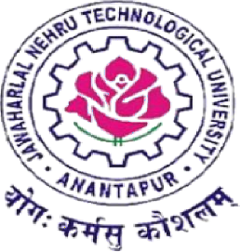

SUBMITTED BY T.MANOJ (21ER1R00B0)
Under the Supervision of
Mr. DORNALA CHAITHANYA DIXIT, M.pharm,(Ph.D),
Associate professor, Department of Pharmacy practice,


Dr.K.V. SUBBA REDDY INSTITUTE OF PHARMACY NAACA+
DUPADU, KURNOOL 518001, A.P.
NOVEMBER -2024


CERTIFICATE BY SUPERVISOR
This is to certify that the work contained in this practice school report entitled "Integrating ayurvedic medicine system into cancer treatment" submitted by T.Manoj (Regd. No.: 21ER1R00B0) for the award of the degree of Bachelor of pharmacy to the Dr. K. V. Subba Reddy Institute of Pharmacy, is a record of Bonafide research works carried out by me under my direct supervision and guidance.
I considered that the work has reached the standards and fulfilling the requirements of the rules and regulations relating to the nature of the degree. The contents embodied in the thesis have not been submitted for the award of any other degree or diploma in this or any other university

DATE:

Place:

Signature of the supervisor:
CERTIFICATE BY HEAD OF THE INSTITUTE
This is to certify that the dissertation entitled "Integrating ayurvedic medicine in cancer treatment" was done for the partial fulfilment for the award of degree of bachelor of pharmacy has been carried out by T.Manoj (Regd. No: 21ER1R00B0) under the guidance and supervision of Mr. Dornala Chaithanya Dixit, M.Pharm.(Ph.D),(Department of Pharmacy Practice) at Dr.
K. V. Subba Reddy Institute of Pharmacy, Dupadu, Kurnool, during the period of 2024-2025. It is further certified that this work or any part of this has not been submitted in part or full for the award of any degree or fellowship.

DATE:
PLACE:

Signature of the Principal :
ACKNOWLEDGEMENT
I would like to extend my heartfelt gratitude to all those who have contributed to the completion of this review article. I am immensely grateful to Mr.Dornala Chaithanya Dixit, M.Pharm,(Ph.D), for his guidance, invaluable insights, and constructive feedback throughout the review and writing process. His expertise and encouragement have been crucial in shaping this work.
I am especially grateful for his patience and willingness to guide me at each step, whether it was in the formulation of ideas, selection of relevant literature, or refining the final drafts.Mr.Dornala Chaithanya Dixit, M.Pharm,(Ph.D), has always been generous with his time, offering guidance and support despite his numerous commitments, and his unwavering belief in my potential gave me the confidence to pursue this work diligently.
I would also like to express my appreciation to Dr. K.V. SUBBA REDDY INSTITUTE of pharmacy for providing the facilities, resources, and intellectual environment that made this study possible. Special thanks to Dr.B.V.Ramana, Principal, for his support, thoughtful discussions, and technical assistance that have greatly enriched the depth and scope of this review.
Furthermore, I acknowledge the contributions of authors of the studies reviewed in this article, whose pioneering work has paved the way for our understanding of (Integrating ayurvedic medicinal system into cancer treatment)Their dedication and innovation are truly inspiring and have provided a solid foundation for this comprehensive analysis.
Abstract:- A major global health concern that causes severe sickness in many people is cancer. Cancer kills 1 in 8 men and 1 in 11 women. Benign and malignant cancers are classified according to the type of tissue or cell they arise from. It is addressed how oncogenes and tumour suppressor genes contribute to the genesis of cancer. Radiation, hormone therapy, gene therapy, and stem cell transplantation are among the many treatment possibilities that are discussed.
Ayurveda, a traditional Indian system, highlighting its basic ideas. By fostering mental, spiritual, and bodily well-being, these Ayurvedic ideas make it possible to maintain balanced health.
Knowing the fundamentals of Ayurveda can help one develop complementary cancer treatment methods. Ayurvedic medicine integration into cancer treatment is a creative strategy that makes use of natural sources, particularly plants, to combat cancer. Plants like curcumin, ashwagandha, guggul, guduchi, and triphala have demonstrated anti-proliferative and anti-inflammatory
activities, enhancing chemotherapy efficacy. Several Ayurvedic centers have conducted clinical trials (Phase I and II), showing promising results against cancer. Although the FDA has not approved Ayurvedic drugs due to, Insufficient clinical trials Limited understanding of active
ingredients and mechanisms Some Ayurvedic herbal supplements have received FDA recognition as "Generally Recognized as Safe" (GRAS). By conducting rigorous clinical trials and establishing clear guidelines for ayurvedhic Integration into conventional cancer care, we can
develop effective, natural cancer treatment.

Key words:- cancer, ayurvedha,benigne,malignant, oncogenes, tumor suppressor gene, hormone therapy,stem cell transplantation, ayurvedhic centers, integrating, ashwagandha, curcumin, triphala, guggul,guduchi,FDA,GRAS.

Table of content

Sl.no | Content | Pg.no
1. | Introduction
 | Introduction to cancer. | 8- 16
 | Introduction to ayurvedha. | 17-22
2. | Methadology | 23- 29
3. | Conclusions | 30
4. | Limitations | 31-32
5. | Bibliography | 33- 37
6. | Future recommendations | 38-39

List of abbreviations:-

Abbreviations | Description
1.FDA | Food And Drug Administration
2.GRAS | Generally Recognised As Safe

List of tables
Tables | Page no
1.Types of cancer treatment in allopathy. | 10-11
2. List of ayurvedic medicines in cancer treatment. | 19-23

List of Figures
Name of the figures | Page no
Figure 1:- Benign and malignant tumors. | 3
Figure 2:- Cell cycle of proto oncogene and tumor suppressor gene. | 6
Figure 3:- Panchamahabhuta | 13
Figure 4:- Three Doshas | 14
Figure 5:- The concept of Dhatu | 15
Figure 6:- The concept of Agni. | 16
Figure 7:- Prakriti and Vikriti | 17

Introduction
CANCER:-cancer is a group of diseases characterized by the uncontrolled proliferation of diseases of abnormal cells that possess the ability to invade surrounding tissue and metastasize to distant sites in the body. It results from genetic mutations that disrupt normal cellular processes, such as growth, division,and apoptosis (programmed cell death).cancer are typically classified based on the type cell or tissue from which they originate, and they can present as benign(noninvasive) or malignant (invasive) tumors, with malignant tumor being of greater clinical significance due to their potential for spread and harm.(¹). Classification:-
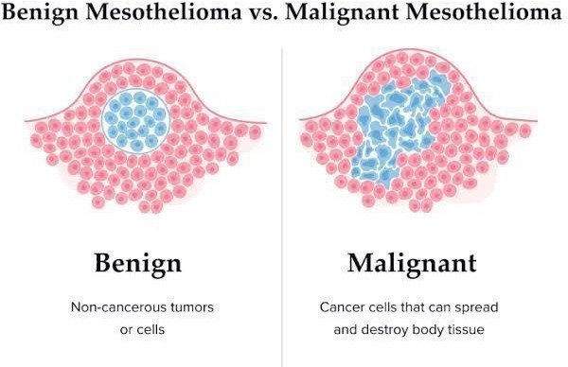

Figure-1 benign and malignant tumors
Benign tumors:- benign tumor are non-cancerous growths that arise from the abnormal proliferation of cells. Unlike malignant tumor,benign tumors do not invade surrounding tissue or metastasize (spread) to other parts of the body.(³).

Characteristics of benign tumor:-1.Growth rate:-Typically grow slowly compared to malignant tumors.Often well-defined and localised,making them easier to distinguish from surrounding tissues.
- structure:-Generally, have a uniform appearance and may resemble the normal tissue from which they originate. Encapsulated by a fibrous capsule, which separates them from surrounding tissues.
- Invasiveness:- do not invade adjacent tissues ,they expand and compress near by structures rather than infiltrate them. Rarely they can cause damage or distruction depending on their size and location.
- Metastasis:-Benign tumours do not spread to distant sites in the body, making them less dangerous than malignant tumours.

Types of benign tumors:-1.Lipomas:-Composed of fat cells, these soft, movable lumps often develop under the skin.(⁷).
- Adinomas:-Arise from glandular tissue and can occur in various organs, including the thyroid and pituitary glands.(⁶).
- Fibromas:-Formed from fibrous or connective tissue, these tumours can occur in various locations,including the skin and lungs.(⁵).
- Haemangiomas:-Composed of blood vessels, these vascular tumours commonly appear on the skin or liver.(⁴).
- Nevi(moles):-Clusters of pigmented cells on the skin that are generally harmless but can change overtime.(⁴).

Malignant tumours:-Malignant tumours are cancerous growths characterized by uncontrolled cell division and the ability to invade nearby tissues and spread to distant parts of the body through the bloodstream or lymphatic system.Unlike benign tumours,malignant tumours pose a significant health risk and can be life-threatening.(²).

Characteristics of malignant tumor:-
- Uncontrolled growth:-Malignant tumours exhibit rapid and disorganized growth due to mutations in the DNA of the affected cells. This uncontrolled proliferation leads to the formation of masses that can grow larger overtime.
- Invasiveness:-These tumours infiltrate surrounding tissues, making them difficult to remove completely. They can destroy normal tissues and disrupt the function of adjacent organs.
- metastasis:- A defining feature of malignant tumours is their ability to spread to distant sites in the body. Cancer cells can break away from the original tumour, travel through the bloodstream or lymphatic system, and establish new tumours in other organs (secondary tumours).
- Anaplasia:- Malignant tumours often show a lack of differentiation, meaning the cancer cells do not resemble normal cells from the tissue of origin.They may appear abnormal in size,shape, and organization.

Types of malignant tumours:-
- Carcinomas:-this tumors originated from epithelial cells and are the most common type of cancer.Examples include breast cancer,lung ,colorectal cancer.(⁸).
- Sarcomas:- Arising from connective tissues such as bone,muscle,and fat,sarcomas are less common than carcinomas.Examples include osteosarcoma( bone cancer) and liposarcoma( fat tissue cancer).(⁹).
- Leukaemias:-this cancer effects the blood and bone marrow,leading to the over production of abnormal white blood cells. Common types include acute lymphoblastic leukaemia (ALL) and chronic myeloid leukaemia(CML).(¹⁰).

- Lymphomas:-originating in the lymphatic system,lymphomas can be classified into Hodgkin lymphoma and non- Hodgkin lymphoma, each with distinct characteristics and treatment approaches.(¹¹).

- Melanomas:- these tumor's arise from melanocutes,the cells responsible for skin pigmentationMelanoma is particularly aggressive and has a higher tendency to metastasize compared to other skin cancers.(¹²).
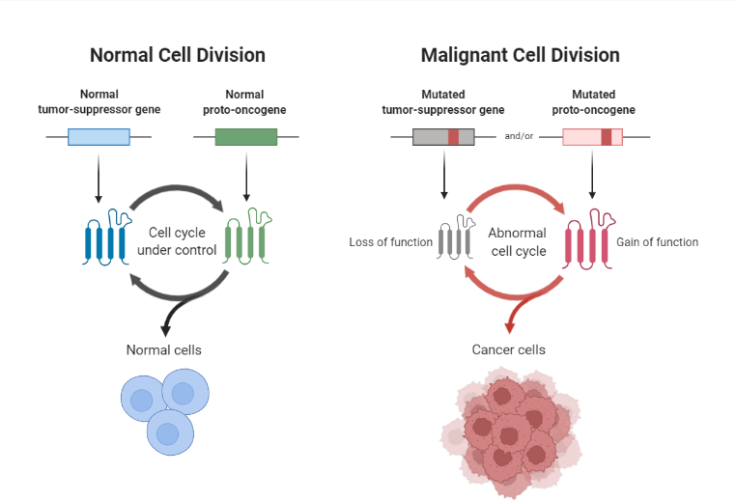

figure-2 cell cycle of proto oncogene and tumor suppressor gene

Mechanism of oncogenes:-Oncogenes are mutated forms of normal genes (known as
protooncogenes) that have the potential to cause cancer.These mutations can lead to uncontrolled cell growth and division, contributing to tumor formation.(¹³).
Characteristics of oncogenes:-
- roll in cell growth:- Oncogenes typically encode proteins that regulate cell growth, differentiation, and survival.When mutated, these proteins can become hyperactive or overexpressed, leading to unregulated cell proliferation.
- types of mutation :- Mutations in oncogenes can occur through various mechanisms, including point mutations, gene amplifications, chromosomal translocations, or insertions. Each of these mutations can alter the function of the proto- oncogene, leading to oncogenic properties.
- Dominant effect:-Oncogenes exert a dominant effect; that is, a mutation in just one allele of a proto-oncogene can drive cancer development. This is in contrast to tumor suppressor genes, where both alleles typically need to be inactivated for PCcancer to occur.

Common types of oncogenes:-
- Growth factor:- Some oncogenes code for growth factors that stimulate cell division. An example is platelet-derived growth factor (PDGF), which can promote tumor growth when overexpressed.
- Receptors:- Oncogenes can also encode receptor proteins that, when mutated, become constitutively active, driving continuous signaling for cell proliferation. An example is the epidermal growth factor receptor (EGFR), and( HER2). commonly implicated in various cancers, including lung cancer.(¹⁴).
- Signal Transduction Proteins:- Oncogenes like RAS and SRC are involved in transmitting signals from outside the cell to the nucleus, leading to cell division. Mutations in these genes can lead to persistent signaling, driving uncontrolled cell growth.(¹⁵).
- Nuclear Proteins:- Some oncogenes code for proteins that directly regulate gene expression. For instance, the MYC oncogene influences cell cycle progression and apoptosis.
Overexpression of MYC is associated with several cancers.(¹⁶).
Role in Cancer Development:-
- Transformation of Cells:- The activation of oncogenes can leaad to the transformation of normal cells into cancerous cells. This transformation is often a multi-step process, requiring additional mutations in other oncogenes or the inactivation of tumor suppressor genes.
- Tumor Progression:- Oncogenes play a critical role not only in the initiation of cancer but also in its progression and metastasis. As tumors grow and evolve, they can acquire additional mutations, leading to more aggressive forms of cancer.

Examples of Oncogenes:-
- KRAS: Frequently mutated in pancreatic, colorectal, and lung cancers, leading to uncontrolled cell growth.(¹⁷).
- HER2/neu: Associated with breast cancer, where its overexpression promotes aggressive tumor growth.(¹⁴).
- BCR-ABL: A fusion protein resulting from a translocation between chromosomes 9 and 22, commonly seen in chronic myelogenous leukemia (CML).(¹⁸).

Mechanism of tumor suppressor genes:- Tumor suppressor genes are a class of genes that regulate cell growth and division, preventing uncontrolled cell proliferation and tumor formation.When these genes are mutated or lost,they can no longer effectively perform their regulatory functions,leading to the development of cancer.(¹⁹).

Characteristics of Tumor Suppressor Genes:- 1.functions in cell cycle regulation:- Tumor suppressor genes play a crucial role in controlling the cell cycle. They produce proteins that can halt cell division in response to DNA damage or other cellular stressors,allowing for repair processes to occur before the cell progresses through the cycle.

- Recessive Action:- Unlike oncogenes, which are typically dominant (where a mutation in one allele can drive cancer), tumor suppressor genes usually require both alleles to be inactivated or mutated for tumorigenesis to occur. This means that an individual can inherit one mutated copy and still remain healthy, but the second copy must also be mutated for cancer to develop.
- Induction of apoptosis:- Many tumor suppressor genes are involved in the apoptotic pathways, promoting programmed cell death in response to cellular stress or damage. This process is essential for eliminating potentially cancerous cells.(²⁰).

Common Tumor Suppressor Genes:-
- TP53:- Also known as the " gardian of the genome," TP53 encoges the p53 protein,Which is pivotal in monitoring DNA integrity.It can induce cell cycle arrest, DNA repair ,or apoptosis in response to DNA damage.Mutations in TP53 are found in a wide range of cancer. (²²).
- BRCA1 and BRCA2:- These genes are crucial for DNA repair mechanisms,
specifically in repairing double-strand breaks. Mutations in BRCA1 and BRCA2 significantly increase the risk of breast and ovarian cancers, among others.(²³).
- APC (Adenomatous Polyposis Coli):- The APC gene is involved in the Wnt signaling pathway, which regulates cell proliferation and differentiation. Mutations in the APC gene are often associated with familial adenomatous polyposis (FAP) and colorectal cancer.(²⁴).
- PTEN (Phosphatase and Tensin Homolog):- PTEN acts as a lipid phosphatase and is a key regulator of the PI3K/Akt signaling pathway, which promotes cell survival and growth. Loss of PTEN function is implicated in various cancers, including prostate and endometrial cancers.(²⁵).

Examples of Tumor Suppressor Gene Action
- Cell Cycle Checkpoints:- Tumor suppressor proteins help maintain checkpoints in the cell cycle. They ensure that cells do not divide when DNA is damaged or when conditions are not suitable for growth.
- DNA Repair:- These genes are involved in DNA repair processes, correcting errors that can occur during DNA replication. Failure to repair DNA can lead to mutations that contribute to cancer progression.
- Inhibition of Oncogenic Signals:- Tumor suppressor genes can inhibit pathways that promote cell division and survival, acting as a counterbalance to oncogenes that drive tumor grow
Table- 1 Types of cancer treatments in allopathy
Treatment Modality | Description | Application | Examples
1. Surgery | Physical removal of the tumors and surrounding cells. | Used for localised tumors. | Lumpectomy,  mastectomy, tumor resection.
2.chemotherapy | Use of drugs to kill rapidly deviding cancer cells. | For systemic  treatment of cancer aften after surgery. | Doxorubisyn,  Cyclophosphamide, Cisplayine.
3. Radiation therapy | High- energy  radiation is used to target and kill  cancer cells. | Localised tumors,  often post-surgery or for pilliation. | External beam radiation, brachytherapy.
4.targeted therapy | Drugs that  specifically target cancer cell  mechanism like growth path way | Common for specific cancer types with known mutation | Imatinib( gleevec),  Trastuzumab ( herceptin),
5. Immunotherapy | Boosts the body's immune response against cancer cells. | Various cancers ,  especially melanoma and lung cancer. | Pembrolizumab  (Keytruda), nivolumab (Opdivo).
6.Harmone therapy | Blocks hormones that fuel certain  cancers (like breast and prostate  cancers). | Hormone sensetive cancer | Tamoxifen,  anastrozole, leuprolide.

7.stem cell transplantation | Replaces damaged bone marrow with healthy stem cells. | Blood cancers like leukemia and  lymphoma | Autologus and allogenic transplantation.
8. Gene therapy | Modifies genes in cancer cells to stop or reverse growth. | Experimental; for specific genetic mutations. | CART cell therapy.

Brief introduction to AYURVEDHA:-

Definition:-
Ayurveda is an ancient Indian system of traditional medicine that emphasizes a holistic approach to health and wellness. The term "Ayurveda" is derived from two Sanskrit words

Ayur meaning: - "life" or "longevity"

Veda meaning: - "knowledge" or "science"
Ayurveda is a comprehensive system of medicine that aims to promote physical, mental, and spiritual well-being through.
- Natural therapies (herbal remedies, diet, lifestyle modifications)

- Prevention and management of diseases

- Balance and harmony of body, mind, and spirit.

Key Principles of Ayurveda
- The Five Elements (Pancha Mahabhuta):-Ayurveda is based on the belief that all matter is made up of five fundamental elements:

  - Earth (Prithvi)
  - Water (Apas)
  - Fire (Tejas)

  - Air (Vayu)

  - Space (Akasha) (²⁷).

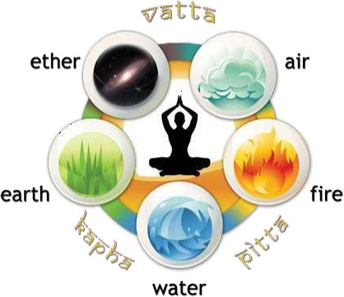

Figure-3 panchamahabhutha
- The Three Doshas:The three doshas "Vata, Pitta, and Kapha" are bioenergetic forces that govern physical and mental processes. Each person has a unique constitution, or Prakriti,
determined by the dosha balance.

  - Vata:- Composed of air and space; associated with movement and communication.

  - Pitta:- Composed of fire and water; governs digestion, metabolism, and transformation.

  - Kapha:- Composed of earth and water; responsible for structure, stability, and lubrication.(²⁶).
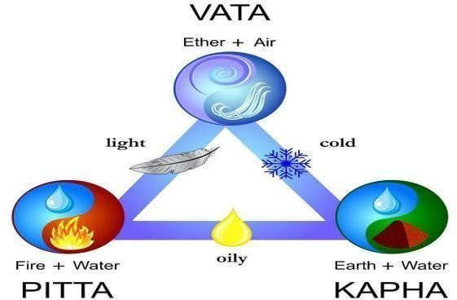

Figure-4 tridosha

The Concept of Dhatu:-
Dhatus are the seven tissue systems that provide structure and support to the body. They are essential for overall health and vitality.
- Rasa (Plasma)
- Rakta (Blood)
- Mamsa (Muscle)

- Meda (Fat)

- Asthi (Bone)

- Majja (Bone marrow)

- Shukra (Reproductive tissue) (²⁸).
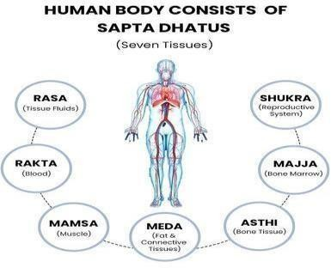

Figure-5 The concept of Dhatu
- Srotas (Channels):-Srotas are the channels through which substances flow in the body, including nutrients, waste, and energy. Proper function of the srotas is crucial for health.
- The Concept of Agni (Digestive Fire):-Agni refers to the digestive fire that transforms food into energy. It's essential for digestion, metabolism,and overall health. A balanced Agni is
critical for maintaining healthy.(²¹).(²⁹).
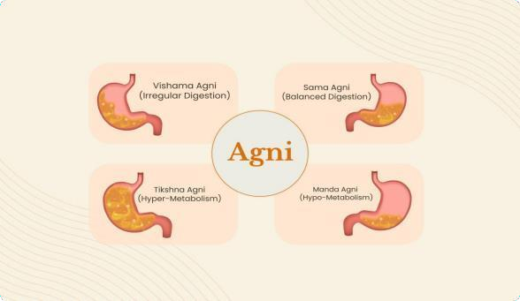

Figure-6 The concept of Agni
- Ama (Toxins):- Ama is the toxic residue produced from improper digestion and metabolism. It is considered the root cause of many diseases in Ayurvedha.(²¹).

Prakriti and Vikriti:-

  - Prakriti:- One’s inherent constitution, determined at birth by the unique balance of doshas.

  - Vikriti:- The current state of one’s dosha balance, which can be affected by lifestyle, diet, and environmental factors.(²¹).
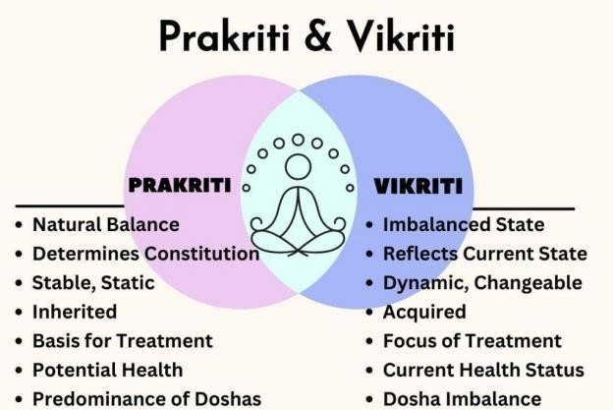

Figure-7:- Prakriti and Vikriti

Integrating Ayurvedhic medicine into cancer treatment:-

Cancer is a group of over 200 neoplastic diseases, all of which are caused by the dysregulation of multiple cell signaling pathways . A cancer may have as many as 500 different dysregulated
genes. The dysregulation of various genes may occur over a period as long as 20-30 years before a given cancer begins to manifest its symptoms. Therefore, targeting or inhibiting a single gene product or cell signaling pathway is unlikely to prevent or destroy cancer.Chemotherapy and
specific targeted drugs have been developed to disrupt these gene products or pathways, thereby inducing cell death and impeding progression of malignant changes in cells.However, problems such as ineffective targeting and drug resistance have plagued these agents.these drugs are
costly, have a long list of undesirable side effects, and are still not effective enough to have a significant effect on the course of the disease.Before the modern chemotherapy era, drugs
derived from natural sources were used for centuries for both cancer prevention and treatment. According to some estimates, as many as 80% of all anticancer drugs today have their roots in
natural products. The molecular targets of these natural compounds and their true potential against cancer, however, are not fully understood.(²¹).

Methadology:-
Ayurvedic formulation composed of many herbs, each with many compounds. Methodologies are needed to determine mechanisms of herbal compounds. It involves multidisciplinary
approaches. Influential component in cancer etiology is the relationship of body ,mins and spirit or consciousness through yoga and meditation can remove stress and develop
consciousness.Consultation with oncologists and Ayurvedic experts,Patient evaluation and diagnosis (conventional and Ayurvedic),Identification of cancer type, stage, and treatment goals are the pre integrating steps in cancer treatment.Along with medications patient should also
include regular diet and regular yoga can improve effectiveness in treatment.

Pre integrating steps:- consulting oncologist and ayurvedhic expert.
Integrating steps:- Complementary Therapy: Ayurvedic herbal supplements (e.g., Turmeric, Ashwagandha) to reduce side effects ,Panchakarma detoxification therapies (e.g., massage, meditation) for stress management,Yoga and Pranayama for physical and mental well-being.
Alternative Therapy (under expert guidance):Ayurvedic treatments as primary therapy for earlystage cancer.

Integration Models:-
Concurrent model: Ayurvedic treatment alongside conventional cancer treatment Sequential model: Ayurvedic treatment before or after conventional cancer treatment. Integrative model: Combining Ayurvedic and conventional treatments under one roof
Panchakarma is a collective term used to refer to the five main Ayurvedic procedures of detoxification:

- vamana (emesis),

- virechana (purgation),

- nasya (nasal instillation of herbal oils/powders),

- basti or vasti (herbal enema), and
- raktamokshana (bloodletting).
These procedures are commonly used in conjunction with allied therapies in order to cleanse the channels, eliminate toxins from the body, and restore balance. Panchakarma is one of the most
important Ayurvedic treatment modalities. When done correctly, it increases the receptivity and effectiveness of subsequent therapies.(³⁰).

Compound | Source | Properties | Functions
1.curcumin  ( Diferulolylmethane)  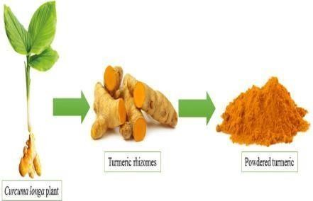 | Derived from turmaric  (curcumalonga);  Polyphenol widely used as an anti-  inflammatory. | Modulates multiple molecular targets (inflammatory  markers, growth factors, protein kinases, etc.)  -Direct binding to DNA/RNA. | Inhibits tumor growth, metastasis, invasion, and  angiogenesis.  -Induces apoptosis, mitotic  catastrophe, and autophagy.  (¹).

2.triphala  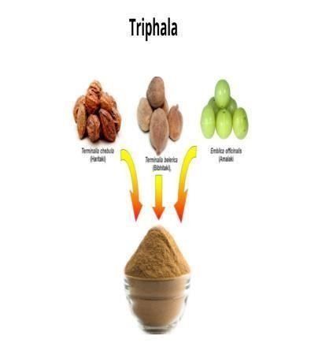 | Herbal formulation from Terminalia chebula, Emblica  officinalis,  Terminalia bellirica, fruits. | Rich in antioxidants and modulates cellular responses. | Demonstrats anti- tumor effects in in vitro and in vivo studies (MCF-7,  lymphoma models).  Anti-proliferative and tumor regression properties.(²).

3.Ashwagandha(Withania somnifera)  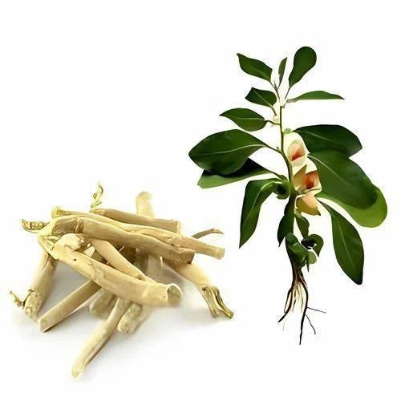  Withaferin A (WA) | Root extract used for stress reduction and immune enhancement.  -Steroidal lactone from Withania somnifera(Ashwagan dha). | Exhibits adaptogenic, anti-inflammatory, and  immunomodulatory effects.  -Targets oncogenic  pathways (ER-α,  STAT3) and  modulates apoptosis, immune function, and autophagy. | Shows anti-cancer activity  through inhibition of tumor growth and metastasis in  preclinical models.  -Demonstrates anti- cancer and  chemopreventive

effects in
preclinical breast cancer models.(⁴).

4.Guduchi (Tinospora cordifolia)  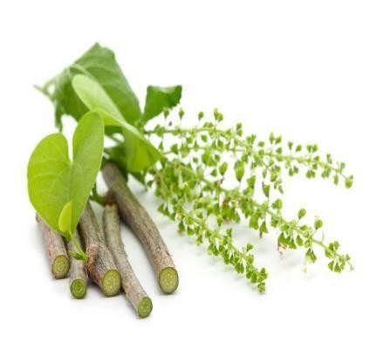 | Medicinal herb used for boosting immunity and antiinflammatory properties. | Enhances immune response, modulates cytokines, and has antioxidant  properties. | Shows anti-  proliferative effects on breast, prostate, and colon cancer cell lines.  - Reduces tumor progression  in preclinical  studies.(³).

5.Neem (Azadirachta indica)  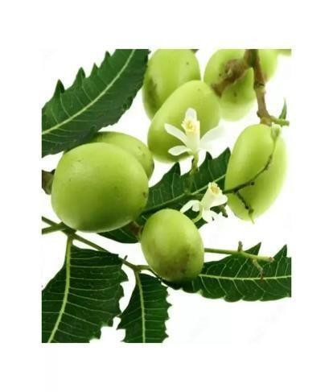 | Extracts from neem tree leaves, seeds, and bark widely used in Ayurvedic medicine. | Modulates immune system, anti- inflammatory,  anti- angiogenic, and pro- apoptotic  pathways. | Exhibits anti- proliferative  effects against skin, breast, and prostate cancer cells.  Promotes apoptosis and  inhibits  angiogenesis.(³¹).

6.Boswellia (Boswellia serrata)  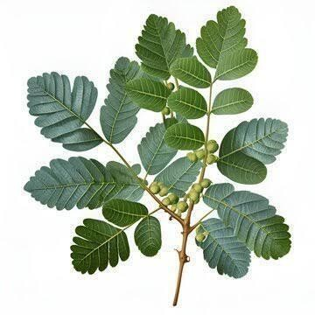 | Resin from  Boswellia tree,  known for its antiinflammatory effects. | Inhibits pro- inflammatory  pathways (e.g.,  5lipoxygenase) and modulates immune response. | Demonstrates anti- tumor effects in  brain, breast, and pancreatic cancer models.  -Inhibits  angiogenesis and induces apoptosis.(³²).

7.Brahmi (Bacopa monnieri)   | Medicinal  herb traditionally  used for improving memory and  cognition. | Modulates anti- oxydent  system,protects against stress  oxydative. | Exhibits anti- cancer effects in brain and colon cancer models.  - Induces apoptosis and reduces oxidative stress.(³³).

8.Amla (Phyllanthus emblica)  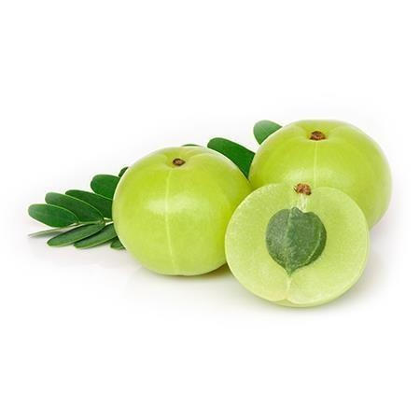 | Fruit rich in Vitamin C and  antioxidants, widely used in Ayurveda. | Modulates oxidative stress, enhances detoxification,  and supports  immune function. | Shows  antiproliferative in liver and colony cancer models.(³⁴).
9.Guggul (Commiphora mukul) | Resin from the  guggul tree, used for anti-  inflammatory and | Modulates  inflammatory pathways,  inhibits nuclear | Exhibits anti-tumor effects in  prostate, breast, and colon cancer models.
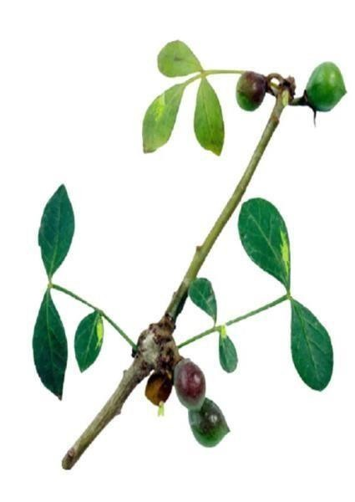 | lipid- lowering effects. | factor-kappa B (NF- κB) signaling. | -Induces apoptosis and inhibits  metastasis.(³⁵).

Table2:- list of ayurvedhic medicines in cancer treatment.
Advantages:-
- Holistic approach: Ayurveda treats the whole person, not just the tumor.
- Enhanced quality of life: Ayurvedic therapies can alleviate symptoms and side effects.
- Increased patient satisfaction: Combining conventional and Ayurvedic treatments can improve patient outcomes.
- Potential for improved survival rates: Some studies suggest Ayurvedic herbs and compounds may enhance chemotherapy efficacy.
- Reduced toxicity: Ayurvedic treatments may minimize side effects of conventional therapies.
- Cost-effective: Ayurvedic treatments can be less expensive than conventional therapies.
- Personalized medicine: Ayurveda tailors treatment to individual constitutions and needs.

Challenges and limitations:-
- Standardization of Ayurvedic products and manufacturing processes.
- Limited clinical trial data and evidence-based research.
- Potential interactions with conventional medications.

- Need for trained Ayurvedic practitioners and integration with conventional healthcare.
Ongoing research and initiatives:-
- National Institutes of Health (NIH) grants for Ayurvedic treatment and research.

- Collaboration between Indian and US institutions.

- Establishment of Ayurvedic research centers and institutes.

- Development of Ayurvedic-based cancer treatment protocols.

Notable hospitals and centers integrating Ayurveda:-
  - Tata Memorial Hospital (India)

  - All India Institute of Ayurveda (India)

  - University of California, San Francisco (US)
  - MD Anderson Cancer Center (US)

  - Memorial Sloan Kettering Cancer Center (US) FDA approved ayurvedhic medicines
:-
Ayurveda is the traditional medicine system of India, and has been in practice for several years. It is a traditional approach that uses 1000's of different plant preparations in various combinations for treatment of human ailments, including cancer. Ethnopharmacological and phytochemical
analyses are now elucidating the bioactive constituents of the different plant species and herbal formulations, including ashwagandha, curcumin, guduchi, triphala, and others.In recent decades, significant research has begins to extract the bioactive compounds of ashwagandha, tumeric, gud uchi, and triphala, such as with aferin A, curcumin,palmatine, and many others.These compounds and extracts are now being applied to brain tumor cells in vitro and in animal models, with positive signs of anti-cancer activity including reduced cell growth, increased apoptosis, cell cycle arrest, increased differentiation, and inhibition of important internal signal
transduction pathways. Several Ayurvedic herbs (ashwagandha, curcumin) have bioactive compounds with significant anti-cancer activity, and are effective in early pre-clinical testing
against brain tumor cells in vitro and in animal models. Further pre-clinical testing is warranted, along with advancement into phase I and phase II clinical trials of patients with glioblastoma and other brain tumors.

The FDA has not approved any Ayurvedic medicinal treatments for various reasons:-

- Lack of standardized manufacturing processes.

- Insufficient clinical trial data.

- Limited understanding of active ingredients and mechanisms.

- Potential interactions with conventional medications

- Concerns about heavy metal contamination However, some Ayurvedic herbal supplements have been recognized as

"Generally Recognized as Safe" (GRAS) by the FDA:-
- Turmeric (Curcuma longa)
- Ginger (Zingiber officinale)
- Ashwagandha (With ania somnifera)
- Boswellia (Boswellia serrata)
- Guggul (Commiphora mukul)
The FDA has also issued warnings and recalls for certain Ayurvedic products due to:-
- Heavy metal contamination (lead, mercury, arsenic)
- Undeclared pharmaceutical ingredients
- False or misleading labeling To bridge the gap between
Ayurveda and Western medicine, researchers are conducting studies on Ayurvedic herbal supplements, including:-
- National Institutes of Health (NIH) grants for Ayurvedic research
- Collaboration between Indian and US institutions
- Standardization of Ayurvedic manufacturing processes. Some notable Ayurvedic products with FDA-recognized status:-
- Himalaya Herbal Healthcare's "Pure Herbs" line.
- Maharishi Ayurveda's "Amrit" line.
- Ayurveda Rasayana's "TRI-DOSHA" line.

Reference:-
- Ibarra N. HeLa Cells, Cer ical Cancer, and the HPV Vaccine. 2023.
- Zhai C, Cai Y, Lou F, Liu Z, Xie J, Zhou X, Wang Z, Fang Y, Pan H, Han W. Multiple primary malignant tumors-a clinical analysis of 15,321 patients with malignancies at a single center in China. Journal of cancer. 2018;9(16):2795.
- Windisch P, Koechli C, Rogers S, Schröder C, Förster R, Zwahlen DR, Bodis S. Machine
learning for the detection and segmentation of benign tumors of the central nervous system: a systematic review. Cancers. 2022 May 27;14(11):2676. 4.Baykal C, Atcı T, Yılmaz Z,
Büyükbabani N. Skin tumors in xeroderma pigmentosum: evaluation of a large series and a literature review. Journal of Cutaneous Pathology. 2021 Jul;48(7):884-95.
- Jones MA, Young RH, Scully RE. Benign fibromatous tumors of the testis and paratesticular region: a report of 9 cases with a proposed classification of fibromatous tumors and tumor-like lesions. The American journal of surgical pathology. 1997 Mar 1;31(3):296-305.
- Espinoza AF, Vasudevan SA, Masand PM, Lòpez-Terrada DH, Patel KR. Pediatric Hepatocellular Adenomas: What Is Known and What Is New?. Cancers. 2023 Sep 29;15(19):4790.
- Ezike KN, Okwudire-Ejeh IA, Ahmed SI, Salu IK, Aghahowa ME, Dallang B, Umar UM. Benign lipomatous soft tissue tumors in Nigerians: an analysis of the clinical and morphological features of a common but important entity. Cureus. 2024 Mar;16(3).
8.(Basolo F, Macerola E, Poma AM, Torregrossa L. The 5th edition of WHO classification of tumors of endocrine organs: changes in the diagnosis of follicular-derived thyroid carcinoma. Endocrine. 2023 Jun;80(3):470-6.
- Gervais MK, Basile G, Dulude JP, Mottard S, Gronchi A. Histology-Tailored Approach to Soft Tissue Sarcoma. Annals of Surgical Oncology. 2024 Aug 22:1-5.
- Mu X, Chen C, Dong L, Kang Z, Sun Z, Chen X, Zheng J, Zhang Y. Immunotherapy in leukaemia: Immunotherapy in leukaemia. Acta biochimica et biophysica Sinica. 2023
Jun;55(6):974.
- Kastenschmidt JM, Schroers-Martin JG, Sworder BJ, Sureshchandra S, Khodadoust MS, Liu CL, Olsen M, Kurtz DM, Diehn M, Wagar LE, Alizadeh AA. A human lymphoma organoid
model for evaluating and targeting the follicular lymphoma tumor immune microenvironment. Cell Stem Cell. 2024 Mar 7;31(3):410-20.
- Xu M, Li S. Nano-drug delivery system targeting tumor microenvironment: a prospective strategy for melanoma treatment. Cancer Letters. 2023 Sep 18:216397.
- van Weverwijk A, de Visser KE. Mechanisms driving the immunoregulatory function of cancer cells. Nature Reviews Cancer. 2023 Apr;23(4):193-215.
- Essogmo FE, Zhilenkova AV, Tchawe YS, Owoicho AM, Rusanov AS, Boroda A, Pirogova YN, Sangadzhieva ZD, Sanikovich VD, Bagmet NN, Sekacheva MI. Cytokine profile in lung cancer patients: anti-tumor and oncogenic cytokines. Cancers. 2023 Nov 13;15(22):5383.
- Fadhal E. Unraveling the significance of signal transduction pathways: Key players in cancer development and progression. J Can Ther Res. 2023;3(1):1-9.
- Shang C, Lai J, Haque M, Chen W, Wang P, Lai R. Nuclear NPM-ALK Protects Myc from Proteasomal Degradation and Contributes to Its High Expression in Cancer Stem-Like Cells in ALK-Positive Anaplastic Large Cell Lymphoma. International Journal of Molecular Sciences. 2023 Sep 20;24(18):14337.
- McCormick F. KRAS as a therapeutic target. Clinical Cancer Research. 2015 Apr 15;21(8):1797-801.
- Advani AS, Pendergast AM. Bcr–Abl variants: biological and clinical aspects. Leukemia research. 2002 Aug 1;26(8):713-20.19.Li P, Xu G, Li G, Wu M. Function and mechanism of tumor suppressor gene LRRC4/NGL-2.Molecular Cancer.2014 Dec;13:1-7.
- Canman CE, Kastan MB. Induction of apoptosis by tumor suppressor genes and oncogenes. InSeminars in cancer biology 1995 Feb 1 (Vol. 6, No. 1, pp. 17-25). Academic Press.
- Arnold JT. Integrating ayurvedic medicine into cancer research programs part 1: Ayurveda background and applications. Journal of Ayurveda and integrative medicine. 2023 Mar 1;14(2):100676.
- van Oijen MG, Slootweg PJ. Gain-of-function mutations in the tumor suppressor gene p53. Clinical cancer research. 2000 Jun 1;6(6):2138-45.
- Rose JM. Genes Involved in the Cisplatin Response of BRCA2 Cancers (Doctoral dissertation,
WORCESTER POLYTECHNIC INSTITUTE).
- van Es JH, Giles RH, Clevers HC. The many faces of the tumor suppressor gene APC. Experimental cell research. 2001 Mar 10;264(1):126-34.
- Dahia PL. PTEN, a unique tumor suppressor gene. Endocrine-related cancer. 2000 Jun 1;7(2):115-29.
- Hankey A. The scientific value of Ayurveda. Journal of Alternative & Complementary Medicine. 2005 Apr 1;11(2):221-5.
- Pundir M, Singh C, Adlakha MK, Gocher G. A COMPREHENSIVE REVIEW ON CONCEPT OF PANCHAMAHABHUTA SIDDHANT AND DRUG ACTION IN AYURVEDA.
- Bhushan VV, Sharma M. SAPTADHATU CONCEPT IN AYURVEDA-A RESEARCH STUDY.
- Chouragade N, Chouragade B, Wanjari A, Kalambe S, Jha R. Review of Concept of Agni in Ayurveda. Indian Journal of Forensic Medicine & Toxicology. 2021 May 17;15(3):900-4.
- Ahlawat V, Ohlan PK. A COMPREHENSIVE REVIEW OF THE BENEFITS OF PANCHAKARMA IN LIFESTYLE DISORDERS.
- Hao F, Kumar S, Yadav N, Chandra D. Neem components as potential agents for cancer
prevention and treatment. Biochimica et Biophysica Acta (BBA)-Reviews on Cancer. 2014 Aug 1;1846(1):247-57.
- Roy NK, Deka A, Bordoloi D, Mishra S, Kumar AP, Sethi G, Kunnumakkara AB. The
potential role of boswellic acids in cancer prevention and treatment. Cancer letters. 2016 Jul 10;377(1):74-86.Roy S, Rakshit S, Shanmugam G, Sarkar K. Participation of Brahmi (Bacopa monnieri L.) plant in regulation of cancer. South African Journal of Botany. 2024 May
1;168:236-45.
- Roy S, Rakshit S, Shanmugam G, Sarkar K. Participation of Brahmi (Bacopa monnieri L.) plant in regulation of cancer. South African Journal of Botany. 2024 May 1;168:236-45.
- Baliga MS, Dsouza JJ. Amla (Emblica officinalis Gaertn), a wonder berry in the treatment and prevention of cancer. European Journal of Cancer Prevention. 2011 May 1;20(3):225-39.
- Ijaz S, Iqbal J, Abbasi BA, Tufail A, Yaseen T, Uddin S, Usman K, Ullah R, Bibi H, Inam P,
Sagindykova E. Current stage of preclinical and clinical development of guggulsterone in cancers: Challenges and promises. Cell Biology International. 2024 Feb;48(2):128-42.
36.1. Hasima N, Aggarwal BB. Cancer-linked targets modulated by curcumin. International journal of biochemistry and. molecular biology. 2012;3(4):328.
- Baliga MS. Triphala, Ayurvedic formulation for treating and preventing cancer: a review. The Journal of Alternative and Complementary Medicine. 2010 Dec 1;16(12):1301-8.
- Saha S., Ghosh S. Tinospora cordifolia: one plant, many roles. Ancient Sci Life. 2012;31(4):151–159.
- Hahm ER, Kim SH, Singh KB, Singh K, Singh SV. A comprehensive review and perspective on anticancer mechanisms of withaferin A in breast cancer. Cancer Prevention Research. 2020 Sep 1;13(9):721-34.
- Goldblum JR, Weiss SW, Folpe AL. Enzinger and Weiss's soft tissue tumors E-Book. Elsevier Health Sciences; 2013 Oct 11.
- DeBerardinis RJ, Lum JJ, Hatzivassiliou G, Thompson CB. The biology of cancer: metabolic reprogramming fuels cell growth and proliferation. Cell metabolism. 2008 Jan 1;7(1):11-20.
- Wagner A, Ploder O, Enislidis G, Truppe M, Ewers R. Virtual image guided navigation in tumor surgery—technical innovation. Journal of Cranio-Maxillofacial Surgery. 1995 Oct 1;23(5):271-3.
- Baskar R, Lee KA, Yeo R, Yeoh KW. Cancer and radiation therapy: current advances and future directions. International journal of medical sciences. 2012;9(3):193.
- DeVita Jr VT, Chu E. A history of cancer chemotherapy. Cancer research. 2008 Nov 1;68(21):8643-53.
- Bhosle J, Hall G. Principles of cancer treatment by chemotherapy. Surgery (Oxford). 2009 Apr 1;27(4):173-7.

Future recommendations:-
Research and Development:-
Focusing into Clinical trials on Ayurvedic herbal supplements and therapies in cancer treatment and Standardization of Ayurvedic products and manufacturing processes.
Pharmacogenomics and pharmacokinetics studies on Ayurvedic herbs will help for effective treatment.
Conducting more Investigation on Ayurvedic medicine's role in cancer prevention and early detection.
Education and Training:-
Integrative oncology courses for medical students and professionals and also Ayurvedic education programs for oncologists and nurses.
Conducting conferences on Ayurvedic oncology and integrating ayurvedic medicinal system into cancer treatment. Clinical Practice:-
Establishment of integrative cancer centers combining conventional and Ayurvedic treatments. Collaborative care models between oncologists and Ayurvedic practitioners.
Development of personalized Ayurvedic treatment plans for cancer patients.
Incorporation of Ayurvedic palliative care (improve quality of life)for advanced cancer patients.
Regulatory Framework:-
Development of guidelines for Ayurvedic medicine in cancer treatment. Regulation of Ayurvedic product manufacturing and marketing.
Licensing and certification for Ayurvedic practitioners in oncology. Insurance coverage for Ayurvedic cancer treatments.
Patient Empowerment:-
Patient education materials on Ayurvedic cancer treatments. Support groups for cancer patients using Ayurvedic medicine.
Online resources and forums for Ayurvedic cancer treatment information. Patient advocacy for integrative cancer care.
International Collaboration:-
Collaborative research between Indian and international institutions. Exchange programs for Ayurvedic practitioners and oncologists.
Development of global guidelines for Ayurvedic medicine in cancer treatment. International conferences on Ayurvedic oncology.
Technology and Informatics:-
Development of Ayurvedic oncology software and apps.
Electronic health records (EHRs) for integrative cancer care. Telemedicine platforms for Ayurvedic consultations.
Artificial intelligence (AI) and machine learning (ML) applications in Ayurvedic oncology.
Economic and Policy Considerations:-
Cost-effectiveness analysis of Ayurvedic cancer treatments. Health economic evaluations of integrative cancer care.
Policy reforms for reimbursement and insurance coverage.
Development of business models for sustainable Ayurvedic oncology practices.

