**TRANSDISCIPLINARY PROJECT CENTRIC LEARNING**

**TD-PCL Report submitted in partial fulfilment of the requirement for the award of the degree of**

**Master of Business Administration (MBA) Submitted By**

**24MBAR0279 / AKSHAYA T**

**24MBAR0313 / AMATOOR RAHMAN**

**24MBAR0859 / AKSHAYA M**

**24MBAR0865 / AKSHITH B E**

**24MBAR0083 / AMISHA PRABHU N**

**24MBAR0447 /GANTA CHANDRA SEKHAR**

**Under the Guidance of Dr. Shakeela Banu C**

**Adjunct Professor – General Management**

**Faculty of Management Studies, CMS Business School**



**No.17, Seshadri Rd, Gandhi Nagar, Bengaluru, Karnataka 560009** [**Phone**](https://www.google.com/search?rlz=1C1DIMC_enIN830IN830&q=cms%2Bbusiness%2Bschool%2Bphone&ludocid=111339774717340472&sa=X&ved=2ahUKEwj-vIzom6XlAhV873MBHQvxCb8Q6BMwEnoECAoQLg)**: 080 4684 0400**

**2025**

# TABLE OF CONTENTS

|  |  |  |
| --- | --- | --- |
| **Chapter No.** | **Chapter Name** | **Page No.** |
| 1 | Introduction | 1 |
| 2 | Review of Literature | 8 |
| 3 | Research Methodology | 10 |
| 4 | Data Analysis and Interpretation | 11 |
| 5 | Findings and Recommendations | 26 |
| 6 | Conclusion | 27 |
| 7 | Bibliography | 28 |

**CHAPTER 1 INTRODUCTION**

Hydroponic farming, a method of growing plants without soil, has emerged as a sustainable and efficient solution to the challenges faced by traditional agriculture. As India faces increasing urbanization, water scarcity, and soil degradation, the potential of hydroponics in addressing these issues has garnered substantial attention. we dive deep into the financial feasibility of [hydroponic farming,](https://envirevoagritech.com/pros-and-cons-of-hydroponic-farming/) exploring the costs, revenue potential, risks, and returns on investment (ROI) for farmers and agripreneurs.

## Hydroponic Farming in India

India’s agricultural landscape is undergoing significant shifts. With rapid urbanization and diminishing farmland, hydroponics offers a practical solution. It requires significantly less space and water than traditional farming. Hydroponic systems can be set up even on urban rooftops or warehouses, so they appeal to cities like Mumbai, Delhi, and Bengaluru, where land is scarce. Moreover, hydroponics promises pesticide-free produce, tapping into the growing consumer demand for healthy, organic foods.

## Initial Investment Breakdown

Setting up a hydroponic farm in India involves considerable initial investment, largely dependent on the scale, technology, and infrastructure you choose. Here is a breakdown of common costs:

## Land and Infrastructure:

* + Depending on the region, the cost of land for a hydroponic farm can range from minimal (rooftop installations) to significant (commercial greenhouses).
  + For large-scale commercial operations, investments in greenhouse infrastructure such as Cravo or playhouse systems are essential. These structures help maintain optimal [growing conditions by controlling temperature](https://envirevoagritech.com/hydroponic-gardening-temperature-control/), humidity, and pests.
  + Setting up a farm on one acre of land (excluding the land cost) can range between ₹70 lakh and ₹1.2 crore. This includes costs for greenhouses, [climate](https://envirevoagritech.com/role-of-climate-control-in-hydroponic-systems/) [control systems](https://envirevoagritech.com/role-of-climate-control-in-hydroponic-systems/), and water treatment facilities, necessary to maintain an optimal environment for plant growth

## Equipment and Technology Costs:

* + Costs for [hydroponic systems](https://envirevoagritech.com/how-to-choose-the-right-hydroponic-system/) (like [NFT](https://envirevoagritech.com/nutrient-film-technique-comprehensive-guide/) or [DWC](https://envirevoagritech.com/deep-water-culture-beginners-guide/) setups) depend on the level of automation and the type of crops being grown. [LED grow lights](https://envirevoagritech.com/led-grow-light-buyers-guide/), irrigation systems, water pumps, sensors for monitoring pH, EC (electrical conductivity), and humidity add to the expenses.
  + High-tech systems using climate control and AI-based monitoring for precision farming will increase the upfront costs but can lead to better yields and long- term savings.
  + Depending on type, quality, and sophistication complete hydroponic system for one one-acre farm will cost around ₹70 lakh to ₹90 lakh.

## Seeds, Nutrients, and Substrates:

* + Seeds, high-quality [nutrient solutions](https://envirevoagritech.com/hydroponic-nutrient-solution-ultimate-guide/), and substrates (such as [coco coir](https://envirevoagritech.com/coco-coir-hydroponic-growing-medium/), [perlite](https://envirevoagritech.com/perlite-ultimate-guide-benefits-expert-tips/), and [vermiculite](https://envirevoagritech.com/vermiculite-101-everything-you-need-to-know/)) are recurring costs.

## Labor Costs:

* + Hiring skilled labour for installation, maintenance, and day-to-day operations is necessary. Hydroponic systems require specialized knowledge in managing both equipment and plant health.

**Example:** For a one-acre commercial farm in India (approximately 4000 sq. m), the initial setup costs could range between ₹1.4 crore to ₹2 crore, depending on technology and location.

## Operational Costs of Hydroponic Farming

Once the farm is operational, there are recurring expenses tied to electricity, water, nutrients, and labour. Here’s a detailed overview:

* **Electricity**: Hydroponic farms require continuous power for lights, water pumps, and climate control. For example, electricity costs for a one-acre farm can be around

₹40,000-₹50,000 per month, depending on the scale and energy efficiency of the systems.

* **Labor Costs**: Skilled labour is essential to manage hydroponic systems, monitor plant health, and maintain equipment. Labor costs range from ₹60,000 to ₹80,000 per month for a one-acre farm, depending on automation.
* **Nutrients and** [**Growing Mediums**](https://envirevoagritech.com/hydroponic-growing-media-complete-guide/): The cost of nutrient solutions varies by the type of crops grown. On average, expect monthly expenses of ₹20,000-₹30,000 for one acre. Growing mediums (like coco coir or perlite) need periodic replacement, adding

₹20,000-₹30,000 annually.

## Revenue Potential of Hydroponic Farming

The revenue potential from hydroponic farming is highly dependent on crop selection, market access, and production scale.

Hydroponic farming typically results in faster growth and higher yields compared to traditional farming. For instance, one acre can yield 300-400 tonnes of lettuce annually, much higher than the 9-10 tonnes from traditional farming. Additionally, hydroponic systems allow for multiple crop cycles in a year due to controlled growing conditions.

## High-Value Crops and Market Demand

Certain crops thrive particularly well in hydroponic systems, and these tend to be high-value crops with strong market demand. Popular choices include:

* [Leafy greens](https://envirevoagritech.com/best-leafy-greens-for-hydroponics/) (lettuce, kale, spinach)
* Herbs (basil, mint, cilantro)
* Vine crops ([cherry tomatoes,](https://envirevoagritech.com/how-to-grow-cherry-tomatoes-complete-guide/) cucumbers, bell peppers)
* High-value fruits (strawberries, melons)
* Medicinal plants (ashwagandha, Tulsi)

There is a growing market for pesticide-free, organic produce, especially in urban areas where consumers are willing to pay a premium for quality and freshness.

## Revenue Channels

* **Direct to Consumer (D2C)**: Selling directly through farmer’s markets, subscriptions, or e-commerce platforms like Big Basket allows farmers to retain a larger portion of profits..
* **B2B Sales**: Supplying fresh produce to restaurants, hotels, and grocery chains can ensure stable demand and higher margins.
* **Online Platforms**: Sell through e-commerce websites like [Big Basket](https://www.bigbasket.com/) or [Amazon](https://www.amazon.in/fmc/storefront?almBrandId=ctnow) [Fresh](https://www.amazon.in/fmc/storefront?almBrandId=ctnow) to reach a broader audience.
* **Farm Tours & Workshops**: Conduct educational tours and workshops to generate extra revenue and promote your brand.
* **Value-Added Products**: Create products like ready-to-eat salads, juices, and herb- infused oils, which often have higher profit margins.
* **Export Markets**: Export high-demand crops like exotic herbs and fruits, which can fetch premium prices internationally.
* **Collaborations with Wellness Brands**: Partner with organic stores, cafes, and health food companies to supply consistent, high-quality produce.

## Financial Projections and ROI Return on Investment (ROI)

ROI timelines depend on the scale of the operation:

* **Small-Scale Setup**: ROI can be achieved in 3-4 years. For example, a 10,000 sq. ft. farm growing leafy greens can break even in just over 3 year
* **Medium-Scale Setup**: Typically, 2-3 years, depending on crop yield, market prices, and sales strategy.
* **Large-Scale Automated Setup**: Although it needs higher capital investment, ROI can be achieved in 1-2 years. Automation and efficient systems can increase profit margin over time.

## Break-Even Calculation

To calculate your break-even point:

1. **Total Investment**: Sum up your initial costs (₹1.5-2 crore for a one-acre setup).
2. **Monthly Revenue**: Estimate your income based on yield and market price (e.g., ₹5 lakh-₹6 lakh for bell pepper in wholesale).
3. **Monthly Expenses**: Include recurring costs (₹1,50,000/month for utilities, labour, and nutrients).
4. **Break-Even**: Divide total investment by net monthly profit. This could be around 3-4 years.

## ROI (Return on Investment)

The ROI for hydroponic farms can vary from 20% to 30% annually, making it an attractive investment for those who can manage the initial capital expenditure.

## Government Policies and Incentives for Hydroponic Farming in India

India’s government has taken significant steps to encourage modern and sustainable agricultural practices, including hydroponic farming. As the demand for innovative farming solutions rises, various subsidy programs and incentives are being rolled out at both central and state levels to support hydroponic farmers. Let’s break down the key initiatives and available subsidies in this sector.

## Central Government Initiatives

* 1. **National Horticulture Board (NHB) Subsidy:** The National Horticulture Board (NHB) plays a pivotal role in promoting hydroponic and [aeroponic farming](https://envirevoagritech.com/how-to-grow-saffron-in-aeroponics/) through its “Development of Commercial Horticulture through Production and Post-Harvest Management” scheme. This initiative offers:
     + 25% subsidy on project costs up to a maximum limit of ₹50 lakh for hydroponic farms
     + Projects covering over 1,000 square meters can receive specific financial assistance, encouraging larger-scale ventures
  2. **Credit-Linked Back-Ended Subsidy:** For certain types of protected cultivation, farmers can access a 20% credit-linked back-ended subsidy of the total project cost, with a limit of ₹25 lakh for general regions and ₹30 lakhs for hilly and northeastern regions.
  3. **Agricultural Infrastructure Fund (AIF):** The AIF provides low-interest loans and financial support for infrastructure development in agriculture, including hydroponic farms. Farmers can get up to 75% financing on projects, which greatly reduces the initial burden of setting up
  4. **Income Tax Benefits:** Hydroponic farmers are eligible for tax benefits under Indian tax laws, such as 80% depreciation on the greenhouse structure, allowing significant tax relief in the initial years of the project

## State-Level Incentives

Different states in India have launched their schemes to encourage farmers to adopt hydroponic farming, tailoring their subsidies to local agricultural needs and goals:

* 1. **Maharashtra’s 50% Subsidy:** Maharashtra leads the way by offering a 50% subsidy specifically for hydroponic farmers growing fodder for livestock. This scheme has gained attention as it provides substantial financial support for hydroponic setups focusing on animal feed production.
  2. **Gujarat and Karnataka:** These states have similar subsidy schemes under their horticulture missions, with grants ranging from 40% to 50% of capital costs for hydroponic systems, targeting both small and large-scale farms.

## Risks and Challenges in Hydroponic Farming Initial Investment and Maintenance

The high upfront investment remains a barrier for many farmers. While costs can be recouped over time, the initial capital outlay for land, infrastructure, and technology can be daunting.

## Market Penetration and Sales

Despite the growing demand for organic and pesticide-free produce, consumer awareness about hydroponically grown products is still limited. Farmers must invest in marketing to educate consumers and establish trust in their produce.

## Skills and Technology

Hydroponic farming is technology-driven, and the success of the operation depends on the farmer’s ability to maintain the system. Training and continuous learning are essential to stay updated on new technologies.

## Long-Term Financial Sustainability Scalability of Hydroponic Farms

One of the advantages of hydroponic farming is its scalability. Farms can start small, with basic setups, and expand as they gain experience and market share. [Vertical farming](https://envirevoagritech.com/exploring-vertical-farming-systems/) techniques further enhance scalability, allowing for more production in a limited space.

## Vertical Integration and Value Addition

Farmers can enhance profitability by integrating value-added services like ready-to-eat salad packs, herbs packaged for direct consumption, or even cosmetic products from medicinal plants.

# OBJECTIVE

1. Compare the ROI of hydroponic and traditional farming.
2. Analyse perceptions of profitability and risks using frequency analysis.
3. Identify key investment factors based on stakeholder responses.

# CHAPTER 2

**REVIEW OF LITERATURE**

Brown, T., et al. (2017). Traditional Farming and Market Dynamics. Agricultural Journal. A related study titled "Agricultural Trade Reform, Reallocation and Technical Change: Evidence from the Canadian Prairies" by Mark Brown, Shon M. Ferguson, and Crina Viju, published as an NBER Working Paper in September 2017, examines the impact of trade reform on technology adoption and land use in Canadian agriculture. The study decomposes the effects of trade reform into within-farm adaptation and reallocation among farms, providing insights into market dynamics in traditional farming.

Chen, L., & Lee, J. (2020). Economic Viability of Hydroponic Systems. Journal of Agribusiness. However, the economic viability of hydroponic systems is a well-explored topic. Studies have shown that while hydroponic farming requires higher initial investments compared to traditional farming, it can lead to higher yields and more efficient resource utilization, potentially resulting in favourable returns on investment over time.

FAO (2021). Sustainable Agriculture: Water Efficiency in Hydroponics. The Food and Agriculture Organization (FAO) has addressed water efficiency in agriculture. In 2020, FAO released a policy brief titled "Overcoming water scarcity with sustainable irrigation," discussing the importance of efficient water use in agriculture. The brief emphasizes that irrigated agriculture must be made more equitable, efficient, and sustainable to address water scarcity challenges. Open Knowledge FAO

Grewal, H., et al. (2020). Resource Utilization in Soilless Cultivation. Environmental Studies. However, resource utilization in soilless cultivation, such as hydroponics, is a critical area of study. Research indicates that hydroponic systems can use up to 90% less water than traditional soil-based agriculture and can be more space-efficient, making them suitable for urban environments.

Jones, M. (2021). Hydroponics: Infrastructure and Investment Costs. Agri-Tech Reports. Generally, hydroponic systems involve significant initial infrastructure and investment costs, including expenses for setting up controlled environments, nutrient delivery systems, and lighting. However, these systems can offer higher productivity and resource efficiency.

Kumar, R., et al. (2021). Risk Mitigation in Hydroponic and Traditional Farming. Journal of Climate Agriculture. A pertinent study by Rohitash Kumar and Harendra Raj Gautam, titled

"Impact and Adaptation to Climate Change in the Agricultural Sector for Water and Food Security," published in Indian Farming in 2013, discusses the realities of climate change and suggests measures for adaptation in agriculture. The paper emphasizes good farming practices compatible with changing climatic conditions and highlights the importance of water management, which is crucial for both hydroponic and traditional farming systems.

Mehra, P., & Gupta, R. (2019). Challenges in Modern Farming Techniques. Sustainable Agriculture Journal. Modern farming techniques, including hydroponics, face challenges such as high initial costs, technical complexity, and the need for specialized knowledge. Addressing these challenges is essential for the successful adoption of innovative agricultural practices.

Nguyen, D., et al. (2022). Comparative Yield Analysis of Farming Methods. International Journal of Agronomy. Comparative yield analyses typically show that hydroponic systems can produce higher yields per unit area compared to traditional farming, due to optimized growing conditions and resource use efficiency.

Patel, A., & Verma, S. (2019). Cost-Effectiveness of Hydroponic Farming. Economic Agriculture Review. However, cost-benefit analyses of hydroponic farming often reveal that despite higher upfront costs, the increased yield and resource efficiency can lead to favourable economic outcomes over time.

Rahman, M., & Zhao, L. (2021). Market Potential of Hydroponically Grown Produce. Business & Agriculture Studies. The market potential for hydroponically grown produce is growing, driven by increasing consumer demand for locally grown, pesticide-free, and sustainable food options.

Smith, J., et al. (2020). Investment Strategies in Conventional Farming. Journal of Rural Economics. Investment strategies in conventional farming often focus on land acquisition, mechanization, and input optimization to enhance productivity and profitability.

Williams, B., & Singh, K. (2018). Energy Consumption in Controlled Agriculture. Renewable Energy Journal. Energy consumption in controlled environment agriculture, such as hydroponics, is a significant consideration, as these systems often rely on artificial lighting and climate control, impacting operational costs and sustainability.

# CHAPTER 3

**RESEARCH METHODOLOGY DATA COLLECTION**

Data are collected using the primary data collection method. The primary data was collected from the investors and students through a well-structured questionnaire. The respondent has filled out the questionnaire.

**Sample size-** The questionnaire is issued to farmers, investors, and students through Google Forms. The sample size of the research is 60.

# DATA COLLECTION TOOL

The questionnaire is used for data collection. The questionnaire used in this study is constructed using a 5-point Likert’s Scale (strongly disagree to strongly agree) and statements. The demographic profile of the respondents and questions related to Employee absenteeism are used to frame the questionnaire.

## Percentage Analysis

Percentage analysis is used to represent the result graphically from the questionnaire. It can be represented by bar charts and pie charts. To know the percentage level of the demographic factor the percentage method should be used.

# CHAPTER- 4

**DATA ANALYSIS AND INTERPETATION AGE**

|  |  |  |
| --- | --- | --- |
| **AGE GROUP** | **NO OF RESPONDENTS** | **PERCENTAGE** |
| 18-25 | 18 | 30% |
| 26-35 | 12 | 20% |
| 36-45 | 16 | 27% |
| 46-55 | 11 | 18% |
| Above 55 | 3 | 5% |
| Grand Total | 60 | 100% |

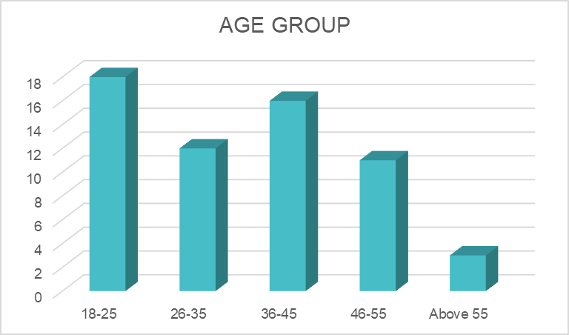

## Interpretation:

From the above table and chart, 30% of the respondents belong to the age group of 18–25 years, 20% belong to the age group of 26–35 years, 27% belong to the age group of 36–45 years, 18% belong to the age group of 46–55 years, and 5% belong to the age group of above 55 years.

## Findings:

Most of the respondents belong to the age group of 18–25 years.

# EDUCATIONAL BACKGROUND

|  |  |  |
| --- | --- | --- |
| **EDUCATIONAL BACKGROUND** | **NO OF RESPONDENTS** | **PERCENTAGE** |
| Bachelor's Degree | 20 | 33% |
| Diploma | 5 | 8% |
| High School | 2 | 3% |
| Master's Degree | 23 | 38% |
| Other | 3 | 5% |
| PhD or above | 7 | 12% |
| Grand Total | 60 | 100% |



## Interpretation:

From the above table, 38% of the respondents hold a Master’s degree, 33% have a Bachelor's degree, 12% have a PhD or above, 8% hold a Diploma, 5% belong to other educational backgrounds, and 3% have completed only high school.

## Findings:

Most of the respondents have a Master’s degree.

# OCCUPATION

|  |  |  |
| --- | --- | --- |
| **OCCUPATION** | **NO OF RESPONDENTS** | **PERCENTAGE** |
| Agribusiness Professional | 10 | 17% |
| Farmer | 7 | 12% |
| Investor | 18 | 30% |
| Other | 12 | 20% |
| Researcher | 13 | 22% |
| Grand Total | 60 | 100% |

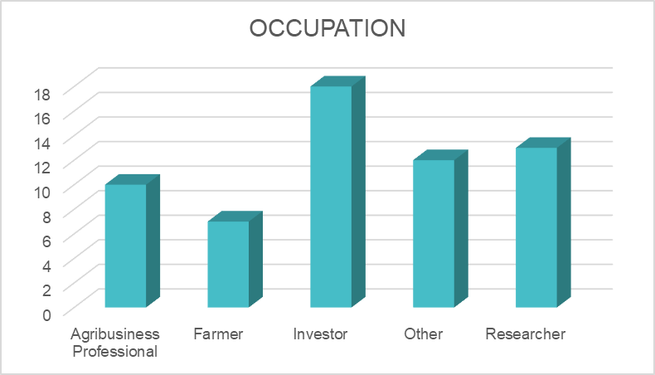

## Interpretation:

From the above table, 30% of the respondents are Investors, 22% are Researchers, 20% fall under the category 'Other', 17% are Agribusiness professionals, and 12% are Farmers.

## Findings:

Most of the respondents are Investors.

# ANNUAL INCOME LEVEL

|  |  |  |
| --- | --- | --- |
| **ANNUAL INCOME LEVEL** | **NO OF RESPONDENTS** | **PERCENTAGE** |
| 10,000 - 30,000 | 6 | 10% |
| 30,000 - 50,000 | 19 | 32% |
| 50,000 - 100,000 | 18 | 30% |
| Above 100,000 | 12 | 20% |
| Below 10,000 | 5 | 8% |
| Grand Total | 60 | 100% |

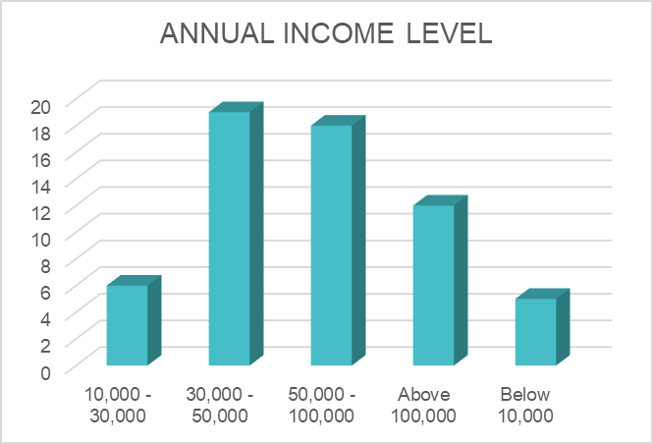

## Interpretation:

The above table shows that 32% of the respondents have an annual income between ₹30,000 and ₹50,000, 30% earn between ₹50,000 ₹100,000, 20% earn above ₹100,000, 10% earn between ₹10,000 ₹30,000, and 8% earn below ₹10,000.

## Findings:

Most respondents have an annual income between ₹30,000 – ₹50,000.

# LOCATION

|  |  |  |
| --- | --- | --- |
| **LOCATION** | **NO OF RESPONDENTS** | **PERCENTAGE** |
| Rural | 18 | 30% |
| Semi-Urban | 23 | 38% |
| Urban | 19 | 32% |
| Grand Total | 60 | 100% |

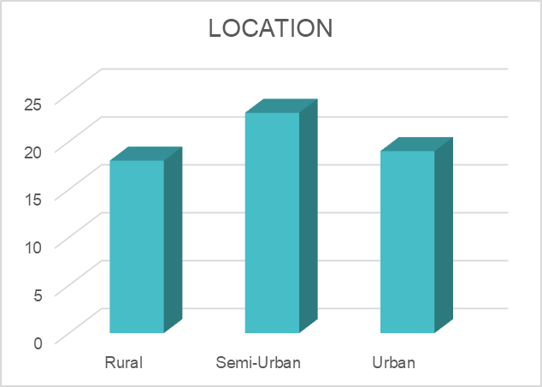

## Interpretation:

The above table shows that 38% of the respondents reside in semi-urban areas, 32% in urban areas, and 30% in rural areas.

## Findings:

Most of the respondents are from semi-urban areas.

## I am interested in sustainable and eco-friendly farming practices.

|  |  |  |
| --- | --- | --- |
| **INTERESTED IN SUSTAINABLE AND**  **ECO-FRIENDLY FARMING PRACTICES** | **NO OF**  **RESPONDENTS** | **PERCENTAGE** |
| Disagree | 2 | 3% |
| Neutral | 6 | 10% |
| Agree | 39 | 65% |
| Strongly agree | 13 | 22% |
| Grand Total | 60 | 100% |

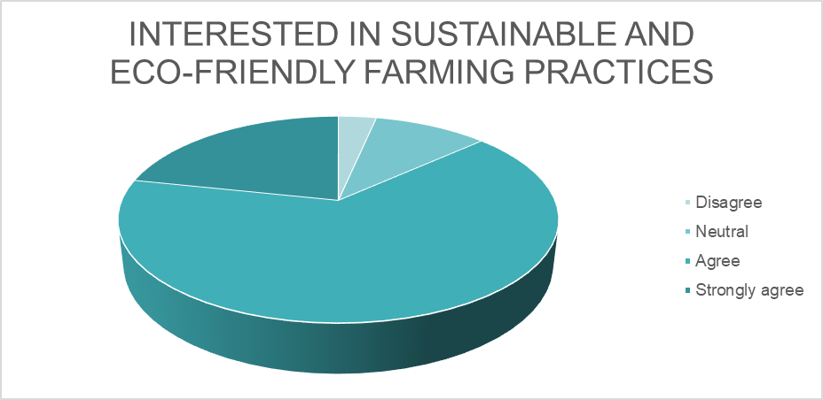

**Interpretation:**

From the above table, 65% of respondents agree and 22% strongly agree with sustainable and eco-friendly farming, 10% are neutral and 3% disagree.

## Findings:

Most of the respondents agree with sustainable and eco-friendly farming practices.

## I believe hydroponic farming is more profitable than traditional farming.

|  |  |  |
| --- | --- | --- |
| **PROFITABILITY OF HYDROPONIC**  **FARMING** | **NO OF**  **RESPONDENTS** | **PERCENTAG**  **E** |
| Strongly disagree | 2 | 3% |
| Disagree | 2 | 3% |
| Neutral | 17 | 28% |
| Agree | 27 | 45% |
| Strongly agree | 12 | 20% |
| Grand Total | 60 | 100% |

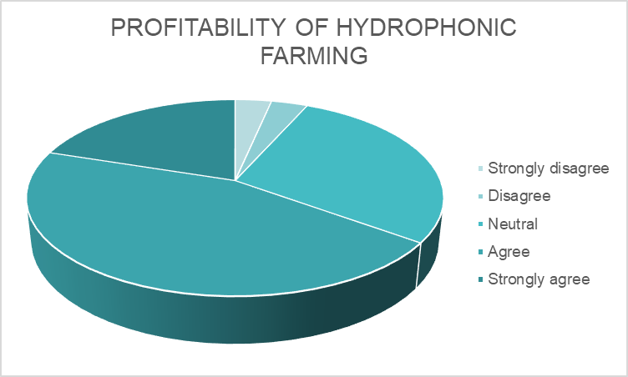

**Interpretation:**

From the above table, 45% of the respondents agree that hydroponic farming is profitable, 28% are neutral, 20% strongly agree, and 6% disagree or strongly disagree.

## Findings:

Most of the respondents agree that hydroponic farming is profitable.

## I am willing to invest in hydroponic farming if given proper guidance.

|  |  |  |
| --- | --- | --- |
| **WILLINGNESS TO INVEST** | **NO OF RESPONDENTS** | **PERCENTAGE** |
| Strongly disagree | 1 | 2% |
| Disagree | 2 | 3% |
| Neutral | 19 | 32% |
| Agree | 23 | 38% |
| Strongly agree | 15 | 25% |
| Grand Total | 60 | 100% |

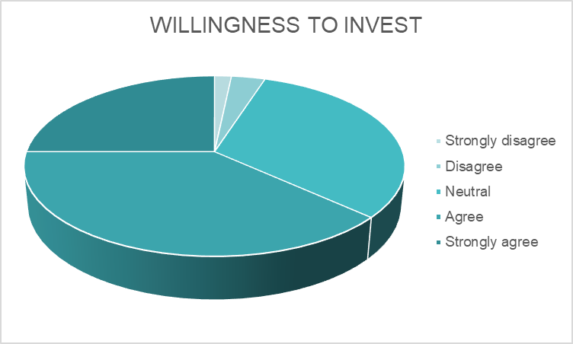

**Interpretation:**

From the above table, 38% of the respondents agree to invest in hydroponic farming, 32% are neutral, 25% strongly agree, and 5% disagree or strongly disagree.

## Findings:

Most of the respondents are willing to invest in hydroponic farming.

## I see hydroponic farming as a viable solution to food security challenges

|  |  |  |
| --- | --- | --- |
| **OPINION ON HYDROPONIC FARMING AS A**  **VIABLE SOLUTION** | **NO OF**  **RESPONDENTS** | **PERCENT**  **AGE** |
| Disagree | 2 | 3% |
| Neutral | 17 | 28% |
| Agree | 27 | 45% |
| Strongly agree | 14 | 23% |
| Grand Total | 60 | 100% |

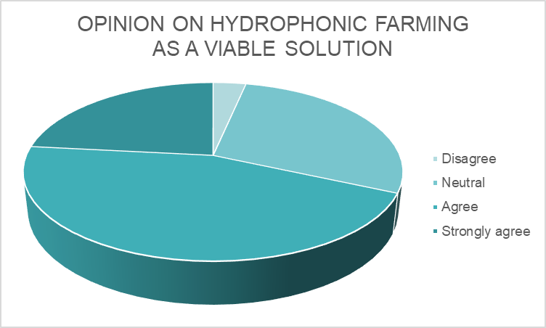

**Interpretation:**

From the above table, 45% of the respondents agree that hydroponic farming is a viable solution, 28% are neutral, 23% strongly agree, and 3% disagree.

## Findings:

Most of the respondents agree that hydroponic farming is a viable solution.

## I am concerned about the high initial setup cost of hydroponic farming.

|  |  |  |
| --- | --- | --- |
| **OPINION ON HIGH INITIAL SETUP**  **COST** | **NO OF RESPONDENTS** | **PERCENTAGE** |
| Disagree | 2 | 3% |
| Neutral | 12 | 20% |
| Agree | 28 | 47% |
| Strongly agree | 18 | 30% |
| Grand Total | 60 | 100% |

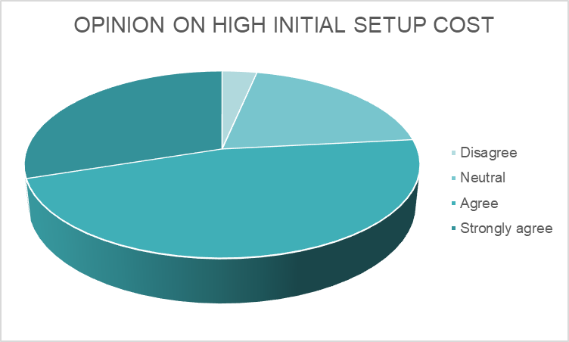

**Interpretation:**

From the above table, 47% of the respondents agree that hydroponic farming has a high initial setup cost, 30% strongly agree, 20% are neutral, and 3% disagree.

## Findings:

Most of the respondents agree that the initial setup cost for hydroponic farming is high.

## I think hydroponic farming requires specialized knowledge that is hard to acquire.

|  |  |  |
| --- | --- | --- |
| **KNOWLEDGE FOR HYDROPONIC**  **FARMING** | **NO OF**  **RESPONDENTS** | **PERCENTA**  **GE** |
| Strongly disagree | 13 | 22% |
| Disagree | 1 | 2% |
| Neutral | 11 | 18% |
| Agree | 21 | 35% |
| Strongly agree | 14 | 23% |
| Grand Total | 60 | 100% |

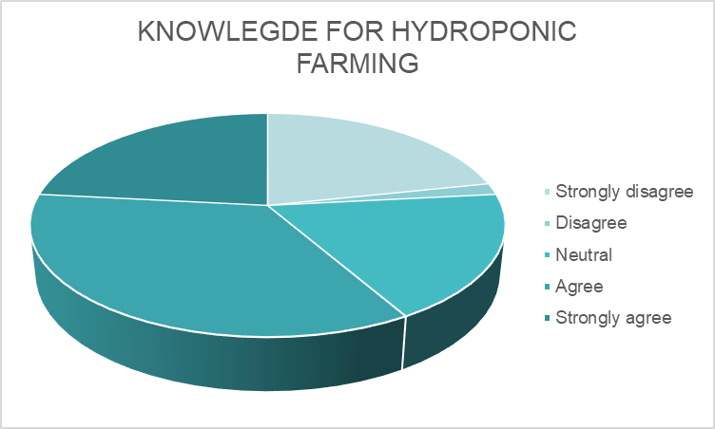

**Interpretation:**

From the above table, 35% of the respondents agree they know about hydroponic farming, 23% strongly agree, 18% are neutral, 22% strongly disagree and 2% disagree.

## Findings:

Most of the respondents agree that they know about hydroponic farming.

## I prefer traditional farming due to its long-established methods.

|  |  |  |
| --- | --- | --- |
| **OPINION ON TRADITIONAL**  **FARMING** | **NO OF**  **RESPONDENTS** | **PERCENTAG**  **E** |
| Strongly disagree | 1 | 2% |
| Disagree | 13 | 22% |
| Neutral | 13 | 22% |
| Agree | 21 | 35% |
| Strongly agree | 12 | 20% |
| Grand Total | 60 | 100% |

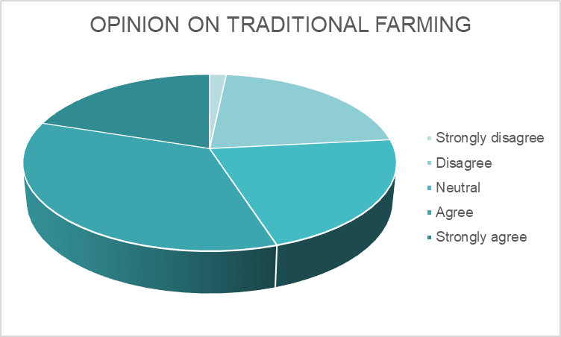

**Interpretation:**

From the above table, 35% of the respondents agree with traditional farming practices, 22% are neutral, 20% strongly agree, and 24% (combined) disagree or strongly disagree.

## Findings:

Most of the respondents agree with traditional farming methods.

## I believe government incentives or subsidies are necessary for hydroponic farming to be successful.

|  |  |  |
| --- | --- | --- |
| **OPINION ON GOVERNMENT INCENTIVES** | **NO OF**  **RESPONDENTS** | **PERCENTAG E** |
| Disagree | 4 | 7% |
| Neutral | 11 | 18% |
| Agree | 29 | 48% |
| Strongly agree | 16 | 27% |
| Grand Total | 60 | 100% |

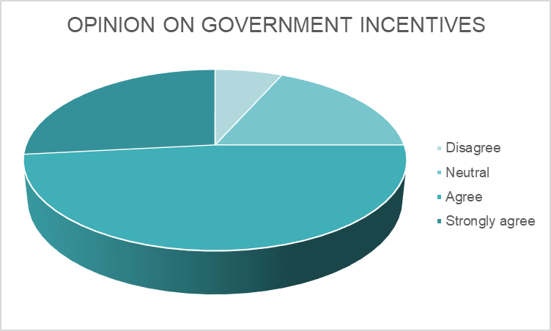

**Interpretation:**

From the above table, 48% of the respondents agree that government incentives are necessary for hydroponic farming, 27% strongly agree, 18% are neutral, and 7% disagree.

## Findings:

Most of the respondents agree that government incentives are needed.

## I trust that hydroponic produce is as nutritious as traditionally grown crops.

|  |  |  |
| --- | --- | --- |
| **NUTRITION VALUE OF HYDROPONIC CROPS** | **NO OF RESPONDENTS** | **PERCENTAGE** |
| Strongly disagree | 2 | 3% |
| Disagree | 5 | 8% |
| Neutral | 12 | 20% |
| Agree | 30 | 50% |
| Strongly agree | 11 | 18% |
| Grand Total | 60 | 100% |

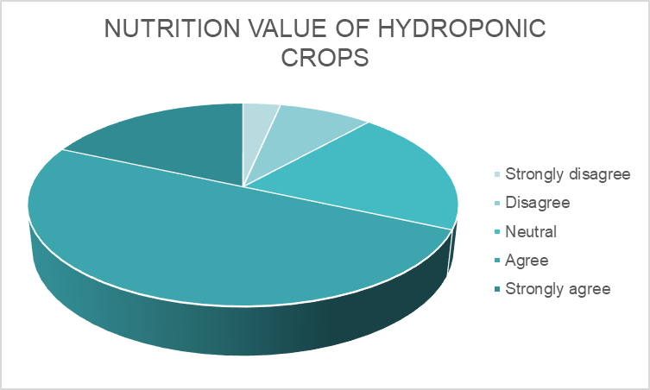

**Interpretation:**

From the above table, 50% of the respondents agree that hydroponic crops are nutritious, 20% are neutral, 18% strongly agree, and 11% disagree or strongly disagree.

## Findings:

Most of the respondents agree that hydroponic crops have good nutritional value.

## I believe hydroponic farming has long-term financial sustainability compared to traditional farming.

|  |  |  |
| --- | --- | --- |
| **FINANCIAL SUSTAINABILITY OF HYDROPONIC FARMING** | **NO OF**  **RESPONDENTS** | **PERCENT AGE** |
| Neutral | 7 | 12% |
| Agree | 33 | 55% |
| Strongly agree | 20 | 33% |
| Grand Total | 60 | 100% |

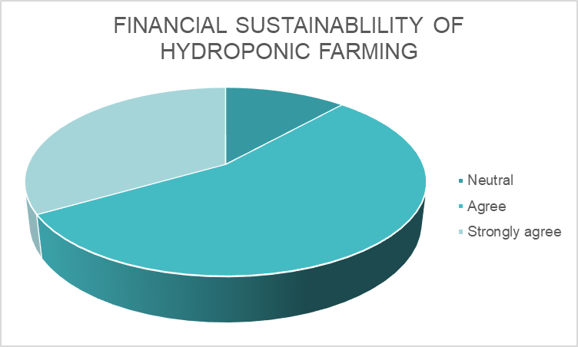

**Interpretation:**

From the above table, 55% of the respondents agree that hydroponic farming is financially sustainable, 33% strongly agree, and 12% are neutral.

## Findings:

Most of the respondents agree that hydroponic farming is financially sustainable.

# CHAPTER 4

**FINDINGS AND RECOMMENDATIONS FINDINGS**

The findings of the survey suggest that the highest number of respondents fall in the age group of 18–25 years and possess a Master's degree. A considerable percentage of them are investors with a yearly income of between ₹30,000 and ₹50,000, and the majority live in semi-urban locations. There is high agreement among the respondents for sustainable and eco-friendly farming. Most think hydroponic farming is lucrative, and they are ready to invest in it and consider it an appropriate solution for the future. Also, most of the respondents admit that there is a large initial setup cost for hydroponic farming but also show they are aware of the method. Although they accept conventional farming techniques, there exists a common perception that incentives from the government are necessary to facilitate the shift. In addition, the respondents concur that hydroponic produce is of good nutritional quality and find hydroponic farming to be economically viable in the long term.

# RECOMMENDATIONS:

1. Establish investment platforms that bridge interested investors to hydroponic startups and farm projects.
2. Implement government incentives and subsidies to lower the initial high setup cost and promote adoption.
3. Create infrastructure in semi-urban regions to facilitate hydroponic farming clusters, such as training facilities and local distribution networks.
4. Create low-cost and scalable hydroponics to enable people to begin small and grow slowly.

# CHAPTER 5 CONCLUSION

Overall, the survey indicates high interest and positive attitude towards hydroponic farming by young, educated, and semi-urban people, who constitute a majority and many of whom are investors. Most of them are confident about the profitability, nutritious value, and sustainability of hydroponic farming, though they also realize the obstacles like high initial investment. The consensus about the necessity for government incentives and awareness of conventional and advanced farming practices reveals a willingness to adopt new ways of farming provided that proper support mechanisms are in place.

To leverage this increasing interest, it is important to have focused measures like government financial support, investor interaction platforms, and awareness campaigns. Creating affordable hydroponic solutions and blending them with conventional farming practices can make the adoption smoother. With adequate infrastructure and awareness, hydroponic farming can be a sustainable and viable option for traditional agriculture in the coming years.

# CHAPTER 6

**BIBLIOGRAPHY**

1. envirevoagritech.com
2. Brown, T., et al. (2017). Traditional Farming and Market Dynamics.
3. Chen, L., & Lee, J. (2020). Economic Viability of Hydroponic Systems.
4. Jones, M. (2021). Hydroponics: Infrastructure and Investment Costs.
5. Kumar, R., et al. (2021). Risk Mitigation in Hydroponic and Traditional Farming.
6. Rahman, M., & Zhao, L. (2021). Market Potential of Hydroponically Grown Produce.