**Research**

**On**

**“Online Certifications: Enhancing Careers or Just Adding Noise”**

**GARIMA MISHRA**

**List of Figures**

|  |  |  |
| --- | --- | --- |
| **Chapter No.** | **Title** | **Page No.** |
| 1 | Introduction | 3 |
| 2 | Conceptual Background | 6 |
| 3 | Research Methodology | 11 |
| 4 | Data Analysis | 15 |
| 5 | Interpretation, Conclusion and Future Research | 23 |
| 6 | References | 27 |

**CHAPTER – 1**

**INTRODUCTION**

**Chapter 1: Introduction**

It all really started during the COVID-19 pandemic. The world went into lockdown, and everything—classes, work, even hobbies—shifted online. With so much time indoors and a sudden need to stay productive, people began turning to online platforms to learn something new. Websites like Coursera, Udemy, and LinkedIn Learning became extremely popular almost overnight.

At first, people joined online courses out of curiosity or just to pass the time. Some even picked up new hobbies—like photography, graphic design, or music—which were usually too expensive or hard to access before. But slowly, this casual learning trend grew into something much bigger. Online certifications became a buzzword. Everyone seemed to be doing some course or another—and not just for fun, but to add something impressive to their résumé or LinkedIn profile.

Suddenly, collecting certificates became the new normal. It felt like a race—how many certifications could one complete in the shortest time? But somewhere along the way, the real goal of learning started to fade. A lot of students, including myself, started asking: “Are we really gaining skills, or just stacking up certificates that don’t mean much in the real world?”

That’s when the gap became clear. Many students proudly showcase multiple certifications, but when it comes to applying that knowledge in an interview or a job, they struggle. The truth is, it’s not the certificate that matters—it's what you *actually* learned and whether you can use that knowledge confidently in real-life situations.

Personally, I’ve taken online courses too. And like many others, I once believed that the more certificates I had, the better it would look on my résumé. But I realized that just finishing a course isn’t enough. What really matters is understanding the subject deeply and being able to apply it. One well-done course that teaches real, useful skills is much more powerful than five rushed ones that you barely remember.

Another important question that comes up is this: What do recruiters think about online certifications? Do they see them as valuable, or do they look beyond the paper and focus more on whether a person has real problem-solving skills? There’s often a big difference between how students view these certifications and how employers actually interpret them.

Still, I believe that online certifications can be very helpful—if done the right way. Choosing relevant courses, putting in genuine effort, and developing real skills can truly help a person stand out, especially in today’s digital job market. But cheating through quizzes or speeding through just to get a certificate won’t help in the long run.

That’s what led me to do this research. I want to understand the real value of online certifications—not just from a student’s point of view, but also from the perspective of recruiters and professionals. Are these certificates opening doors, or are they just adding noise to job applications?

This study is for students, job seekers, and early professionals who want honest answers. It will explore how online certifications are viewed in the job market, what kind of impact they actually have on career growth, and what students can do to make the most of them. The findings might surprise you as the next chapters unfold, but more importantly, I hope they’ll help you make smarter, more informed choices when it comes to online learning.

**CHAPTER – 2**

**CONCEPTUAL BACKGROUND**

**Chapter 2: Conceptual Background**

Education has long been the cornerstone of individual development and career advancement. For decades, traditional classroom education served as the primary method of acquiring knowledge and formal certification. Structured environments, face-to-face learning, and institutional recognition defined the credibility of a student's learning experience. However, the onset of globalization, technological advancements, and shifting workforce demands have transformed how knowledge is consumed and validated.

In response to these changes, **online certifications** have emerged as an increasingly popular alternative to conventional education models. These certifications offer digital credentials through web-based platforms, allowing learners to gain new skills at their own pace, often at a lower cost and with greater flexibility.

**2.1 The Rise of Online Learning: Access and Acceleration**

Online certifications cater to a diverse and expanding audience. Students from small towns, working professionals who want to upgrade their skills, and people trying to switch careers are all turning to online learning.

Platforms like **Coursera**, **Udemy**, **LinkedIn Learning**, **edX**, and **Skillshare** have made education more open to everyone. You can find courses on almost anything—data science, graphic design, communication skills, business, and more.

The biggest reason people choose online learning is flexibility. You can learn at your own pace and avoid the high costs of traditional colleges. During the COVID-19 pandemic, online learning became even more popular as schools closed and people looked for ways to stay busy and productive.

However, this flexibility also brings some problems. Many people don’t finish the courses they start. Some courses don’t offer the best quality content. And since there’s no physical classroom, some learners lose motivation easily.

.

**2.2 Comparison: Traditional vs. Online Certifications**

Understanding the differences between traditional and online certifications helps frame their respective roles in education and professional development:

|  |  |  |
| --- | --- | --- |
| Feature | Traditional Certifications | Online Certifications |
| Learning Format | In-person, Classroom style | Self-paced, Online |
| Cost | Generally high | Usually affordable or free |
| Accessibility | Location-limited | Globally accessible |
| Duration | Long-term (months/years) | Short-term (days/weeks) |
| Assessment | Exams, projects, direct feedback | Online quizzes, assignments |
| Interaction | Direct with peers and faculty | Limited or peer-based online |
| Recognition | Widely recognized by companies | Varies by platform and course |

While traditional education is seen as more credible due to institutional backing, online certifications are evolving with industry-aligned content and shorter learning cycles that reflect real-world demands.

**2.3 The Psychology Behind Certifications**

Certificates are more than just proof of learning. For many people, they’re a confidence boost. In a competitive world, getting a certificate makes people feel like they’re improving and moving forward. Posting certificates on social platforms like LinkedIn is a way to signal growth, seriousness, and intent to recruiters and peers alike.

But here’s the issue: Some learners get caught up in just collecting certificates. They sign up for many courses, often without finishing them or fully understanding the content at times even abandoning the course midway. This creates a loop where people focus more on how many certificates they have, rather than what they’ve actually learned.

Below is a **flowchart** that captures the psychological cycle some students experience with online certifications:

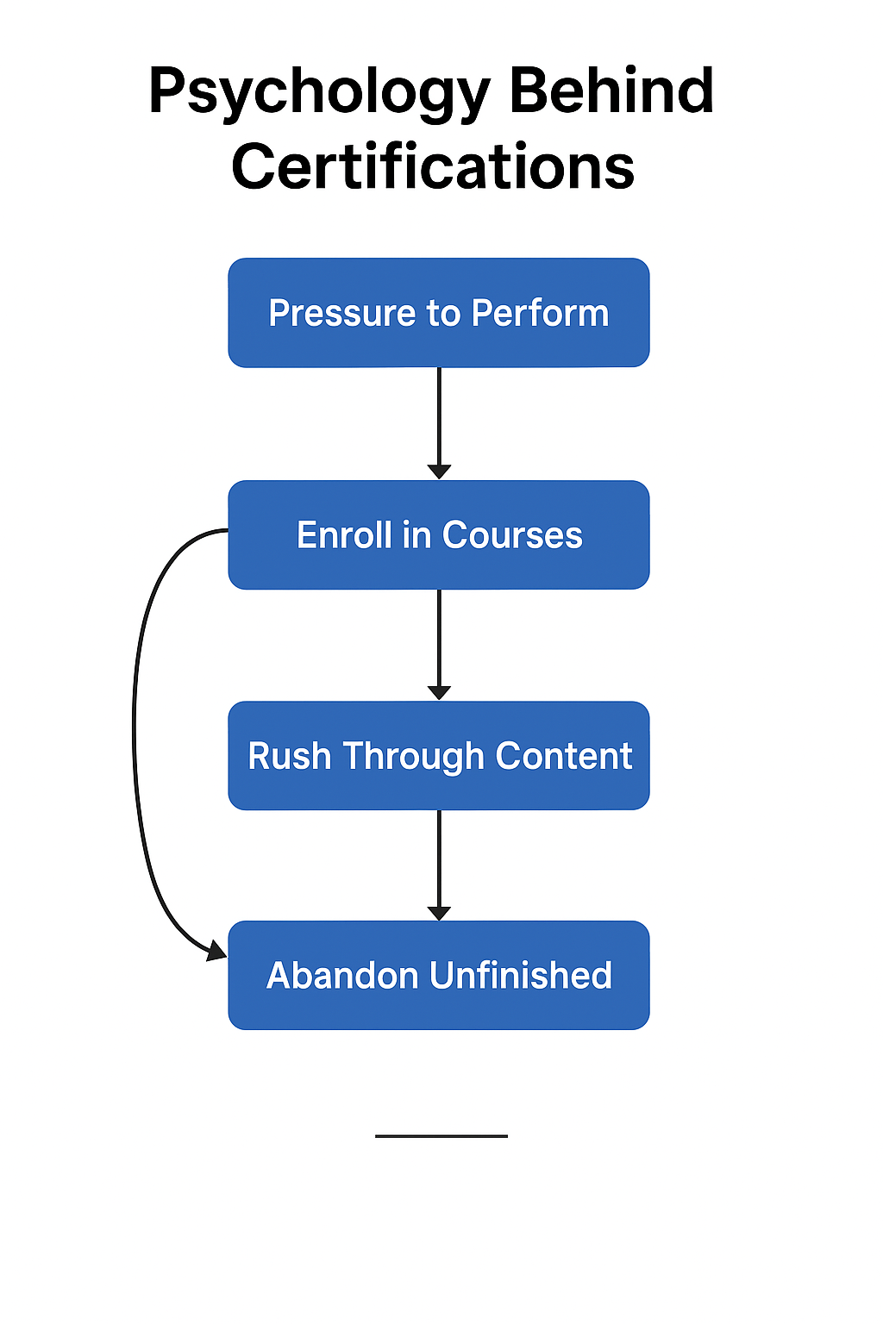

The diagram illustrates how initial enthusiasm can transition into pressure, leading to superficial learning and ultimately burnout. Recognizing this pattern is essential in understanding both the advantages and limitations of online learning.

**2.4 Do Recruiters Really Value Online Certifications?**

It depends. Some industries like **tech**, **marketing**, and **design** are open to online certifications—especially if the course teaches real, usable skills. But in fields like **law**, **finance**, and **core business roles**, traditional degrees from well-known universities are still preferred.

More and more recruiters want **evidence of practical skill**, not just a certificate. For example, showing a project you built, a portfolio, or an internship experience along with your certificate makes a stronger impression. Big companies are also using online platforms to train their employees. They build custom online courses to help workers learn new skills. This shows that online learning is becoming a normal part of job training and professional growth.

**2.5 The Blended Future of Learning**

The future of learning isn’t just online or offline—it’s both. Many top universities now offer a mix of classroom learning and online courses. This is called **blended learning**.

This blended style helps meet different learning needs. Some people prefer structured classroom environments, while others like the flexibility of online study. When used together, it creates a more balanced way of learning.

As the line between formal and informal education continues to blur, learners have to make smart choices. It’s important to choose courses that are both useful and respected—and to make sure that you actually *learn* something, not just earn a certificate.

**CHAPTER – 3**

**RESEARCH METHODOLOGY**Top of Form

**Chapter 3: Research Methodology**

**3.1 Research Design**

To understand the real value of online certifications, this study used a **mixed-methods approach**—meaning it combined both numbers (quantitative data) and personal opinions (qualitative data).

Most of the questions in the survey were close-ended—like multiple-choice and rating scale questions. These helped us gather structured data that could be measured and compared. But to make the research deeper and more meaningful, we also included a few open-ended questions. These allowed people to share their own thoughts, stories, and experiences with online courses. This mix helped us get both facts and feelings, making the research more complete.

**3.2 Sampling and Sample Size**

A total of **103 responses** were collected for this research. The target respondents were primarily **MBA students and early-career professionals**, as they represent a group actively involved in skill development and career planning.

The sampling technique used was **convenience sampling**. The survey link, created through Google Forms, was distributed via WhatsApp to classmates and posted on LinkedIn to reach personal and professional connections. This method was chosen due to ease of access and time constraints.

**3.3 Data Collection Tool**

The primary tool for data collection was **Google Forms**, which allowed for easy distribution and real-time response tracking. The questionnaire included a total of **14 questions**, divided as follows:

* **10 main research questions**, including:
  + Multiple choice questions
  + Likert scale questions (to measure agreement, usefulness, and satisfaction)
  + Open-ended questions (to gather qualitative insights)
* **4 demographic questions**, covering age, gender, education level, and professional status.

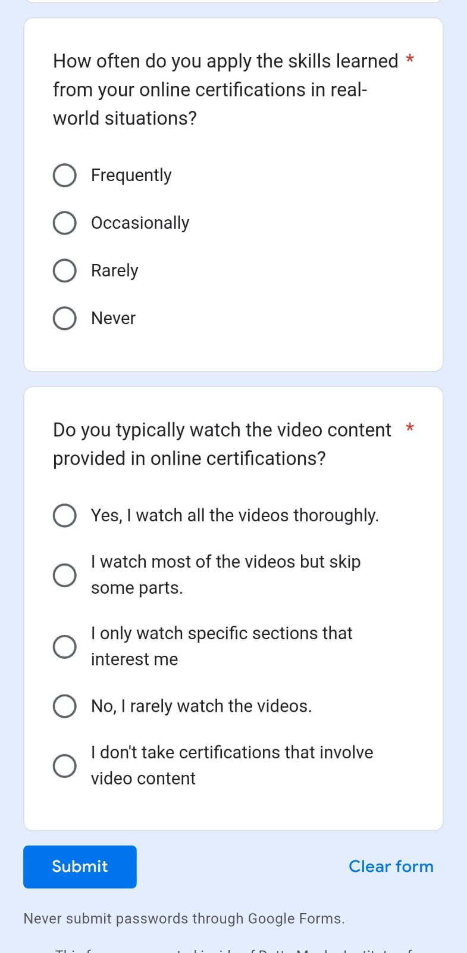  
**Figure 1: Sample section of the Google Form used for data collection.**

**3.4 Data Analysis**

The collected data was analysed using **Microsoft Excel**. Basic statistical techniques were applied to interpret the quantitative responses, such as calculating percentages, averages, and visualizing trends through charts and graphs. For the qualitative responses, we looked for **recurring words, ideas, and feelings** that kept coming up. This helped us understand the mindset of learners and what they really think about online certifications.

The analysis was also used to test the following hypotheses:

* **Null Hypothesis (H₀):** Online certifications do not provide practical skills that benefit students in real-world scenarios.
* **Alternative Hypothesis (H₁):** Online certifications provide significant practical skills that benefit students in real-world scenarios.

This structured methodology ensures that the research is both data-driven and grounded in the real experiences of students and professionals.

**3.5 Ethical Considerations**

All data for this research was collected ethically and responsibly. The survey questions were **mandatory**, but the form was only shared with **concerned individuals**—MBA students and professionals—who were genuinely interested and relevant to the study.

No fake or duplicate responses were submitted by the researcher to manipulate the results. Each response came from a real participant, and no personally identifiable information was collected or misused. Participants were informed that their responses would be used for academic purposes only, and participation was completely voluntary.

**3.6 Limitations of the Methodology**

While the research provides useful insights, there are some limitations to keep in mind:

* **Convenience sampling** may not fully represent learners from all educational backgrounds, fields, or regions.
* The sample size, though decent, is still small compared to the wide range of online learners worldwide.
* Since the survey focused more on student and early-career perspectives, it does not deeply explore the recruiter or employer viewpoint.
* Time constraints and the lack of advanced data tools limited deeper analysis of patterns and trends.

Despite these limitations, the data collected gives a strong base to understand how learners today view online certifications—and how seriously they take them.

Bottom of Form

**Chapter – 4**

**DATA ANALYSIS**

**CHAPTER 4 – DATA ANALYSIS**

**4.1 Demographics Profile of Respondents**

1. Age Group –

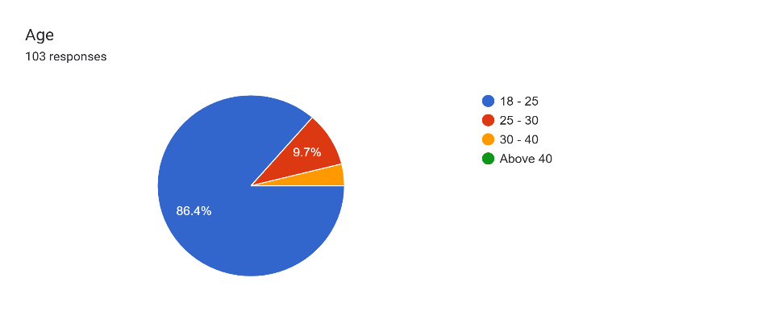

Most respondents (18–25 age group) are young adults, likely students or early professionals, making them key users of online certifications

1. Gender

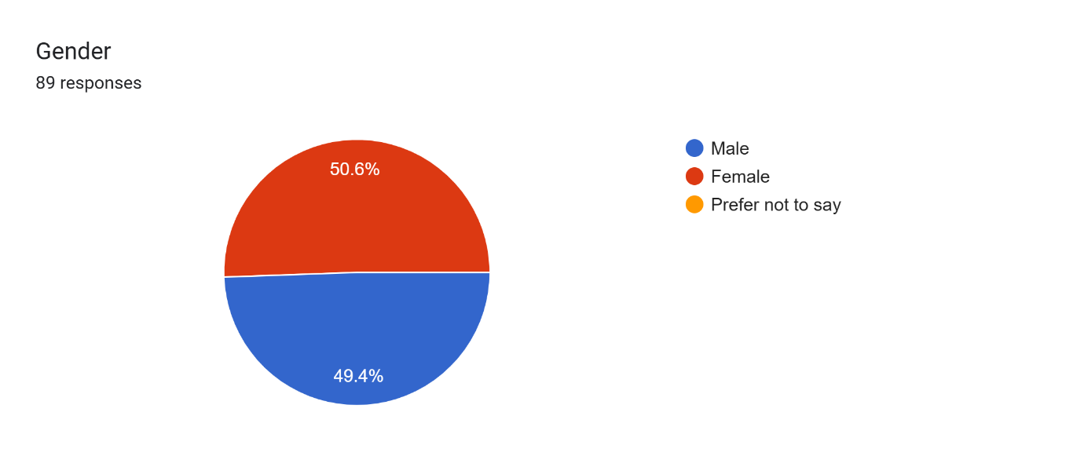

The gender distribution is almost balanced, with 50.6% male and 49.4% female respondents.

1. Current Occupation

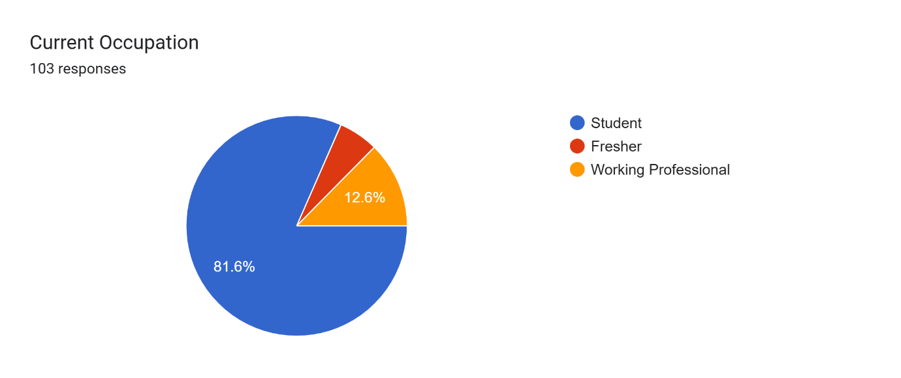

Out of 103 respondents, 84 are students, 13 are working professionals, and 6 are freshers, showing that the majority are currently pursuing education.

**4.2 Perception & Usefulness of Online Certifications**

1. Do you believe that online certifications are useful?

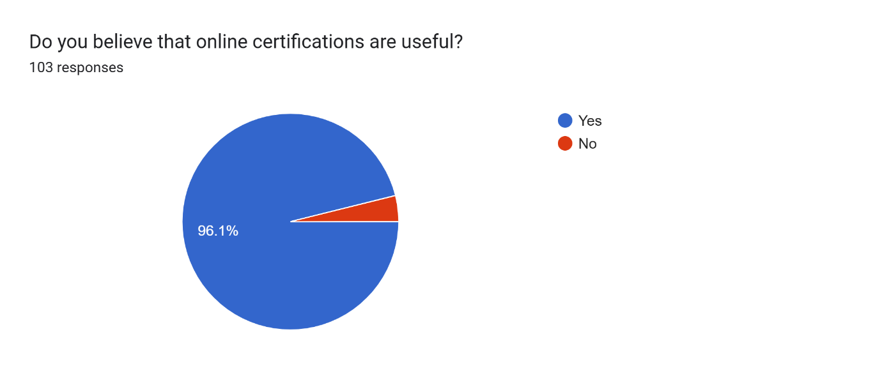

Most respondents believe that online certifications are useful.

1. Do you think online certifications are as valuable as traditional classroom certifications? Why or why not?

This question was open-ended, allowing respondents to share their personal views on the relative value of online certifications compared to traditional classroom-based certifications.

|  |  |  |
| --- | --- | --- |
| Category | Key Points | Examples |
| Positive Responses (Supportive of Online Certifications) | Reputable sources, skill development, flexibility, practical skills, convenience, real-world relevance | Online certifications from trusted sources are valuable for skill development and flexibility. "Online certifications can be as valuable as traditional ones if they come from reputable institutions." |
| Neutral/Mixed Opinions (Depends on Context) | Depends on field, provider, and individual effort; both types have advantages depending on career goals | Value depends on field and certification provider. "It depends on the field and the credibility of the certification provider." |
| Negative Responses (Sceptical about Online Certifications) | Lack of hands-on experience, credibility concerns, less recognition in certain industries | Concerns about lack of practical knowledge and recognition. "Traditional certifications are more recognized in certain industries due to their established credibility." |

Most respondents believe online certifications are valuable and can be just as good as traditional classroom certifications, especially if they come from trusted platforms. Key benefits highlighted include flexibility, convenience, and the opportunity to develop practical skills. However, some people feel that traditional certifications are more recognized, particularly in industries that require hands-on experience or networking.

* 1. **Platform Preferences & Motivation**

1. Which online certification platform do you primarily use for gaining practical experience?

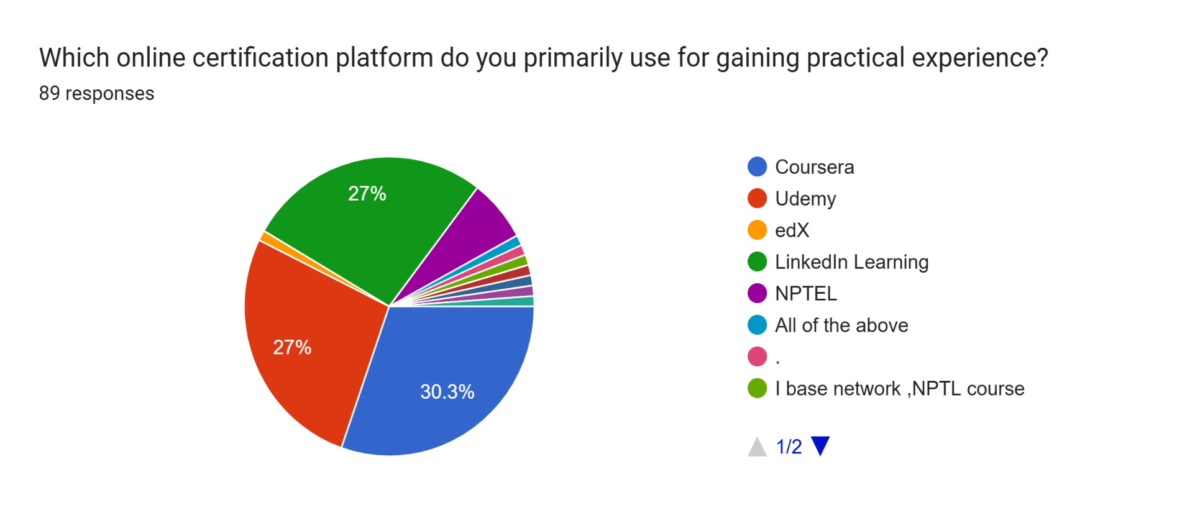



The data shows that **Coursera** (30%), **LinkedIn Learning** (27%), and **Udemy** (27%) are the most popular platforms for gaining practical experience. **NPTEL** was preferred by 9% of respondents, while other platforms like **edX**, **Devtown**, and **Microsoft Certifications** were mentioned less frequently.

1. What is your primary reason for pursuing an online certification?

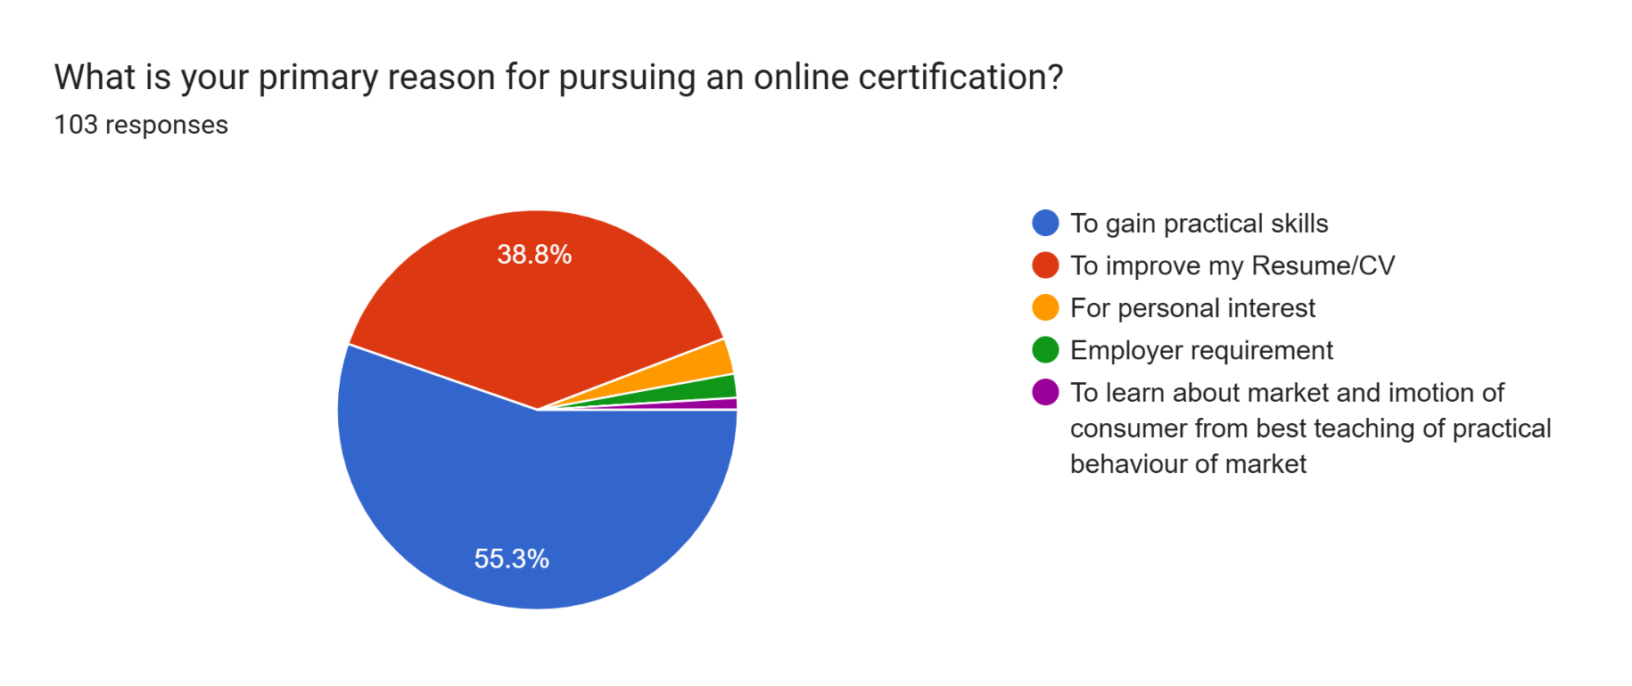

Most respondents (**55.3%**) said they pursue online certifications to **gain practical skills**. Another **38.8%** mentioned **improving their resume or CV** as the main reason. A small number (**around 6%**) cited **personal interest**, **employer requirements**, or **curiosity about market behaviour** as their motivation.

**4.4 Skill Development & Confidence**

1. On a scale of 1-5, how much did the online certification improve your practical skills?

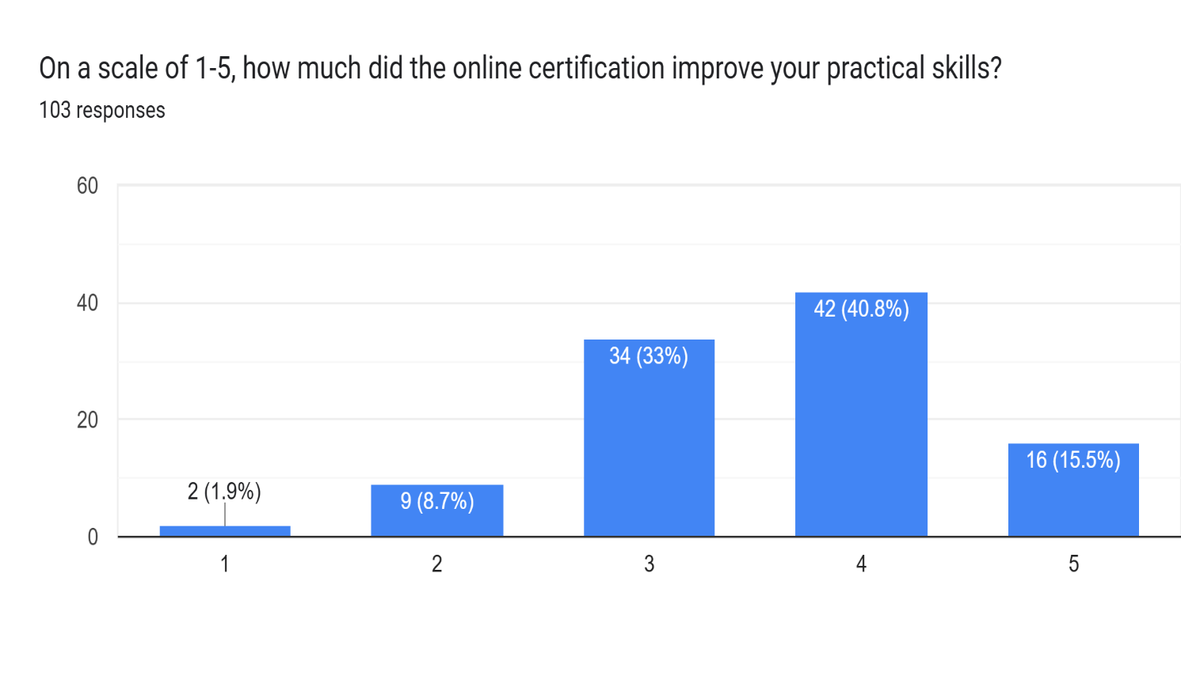

Most respondents rated the improvement in their practical skills between **3 and 4**, indicating a **moderate to high** level of skill development through online certifications.

1. Do you feel confident applying the skills you learned in an online certification to real-world tasks?

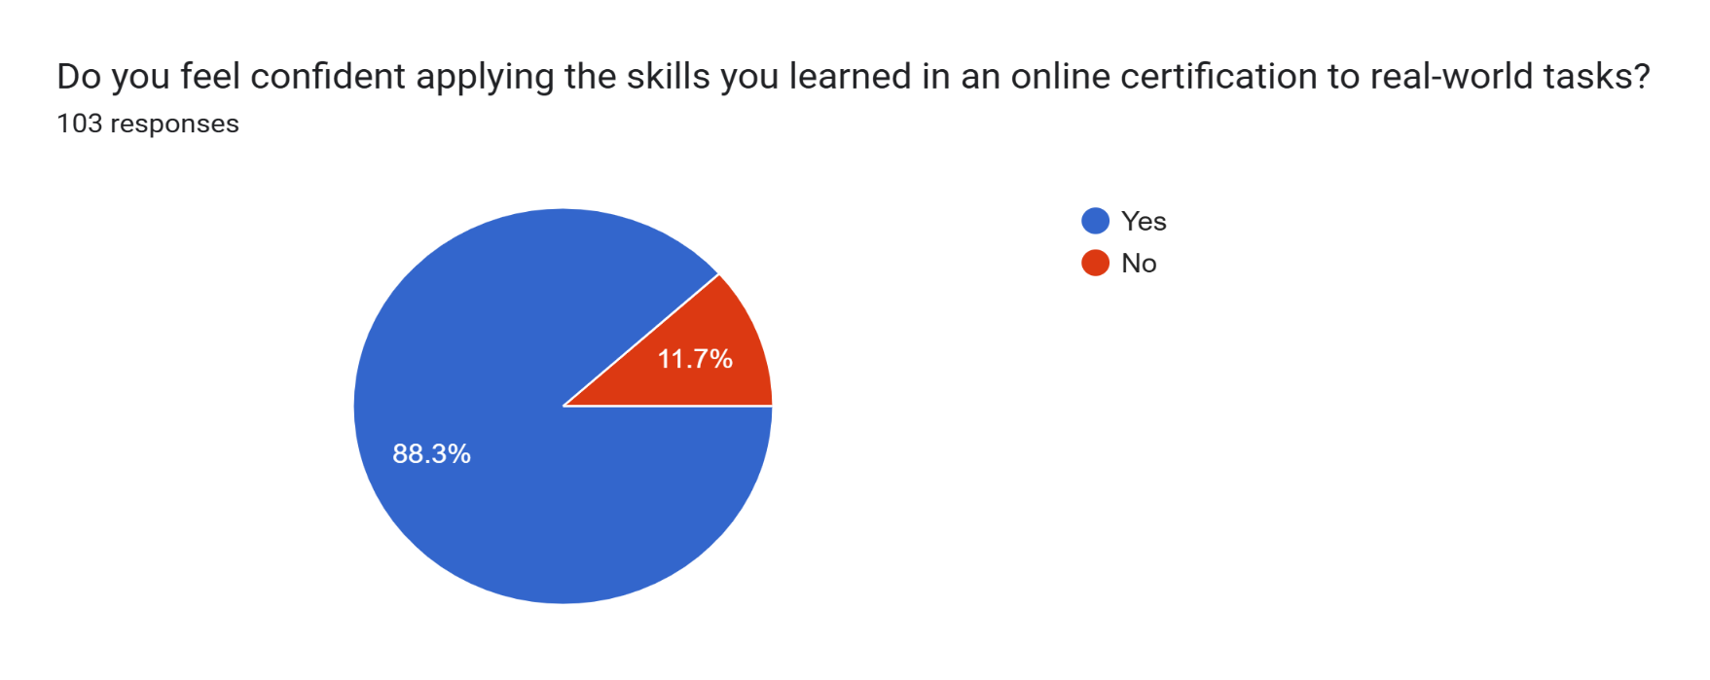

A strong majority of respondents (**91 out of 103**) said **yes**, they feel confident applying the skills gained from online certifications to real-world situations. This shows a high level of practical relevance and usefulness of the certifications.

1. How often do you apply the skills learned from your online certifications in real-world situations?

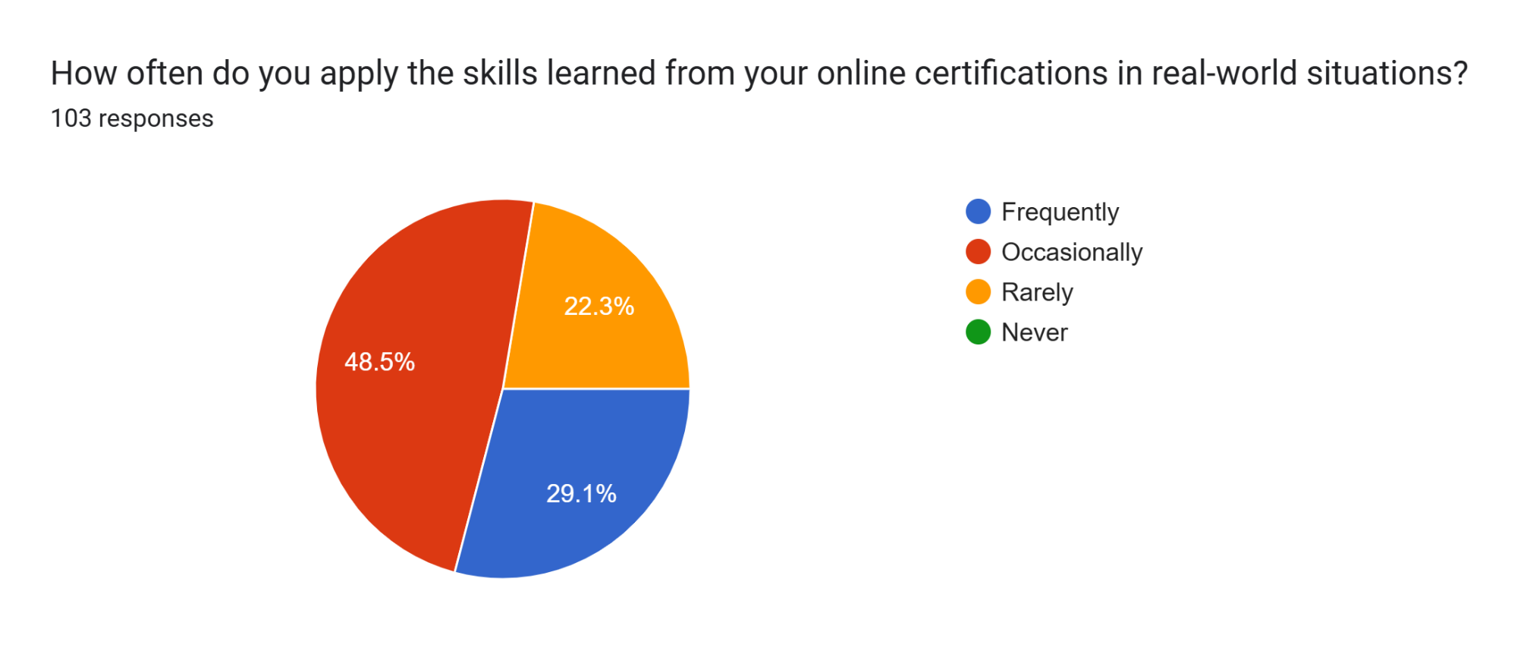

Nearly **half of the respondents (48.5%)** said they apply their skills **occasionally**, while **29.1%** use them **frequently**. A smaller portion, **22.3%**, reported applying their skills **rarely**, indicating that while many find the skills useful, their usage may depend on specific job roles or opportunities.

**4.5 Engagement & Learning Behaviour**

* 1. Which of the following describes your engagement with online courses?

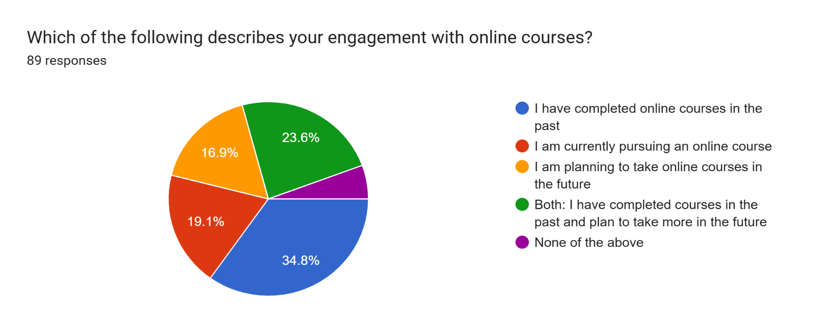

The responses showed a variety of engagement levels. **34.8%** of respondents have **completed online courses in the past**, while **19.1%** are **currently pursuing** one. **16.9%** plan to take courses in the future, and **23.6%** have **both completed courses and plan to take more**. Only **5.6%** said **none of the above**, indicating overall high interest and participation in online learning.

[

* 1. Do you typically watch the video content provided in online certifications?

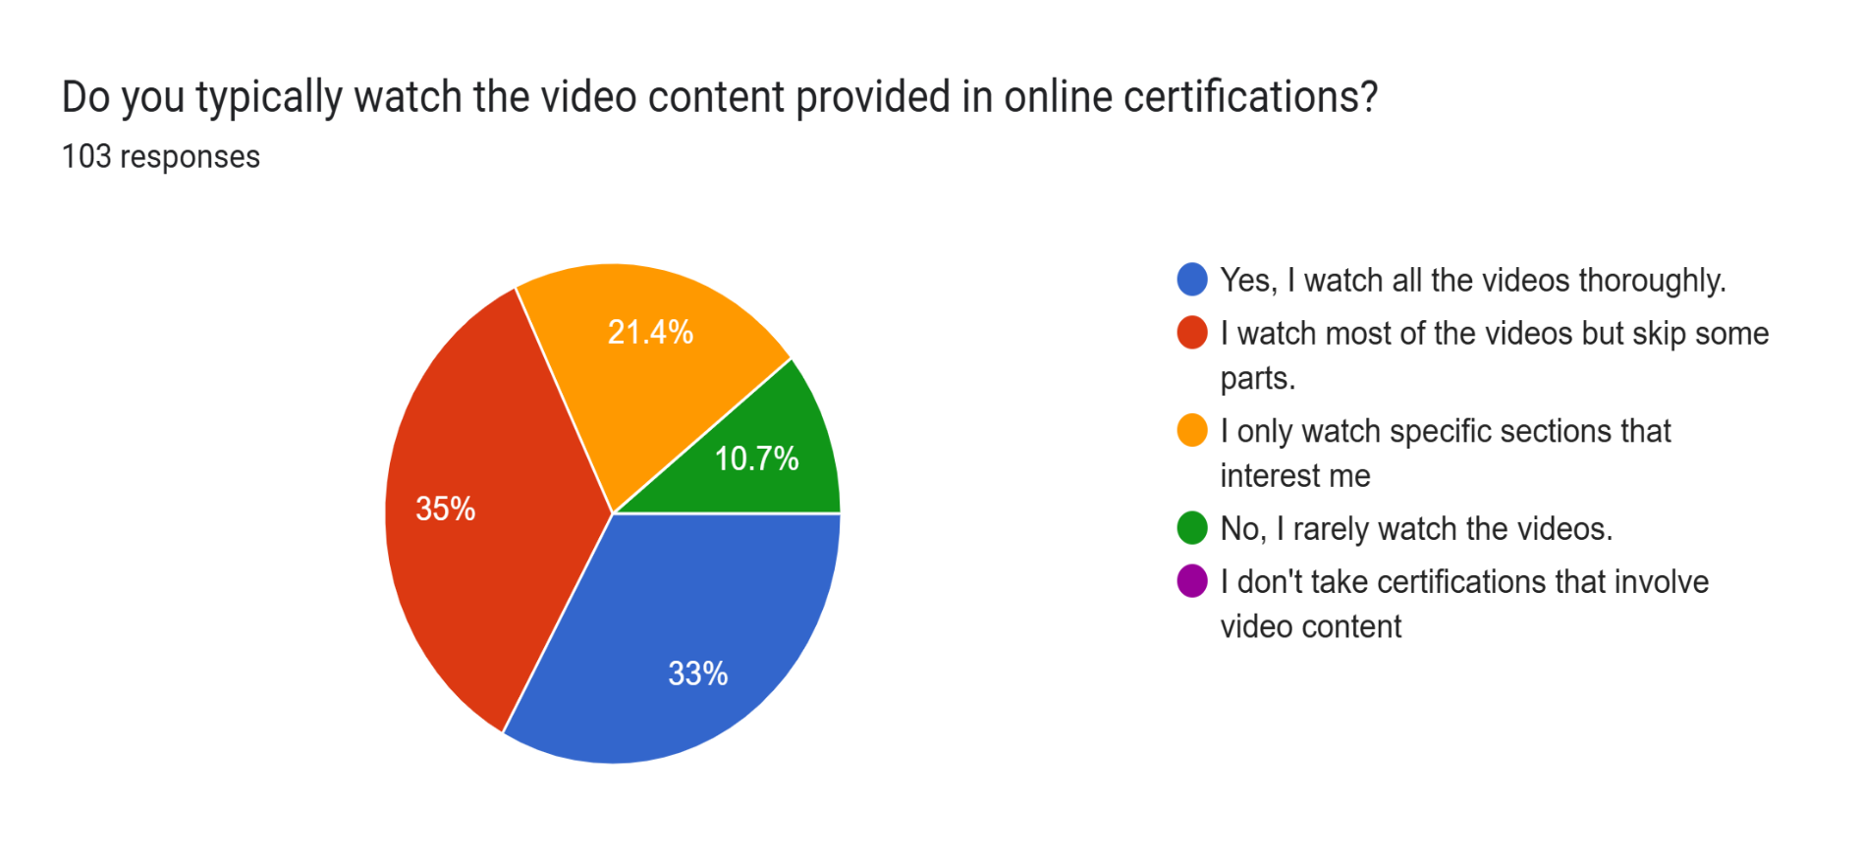

When it comes to engaging with video content, **35%** of respondents said they **watch most videos but skip some parts**, while **33%** reported watching **all the videos thoroughly**. **21.4%** prefer to watch **only specific sections** that interest them, and **10.7%** said they **rarely watch the videos**. This shows that while many learners stay engaged, selective viewing is also common.

**4.6 Limitations of Online Certifications**

a)In your opinion, what are the biggest limitations of online certifications?

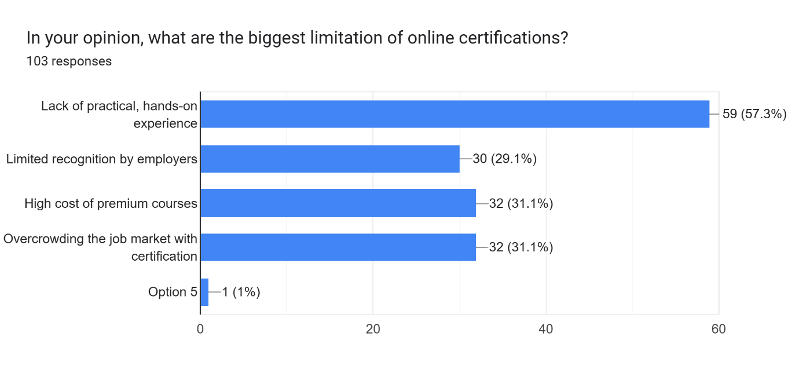

Most people said the biggest problem with online certifications is the **lack of hands-on experience** (59 votes). Other common issues were the **high cost**, **too many people with similar certificates** (both 32 votes), and **limited value in the eyes of employers** (30 votes)

**Chapter – 5**

**Interpretation, Conclusion and Future Research**

**CHAPTER 5 – INTERPRETATION, CONCLUSION, AND FUTURE RESEARCH**

**5.1 Interpretation of Findings**

This research set out to answer a big question: *Do online certifications truly enhance careers, or are they just digital decorations on résumés?* The answer? It’s complicated—but eye-opening.

Let’s break down what the data really told us:

**1. Perceived Value vs. Real-World Use**  
A massive *91 out of 103 respondents* felt that online certifications boosted their skills and confidence. Sounds great, right? But here’s the twist—*almost half of them said they rarely used those skills*. That’s a red flag. It means many courses might be teaching theory without offering real chances to practice.

And nothing illustrates this better than the story of *Bisma Fareed*, the Delhi University topper with *50+ certificates*—yet she couldn’t land a job. Her viral LinkedIn post said it all: *“I wasn’t ready for the skills question.”* That one sentence mirrors what our data revealed—certificates can’t replace competence.

**2. Platform Choices and Real Intentions**  
*Coursera, LinkedIn Learning, and Udemy* led the pack—84% of respondents favoured them for their industry-aligned content. But here's the kicker: *59% still felt these platforms lacked hands-on learning opportunities.* Even the best-known names aren’t closing the skill gap entirely.

As for why people pursue these courses? It’s a mix: *55.3% wanted practical skills*, while *38.8% were résumé-driven*. This tug-of-war between learning for growth vs. learning for display reflects today’s fast-paced job market—and maybe even some peer pressure.

**3. What Employers Really Think**  
When we looked at qualitative responses, the divide became clear. *Tech, design, and marketing recruiters* are more welcoming of online certifications. But in *law, finance, and traditional business roles*, degrees still carry more weight.

One recruiter summed it up perfectly: *“Certificates are everywhere now. We look for projects, not paper.”* That comment echoes again and again—recruiters want proof, not printouts.

**4. Engagement Patterns: Are Learners Really Learning?**  
Here’s a stat that made us pause: only *33% of learners* watched course videos completely. *35% skipped sections*, and *22.3% rarely applied what they learned*. This trend of “checklist learning”—doing courses just to get the certificate—is very real. And it's holding learners back.

**5.2 Conclusion**

Online certifications are a *blessing and a trap*. On one hand, they open doors and democratize learning. On the other, if pursued carelessly, they become just another checkbox in the race for validation.

This research makes one thing very clear:

* *Certifications only work when paired with action.* Without real application, they’re just digital trophies.
* *Recruiters are changing the game.* Stories like Bisma’s aren’t exceptions anymore—they’re warnings. The skill-first mindset is here.
* *One good course beats five rushed ones.* The quality-over-quantity rule isn’t just for food or fashion—it applies to learning too.

**Limitations to Keep in Mind:**  
While the insights are strong, this study has a few limitations. The sample mainly included students and early-career professionals. We gathered employer views through open-ended comments, not structured interviews. Future studies could dive deeper into what hiring managers *really* think.

**5.3 Future Research**

The findings have sparked exciting possibilities for further exploration. Here’s where future research can go:

1. **Track Long-Term Impact:**  
   Let’s follow learners for 5–10 years to see if and how certifications actually shape their careers over time.
2. **Dig Into Recruiter Preferences:**  
   What *exactly* do employers want from a certified candidate? Do certain skills or platforms stand out more than others?
3. **Test New Learning Models:**  
   Platforms like Coursera are adding *Guided Projects*. Do these new formats actually build better skills? Let’s find out.
4. **Compare Certifications with Degrees:**  
   As micro-credentials grow, do they stand a chance against traditional degrees? Which one do employers pick when both are on the table?

**Final Thought**

Bisma’s viral post ended with a message that still rings in our ears: *“Master a skill like a habit.”* And this research backs her up. Certificates can open doors—but it’s your skills that get you through them.

The future of online learning isn’t about collecting badges. It’s about becoming someone who knows their craft, shows up with confidence, and stands out in a sea of paper qualifications. In the race for careers, it’s not the one with the most certificates who wins—it’s the one who knows what to do when the real questions come.

**CHAPTER – 6**

**REFERENCES**

**References**

1. Bisma Fareed (18 April 2025). “I wasn’t ready for the skills question: - LinkedIn Post. Retrieved from: <https://www.linkedin.com/posts/bisma-fareed-1a522b291_im-a-topper-or-mujhe-internship-nhi-mil-activity-7318838213261893634-YMNw?utm_source=share&utm_medium=member_desktop&rcm=ACoAAEtiWooBdnxOA4nuxz2ozIB1DUcFnjGgYB4>
2. Professional Skills Development Through the Network Learning Community Using an Online Learning Platform. (2020) Retrieved from: <https://online-journals.org/index.php/i-jim/article/view/21587>
3. What are the pros and cons of online certification vs. traditional certification (2023) LinkedIn Post. Retrieved from: <https://www.linkedin.com/advice/0/what-pros-cons-online-certification?utm_source=share&utm_medium=member_desktop&utm_campaign=copy>