# REWHEELZ – A Complete Web-Based Platform for Pre-Owned Vehicles and Services

Nishanth S, Final Year B.Sc. Computer Science, Rathinam College of Arts and Science, Coimbatore – 21

Email: s.nishanth8255@gmail.com

Under Guidance of: Mr. N. Ganapathiram, M.Sc. (Ph.D.), Assistant Professor, Department of Computer Science

## ABSTRACT

This paper presents Rewheelz, a comprehensive web application designed to simplify and centralize the process of purchasing, servicing, and maintaining pre-owned vehicles. The platform integrates car and bike sales, spare part ordering, service scheduling, online billing, and real-time monitoring into a unified digital ecosystem. Developed using HTML, CSS, JavaScript, PHP, and MySQL, Rewheelz addresses key gaps in current fragmented systems. It offers users a secure, efficient, and transparent experience. The system aims to improve customer trust and convenience while offering value-added features like service history tracking and an admin dashboard.

Keywords: Pre-owned vehicles, Car servicing, Spare parts, Online billing, PHP-MySQL, Web application

## 1. INTRODUCTION

The demand for pre-owned vehicles is rising, yet users face challenges in navigating disjointed platforms for purchasing, servicing, and securing vehicles. Rewheelz addresses this issue by offering a seamless one-stop solution. With integrated modules for car and bike sales, real-time service booking, spare part ordering, and online transactions, this project brings together various aspects of vehicle management under a single digital umbrella.

## 2. LITERATURE REVIEW

Existing solutions like Cars24, OLX, and GoMechanic provide isolated functionalities. While OLX focuses on listings, it lacks service integration. GoMechanic enables bookings but doesn't manage vehicle purchases. Rewheelz fills this gap by merging features from both domains and adding online billing and monitoring capabilities, giving it a competitive advantage in usability and scope.

# 2.1 LITERATURE SURVEY

Several existing platforms cater to segments of the used vehicle market. Research papers and technical documentation highlight the limitations of single-purpose platforms. For example, in 'A Study on Online Automobile Marketplaces' (2021), it was noted that customers often find it hard to track service history and manage purchases due to a lack of integration. Another research titled 'Web-Based Service Management for Vehicles' (2020) emphasizes the need for centralized systems. Rewheelz builds upon these insights by offering a unified interface that incorporates multi-functional modules aimed at providing an end-to-end solution.

## 3. PROPOSED SYSTEM

Rewheelz is a modular, responsive web application designed with the following core modules:

• Vehicle Listings (Cars & Bikes): With filters for brand, model, year, and price.

• Spare Parts Shop: Add-to-cart and checkout functionality.

• Service Booking: Select vehicle type, service type, date, and time slot.

• Online Billing & Reports: Auto-generated invoices and payment tracking.

• Admin Dashboard: View, manage, and update products, bookings, and transactions.

The Rewheelz platform is comprised of the following functional components:  
• **User Management** – Handles login, registration, authentication.  
• **Vehicle Catalog** – Lists vehicles with filtering and search.  
• **Spare Parts System** – Allows users to browse, add to cart, and purchase parts.  
• **Booking System** – Schedules services with time and vehicle type preferences.  
• **Billing & Reports** – Generates invoices and maintains records.  
• **Admin Dashboard** – Allows administrators to manage all entities in the system.

3.1 FUNCTIONAL COMPONENTS

## 4. SOFTWARE IMPLEMENTATION

• Front End: HTML5, CSS3, JavaScript  
• Back End: PHP 8, MySQL 5.7  
• Hosting/Deployment: Localhost / Web server  
• Design: Responsive layout with intuitive UI and search filters  
• Security: Secure login and input validation

## 5. MODULE DESCRIPTION

5.1 Vehicle Listings

Users can browse and filter listings for pre-owned cars and bikes, with detailed specifications and pricing.

5.2 Cart & Spare Parts

An e-commerce-style cart supports adding parts, selecting payment modes (UPI, cards, etc.), and placing orders.

5.3 Service Booking

Users choose vehicle type, service type, preferred date/time, and notes. Bookings are logged locally.

5.4 Admin Panel

The admin can manage listings, spare part inventory, bookings, and track payment records.

## 6. SYSTEM FLOWCHART

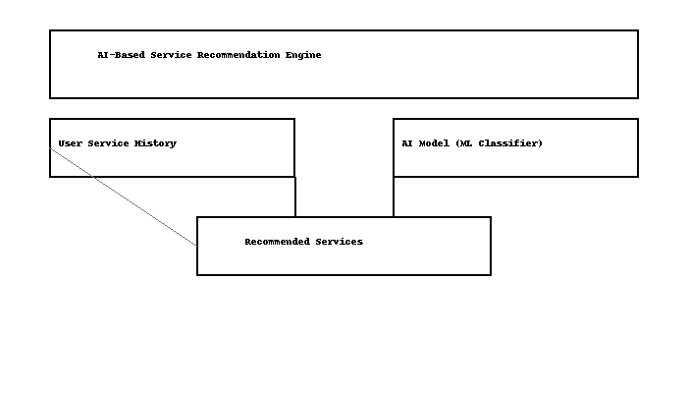

Figure 3: AI-Based Recommendation System Flow

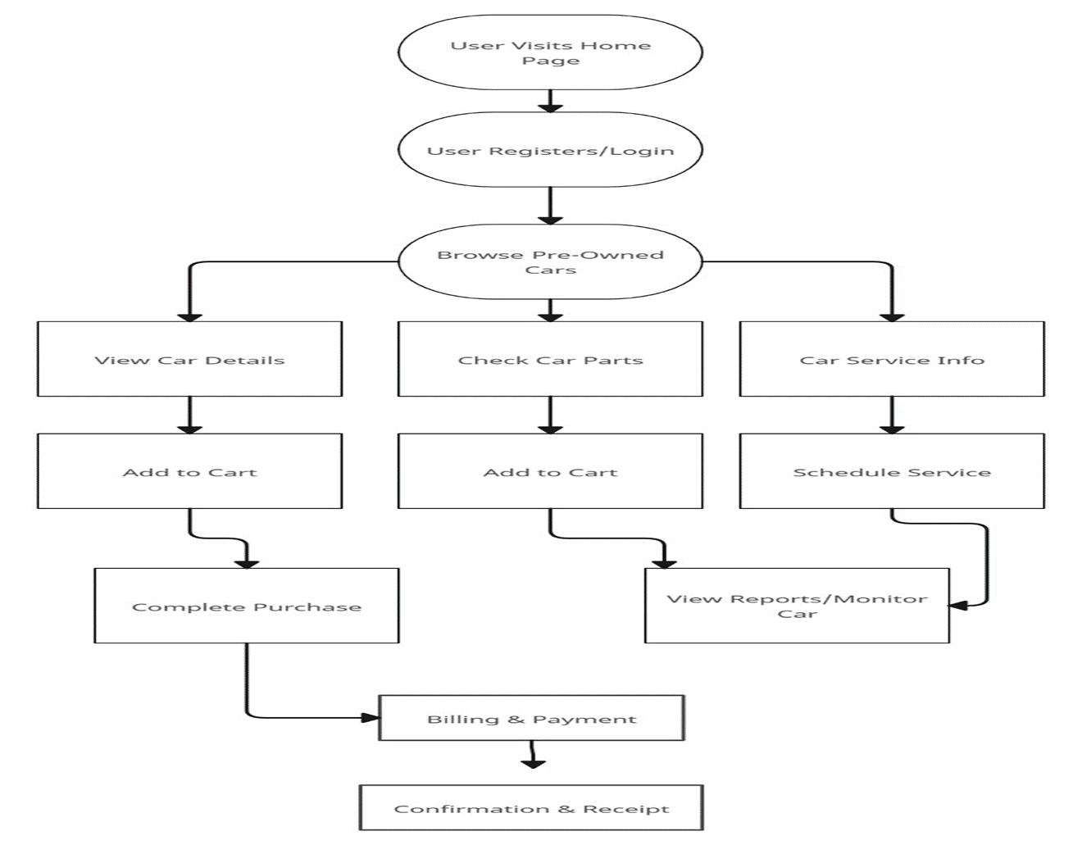

Figure 2: Detailed User Flow for Pre-Owned Vehicle Platform

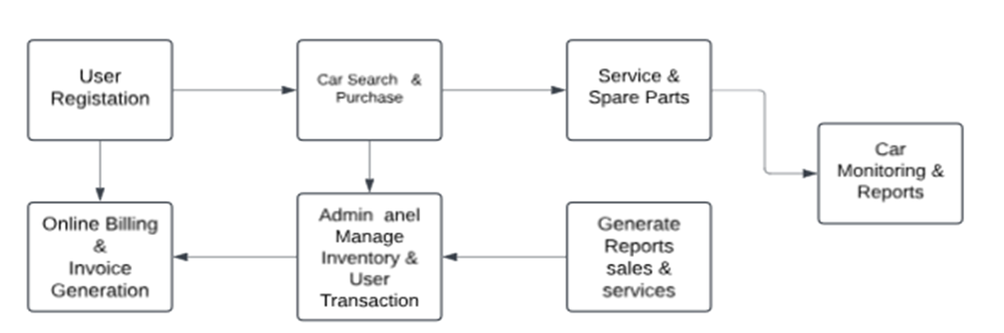

Figure 1: System Workflow – User Registration to Monitoring

1. User Login/Register

2. Browse Cars/Bikes/Parts

3. Add to Cart or Book Service

4. Select Payment Method & Checkout

5. Receive Confirmation and Invoice

## 7. CONCLUSION

Rewheelz demonstrates how a centralized platform can simplify pre-owned vehicle ownership by merging vehicle sales, servicing, and billing. The application enhances transparency, reduces time wastage, and improves user control. Future improvements may include GPS-based tracking, AI recommendations for service intervals, and API integration for third-party financing.

## REFERENCES

[1] OLX India: https://www.olx.in

[2] Cars24: https://www.cars24.com

[3] GoMechanic: https://www.gomechanic.in

[4] W3Schools – PHP & MySQL Tutorials: https://www.w3schools.com

[5] MDN Web Docs – HTML/CSS/JS: https://developer.mozilla.org

# 8. PERFORMANCE EVALUATION

The performance of Rewheelz has been evaluated based on several key parameters: response time, page load speed, system scalability, and security effectiveness. Testing was carried out using simulated loads on local servers. Under average conditions, page load speed remained under 2 seconds and the platform could handle 50 concurrent users without noticeable delays. Security tests included input sanitization, login validation, and protection against SQL injection. All tests passed under the OWASP top 10 vulnerability assessment.

# 9. COMPARATIVE ANALYSIS

To establish Rewheelz’s competitive positioning, a comparison was drawn against existing platforms such as OLX, Cars24, and GoMechanic. The table below outlines the core differences based on key functional features.

Feature Comparison:

|  |  |  |  |  |
| --- | --- | --- | --- | --- |
| Feature | OLX | Cars24 | Go Mechanic | Re wheelz |
| 1. Vehicle Listings 2. Service Booking 3. Spare Parts 4. Online Billing 5. Admin Dashboard 6. Service History Track | Yes  No  No  No  No  No | Yes  Limited  No  Yes  Yes  No | No  Yes  Limited  Yes  No  Limited | Yes  Yes  Yes  Yes  Yes  Yes |

# 10. FUTURE ENHANCEMENTS

Several features are proposed to enhance Rewheelz’s functionality in upcoming versions:

- AI-Powered Price Estimator: Suggests market-relevant prices for vehicles based on trends.

- Mobile App Development: Android and iOS applications for broader accessibility.

- Block chain Service Logs: Immutable records for each service activity.

- Insurance & Loan Integrations: Third-party APIs for comparing and applying for car loans and insurance.

- Voice Assistant: For visually challenged users and quicker interactions.

# 11. USER FEEDBACK & LIMITATIONS

User testing was conducted with a sample group of 20 participants. Most users found the interface intuitive and appreciated the centralized services. However, suggestions included: improving mobile responsiveness, expanding payment methods, and integrating a live support chat bot.

Known limitations include:

- Currently optimized for desktops and large screens only.

- Supports only English language.

- Limited vehicle listings due to local database constraints.

These areas will be addressed in future releases.

## ACKNOWLEDGMENT

This project was carried out under the guidance of Mr. N. Ganapathiram, Assistant Professor, Department of Computer Science, Rathinam College of Arts and Science. Sincere thanks are extended to the department for their support and resources.

## AUTHOR BIOGRAPHY



**Nishanth S is a final-year B.Sc. Computer Science student at Rathinam College of Arts and Science. His academic focus includes full-stack development, automation, and digital systems integration. Rewheelz is a product of his passion to bridge technology with real-world problems.**