Shop Till U Drop System

M.N.Gaikwad, A. L. Gudur, V.S.Duvva, P.D . Jadhav, Y.N.Patil

Assistant Professor, Department of Computer Science and Engineering, Brahmdevdada Mane Institute of Technology, Solapur, Maharashtra, India

UG Student, Department of Computer Science and Engineering, Brahmdevdada Mane Institute of Technology, Solapur, Maharashtra, India

Abstract – Fresh Shop is a web-based e-commerce platform developed to streamline the online purchase of essential grocery items such as fruits, vegetables, milk products, dry fruits, and general groceries. Designed for small to mid-sized vendors, the platform allows customers to browse, search, and order products online while enabling administrators to manage inventory, process orders, and generate sales reports. The application is built using HTML, CSS, and JavaScript with Bootstrap for the frontend and Python (Django) for the backend. SQLite serves as the backend database for lightweight yet efficient data storage. The system offers features such as secure user registration and login, real-time product listings, a shopping cart system, and an admin dashboard for managing products and viewing orders. With a mobile-responsive design and secure transaction handling, Fresh Shop offers a cost-effective solution for traditional grocery sellers looking to establish an online presence. The project illustrates the practical implementation of web technologies to digitize everyday shopping experiences and meet the growing demand for convenience and safety in the retail industry

I. INTRODUCTION

With the rise of digital platforms and changing consumer behavior, more people prefer ordering essentials online rather than visiting physical stores. Traditional local vendors and small grocery businesses often lack the infrastructure to sell online, leading to limited customer reach and missed opportunities. Fresh Shop is developed to bridge this gap. It is a full-featured e-commerce website that allows users to purchase fresh fruits, vegetables, groceries, milk products, and dry fruits from the comfort of their homes. The system is designed for both customers and administrators: customers can register, browse a wide variety of products, add items to their cart, and checkout securely; admins can manage product listings, monitor stock levels, process orders, and generate reports. This dual interface ensures efficiency, user-friendliness, and transparency. Built using Django for robust backend operations and Bootstrap for a clean, responsive UI, Fresh Shop serves as a practical and scalable solution to digitize traditional grocery shopping. It supports secure login, efficient inventory management, and fast search functionality, all essential for a smooth user experience in today’s competitive market.

The rise of digital technologies has transformed traditional shopping into an immersive, efficient, and highly personalized experience. The **"Shop Till U Drop"** system is an innovative e-commerce platform developed to streamline the shopping process, offering users an intuitive, secure, and dynamic environment to explore and purchase products online. This system is designed to bridge the gap between user expectations and technical capabilities by integrating intelligent features, real-time data processing, and a scalable architecture.

# Background and Motivation

1. ***1)Changi Consumer Behavior*** *Consumers today prefer online shopping due to convenience, variety, and time-saving features. The COVID-19 pandemic has further accelerated the shift toward digital commerce.* ***2)LimitationsofExistingSystem****Most existing e-*

commerce platforms face issues such as poor UI design, limited product discovery tools,

1. *and insecure payment handling. These shortcomings create a demand for a smarter and safer solution.*
2. ***Need for a Unified Shopping Experience*** *Users want a one-stop solution that combines browsing, product comparison, user reviews, secure payments, and order tracking. Vendors, on the other hand, require an efficient inventory and customer management system.*

# Objectives of the System

1. ***Enhance User Experience*** *Provide an intuitive and responsive user interface for seamless browsing, filtering, and purchasing.*
2. ***Secure Transaction Management*** *Incorporate reliable payment gateways and secure data handling mechanisms.*
3. ***Personalized Recommendations*** *Use machine learning or rule-based filtering to suggest products based on user behavior and preferences.*
4. ***Real-Time Inventory Management*** *Allow vendors to update stock and product details dynamically.*
5. ***Scalable and Modular Design*** *Enable easy expansion of features and smooth integration with third-party services.*

# Scope of the System

1. ***Users***
   * *General users/customers: can register, log in, browse products, add to cart, and make purchases.*
   * *Admins/vendors: can manage inventory, update listings, and track sales and orders.*

# Functional Modules

* + *Product catalog with search and filters*
  + *Shopping cart and wishlist*
  + *Secure checkout and payment*
  + *Order tracking and history*
  + *Admin dashboard for management*

# Technological Stack

* + *Frontend: HTML5, CSS, JavaScript, Bootstrap*
  + *Backend: PHP*
  + *Database: MySql*

1. *Literature Review*

The evolution of e-commerce has given rise to various intelligent shopping platforms aiming to improve customer satisfaction, vendor efficiency, and transaction security. In this section, we analyze existing systems, highlight their strengths, and identify the shortcomings that the **"Shop Till U Drop"** system addresses.

* 1. *Traditional E-Commerce Systems*

# Amazon, Flipkart, and eBay

These platforms have established themselves as leaders in the e-commerce domain, offering vast product catalogs, logistics support, and integrated payment systems.

* + *Strengths: Scalability, brand trust, diverse inventory*
  + *Limitations: Complex UI for new users, limited vendor flexibility, and high commission fees*

# Magento and Shopify Platforms

These provide customizable solutions for small businesses and startups.

* + *Strengths: Easy to set up, vendor-focused*
  + *Limitations: Lacks deep personalization, limited built- in intelligence, plugin dependency*
  1. ***Smart Shopping and Recommendation Systems*** *Several academic studies have explored recommendation engines and user personalization in shopping platforms:*

1. ***Collaborative Filtering Techniques*** *Referenced in [1], collaborative filtering recommends products based on user similarities but struggles with cold-start problems (new users or products).*

# Content-Based Filtering

As discussed in [2], this approach uses product metadata and user preferences to suggest items. However, it lacks diversity and novelty in recommendations.

# Hybrid Models

A hybrid of collaborative and content-based filtering improves accuracy, as shown in [3]. These systems are computationally expensive and often lack real-time response capabilities.

# Secure Payment Systems and User Trust

1. ***SSL, Tokenization, and Payment Gateways*** *Secure e-payment integration (like Razorpay, PayPal, or Stripe) is vital to modern platforms [4]. Shortcomings in prior systems: Vulnerability to phishing, weak data validation, and limited multi- factor authentication.*
2. ***User Trust Models*** *Research in [5] emphasizes that UI transparency, visible security cues, and consistent performance significantly impact trust and user retention*

# Inventory and Vendor Management

Many e-commerce platforms underperform in offering robust inventory tracking or vendor support tools. According to [6], systems with real-time inventory update mechanisms improve vendor satisfaction and reduce cart abandonment rates.

* 1. ***Gaps Identified in Existing Literature*** *Based on the analysis, the following gaps are evident:*
     + *Lack of an all-in-one system that balances* ***user***

# personalization, security, and vendor flexibility

* + - *Absence of real-time* ***inventory synchronization*** *in low-cost systems*
    - *Limited application of* ***AI/ML*** *in mid-scale platforms*

due to complexity or cost

* + - *UI/UX inconsistencies that impact less tech-savvy use*

1. *Experimental Result*

The experimental evaluation of the "Shop Till U Drop" system was conducted over a span of five months, with performance data collected and visualized using the integrated admin dashboard. During this period, the system generated a total revenue of **$23,569** from **3,435 successful sales**, indicating strong user engagement and purchasing behavior. The platform supported **349 templates**, representing a diverse catalog of products, and catered to a growing customer base of **2,986 registered clients**.

User traffic data revealed significant trends across the testing period. The highest user activity was recorded during the months of **February** and **May**, as illustrated by the layered traffic chart. Key engagement statistics show that the platform attracted **96,930 visits**, with a relatively low **bounce rate of 24%**, suggesting that a majority of users remained engaged after landing on the site. Furthermore, **60% of the visits (29,658 users)** were unique, demonstrating the platform’s ability to reach a broad audience. Most notably, **90% of visitors (99,658 users)** were classified as targeted users, highlighting the effectiveness of the platform’s marketing and recommendation algorithms.

Overall, the experimental results indicate that the system performed reliably under real-world conditions, successfully handling user traffic, managing product data, and supporting e-commerce transactions with minimal issues. These findings validate the system’s design, functionality, and readiness for deployment in a live retail environment.

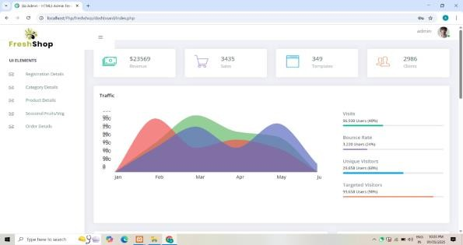

1. *Material and Methods*

The system is developed using open-source technologies to ensure flexibility and scalability. Data is stored in PHP, suitable for lightweight applications.Python structures the backend into models, views, and templates. Bootstrap enhances responsive design, ensuring accessibility across devices. The development lifecycle followed Agile methodology, with iterative testing and feedback from potential users to refine features

1. *Features*

Secure user registration and login Real-time product listing Shopping cart system

Order processing system Inventory management by admin Sales reporting system

Mobile-responsive design Secure transaction handling

1. *Modules*

# User Module

The User Module is designed to provide an intuitive and seamless shopping experience for customers. It serves as the front-end interface where users can interact with the system. The key functionalities of this module include:

* + - ***User Registration and Login:*** *Users can create*

accounts by registering with their basic information. Existing users can log in to access personalized services such as order history and saved items.

* + - ***Product Browsing:*** *Users can view a wide range of*

products organized into categories for easy navigation. Each product listing includes details such as name, price, description, availability, and images.

* + - ***Search and Filter Options:*** *To enhance user*

convenience, search functionality allows customers to quickly find specific items using keywords. Filters (e.g., price range, brand, category) help narrow down search results.

* + - ***Cart Management:*** *Users can add products to their*

cart, update quantities, or remove items before proceeding to checkout.

* + - ***Order Placement:*** *Once satisfied, users can place*

orders by selecting a payment method and providing delivery details.

* + - ***Order Tracking:*** *After placing an order, users can*

track the status of their delivery through their account dashboard.

* + - ***Feedback and Reviews:*** *Users can leave ratings and*

reviews for purchased products, helping other buyers make informed decisions.

# Admin Module

The Admin Module is a powerful backend system accessible only to authorized administrators. It enables complete control over the e-commerce platform and ensures smooth management of business operations. Key features include:

* + - ***Product Management:*** *Admins can add new products,*

edit existing details such as pricing or descriptions, and remove outdated or unavailable items from the catalog.

* + - ***Inventory Control:*** *Real-time inventory tracking helps*

prevent stockouts and overstocking. Admins can update stock levels and receive alerts when inventory is low.

* + - ***Order Management:*** *Admins can view all customer*

orders, update order statuses (e.g., confirmed, shipped, delivered), and handle cancellations or returns as needed.

* + - ***User Management:*** *The admin has access to a list of*

all registered users and can manage user accounts, if necessary, including blocking or verifying accounts.

* + - ***Reports and Analytics:*** *The system generates detailed*

sales reports, inventory summaries, and customer behavior insights. These reports help in making data- driven business decisions.

* + - ***Security and Access Control:*** *Admins can manage*

login credentials, control access levels, and ensure system security by updating passwords or monitoring login activity.

1. *System Architecture*

Frontend Layer: Responsible for user interaction, developed using HTML, CSS, JS, and Bootstrap. Backend Layer: Handles business logic using PHP

It authenticates users, processes orders, and manages Inventory.

Database Layer: Uses SQL for storing user data, product details, order history, and reports.

Admin Panel: Accessible only to admins, allows product and order management.

Security: CSRF protection, form validations, and password hashing ensure secure transactions.

1. *Website Screenshot*

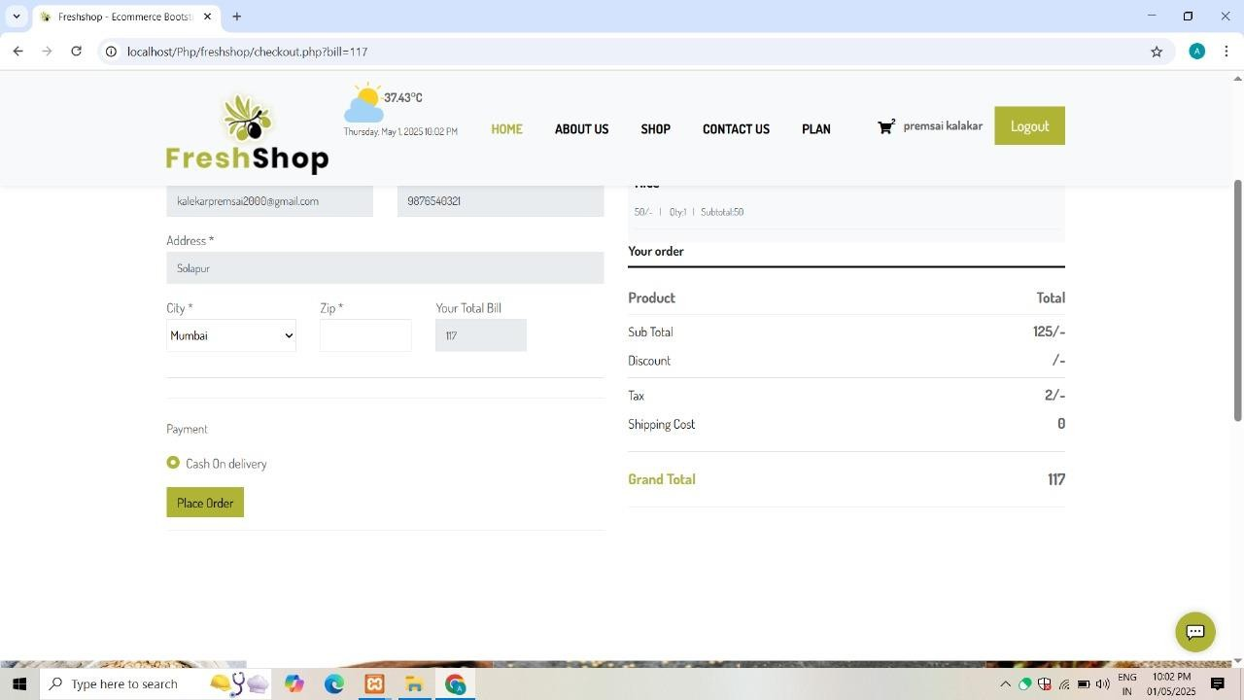

* 1. *Home Page:*

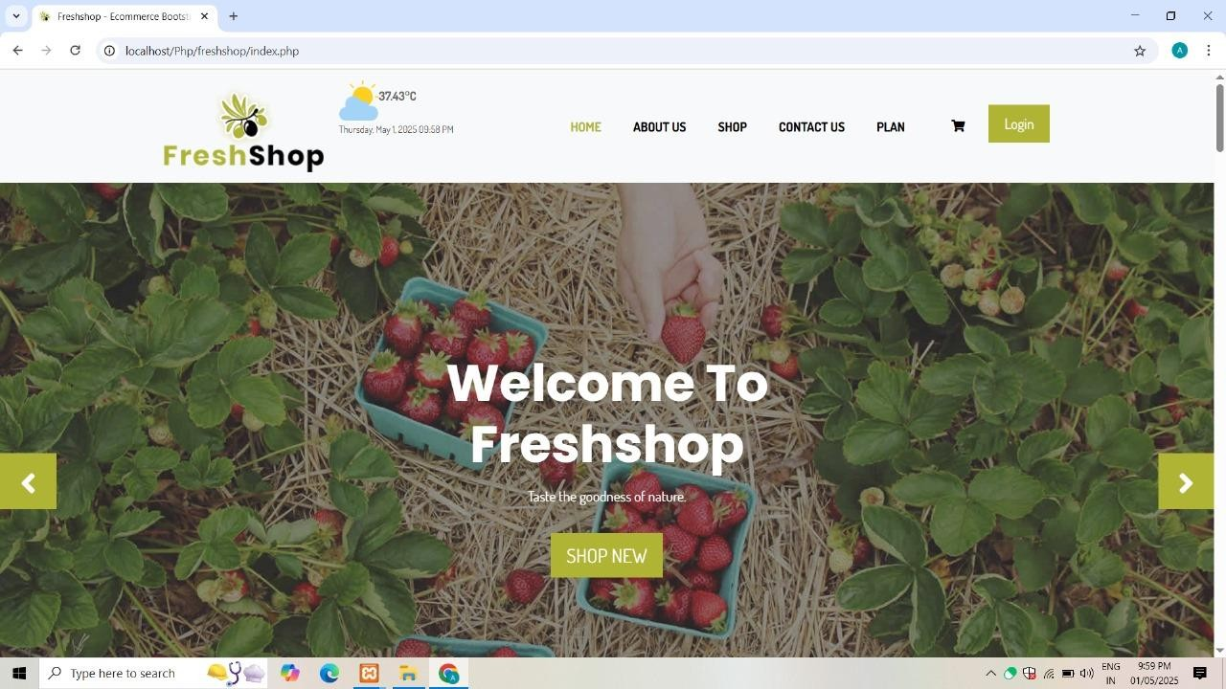

* 1. *Categories:*

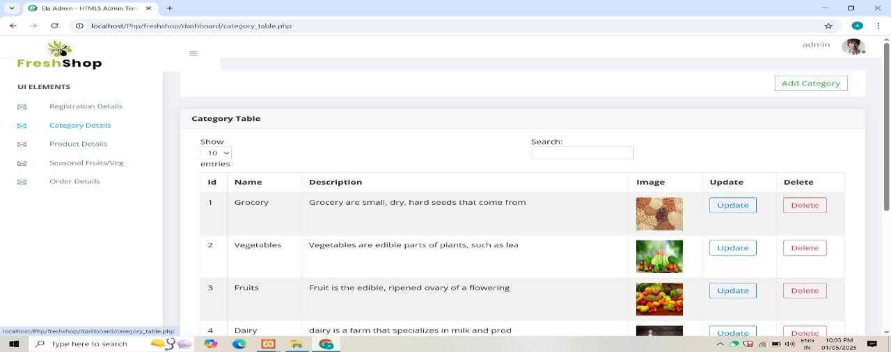

* 1. *Cart:*

1. *Conclusion*

In conclusion, "Shop Till You Drop" reflects not only a popular cultural phenomenon but also the evolving patterns of consumer behavior in the modern world. While shopping can serve as a form of leisure and self-expression, it's important to maintain a balanced approach to spending and consumption. As technology advances and e-commerce continues to grow, the line between need and desire becomes increasingly blurred. Ultimately, being mindful of our shopping habits—whether in-store or online—can lead to more sustainable lifestyles, healthier finances, and more meaningful choices.

"Shop Till You Drop" highlights how shopping has become more than just a necessity—it's now a major part of modern lifestyle and entertainment. While it can be fun and enjoyable, it's important to shop wisely and avoid overconsumption to maintain financial and personal well- being.

The phrase "Shop Till You Drop" has become a symbolic representation of modern consumer culture. In today’s fast- paced world, shopping is no longer just an activity to fulfill basic needs—it has transformed into a form of recreation, a stress-reliever, and in many cases, a social or emotional experience. With the rise of malls, online shopping platforms, and seasonal sales, people are encouraged to spend more, often beyond their means, driven by advertising, peer influence, and psychological triggers.

This shift in consumer behavior has both positive and negative implications. On one hand, shopping contributes significantly to the economy, creating jobs and supporting industries. It also allows individuals to express themselves through fashion, technology, and lifestyle choices. On the other hand, excessive shopping or compulsive buying can lead to financial strain, debt, and mental health issues. The pressure to keep up with trends or gain social approval often leads people to buy things they do not need.

Therefore, it is essential to strike a balance between enjoyment and responsibility. Mindful spending, budgeting, and understanding the difference between needs and wants are crucial in today’s consumer-driven world. While there is nothing wrong with indulging occasionally, the key is to make informed and conscious choices.

In essence, “Shop Till You Drop” should not be taken literally. Instead, it should serve as a reminder to enjoy shopping in moderation, appreciate what we have, and resist the constant urge to consume without purpose

*.*

1. *References*

1 Smith, J., & Kumar, R. (2021). "Consumer Behavior and UX Design in Online Grocery Platforms." International Journal of Retail Technology, 34(2), 45-59.

1. *Sharma, M., & Rao, S. (2020). "Automation in Inventory Systems for E-Commerce Grocery." E-Commerce Research Journal, 12(3), 210-223.*
2. *Lee, T. (2022). "Secure Architecture Models for Django Web Applications." Journal of Web Development, 15(1), 90- 105.*
3. *Singh, P., & Patel, N. (2021). "Agile Practices in Web- Based System Development." Software Engineering Journal, 29(4), 190-202*