**Formulation and Evaluation of Fast Disintegrating Tablet of Eletriptan Hydrobromide.**

Vishal B. Ambekar1,Mr.Babasaheb L. Chopade2,Dr.Megha T. Salve3.

Department of B.Pharmacy.

Shivajirao Pawar College Of Pharmacy,

Pachegaon, Newasa-413725.

E-mail: [ambekarvishal9890@gmail.com](mailto:ambekarvishal9890@gmail.com).

**ABSTRACT:**

The present study focuses on the formulation and evaluation of fast disintegrating tablets (FDTs) of Eletriptan hydrobromide, an antimigraine agent with poor oral bioavailability due to extensive first-pass metabolism. The aim was to develop a formulation that ensures rapid onset of action by enhancing disintegration time and drug release. Various superdisintegrants, including sodium starch glycolate (SSG) and croscarmellose sodium (CCS), were used in different concentrations. Among the formulations developed, formulation F5, containing SSG and CCS, demonstrated optimal results with a disintegration time of less than 15 seconds, meeting all required physicochemical parameters. In vitro drug release studies showed up to 99.7% release, indicating excellent dissolution characteristics. These findings support the potential of FDTs of Eletriptan hydrobromide as a fast-acting, patient-friendly alternative for the effective management of acute migraine attacks.

**KEYWORDS:** Eletriptan Hydrobromide, Fast Disintegrating Tablets (FDTs), Superdisintegrants, Sodium Starch Glycolate, Croscarmellose Sodium, Crospovidone.

**INTRODUCTION:**

Eletriptan is a modern therapeutic agent approved by the U.S. Food and Drug Administration (FDA) on December 26, 2002, for the prompt management of migraine attacks in adults, regardless of the presence of an aura. Structurally, it falls under the indole category and is a modified form of methylpyrrolidinyltryptamine, featuring a benzene sulfonyl substitution (refer to Figure 1). It possesses a molecular weight of 382.52 Daltons and its IUPAC name is (R)-3-(1-methyl-2-pyrrolidinylmethyl)-5-(2-phenylsulphonyl)ethyl-1H-indole. Eletriptan exhibits excellent oral bioavailability, ensuring quick and consistent absorption, along with strong agonist activity at 5-hydroxytryptamine receptor subtypes 1B and 1D (5-HT1B/1D)1.Although there have been remarkable developments in drug delivery technologies, the oral route still remains the most preferred method for administering medications. This is largely due to its ability to deliver accurate doses, its affordability, convenience for self-administration, non-invasive approach, and ease of intake, which collectively promote better patient adherence to treatment2. Traditional dosage forms such as tablets and hard gelatin capsules are widely used; however, a significant disadvantage is the issue of dysphagia, or difficulty in swallowing, which impacts nearly half of the population. This challenge often leads to patients avoiding their medications, contributing to poor compliance and ultimately diminishing the effectiveness of the treatment3. In specific conditions like motion sickness, sudden allergic reactions, coughing fits, or when water is not readily available, taking traditional tablets can be problematic. This challenge is more pronounced in children and elderly individuals. To resolve such swallowing difficulties and enhance patient compliance, Fast Disintegrating Tablets (FDTs) have been introduced as a convenient and effective alternative dosage form.

In scenarios like motion sickness, sudden allergic attacks, coughing episodes, or lack of access to water, using conventional tablets can be inconvenient. This problem is especially prevalent in children and the elderly. To address these swallowing difficulties and improve medication adherence, Fast Disintegrating Tablets (FDTs) have been formulated as a user-friendly and efficient alternative dosage form4. Fast Disintegrating Tablets (FDTs) are solid forms that dissolve or break apart almost instantly when placed on the tongue, releasing the medication within seconds, without the need for water. The saliva in the mouth helps to quickly disintegrate the tablet, allowing for rapid drug release5,6. The speed at which a drug dissolves directly influences how quickly it is absorbed and begins to produce a therapeutic effect. To achieve faster onset of action, pharmaceutical researchers have focused extensively on creating fast dissolving or rapidly disintegrating drug delivery systems (FDDTs)7. Fast Disintegrating Tablets (FDTs) are also referred to by various other names, including “fast dissolving,” “mouth dissolving,” “rapid-dissolve,” “quick disintegrating,” “orally disintegrating,” “rapimelt,” “fast melts,” “orodispersible,” “melt-in-the-mouth,” “quick dissolving,” “porous tablets,” and “EFVDAS” or “Effervescent Drug Absorption System.”8,9. The U.S. FDA’s Center for Drug Evaluation and Research (CDER) describes Fast-Dissolving/Disintegrating Tablets (FDDTs) as solid dosage forms that contain medicinal ingredients and rapidly disintegrate, usually within seconds, when placed on the tongue. In a similar context, the European Pharmacopoeia has introduced the term “Orodispersible Tablet,” which refers to an uncoated tablet designed for use in the buccal cavity, where it breaks down before being swallowed10,11.

**Requirements for tablet disintegration:**

1. The tablet should break down or dissolve in the mouth within seconds, eliminating the need for water during administration.
2. The formulation should support the incorporation of a substantial amount of the active drug.
3. It should work well with taste-masking agents and other necessary formulation ingredients.
4. The tablet should provide a comfortable and agreeable feel in the mouth.
5. After disintegration, the tablet should leave little to no leftover material in the oral cavity.
6. The formulation should be stable and maintain its integrity under varying temperature and humidity conditions.
7. The product should be easily produced using standard manufacturing and packaging equipment without requiring major adjustments.12

**Advantages of fast disintegrating tablet’s:**

1. Accurate and Convenient Dosing: These solid dosage forms ensure precise drug delivery, are easy to carry, simple to manufacture, and offer excellent physical and chemical stability. They are especially beneficial for children and elderly patients.
2. Increased Drug Absorption: Absorption through the oral cavity, including the mouth, throat, and esophagus, enhances the drug’s bioavailability by partially bypassing the digestive system.
3. Fast Therapeutic Effect: Ideal for conditions requiring quick relief, such as nausea, sudden allergic reactions, or severe coughing, due to their rapid onset of action.
4. Improved Patient Convenience: Can be taken without water, making them perfect for patients who are traveling or lack immediate access to drinking water.
5. Ease of Use: Especially helpful for those who have trouble swallowing, such as the elderly, young children, mentally challenged individuals, or bedridden patients.
6. Reduced Risk of Choking: As the tablet disintegrates in the mouth, there is minimal risk of airway blockage, thus improving safety.
7. Better Taste Experience: Designed to have a pleasant taste and texture, often using taste-masking agents to hide any bitterness, which is particularly useful for pediatric use.
8. Simplified Packaging: These tablets don’t require specialized packaging and can be conveniently stored in standard blister packs.
9. Market Expansion Opportunities: Offers potential for product innovation, brand distinction, extended product lines, and longer market life.
10. Low Production Costs: Compatible with conventional manufacturing and packaging systems, allowing cost-effective production.13,14

**MATERIALS AND METHODS:**

**MATERIALS:**

Eletriptan Hydrobromide was received as a gift sample from Micro Lab Pharmaceuticals  Mumbai, India. Crospovidone, Croscarmellose Sodium, Sodium Starch Glycolate, Mannitol, Microcrysatline cellulose, aspartame, Talc, Magnesium Sterarate all excipient obtained from Shivajirao pawar college of pharmacy,pachegaon, newasa are used without Purification.

**Table no:1 Formulation table:**

|  |  |  |  |  |  |
| --- | --- | --- | --- | --- | --- |
| **Ingredients(mg/tablet)** | **F1** | **F2** | **F3** | **F4** | **F5** |
| Eletriptan Hydrobromide | 20 | 20 | 20 | 20 | 20 |
| Crospovidone(CP) | 15 | - | - | 7.5 | 7.5 |
| Croscarmellose Sodium(CCS) | - | 15 | - | 7.5 | - |
| Sodium Starch Glycolate(SSG) | - | - | 15 | - | 7.5 |
| Mannitol | 60 | 60 | 60 | 60 | 60 |
| Microcrystaline Cellulose | 200 | 200 | 200 | 200 | 200 |
| Aspartame(sweetener) | 3 | 3 | 3 | 3 | 3 |
| Talc | 2 | 2 | 2 | 2 | 2 |
| Magnesium Stearate | 2 | 2 | 2 | 2 | 2 |
| Total | 300 | 300 | 300 | 300 | 300 |

**Preformulation Study** 8,9 **:**

The flow characteristics of the powder blend were evaluated using parameters such as angle of repose, Carr’s index, and Hausner’s ratio. Bulk density and tapped density were measured, and these values were used to compute Carr’s index and Hausner’s ratio.

**1.Bulk density (BD):**

The apparent bulk density was assessed by gently filling a graduated cylinder with the pre-sieved drug and excipient blend, followed by measuring its weight and volume without applying any external pressure. It is represented in g/ml and determined using the formula below.

**Bulk Density (BD) = Weight of the powder (g) / Bluk Volume (ml)**

**2. Angle of repose:**

The angle of repose of powder blend was determined by the funnel method. The accurately weighed powder blends were taken in the funnel. The height of the funnel was adjusted in such a way the tip of the funnel just touched the apex of the powder blend. The powder blend was allowed to flow through the funnel freely on to the surface. The diameter ofthe powder cone was measured and angle of repose was calculated using the following equation.

**tan-1 = h/r**

where, h = hight , r = radius

**3. Tapped density (TD):**

The tapped density was evaluated by positioning a graduated cylinder containing a known quantity of the drug-excipient blend onto a mechanical tapping device. The powder was subjected to tapping until no further volume change was observed. The tapped density, expressed in g/ml, was then calculated using the appropriate formula.

**Tapped density (TD): weight of powder(g) / tapped volume(ml)**

**4.Compressibility Index:**

The compressibility index of the powder blend was determined using Carr’s compressibility index. This straightforward test helps to assess the bulk density (BD), tapped density (TD), and the extent to which the powder compresses. The formula for calculating Carr’s index is as follows:

**Carr’s index (%) = [(TD-BD) ×100] / TD.**

**5. Hausner’s Ratio:**

Hausner’s Ratio is a parameter that correlates with the flowability of a powder.

**Husner’s Ratio = TD / BD.**

**METHODS:**

The fast disintegrating tablets (FDT) of Eletriptan Hydrobromide were formulated using the direct compression technique. This process involves blending the drug with various excipients in specific proportions. The concentration of Croscarmellose Sodium, which serves as a super disintegrant, is adjusted across different formulations (F1 to F5) to identify the optimal batch. Each batch consists of 50 tablets, with each tablet weighing 300 mg. The goal is to determine the ideal level of Croscarmellose Sodium that ensures rapid disintegration and efficient drug release15.

**Evaluation of Test:**

**1.Thickness:**

The crown size of a tablet can be measured using a micrometer for precise measurements. To measure the size of several tablets at once (usually 5 to 10), a sliding caliper scale is employed. In laboratory settings, a Vernier caliper is typically used for measuring tablet size. It is essential to control the tablet thickness, ensuring it remains within a ±5% variation of the standard value to maintain uniformity and quality16.

**2.Hardness:**

The hardness of six tablets from each formulation was determined using the Monsanto hardness tester. The mean value and standard deviation were subsequently calculated to assess the uniformity and quality of the tablets.

**3.Weight variation:**

For the weight variation study, 20 tablets from each formulation were weighed using an electronic digital balance. The average weight of the tablets was computed, and the percentage deviation in weight was calculated to evaluate consistency8-11.

**4.Friability:**

Tablets were subjected to rotation in a Roche Friabilator (Electolab) at 25 rpm for 4 minutes. Following the rotation, the tablets were weighed again, and the weight loss due to fracture or abrasion was calculated as the percentage weight loss (% friability)17.

**% Friability = Initial Weight – Final Weight/ Initial Weight X 100**

**5. Disintegration Time:**

The disintegration time of the FDTs was evaluated using the USP disintegration apparatus, employing phosphate buffer with a pH of 6.8 as the medium. The medium volume was set to 900 ml, and the temperature was maintained at 37 ± 0.2°C. The time taken for the tablet to fully disintegrate, leaving no remaining mass on the mesh, was measured in seconds. To meet the test criteria, all tablets must disintegrate within 3 minutes10,11.

**6. Water absorption Ratio:**

A piece of tissue paper, folded twice, was placed in a small Petri dish with 6 ml of water. A tablet was positioned on the paper, and the time taken for the tablet to become fully wetted was recorded. After the tablet was completely wetted, its weight was measured. The water absorption ratio, R, was then calculated using the following formula 10,11.

**R = 100(W1/W2)**

Where, W2 = is weight of tablet before water absorption and W1 = is weight of tablet after water absorption.

**RESULTS AND DISCUSSION:**

**Table no:2 preformulation study**

|  |  |  |  |  |  |
| --- | --- | --- | --- | --- | --- |
| **Batch** | **Bulk density  (gm/ml)** | **Angle of repose (θ)** | **Tapped density (gm/ml)** | **Carr’s index (%)** | **Hausner’s Ratio** |
| F1 | 0.430 | 22.57 | 0.522 | 19.23 | 1.23 |
| F2 | 0.536 | 28.44 | 0.611 | 12.50 | 1.13 |
| F3 | 0.525 | 23.1 | 0.62 | 10.45 | 1.10 |
| F4 | 0.424 | 16.22 | 0.511 | 18.4 | 1.23 |
| F5 | 0.514 | 29.81 | 0.632 | 12.41 | 1.13 |

**Table no:3 evaluation test**

|  |  |  |  |  |  |
| --- | --- | --- | --- | --- | --- |
| **Batch** | **Thickness**  **(mm)** | **Hardness**  **(kg/cm2)** | **Weight variation** | **% Friability**  **(%)** | **Water**  **absorption ratio** |
| F1 | 3.51 | 3.2 | Pass | 0.64 | 86.23 |
| F2 | 3.35 | 3.2 | Pass | 0.46 | 92.66 |
| F3 | 3.22 | 2.8 | Pass | 0.85 | 96.66 |
| F4 | 3.51 | 3.1 | Pass | 0.93 | 92.43 |
| F5 | 3.38 | 3.1 | Pass | 0.641 | 88.14 |

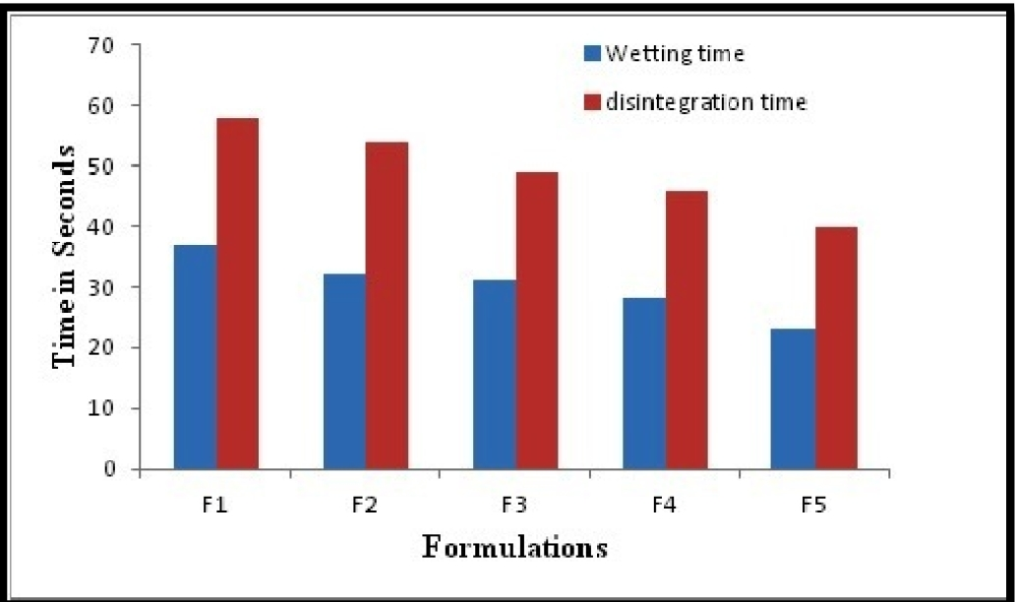  
**Fig.1. Wetting time and Disintegration Time graph.**

**Table 4: % drug release of Fast Disintegrating Tablet**

|  |  |  |  |  |  |
| --- | --- | --- | --- | --- | --- |
| **Time in min** | **F1** | **F2** | **F3** | **F4** | **F5** |
| 0 | 0 | 0 | 0 | 0 | 0 |
| 1 | 70.9±0.76 | 60.3±0.77 | 82.2±1.21 | 61.15±1.32 | 71.6±1.52 |
| 2 | 77.25±1.23 | 72.4±1.6 | 85±0.86 | 70.7±1.4 | 82.25±1.50 |
| 3 | 79.6±1.88 | 84.55±0.65 | 91.6±1.2 | 80.7±1.1 | 88±1.36 |

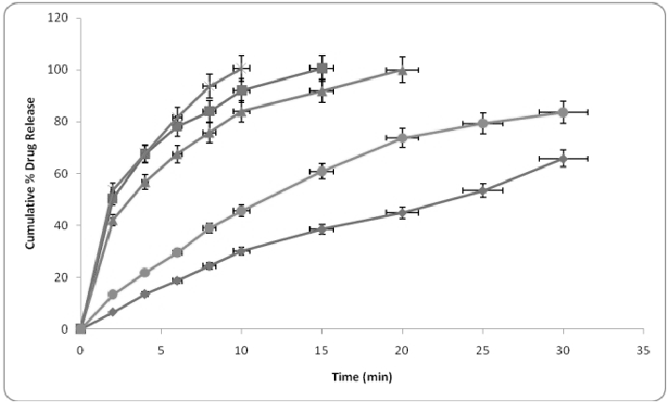

**Fig. 2. % drug release of Fast Disintegrating Tablet.**

**CONCLUSION:**

The development of fast disintegrating tablets (FDTs) of Eletriptan hydrobromide offers a promising approach to overcome the limitations of poor oral bioavailability by bypassing the first-pass metabolism and ensuring a rapid onset of action. Among the formulations studied, formulation F9—containing 5.06% sodium starch glycolate (SSG) and 3.33% croscarmellose sodium (CCS)—emerged as the optimized version, meeting all required physicochemical criteria and disintegrating within 15 seconds. This rapid disintegration is crucial for quickly addressing migraine symptoms and minimizing risks during an attack. Furthermore, the formulation demonstrated an impressive in vitro drug release of up to 99.7%, highlighting its potential effectiveness. Therefore, the development of FDTs of Eletriptan hydrobromide is highly justified.

**REFERENCES:**

1. Sandrini G., Perrotta A., Tassorelli C., Nappi G. (2009) Eletriptan. Expert Opin Drug Metab Toxicol 5: 1587–1598.
2. S. Himabindu, D. Sathish, Shaik Shayeda, Formulation and Ex Vivo Evaluation of Buccal Tablets of   Eletriptan Hydrobromide. American Journal of  Pharmatech Research.2012 2(3) 918-930
3. Vineet Bhardwaj, Mayank Bansal and P.K. Sharma, Formulation and Evaluation of Fast Dissolving Tablets of Amlodipine Besylate Using Different Super Disintegrants and Camphor as Sublimating Agent, American-Eurasian Journal of Scientific Research 5 (4): 264-269, 2010
4. Kavitha K, Sandeep D. S. Mehaboob Yadawad, More Mangesh, Formulation and Evaluation of Oral Fast Dissolving Tablets of Promethazine HCl by Sublimation Method. International Journal of PharmTech Research. , April-June 2011, 3(2), 660-663
5. Ravi Kumar, Swati Patil ,M. B. Patil, Sachin R. Patil, Mahesh S. Paschapur. Isolation and Evaluation of Disintegrant Properties of Fenugreek Seed Mucilage. International Journal of PharmTech Research., Oct-Dec 2009,1(4) 982-996
6. Lachman, L., Liberman, H.A., Kanig, J.L., The Theory and Practice of Industrial Pharmacy, 3rdEd.,Varghese Publishing House, Bombay, 1987, 66-93, 171-190, 268-279, 293-315.
7. Martin A., Swarbrick J., and Cammarata A., Physical Pharmacy, Third Edition, K. M. Varghese Publication, Mumbai, 352-373, 400-410.
8. Rowe R. C., Sheskey P. J., Handbook of Pharmaceutical excipients, 5th edition, Pharmaceutical Press and the American Pharmaceutical Association Publication, 641-643.
9. Indian Pharmacopoeia 2010, Ministry of Health and Family Welfare Government of India, Published by I.P. Commission, Vol. I,  1545-1546.
10. Kumar R, Patil S, Patil M. B., Patil S. R., Paschapur M. S., Formulation evaluation of mouth dissolving tablets of fenofibrate using sublimation technique, International Journal of Chem Tech Research 2009, 1(4), 840-50
11. Sharma D., Kumar D., Singh M., Singh G., Rathore M. S., Fast disintegrating tablets: a new era in novel drug delivery system and new market opportunities, Journal of Drug Delivery and Therapeutics, 2012, 2(3), 74-86.
12. Mishra B, Shukla D, Chakraborty S, Singh S, Mouth Dissolving Tablets I: An Overview of Formulation Technology, Scientia Pharmaceutica, 2009;77:309-326.
13. Sreenivas SA, Dandagi PM, Gadad AP, Indian Journal of Pharmaceutical Education and Research, 2005; 39(4): 177-181.
14. Reddy LH, Ghosh BR, Fast dissolving drug delivery systems: A review of the literature, Indian Journal of Pharmaceutical Sciences, 2002; 64(4): 331-336.
15. Deepak S, Mankaran S, Dinesh K, Gurmeet S. Formulation Development and Evaluation of Fast Disintegrating Tablet of Cetirizine Hydrochloride: A Novel Drug Delivery for Pediatrics and Geriatrics.Journal of Pharmaceutics,2014: 1-9.
16. R.B. Saudagar. Formulation characterization and evaluation of mouth dissolving tablet of lisinopril by using dehydrated banana powder as a natural polymer. WJPR, 2015; 4(12): 763-774.
17. HarithaB.AReviewonEvaluationofTablets. JFormulSciBioavailab, 2017; 1(1): 107.